HOW TO CREATE CLIENT ACCOUNT VIA BITS-AUTO 8081

FIRST STEP CREATE COMPANY:

GOTO----MENU-----COMPANY----COMPANY CREATION

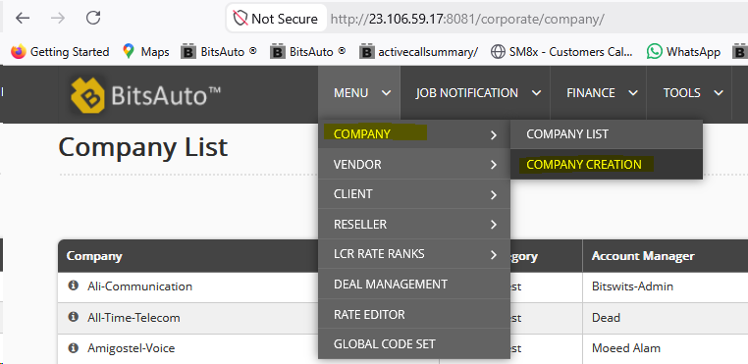

INSIDE COMPANY CREATION JUST PROVIDER COMPANY NAME ,ACCOUNT MANAGER NAME,COMPANY TYPE (RETAIL OR WHOLESALE) ,CONTRACT (CLIENT,VENDOR OR BILLATERAL) AND EMAIL ADRESS DETAIL .

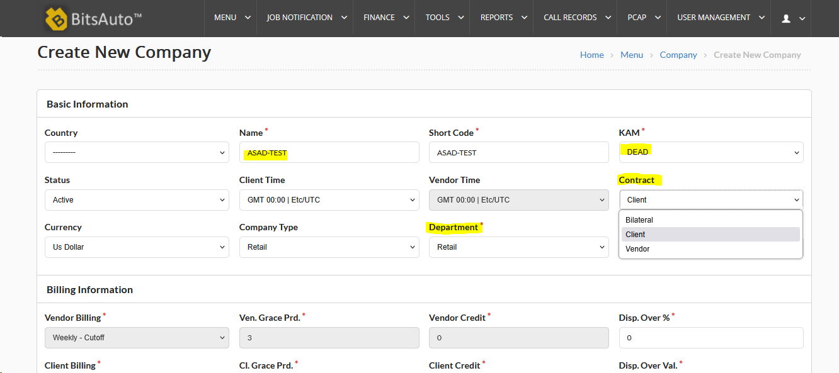

2nd STEP:

CREATE CLIENT:
GOTO-MENU-CLIENT-----CREATE CLIENT
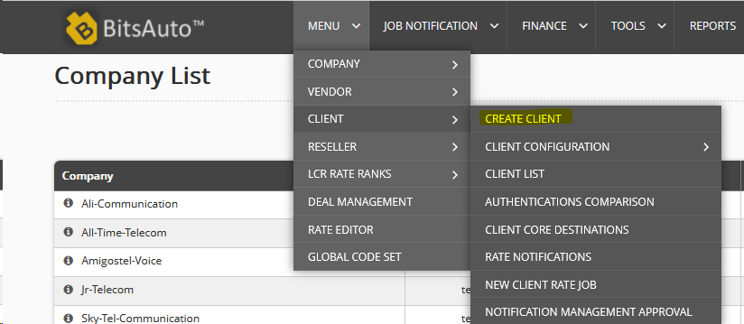
INSIDE CLIENT CREATION STEP1:
SELETC DEPARTMENT(RETAIL OR WHOLE) SLECT COMPANY ,
ENTER PASSWORD,NOTIFICATION INFO ENDS

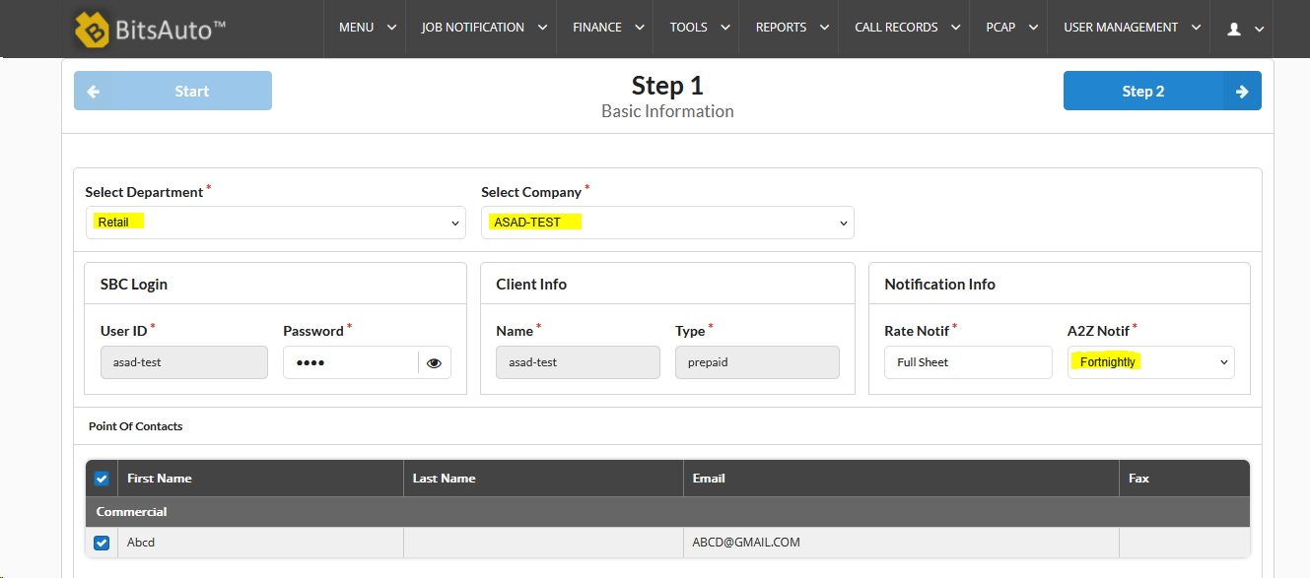

INSIDE CLIENT CREATION STEP 2:
IN STEP 2 JUST SELECT RATE-SHEET FORMAT.

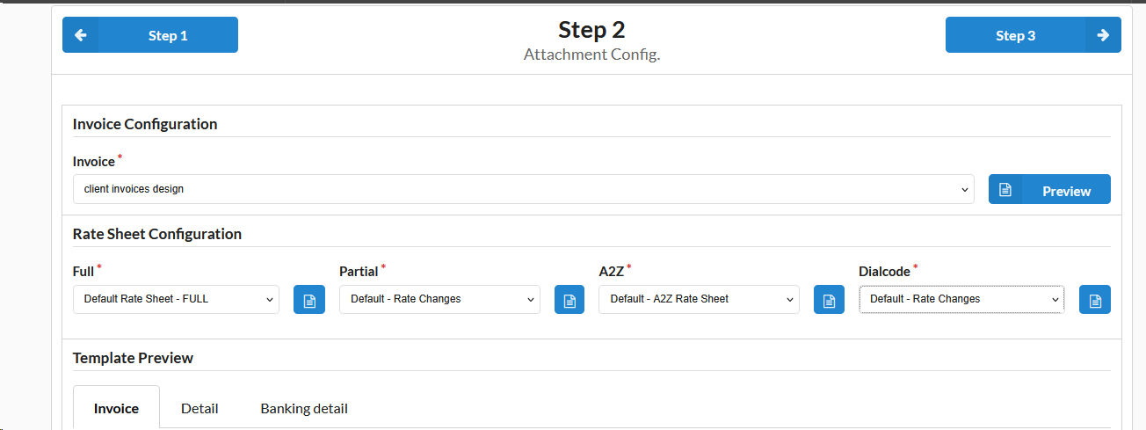

INSIDE CREATE CLIENT STEP 3:

IN STEP 3 PROVIDE CLIENT TECHNICAL CONGIFURATION DETAILS LIKE SWITCH NAME,ASSIGN SPECIFIC TECH PREFIX,DEFAULT ROUTING GROUP,MAX CALL TIME ,MAX SESSION,CODEC
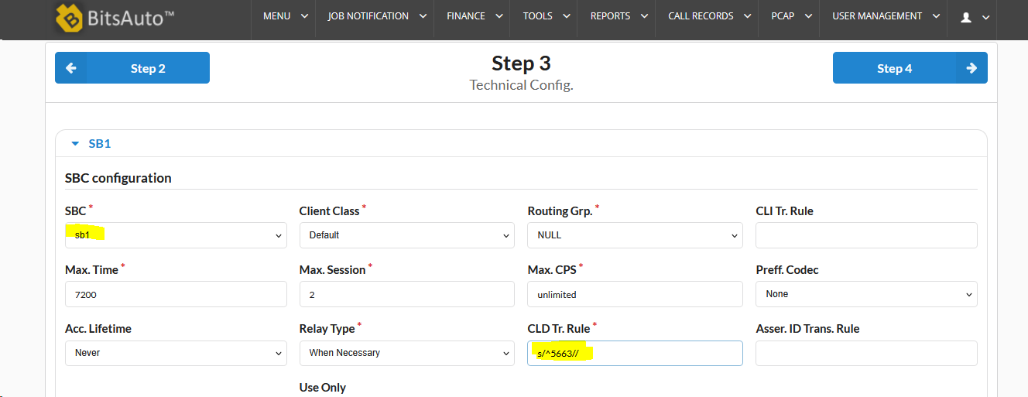

STEP 4:

PROVIDE CLIENT IP TO THE SYSTEM
AND SELECT TRUNKS THAT WILL BE PROVIDE TO THE CLIENT LIKE ,PREMIUM,STANDARD AND CHARLIE ETC

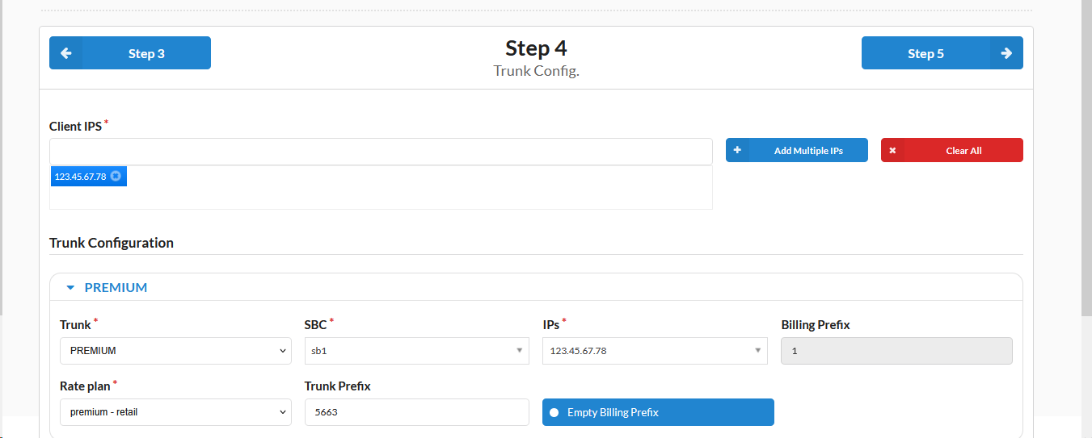

STEP 5:

MAKE AUTHENTICATION RULES TRUNK WISE FOR THE CLIENT

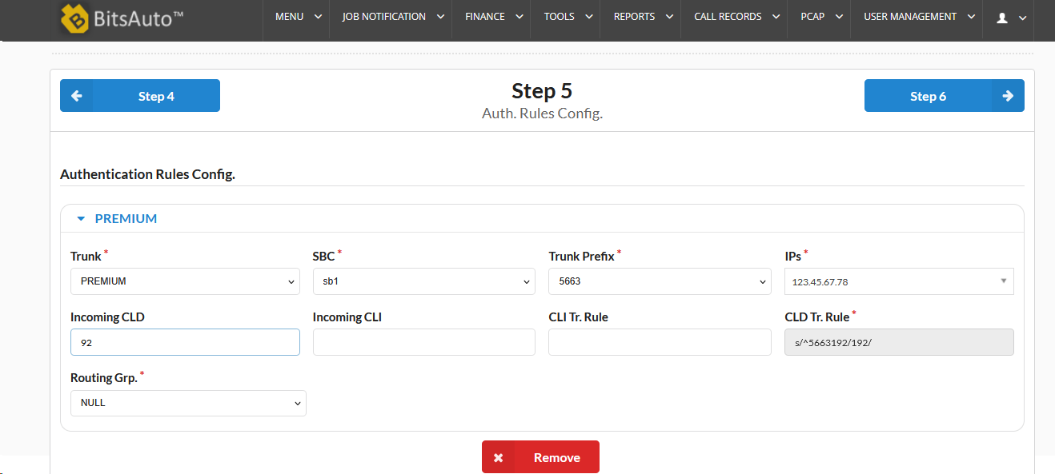

Last step:

Client Validation Rules

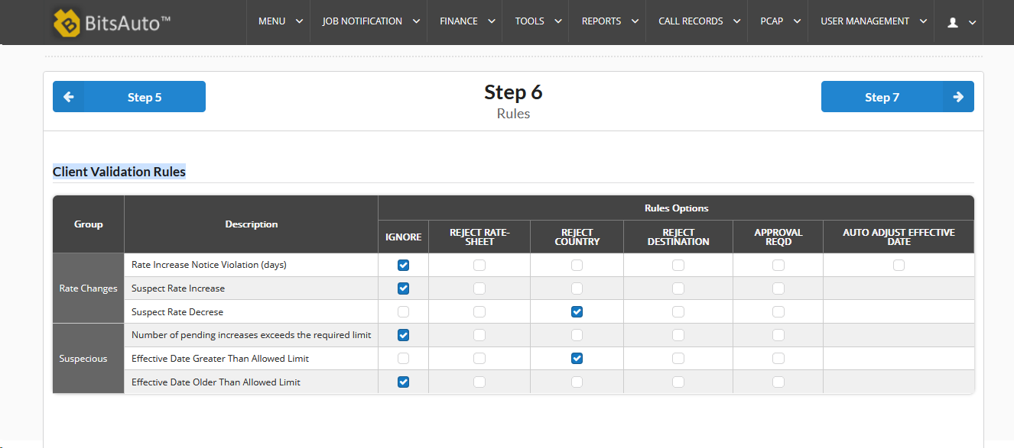
End

