HyperFusion SOP
Version 1.0 Jinhong 10/12/2026
- Turn on the power strip switch for the light sources.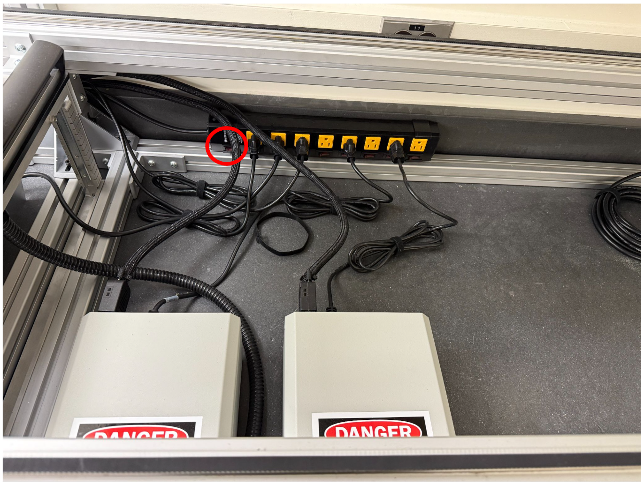
- Switch the buttons following the indicated orders of SWIR PCU if you are planning to use SWIR. Wait for at least 5 min before connecting SWIR to let the cooling system be stable. Skip this step if you only need to use FX10e.
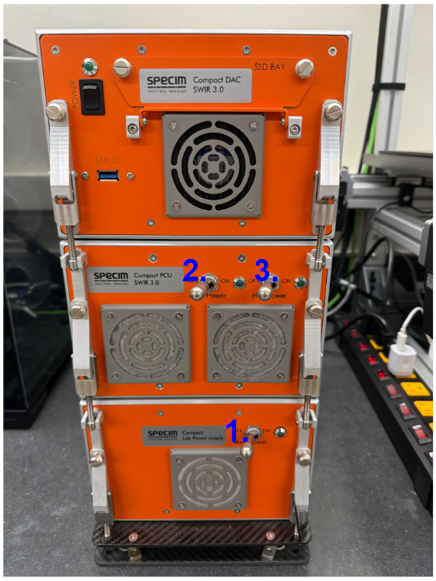
- Open the HyperFusion app, which is usually located in "D:\HyperFusion\app\app.exe".
- Connect FX10e under the Camera tabs, an eBus Device Selection window will pop up (if you don’t see it check the windows at the taskbar). Check “Show unreachable Network Devices” and the FX10e device will show up. Double click it to connect to FX10e. The default setting is optimized parameters.
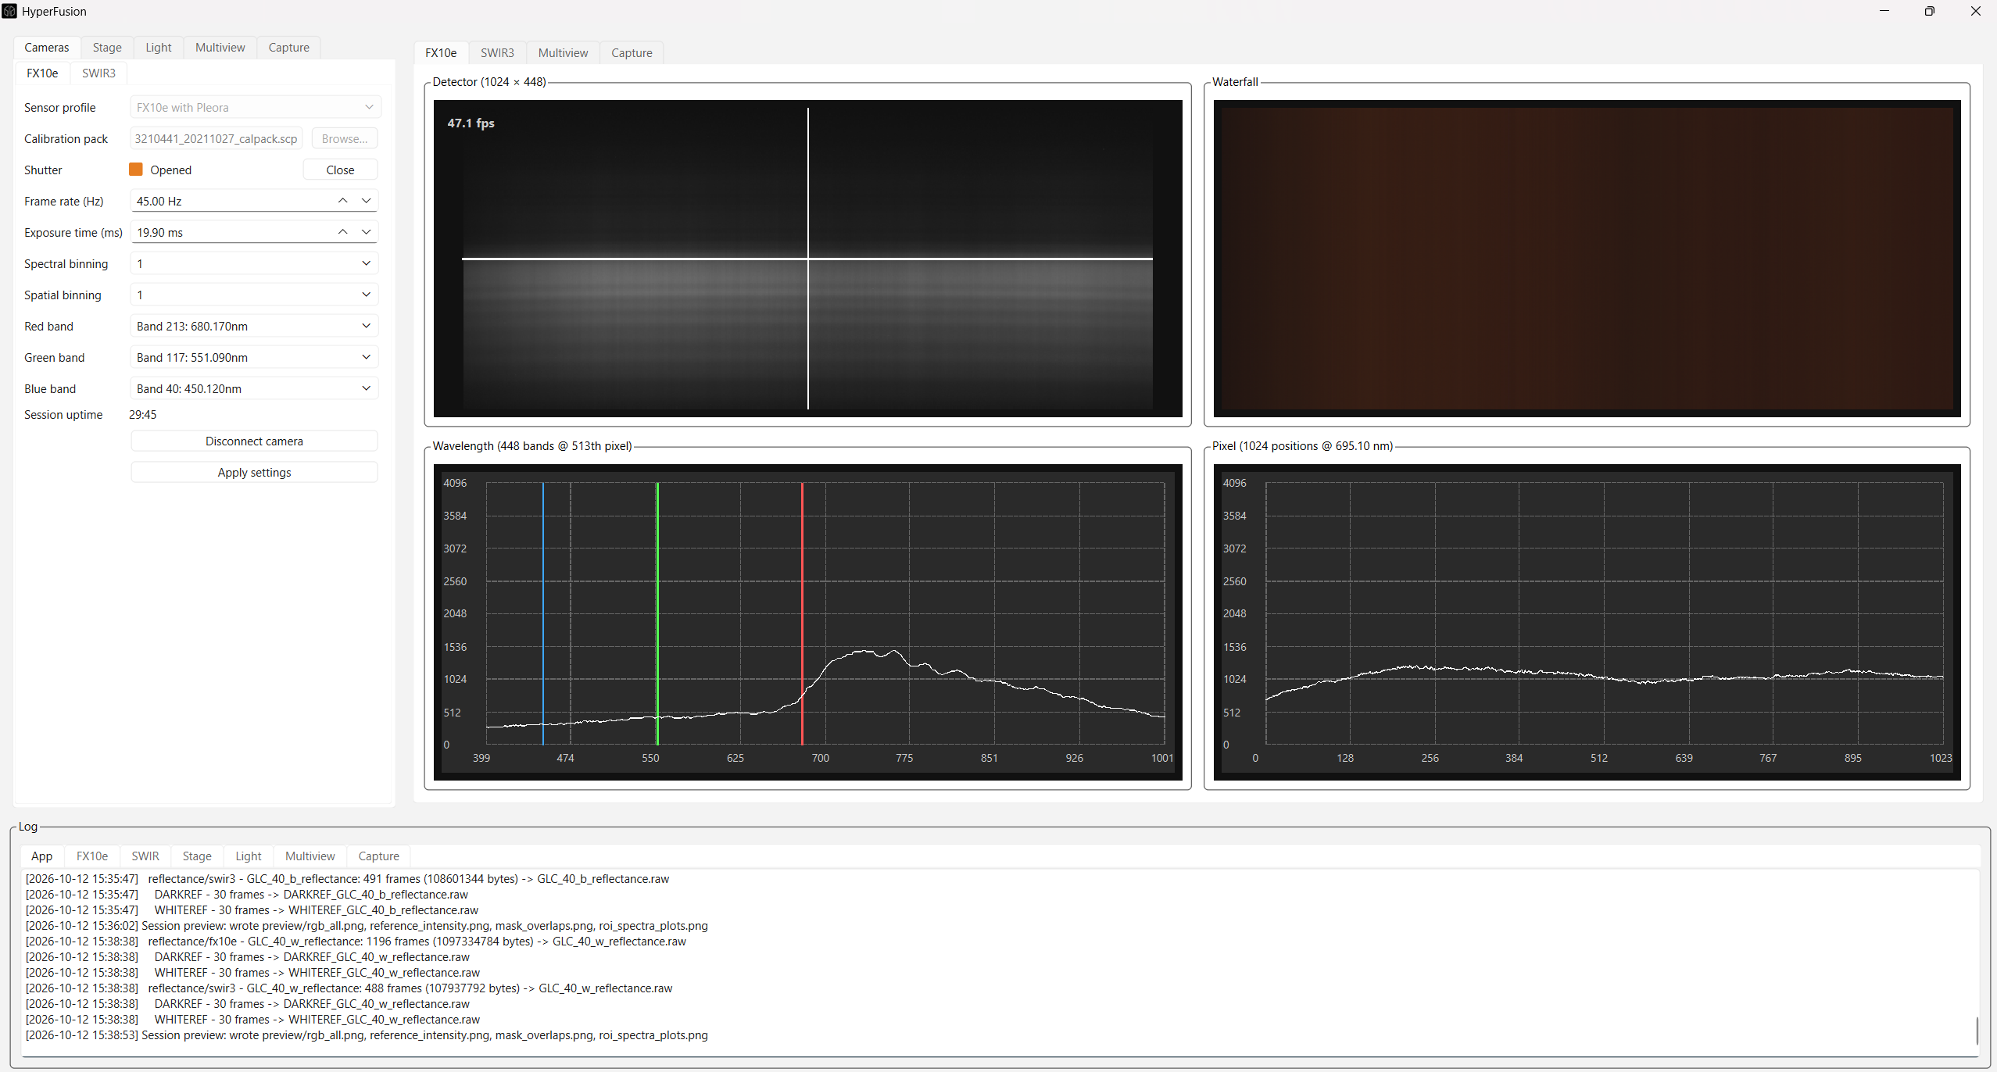
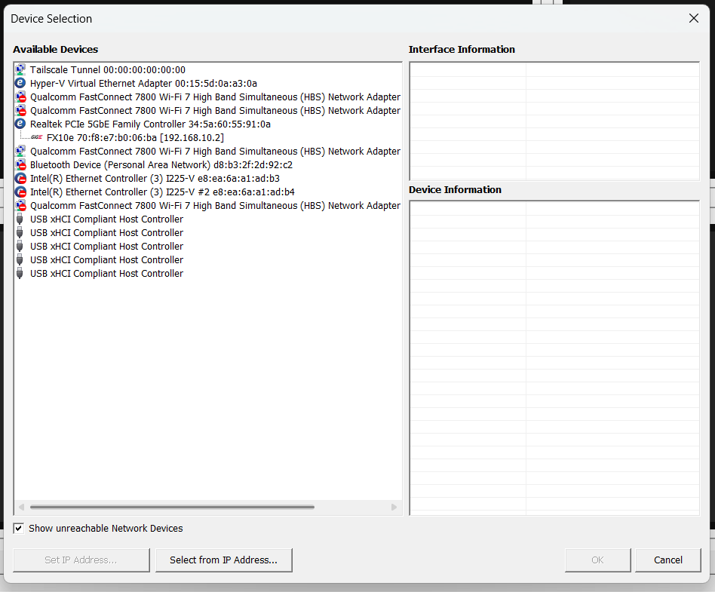
- Connect SWIR under the Camera tabs by simply clicking the “Connect” button. It might take 20-30 seconds to connect SWIR. The default setting is optimized parameters.
- Connect the Stage under the Stage tab by simply clicking the “Connect” button.
- Connect the light houses under the Light tab by clicking “Refresh” and “Connect” buttons. Adjust the lighting intensity and configuration as you need. The default setting is optimized parameters.
- Go to the Capture tab to begin your data acquisition, where you can set the data folder location, scanning configuration (what cameras and what scanning modes), sample physical length, and preprocessing configuration.
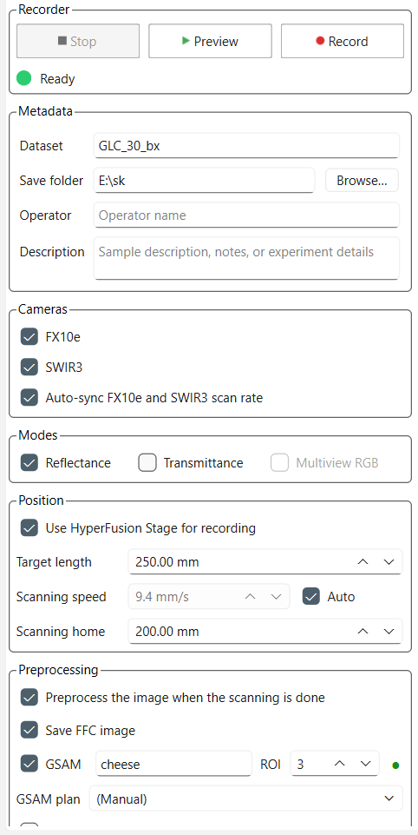
- For more user manual details, please refer to "D:\HyperFusion\USERMANUAL.md"

