James Yang

CSCI 431

HW01

**Abstract**

This assignment introduces us to MATLAB and how to process images using it.

**Questions**

1. License number: 364896
2. 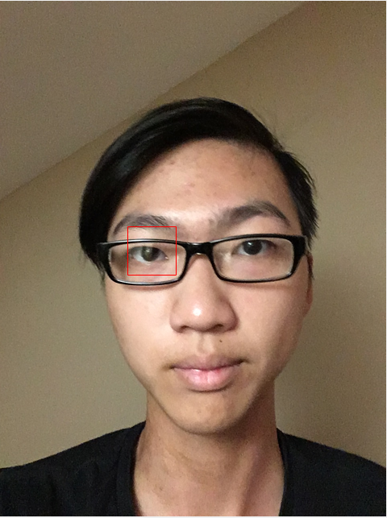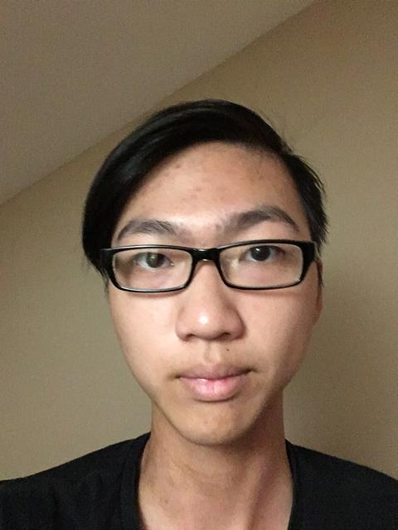
4. 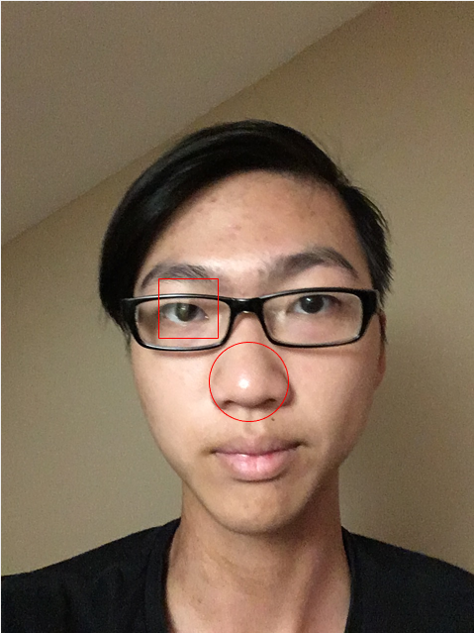

1. **Conclusion and Observations**

From this assignment, I’ve learned the basics of how to write functions and image processing in MATLAB. I wasn’t sure if we were supposed to hardcode the coordinates in for the square and circle, so I left the ginput() function in the code but commented out. Plotting out a circle and square also refreshed the mathematical equations to represent them.