James Yang

CSCI 431

HW04

**Introduction**

We use MATLAB to learn about the colon operator and the logical operators. Then we explore how to segment an image using the different channels (rgb, hsv, lab, etc) and different methods to better segment them.

1a. m5(2,3) = 7

1b. m5(1,5) = 15

1c. m5(2:3, 3) = 7  
 13

1d. m5(21) = 15

1e. m5(end-2:end) = 22 3 9

1f. m5(1:2;end, :) = 17 24 1 8 15  
 4 6 13 20 22  
 11 18 25 2 9

1g. m5(1:7:end) = 17 6 25 16

1h. m5(end-4:end).’

1i. m5(2:4, 2:4)

1j. The colon operator by itself is used to signify all values in a matrix.

2a. m5(:) > 21 returns an array of logical values.

2b. m5(:) > 21 returns 0 or 1.

2c. m5(13) returns integer.

2d. m5(20) = 2

2e. 5x5 logical array

2f. 5x5 logical array

2g. m5(m5>20) = 23  
 24  
 25  
 21  
 22

2h. 25x1 logical array

2i. 5x5 logical array

2j. m5(m5 <= 2 | m5 >= 23) = 23  
 24  
 1  
 25  
 2

3a. 64 grayscale levels

3b. Quantization 32 is when the lighter parts of the balls become noticeably different.

3c. Quantization 128 makes the red ball contrast from the background.

3d. The white spots are where the light is reflecting off the surface of the ball, thus masking the actual color of the ball.

3e. The green channel isolates the green and yellow ball. To isolate just the green ball, it should be compared with the red channel to see that one ball is a combination of the two colors, therefore is not fully green. Then, you can deduce that the other ball in the green channel is fully green.

4. Blue ball is easiest to segment because the other balls do not contain blue in them. The yellow ball contains green and red, therefore, needs to use more than one channel to isolate the balls.

5. Using the hsv saturation channel, if we multiply it by a large factor, the birds will show up as black chunks compared to everything else in the photo.

6. To determine the color yellow, we know that it is a mix with green and red. If we take the red channel and the green channel and see the areas where they are both high, and there is no blue, then we can deduce that the square is yellow.

7. After testing, it appears that the blue channel would be best to segment the license plate. This way, the green grass is almost fully blacked out, and the surrounding car is also darker. The threshold that seems to be best is 255, when the license is very clearly contrasting from the color of the car.

8. For red pieces, you can cross-reference between the green and blue channel to see the overlap. The pieces that are dark for both channels would be red. For green pieces, you can cross-reference between red and blue to find the pieces that are dark in both. For blue pieces, cross-reference between red and green. For yellow, cross-reference between all three and see which pieces are dark in the blue channel but not in red or green. The more of the color there is, the lighter it is in the rgb channel.

9. The red color channel clearly shows the license plate and the letters at 255 quantization.

10. For each of the hsv channels, I multiplied it by 100 so that I could utilize the quantization without it flooring to 0 for all the values. I took the saturation channel and used a quantization of 64 to bring out the red apple. To clean up some of the noise, I used the hue channel and inverted it to get more of the red apple structure.

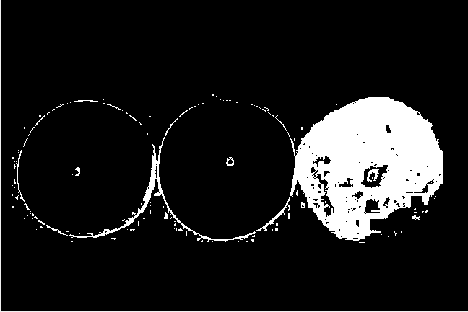

**Conclusion and Observations**

The colon operator is very versatile in its uses. Segmentation can be difficult when different channels overlap with information and sometimes, like the in the case of the apples, are missing information that is needed. In order to find specific elements in a picture, it is necessary to combine different channels so that an element can be segmented from the rest of the image.