**Assignment: PHP Blog Security**

In this assignment you will use the template “blog.zip” folder found on LEARN/Teams. You will make the changes we made during class to secure the login!   
  
First, let’s ensure you’ve got the Blog software installed properly…

Open up your Debian, sign in, switch to root:

su -

Log into the command line version of mysql:  
  
mysql –u root

create database blog;  
  
grant all privileges on blog.* to 'bloguser'@'localhost' identified by  
'password';

grant all privileges on blog.* to 'blogadmin'@'%' identified by  
'password';

flush privileges;

exit

Use WinSCP to upload the Blog software to the server under /var/www/html

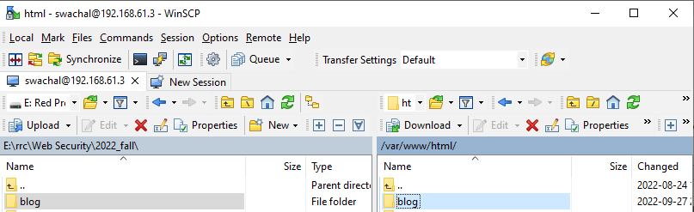

Edit the config.php file and ensure it has the right details:

Be sure to modify the permissions on the blog folder:

Open MySql editor and register the Blog database we just made (Be sure to use YOUR Debian IP address and not the one in the screenshot):  
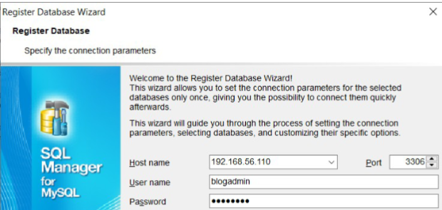

Select it from the drop down:

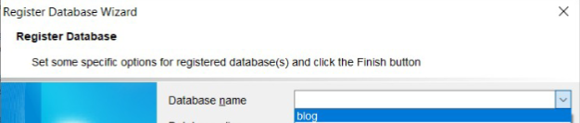

Use F-12 to execute this SQL on the blog database we just made:   
  
**CREATE TABLE `members` (  
`id` int(4) NOT NULL auto_increment,  
`username` varchar(255) NOT NULL default '',  
`password` varchar(255) NOT NULL default '',  
PRIMARY KEY (`id`)  
) AUTO_INCREMENT=2 ;  
  
INSERT INTO `members` VALUES (1, 'john', '1234');   
  
CREATE TABLE IF NOT EXISTS `posts` (**

**`id` int(11) NOT NULL AUTO_INCREMENT,**

**`title` varchar(255) NOT NULL,**

**`content` text NOT NULL,**

**`created_at` timestamp NOT NULL DEFAULT '0000-00-00 00:00:00',**

**`updated_at` timestamp NOT NULL DEFAULT CURRENT_TIMESTAMP ON UPDATE CURRENT_TIMESTAMP,**

**PRIMARY KEY (`id`)**

**) ENGINE=InnoDB DEFAULT CHARSET=latin1 AUTO_INCREMENT=5 ;**

**INSERT INTO `posts` (`id`, `title`, `content`, `created_at`, `updated_at`) VALUES**

**(1, 'Luctus Metus Libero', 'Lorem ipsum dolor sit amet, consectetuer adipiscing elit. Phasellus hendrerit. Pellentesque aliquet nibh nec urna. In nisi neque, aliquet vel, dapibus id, mattis vel, nisi. Sed pretium, ligula sollicitudin laoreet viverra, tortor libero sodales leo, eget blandit nunc tortor eu nibh. Nullam mollis. Ut justo. Suspendisse potenti.\r\n\r\nSed egestas, ante et vulputate volutpat, eros pede semper est, vitae luctus metus libero eu augue. Morbi purus libero, faucibus adipiscing, commodo quis, gravida id, est. Sed lectus. Praesent elementum hendrerit tortor. Sed semper lorem at felis. Vestibulum volutpat, lacus a ultrices sagittis, mi neque euismod dui, eu pulvinar nunc sapien ornare nisl. Phasellus pede arcu, dapibus eu, fermentum et, dapibus sed, urna.', '2013-05-08 15:50:00', '2013-05-08 18:57:22'),**

**(2, 'Consectetuer Adipiscing', 'Lorem ipsum dolor sit amet, consectetuer adipiscing elit. Donec odio. Quisque volutpat mattis eros. Nullam malesuada erat ut turpis. Suspendisse urna nibh, viverra non, semper suscipit, posuere.', '2013-05-08 18:12:25', '2013-05-08 18:58:11'),**

**(4, 'New Post', 'This is some content.', '2013-05-08 19:01:07', '2013-05-08 19:01:07');**

You should now be able to goto the blog site using the IP address of your Debian server.

To complete the assignment, you will need to add the following functionality that is missing from the default blog site:

* Login / Log out (in their own tabs)
* Register User (ensure that this user’s password is hashed and salted)
* Privacy Policy

Note: there is a DropBox for your code when you are done.

In addition to the DropBox, you must show me in person, or create a video.

If you do a recording, I'd like to see the database being updated as you create a new user. Show me:

* wrong user, wrong password
* right user, wrong password
* trying to use: ' OR 1=1 # For username / password
* logging in successfully.
* privacy policy (scroll through)
* logging out.

Note: We made our own hardened login/register php code using the example found in learn:  


You should maintain the CSS (look and feel) of the site while adding functionality to it.

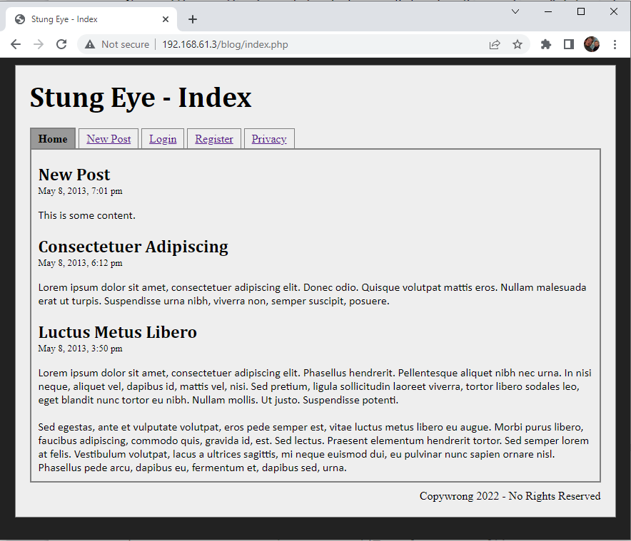

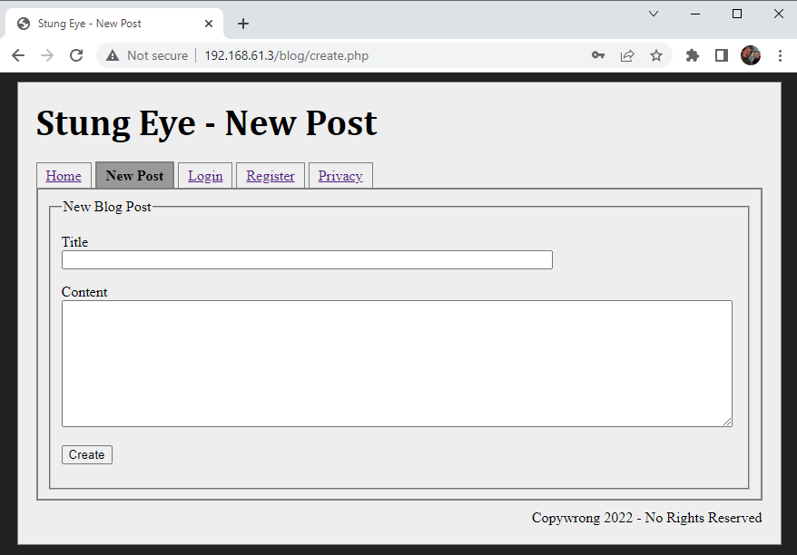

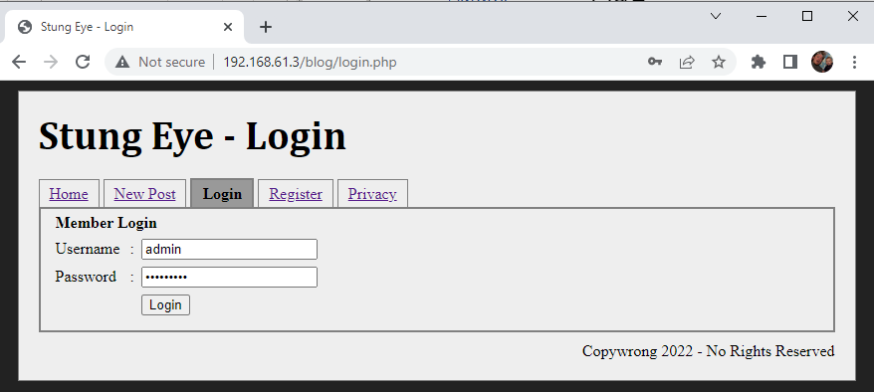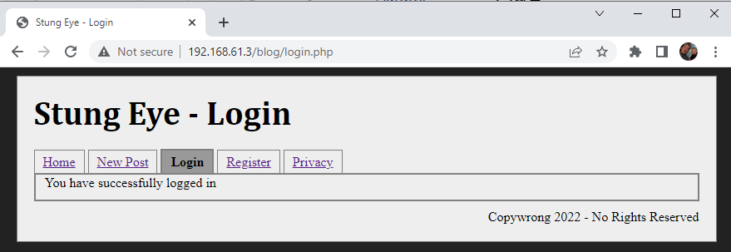

Note: the login changes to Log out! The “Register” disappears, because we’re logged in.

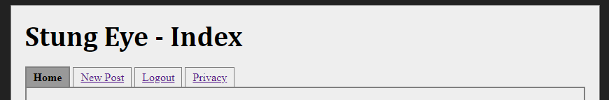

Clicking on “Logout” causes:  
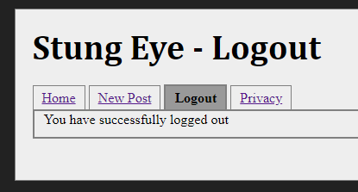

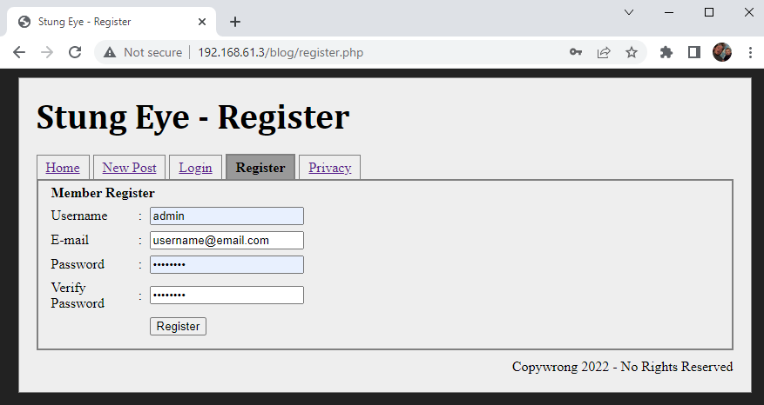

Registering a user shows a success page and redirects to being logged in.. or redirects to the login.

The database should contain a properly hashed value with salt:

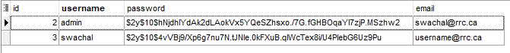

An example privacy policy: You can just find anything on the internet within reason. 😊You should not just copy paste the screenshot privacy policy (this is an EXAMPLE).