Semra Palali Delen

In this part, we estimated the site frequency spectrum by using the bam files.

I also run another code to make it more fancy.

We can see the distribution of the theta values in the histogram above.

When we look at the Fst values in the upper picture, we can catch the similarity between this and the last picture, Fst distribution.

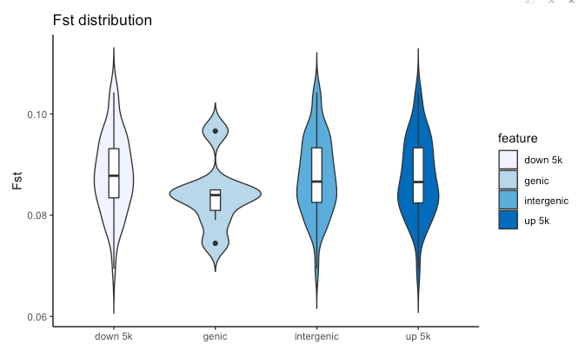

Fst measures reduction in heterozygosity of a subpopulation compared to total population. It ranges from 0 to 1. If Fst is zero, it means that there is no differentiation among populations. When Fst is high, it implies a considerable degree of differentiation among populations.

Here I calculated the Fst based on different genomic regions and upstream and downstream of the gene. In the picture above, we can see how is Fst distribution in different regions. Whereas in intergenic region, down 5k and up 5k Fst is between 0.07 and 0.09, in the genic region, Fst is around 0.085. In my result Fst value is relatively small so we can conclude no big differentiation observed. Since we assume that Fst, between 0.15 and 0.25, presents moderately great differentiation if we say Fst=0.25, our Fst values are very smaller and do not support differentiation.