R 101

Jinliang Yang

05-17-2019

My first R code

# Creating a Graph  
attach(mtcars)  
plot(wt, mpg)   
abline(lm(mpg~wt))  
title("Regression of MPG on Weight")

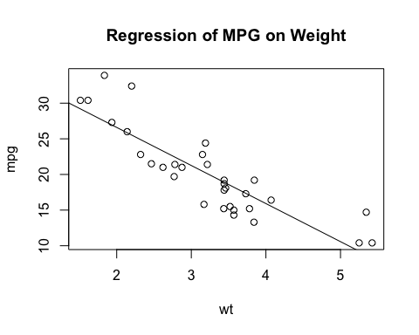

Add a new chunk by clicking the *Insert Chunk* button on the toolbar or by pressing *Cmd+Option+I*.

When you save the notebook, an HTML file containing the code and output will be saved alongside it (click the *Preview* button or press *Cmd+Shift+K* to preview the HTML file).

The preview shows you a rendered HTML copy of the contents of the editor. Consequently, unlike *Knit*, *Preview* does not run any R code chunks. Instead, the output of the chunk when it was last run in the editor is displayed.