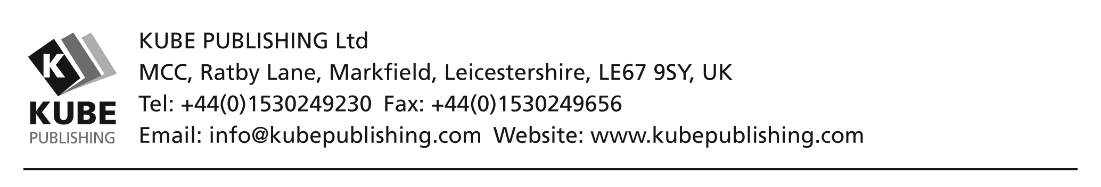

THIS IS AN AGREEMENT BETWEEN KUBE PUBLISHING LTD AND YOU
After completing this form and returning it to us you will be on the way to becoming a Kube Books Ambassador, with the ability to sell and market our range of products to your community.

Kube Ambassador Information
Full Name:
Last |  |  |  |  |  |  |  | First |  |  | M.I.
Address:
Street Address |  |  |  |  |  |  |  |  |  |  | Flat/House No.
City |  |  |  |  |  |  |  |  |  | County | Postcode
Home Phone: |  |  | ( ) |  |  |  | Mobile Phone: |  | ( )
E-mail Address:
Birth Date: |  |  |  |  | Desired Book Hamper/s:

I agree to act as a Kube Books Ambassador on the terms stated overleaf on this Agreement.

Sign/Print your name:
DATE:
Signed on behalf of Kube:
Haris Ahmed
Director

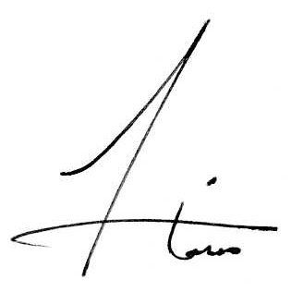

Please outline the area you would be covering below (try to be as specific as possible):

