RepData_PeerAssessment1

This is an R Markdown document for Reproducible Research assignment 1.

### 1. Load the libraries and data, and preprocess the data

library(dplyr)

##   
## Attaching package: 'dplyr'  
##   
## The following object is masked from 'package:stats':  
##   
## filter  
##   
## The following objects are masked from 'package:base':  
##   
## intersect, setdiff, setequal, union

library(stringr)  
library(ggplot2)  
  
ac<-read.csv("activity.csv")  
  
# pad the left side of the interval entry "0" with "so that each entry has four characters  
ac$interval<-str_pad(ac$interval,4,"left","0")  
  
datetime<-strptime(paste(ac$date,ac$interval), "%Y-%m-%d %H%M")  
  
# create a new data frame "acdatetime" by adding column "datetime" to the data frame  
acdatetime<-cbind(ac,datetime)  
  
# a data frame with missing value removed  
steps_datetime<-filter(acdatetime,steps!="NA")

### 2.What is mean total number of steps taken per day?

by_day<-group_by(steps_datetime,date)  
sumbyday<-summarise_each(by_day,funs(sum),steps)  
hist(sumbyday$steps,breaks=10,main="Histogram of steps taken per day",xlab="Steps taken per day")

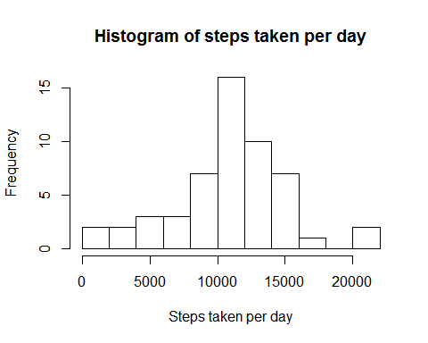

print(summary(sumbyday$steps))

## Min. 1st Qu. Median Mean 3rd Qu. Max.   
## 41 8841 10760 10770 13290 21190

The mean total number of steps taken per day is 10766.

### 3. What is the average daily activity pattern?

pattern<-group_by(steps_datetime,interval)  
avgbyinterval<-summarise_each(pattern,funs(mean),steps)  
  
plot(avgbyinterval$interval,avgbyinterval$steps, type="l", xlab="5-min intervals throughout the day", ylab="steps taken in each 5-min interval")

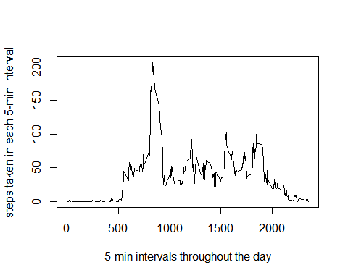

ordered<-arrange(avgbyinterval,desc(steps))  
maxinterval<-ordered[1,1]  
maxstep<-as.integer(ordered[1,2])

The 5-min interval at 0835 contains the maximum number of steps: 206.

### 4. Imputing missing values

Imputing strategy: The rounded average number of steps taken per interval calculated from the data set with missing data removed will be used for that interval whenever the data is missing.

# obtaining a data frame containging rounded value of the mean of steps per interval  
intavgsteps<-as.integer(round(avgbyinterval$steps))  
avgbyinterval<-cbind(avgbyinterval,intavgsteps)  
#rename steps to mysteps to avoid column name duplication in the merged data frame  
avgbyinterval<-rename(avgbyinterval, mysteps=steps)  
  
#merge the orginal data frame with the above data frame containg the mean steps per interval  
mymerge<-merge(acdatetime, avgbyinterval, by=c("interval","interval"))  
mymerge<-arrange(mymerge,datetime)  
  
# replace NA with the mean steps for that interval  
mymergena<-filter(mymerge, is.na(steps)==TRUE)  
mymergena$steps<-mymergena$intavgsteps  
imputed<-rbind(mymergena,filter(mymerge,is.na(steps)==FALSE))  
  
#calculate the number of missing values  
num_missing<-length(mymergena$steps)  
  
#calculate step per day for data set with missing value imputed  
by_day_imputed<-group_by(imputed,date)  
sumbyday_imputed<-summarise_each(by_day_imputed,funs(sum),steps)  
# make a histogram with data set containing imputed data  
hist(sumbyday_imputed$steps,breaks=10,main="Histogram of steps taken per day with missing data imputed",xlab="Steps taken per day")

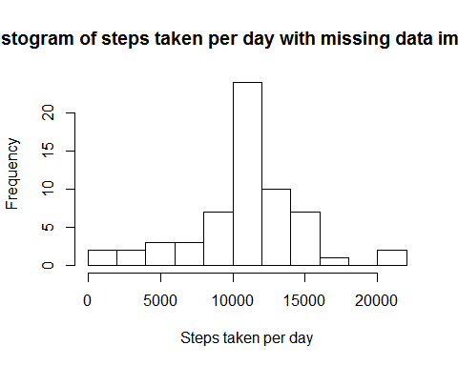

# group and summarize the data set containing imputed data  
patternimputed<-group_by(imputed,interval)  
avgbyintervalimputed<-summarise_each(patternimputed,funs(mean),steps)  
  
#make plot with or without missing value imputed  
par(mfrow=c(2,1))  
plot(avgbyinterval$interval,avgbyinterval$mysteps, type="l",xlab="5-min intervals throughout the day", ylab="steps taken in each interval", main="missing value removed")  
plot(avgbyintervalimputed$interval,avgbyintervalimputed$steps, type="l",xlab="5-min intervals throughout the day", ylab="steps taken in each interval", main="missing value imputed")

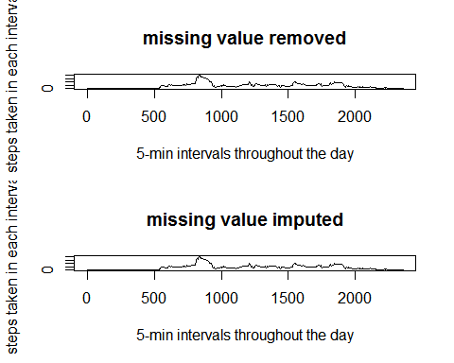

par(mfrow=c(1,1))

The total number of missing values in the dataset is 2304.

Summary with missing data removed:

## Min. 1st Qu. Median Mean 3rd Qu. Max.   
## 41 8841 10760 10770 13290 21190

Summary with missing data imputed:

## Min. 1st Qu. Median Mean 3rd Qu. Max.   
## 41 9819 10760 10770 12810 21190

The results are very similar but not identical; therefore, imputing missing data using the way described above does not have a dramatic effect on the results of the estimates of the total daily number of steps.

### 5. Are there differences in activity patterns between weekdays and weekends?

# use the data set with the filled-in missing data  
  
#create a column "dayorend" to denote weekday and weekend  
imputed_wd<-mutate(imputed,weekday=weekdays(datetime),dayorend="weekday")  
imputed_wd$dayorend[imputed_wd$weekday=="Saturday"|imputed_wd$weekday=="Sunday"]<-"weekend"  
#group the data by interval and weekday/weekend  
patterndayorend<-group_by(imputed_wd,interval,dayorend)  
avgdayorend<-summarise_each(patterndayorend,funs(mean),steps)  
  
#plot the result  
g<-ggplot(avgdayorend,aes(interval,steps,group=1))  
print(g+geom_line()+facet_grid(dayorend~.))

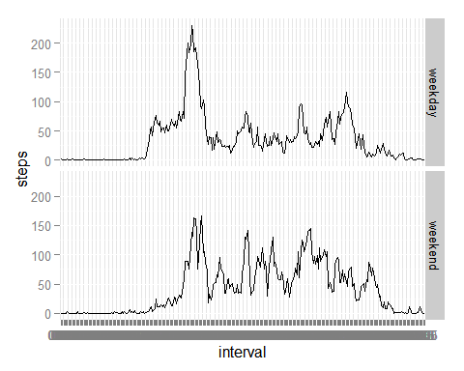

Comparison of the two graphs shows that on the weekdays, the activity starts earlier and has a larger early morning peak and that, on the weekend, the activity starts later and the morning peak is less pronounce, i.e., the activity is more evenly spreaded over the course the day.