Unity Sound Tutorial

**How To Play a Sound:**

* Sound can originate from any gameobject. There are only 2 components necessary for playing sound:  
  + - Audio Source: this component holds the sound that will be played. It also controls where the sound is sent to be mixed( more on this later).
    - Audio Listener: Living up to its namesake, the audio listener simply listens to audio and play it.
* We’ll start off with an empty scene. First in the hierarchy create> empty gameobject and add a Component > Audio > Audio Source component to it. Name the empty gameobject “PlayableSound”.  
  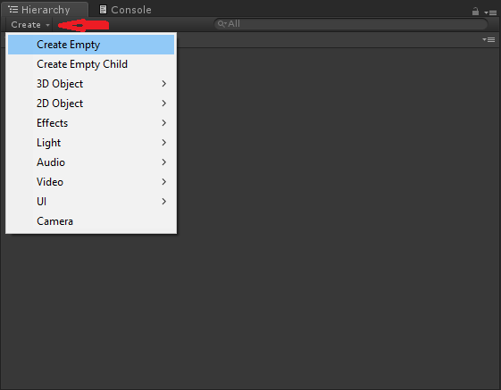
* Take a quick look at the camera and peek at its components. You should see the Audio Listener as the final component. Audio Listeners are usually always placed on the camera. Go ahead and leave it there.  
  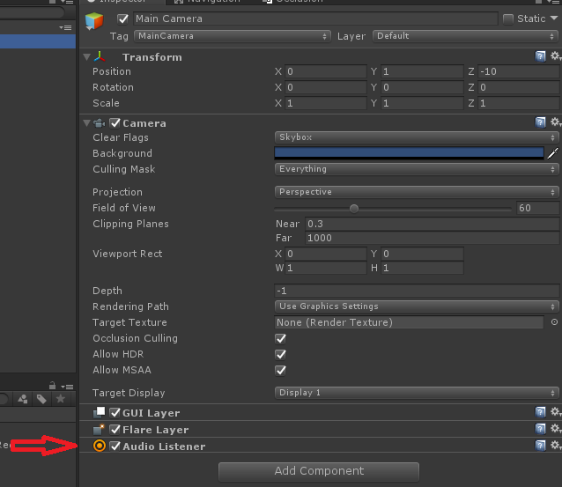
* Go back the the Playable Sound object and look at the audiosource component. Drag an audio file into the audiosources’ “AudioClip” box. You should see the audio file nested into the component.  
  *(Alternatively, dragging an audio file on top of a gameobject in the hierarchy will automatically place it into the AudioClip box)*  
  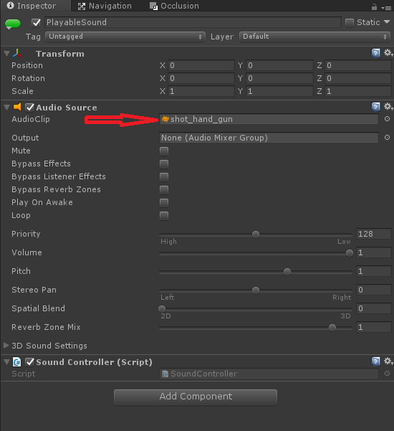
* Make sure “Play On Awake” is Checked, and hit play on the scene. The sound should go off when you start.
* Now we’ll play the sound based on input. Create a new script and call it “SoundController”. Attach the script to your “PlayableSound” gameobject and access the script with the scripting IDE.
* Enter the following code:

**using UnityEngine;**

**public class SoundController : MonoBehaviour**

**{**

**AudioSource audio;**

**// Use this for initialization**

**void Start () {**

**audio = GetComponent<AudioSource>();**

**}**

**// Update is called once per frame**

**void Update () {**

**if (Input.GetKeyDown(KeyCode.Space))**

**{**

**audio.Play();**

**}**

**}**

**}**

* Save and go back to the Unity project. Hit play on the scene and test out the script.

**How To Loop a Sound**

* Go to your AudioSource component on the “PlayableSound” gameobject and check the Loop box. Hit play on the scene.  
    
  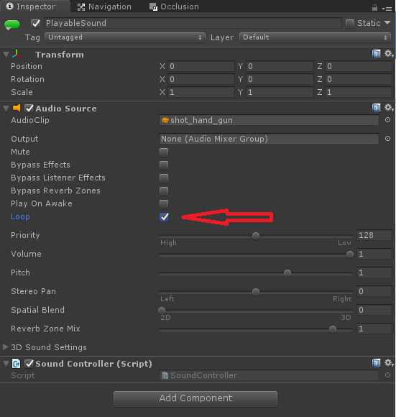
* That’s it. If the sounds are made ideally to loop, than you can leave it at that. Unity can also handle when a clip starts and begins.
* Disable “PlayableSound” and create a new gameobject and call it “BGM”. go through the earlier steps to add a sound, except this time, make a new script called “MusicController” and add that to BGM instead.  
  *(with the convention and assumed purpose for this tutorial, use actual music as your audio for this object, that’s longer than 5 seconds.)*
* Open the MusicController in an IDE and write the following Code:

**using UnityEngine;**

**public class MusicController : MonoBehaviour {**

**AudioSource audioSource;**

**float loopEnd = 5f;**

**// Use this for initialization**

**void Start () {**

**audioSource = GetComponent<AudioSource>();**

**}**

**// Update is called once per frame**

**void Update () {**

**if (audioSource.time > loopEnd)**

**{**

**audioSource.time = 0.0f;**

**}**

**}**

**}**

* Quick rundown on what's happening here:
  + AudioSource.time is the current point at which the audio is playing, in seconds. You can read and write this value in, which is important to know.
  + What we are doing is checking if the time played is greater than the finish point we have declared. If it is, then we set AudioSource.time to zero, effectively forcing a loop.
* Save and test to ensure the code is functioning properly.

**How To Use The Mixer**

* On the taskbar click Assets > Create > AudioMixer and name it accordingly.  
  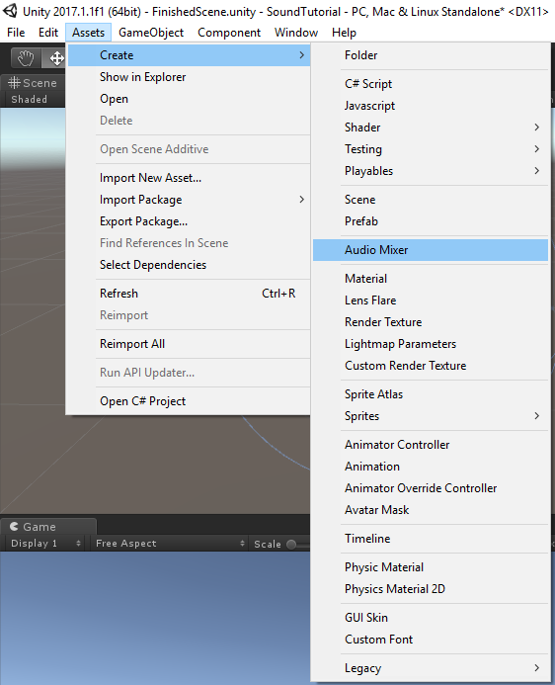
* On the TaskBar click Window > AudioMixer  
  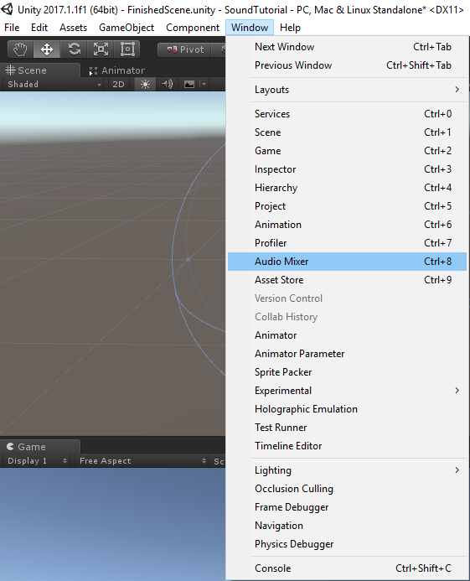
* In the window you should see 4 categories on the left side and a bar reader for the Master on the right. You can simply use the master to mix in for your sounds or break it up further into “Groups”. We’ll do that.
* Click the plus sign beside the Groups category and name it “Noises”. Notice how the group is now a child of Master. A group will inherit mixing from any parent group it is attached to. Create a new group under Master and call it “Music”  
  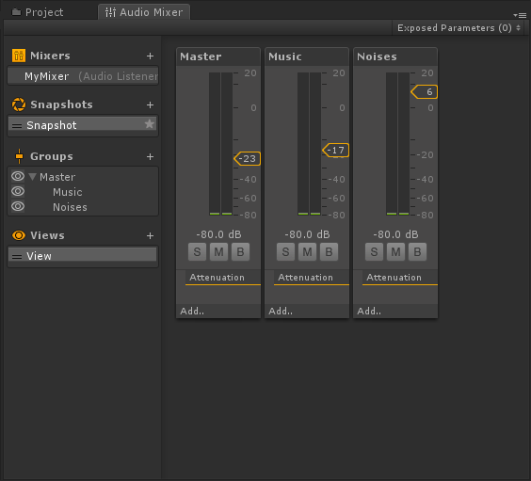
* Select the BGM gameobject and click on the circle beside Output in the AudioSource component. It should show your mixer and all the groups in it. Select the Music group  
  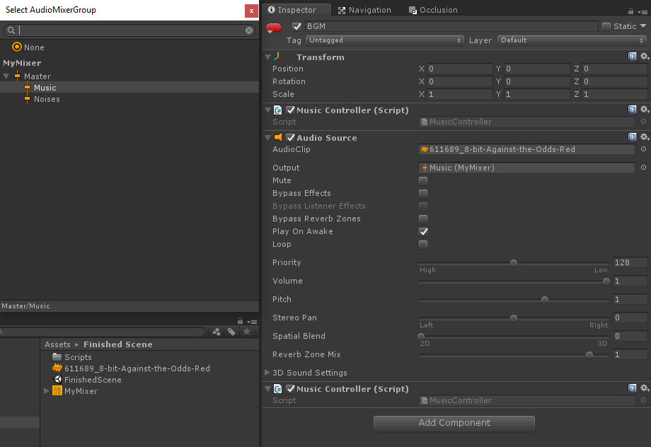  
  .
* Re-enable the PlayableSound gameobject and have it output to the Noises group
* Back at the AudioMixer window, look at the bars on the right. There should be 3 now, one for each group. Set these bars to different levels and hit play on the scene.
* When you hit play there should be a little tab on top of the AudioMixer window that says “Edit In Play Mode”. Click on it.  
  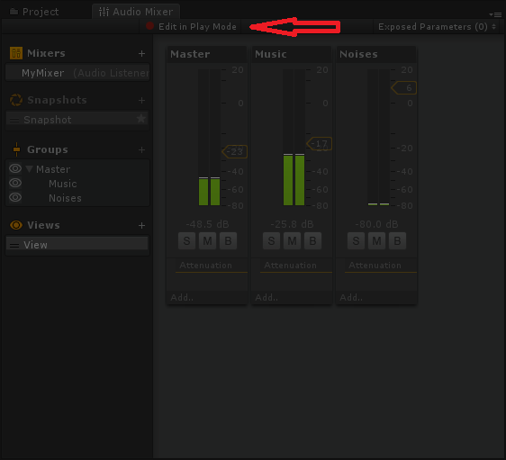
* Now you can edit the levels of each channel as the scene is playing. Continue to mess around till you find suitable levels.