Audio Tutorial (Making buttons for one-shot and a looping sounds)

* Create a canvas with two buttons. (One for the looping sound and one for the one-shot sound)
* Attach an audio source to each button.

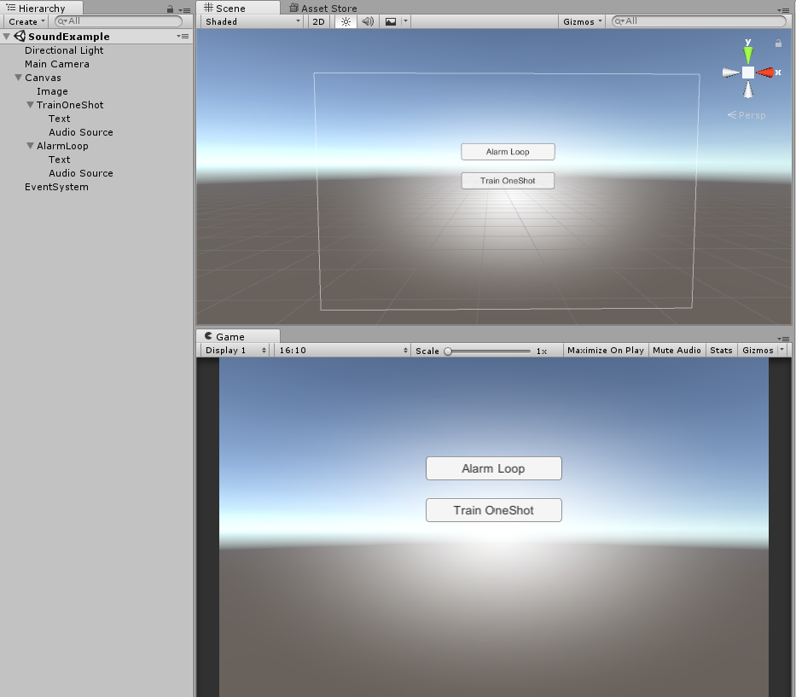

How to use once only (fire and forget) sounds

* On your one-shot button within the Button component, find the ‘OnClick()’ method and press the ‘+’ button in the bottom right corner.
* Drag the Audio Source from the one-shot button onto the ‘None (Object)’ below the ‘Runtime Only’ dropdown of the ‘OnClick()’ method
* Beside the ‘Runtime Only’ dropdown of the ‘OnClick()’ method, click on the dropdown menu and select ‘AudioSource’ and then ‘PlayOneShot’
* Add your choice of sound to the ‘None (Audio Clip)’` beside the Audio Source.

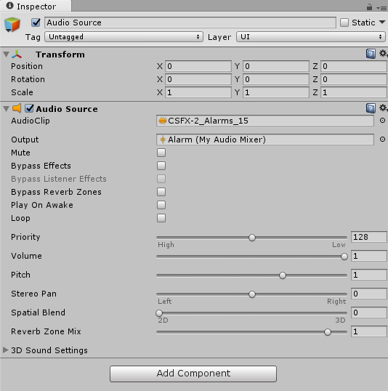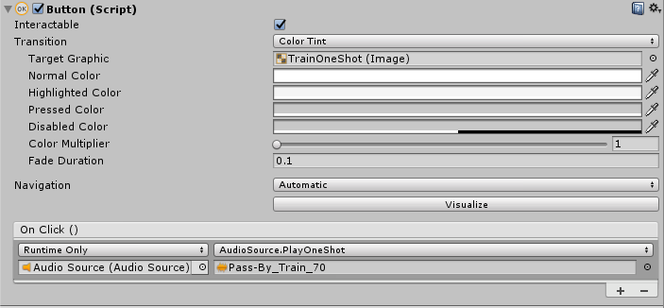

* Leave your audio source alone for now.

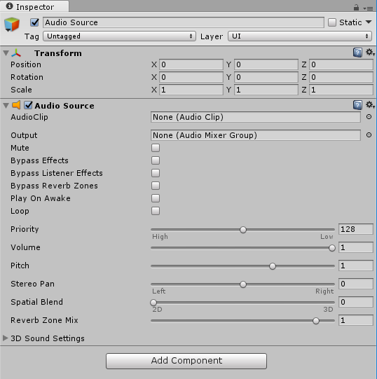

How to use looping sounds

* Create a c# script and type the following into it.

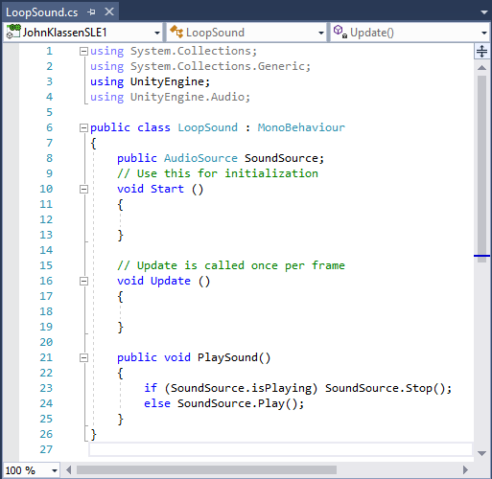

* Drag the created script onto your looping sound button.
* Drag the Audio Source from the one-shot button onto the ‘None (Object)’ in the ‘Sound Source’ in your script.
* On your one-shot button within the Button component, find the ‘OnClick()’ method and press the ‘+’ button in the bottom right corner.
* Drag the script you made onto the ‘None (Object)’ below the ‘Runtime Only’ dropdown of the ‘OnClick()’ method
* Beside the ‘Runtime Only’ dropdown of the ‘OnClick()’ method, click on the dropdown menu and select your scripts name and then ‘PlaySound’

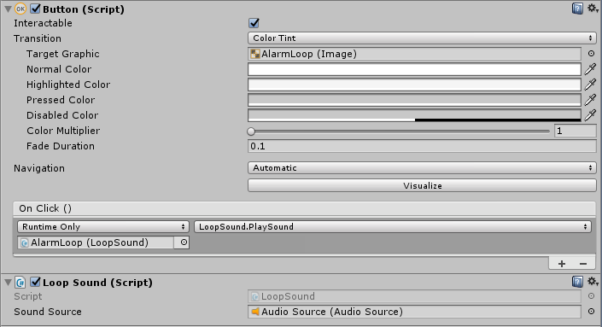

* Select the Audio Source in your looping button and drag your choice sound into the ‘AudioClip’

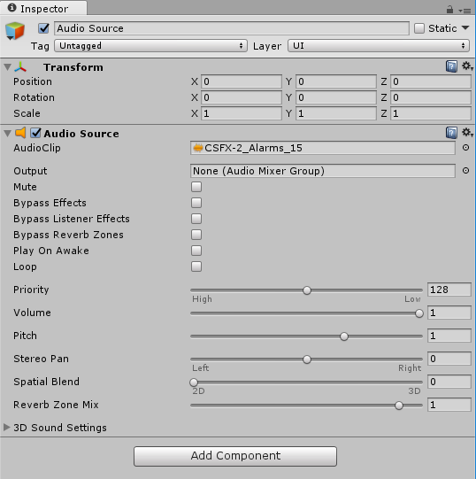

How to use the mixer to create at least two groups and set volumes

* Bring down the window menu and select Audio Mixer (or press CTRL + 8)
* When the audio mixer appears, click the ‘+’ beside Mixers
* Create one for every separate sound button you have.
* Drag the group you made onto the corresponding Audio Source in the Output slot.



* Adjust sliders in mixer to fit your preferences.

