If you need to get audio then you can get audio files from [flashkit](http://www.flashkit.com)

# To Play a sound once (Button Click Sound)

1. Make a new empty GameObject and rename it “AudioSource_Object”
2. Add a new Component->Audio->Audio Source to the “AudioSource_Object”

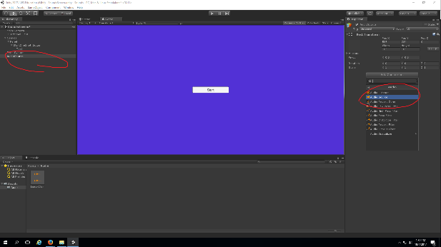

1. On the audio source, uncheck “Play on wake”

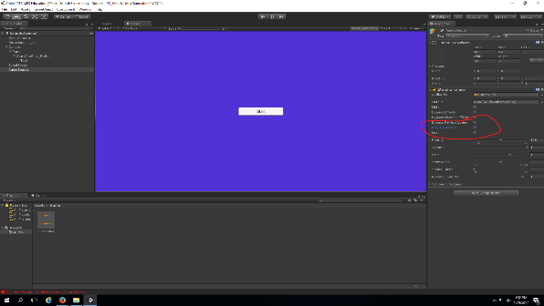

1. Make a new GameObject->UI->Button and rename it “Play_Button”

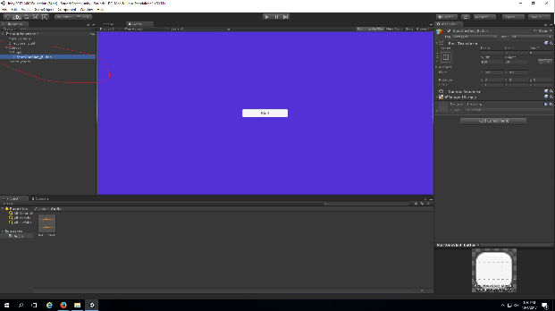

1. On the button add a new method to the “OnClick” property
2. Add the “AudioSource_Object” to OnClick()

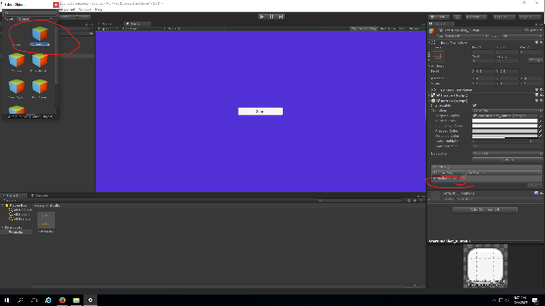

1. Select NoFunction->AudioSource->PlayOneShot

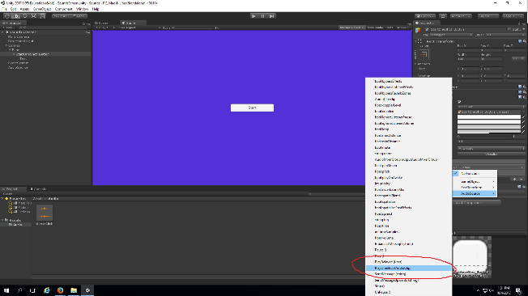

1. Add the desired audio file to the OnClick->AudioClip section

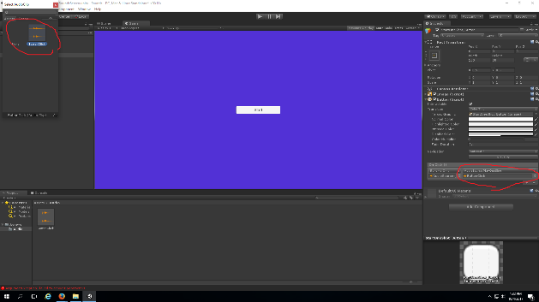

Now when you click the Play_Button the sound will play once.

# Toggle Looping Audio (Background Music)

1. Add a new GameObject->UI->Button and rename it “ToggleBackgroundMusic_Button”

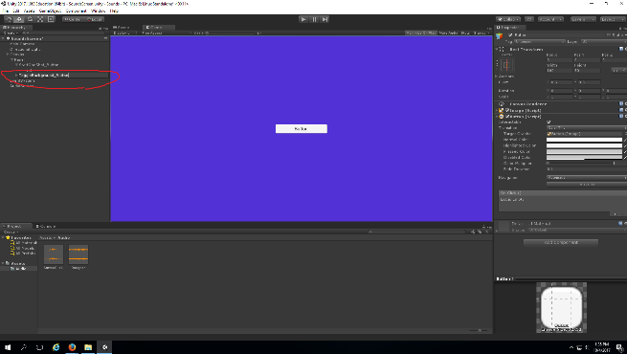

1. Add a new Component to the MainCamera Audio->AudioSource
2. Add the desired audio file to the AudioClip property
3. Check “PlayOnWake” and “Loop”

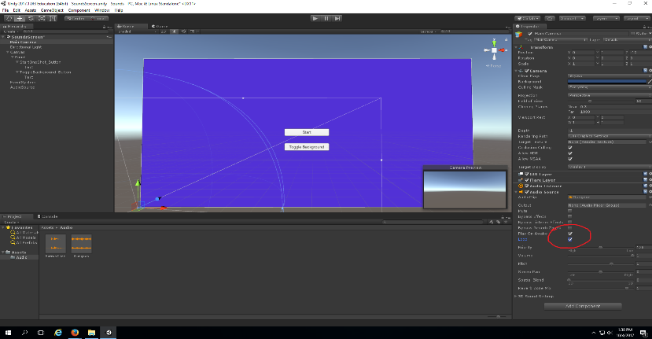

1. Create a new C# script called “Volume”

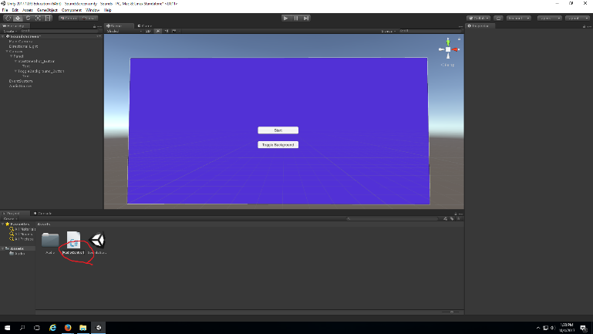

1. Make the script look like this

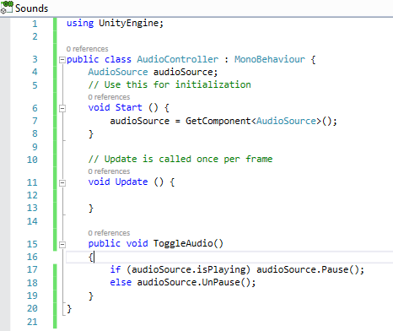

1. Add the script to the MainCamera
2. Reference the MainCamera in the OnClick of the ToggleBackgroundMusic_Button
3. Select OnClick->NoFunction->Volume->ToggleAudio

Now when you click the ToggleBackgroundMusic_Button it will turn the music on and off.

# Adding audio to a Mixer Group

1. Create->AudioMixer in your assets
2. Rename it “MyAudio”

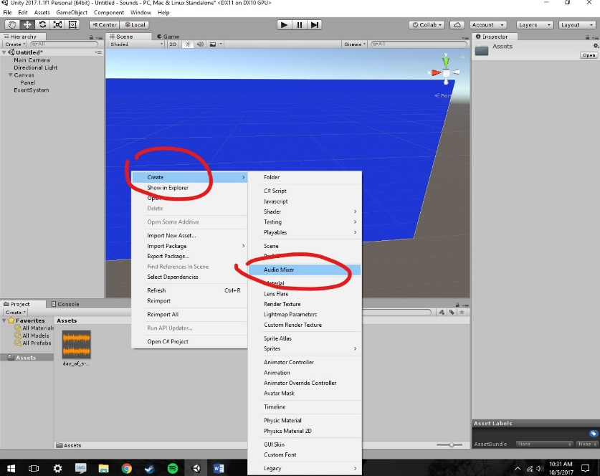

1. Add two new child groups to the master group
   1. If you are unable to rename the group then:
      1. Play the scene
      2. Delete the group
      3. Recreate the group

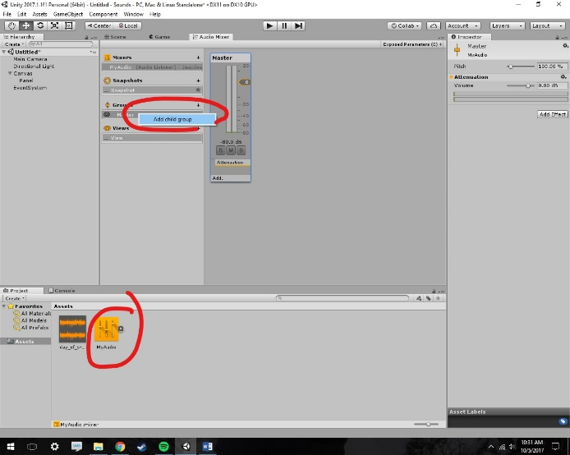

1. Rename the groups “Background” and “Environment”

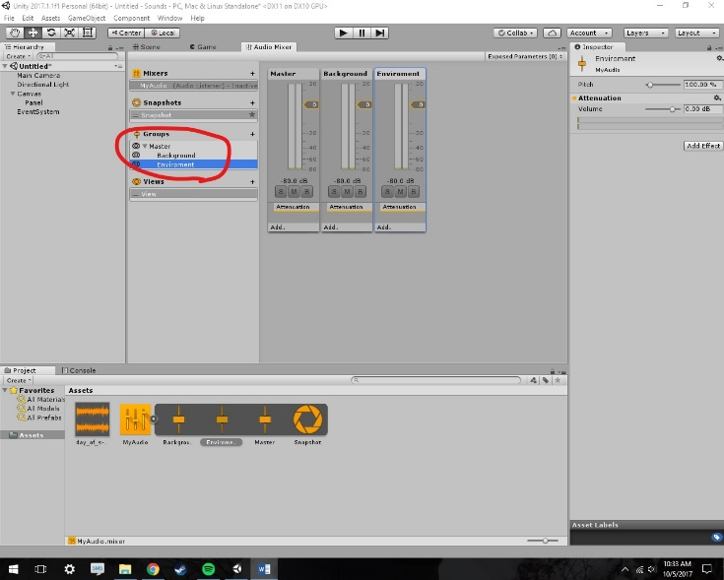

1. On the AudioSource’s we created earlier add the proper Audio Group the Output properties

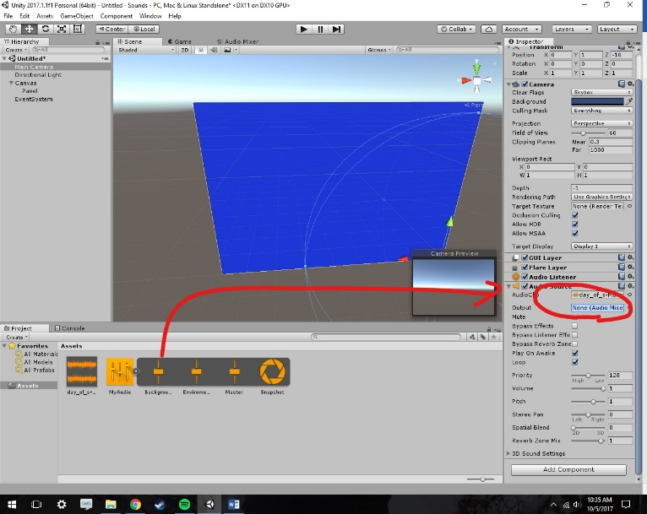

Now the Audio is played by the audio mixer.

# Adjusting Audio Group Volumes

1. On each of the Audio Group right click on the Attenuation and select “Expose” in the inspector.

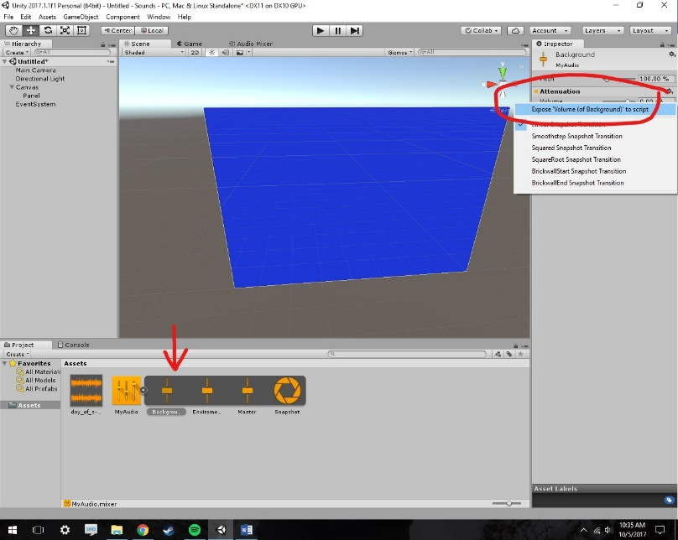

1. In the AudioMixer rename both of the Parameters to “BackgroundVolume” and EnvironmentVolume”

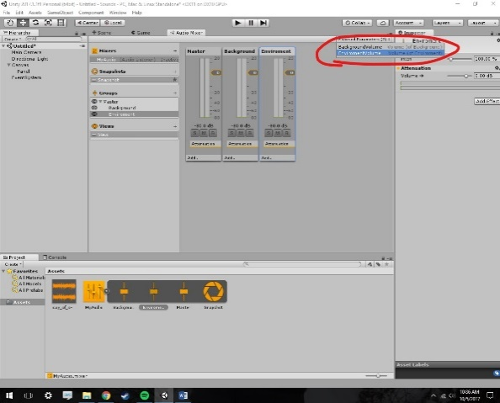

1. Create a new GameObject->UI->Slider and rename it “BackgroundVolume_Slider”
2. Adjust the Max Value to -80
3. Adjust the Min Value to 20

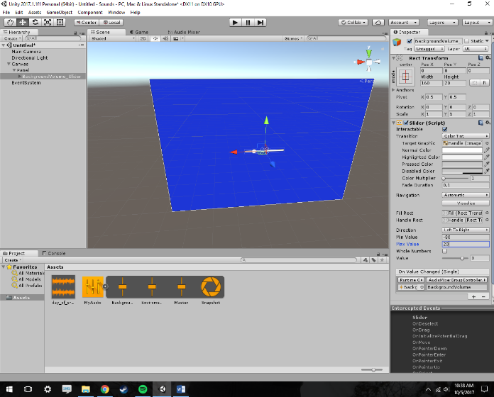

1. Add the following code to the Volume script

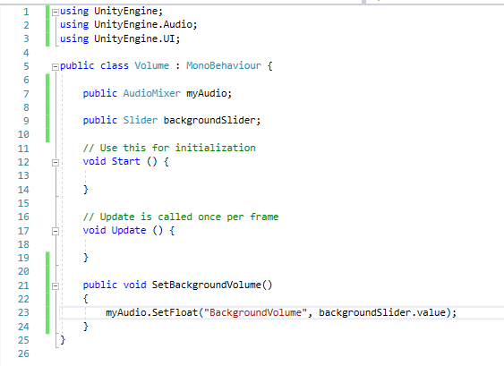

1. Add the mainCamera to the OnValueChanged
2. Select NoFunction->Volume->SetBackgroundVolume

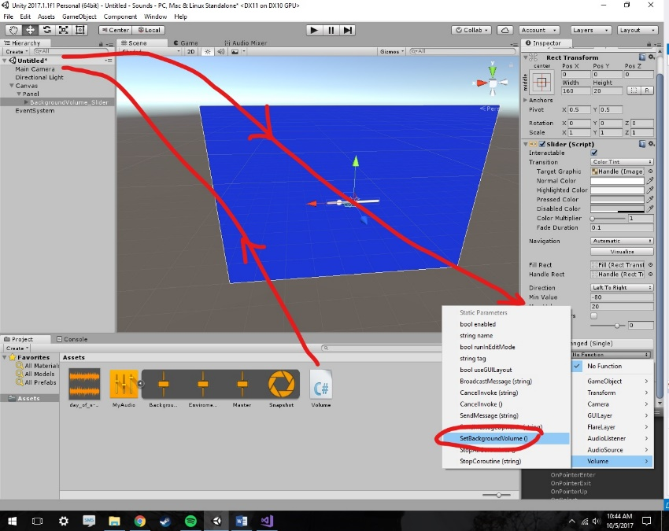

1. Repeat steps 3-11 for the environment sounds such as the button click audio
2. Repeat steps 1-11 for the Master Volume

Now the Audio volumes can be adjusted in game.