

# One Shot Sounds

One shot sounds are useful for many situations. Gun fire, grenades, a door opening… the possibilities are endless. Thankfully setting up these sounds is easy. The first thing we need is an empty game object. In the hierarchy right click and select ‘create empty’.

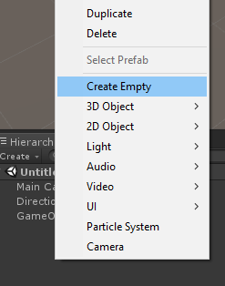

On this object you will want to create an audio source and a C# script. To do this, click on the empty game object you just made in the hierarchy and press the ‘add component’ button in the inspector window. Then search for audio source and script.

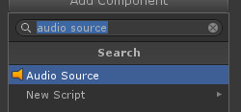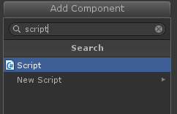

Make sure the loop option is unchecked in the audio source options and open up your script. The first thing we will want to do is assign our audio source to a variable. One way of doing this is below.

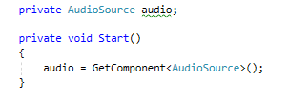

With this set up, we will want another variable for our audio clip.



The code to play the sound is simple. All we need to do now is set up a condition in which we use it. One such condition is when we press a button.

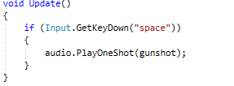

In this example the audio clip assigned to the gunshot variable will play each time the space button is pressed.

# 1.1 Looping Sounds

Let’s say that you want to have background music for a title screen. For that, you will want your audio clip to loop continuously. For this all we need to do is add the audio source component to a game object in the scene, the main camera being one example, and set up some options.



In the image below the settings to loop and play on awake are checked. Play on awake will play the audio clip once the scene starts and loop will continuously loop the audio clip.

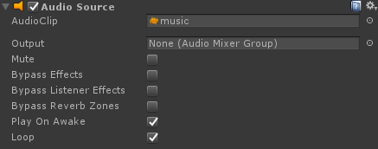

# 1.2 The mixer

This tutorial will show you how to use the mixer to create two groups and adjust their volumes. First, create an audio mixer.

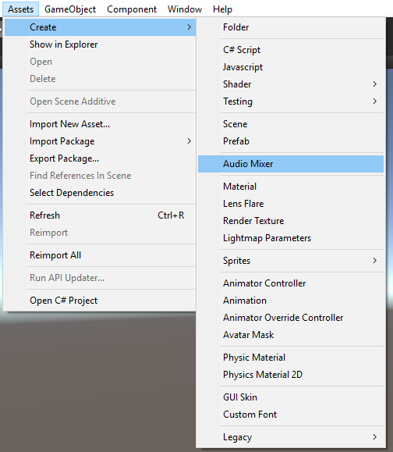

Then double click it when it appears in the hierarchy. In the groups section, press the + button which will create a group. With a group made, now we want to assign the mixer to our audio sources. Find the audio source you want to add to the mixer and select the output section, then select the mixer we created.

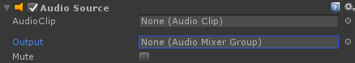

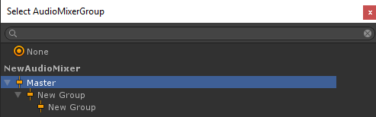

This also let’s you select which group you wish to use. In the example below, instrument sounds were added to different groups. This allows the editor to set how loud each instrument is and use user options and input to set the master volume.

