In Unity, sounds are played from an Audio Source while they are captured by Audio Listeners.

Unity can import many different audio formats, simply dragging and dropping the files into the Project will create an Audio Clip that is played with an Audio Source.

Let’s talk about “Fire and Forget”, or “One shot” clips in Unity. In my example I will be showing two ways of doing these types of sounds the first will be my gunshot and the second will be the shell casing hitting the ground. First we will import these two sounds into Unity by dragging them and dropping them into the Project window.

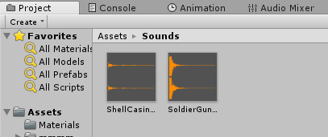

Then add an audio source to the game with the script that fires the gun and drag the gunshot audio clip to the respective property in the inspector window (Make sure Play on Awake and Loop are unchecked)

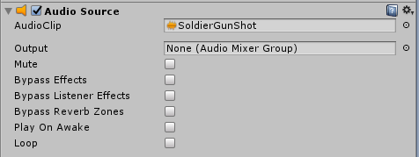

Then we are ready to add a few lines to our fire gun method to play these sounds.

At the top of your script make sure to add these properties

private AudioSource audioSource;

public AudioClip shellCasings;

In the Start() method add:

audioSource = GetComponent<AudioSource>();

Then where you fire the gun add something like the following:

//This will play the Audio clip that the Audio Source has referenced

audioSource.Play();

//This will play the Audio clip that is referenced in script

audioSource.PlayOneShot(shellCasings);

Then just go back to unity and make sure to drag and drop your shellCasing AudioClip onto your new public property in the inspector window.

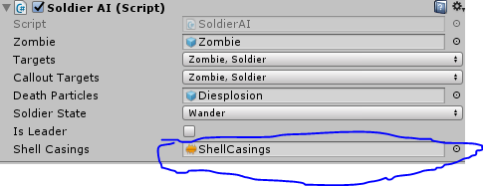

Play your game and enjoy your new gunshots!

Next we will talk about looping sounds, these can be anything from background music to a small rain clip that loops during a storm. In my example I will be using it for background music. Just like before import the background music clip into unity, add an Audio Source to the Main Camera and drag the background music to the reference slot (Play on Awake and Loop are selected in this case)

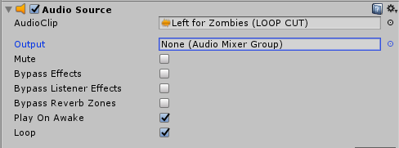

That is all you need to do, now when you play the game the music will start and loop back to the start of the clip when it’s finished.

The Audio Mixer allows you to mix Audio Sources, apply effects, and perform mastering. You need to create an Audio mixer in the Project manager, double clicking on the audio mixer will open the Audio Mixer window. In my example we will make the BGM lower its volume when a gunshot is heard. Create two groups in the audio mixer one for BGM and one for Gunshot.

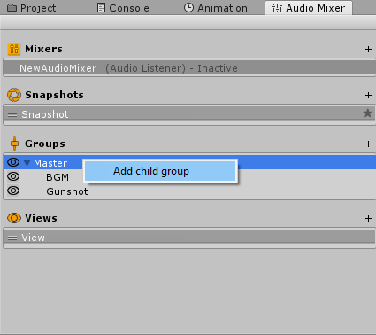

Since we already have these two sounds being played in our scene we will just add the mixer groups by dragging it from the Mixer Hierarchy and dropping it in the Inspector window of our Audio Sources Output.

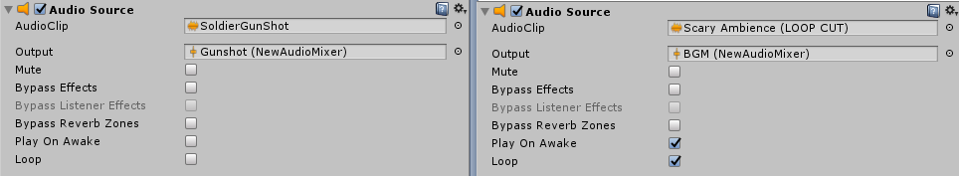

The Audio mixer is also useful for controlling the volume of multiple Audio Sources in a single place. If, for example, you want to change the volume of the background music when a gunshot or explosion plays. Go into the mixer tab, select the BGM group and click add > Duck Volume. Do the same thing with the Gunshot group but add > Send instead of Duck volume. In the inspector window for Gunshot drag the send level slider to 0 dB so that it will send the full volume of the gunshot to be heard by the BGM.

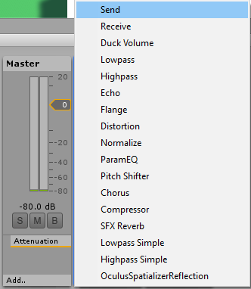

Then in the BGM group inspector window you will need to play with the threshold slider until it is where you want it to be. The threshold is how loud the Gunshot must be before it will make the BGM duck, I recommend doing this while your scene is playing so you can adjust it in real time (Make sure to click edit in play mode). The ratio slider is used to decrease/increase the volume of the BGM, in our case we want to reduce it so I will be setting mine to 300%.

The Attack time and Release time are opposites, Attack time is the time it takes the ducking to take effect after it has passed the threshold, the default value is fine here. Release time is the time it takes the ducking to go back to normal volume, I set my release time to 1000ms to prevent the BGM volume from turning back up too fast.

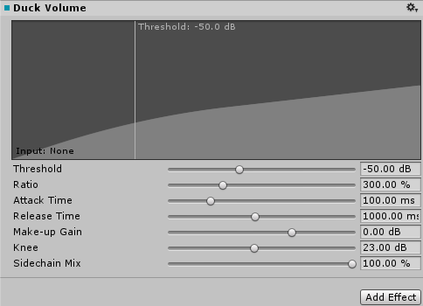

Once the settings are where you want them, play your game and enjoy listening to those sweet, sweet gunshots without the BGM getting in the way!