Front Range Action Sports

1926 Quebec Street

Denver, CO 80207

(303) 555-0970

www.frontrangeactionsports.com

May 23, 2019

Michael Dixon, President

Front Range Action Sports

12756 St. Austin Drive

Vail, CO 81658

Dear Michael:

Plans are almost final for our first company-wide live training program, which will be delivered to various employee groups during the third week of September. All sessions will be delivered via teleconference using the latest tools in delivering training electronically.

Included here is a packet of information with the following documents:

* A company newsletter for employees with information about both the various training sessions and how each employee can update his or her resume to use for possible promotion within the company
* A resume of Dr. Lourdes Sanchez, our keynote speaker, featuring the highlights of her career
* A research report on the development of CRM—customer relationship management—which will be the focus of many of the training sessions
* A flyer that will be posted in all employee locations and sent to all employees

We are excited to be at the forefront of employee training and development by offering this unique training for our valued employees. Please let me know if you want to change or update any of these materials.

Sincerely,

Clint Hill, Vice President Human Resources

Enclosures

Front Range Action Sports

Employee Newsletter Live CRM Training Special Edition

**Live Company-Wide Training**

In the third week of September, Front Range Action Sports will conduct a week-long professional development training program emphasizing Customer Relationship Management (CRM). The training sessions will be broadcast live from the teleconferencing center at the company headquarters.

All individuals involved in management, marketing, information technology, sales, product development, operations, and administrative support will attend. Each employee participating will receive a special invitation from Michael Dixon, the company president. There will be two sessions per day. At each company location, employees can attend in their offices or in conference rooms.

The sessions will last until approximately 3:30 p.m. Monday - Thursday. Following each day’s sessions, individuals will have time to informally discuss what they have learned and enjoy some refreshments. On Friday, each location will meet to discuss implementing CRM. All attendees are invited for a festive dinner afterward.

**Why CRM?**

Customer Relationship Management (CRM) is one of the best tools for increasing sales and enhancing the experience for the customer. It is a proven technique that is employed across all industries.

At Front Range Action Sports, we interact with our current customers and potential new customers in numerous ways including direct mail, Internet promotions, e-mail messages, customer support, and a variety of other direct contacts. CRM, handled properly and with appropriate data collection, provides valuable information that can be useful throughout all levels of our organization.

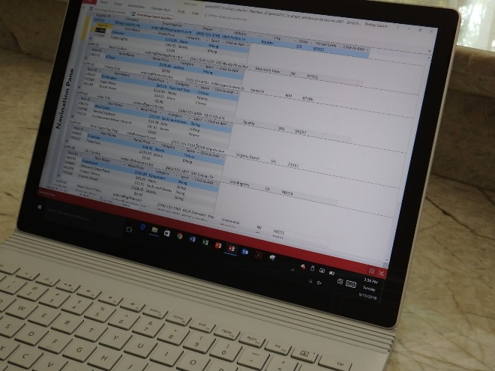

You will leave the program with a collection of procedures that will enhance your professional growth and increase income potential for both you and the company. Each attendee is encouraged to update his or her LinkedIn profile listing each new skill. These newly-acquired skills will enable us to better understand both our current and future customers.

|  |  |
| --- | --- |
| **Lourdes Sanchez** 1651 Marquette Place Boston, MA 90016 lsanchez@sanchezcrm.biz | |
| **CAREER HIGHLIGHTS** | **PROFESSIONAL EXPERIENCE**   * Social Media Marketing VP, Sports USA * CRM Manager, US Bank & Trust * Sales Director, Mega Insurance * Department Manager, Best Buy * Direct Sales, Cameras and Accessories * Marketing Manager, Ross Publishing * Marketing Coordinator, Xerox   **PUBLICATIONS**   * CRM Solutions * CRM: A Technology Solution * Social Media Marketing: CRM Strategies * CRM and Corporate Revenue |
| **EDUCATION** | **Boston University** Ph.D. in Business Management **University of Pittsburgh** M.S. in Marketing **University of Michigan** B.S. in Social Psychology |
| **CONSULTANT** | NH Savings and Loan Arrowhead Sporting Goods Forward Ski Corporation |

Priyanka Sharma

Irene Shviktar

Marketing

June 5, 2019

Customer Relationship Management

A proven method to increase sales and market share is the implementation of a Customer Relationship Management (CRM) System (Benioff). CRM, stated simply, is a system to manage a company's interaction with current and future [customers](https://en.wikipedia.org/wiki/Customers). The CRM approach attempts to track and then analyze data about customers' history with a company. The goal is to improve business relationships with customers—specifically focusing on retaining customers—to drive sales growth. Marc Benioff, founder and CEO of salesforce.com, calls this “the power of the customer exchange,” and he believes it to be a critical lesson that he learned early in his career.[1] In short, companies need to understand what leads to customer success or what leads to customer failure.

The components of CRM have a logical sequence. The first is appropriate data classification; that is, you must identify how the data was acquired. For example, data about customers is frequently acquired through personal communication, direct mail advertising, e-mail advertising, Internet marketing, social media marketing, or telephone marketing.

Next, there must be an organized database that provides for organization of the data into a usable form. The organization of the data can take many forms and includes demographics such as age, gender, income level, frequency of purchase, dollar value of purchase, and loyalty to the company, among others.

The most critical component of a CRM system is the dissemination of the data to the four major areas of most organizations—customer support, sales, marketing, and management. All of these areas contribute to a company’s success. A given organization might use the information in different ways, but the combined use of the information typically results in a positive corporate synergy that can lead to increased sales.

Successful implementation of CRM can have the following important results: increased customer personalization of services, increased responsiveness to services and needs, more frequent interaction with customers, better targeted marketing, and improved customer knowledge in a time-saving manner.

Effective CRM systems enhance customer satisfaction in a number of ways, and customer satisfaction has proven to have a direct bearing on sales. After implementing CRM, numerous industries have shown remarkable increases in sales and profits including banks, insurance companies, retail stores, and direct marketers.

Combining CRM with social media marketing is probably the newest and most challenging aspect of implementing CRM. According to Barton Goldenberg, “it is difficult to lock into an approach that will completely dominate the Social Media marketplace” (Goldenberg).

# Works Cited

Benioff, Marc. *Behind the Cloud*. San Francisco: Jossey-Bass, 2009. Print.

Goldenberg, Barton. *The Definitive Guide to Social CRM: Maximizing Customer Relationships with Social Media to Gain Market Insights, Customers, and Profits*. Upper Saddle River: Pearson FT Press, 2015. Print.

CRM Training

**Monday, September 23, 9 a.m. to 3:30 p.m.**

**Tuesday, September 24, 9 a.m. to 3:30 p.m.**

**Wednesday, September 25, 9 a.m. to 3:30 p.m.**

**Thursday, September 26, 9 a.m. to 3:30 p.m.**

Front Range Action Sports is proud to announce company-wide training for Customer Relationship Management (CRM), which will be held live via teleconference during the third week of September. This training will be just in time for our winter sports sales campaigns.

Topics and hands-on sessions, which you will attend at your local office, include: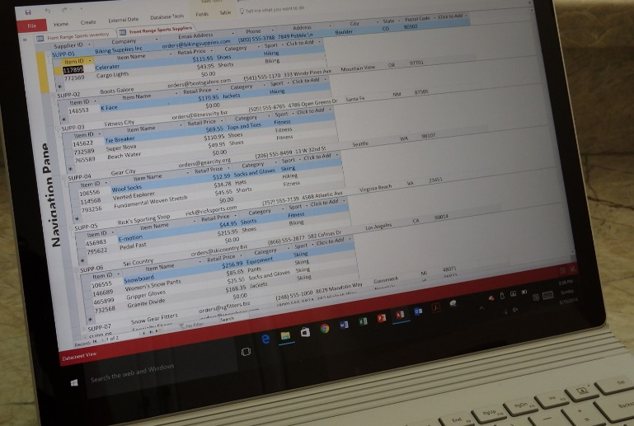

* Customer engagement
* Social media challenges
* Enterprise collaboration
* Vendor selection
* Technical road map
* CRM road map
* Implementation

Many of the sessions will focus on how to gain customer loyalty by providing customer service and support that goes above what is expected. Retaining existing customers is another special focus of the training sessions.

The training session will kick off with a presentation from one of the leading researchers in CRM, Dr. Lourdes Sanchez. Dr. Sanchez has authored several textbooks and journal articles about the implementation of CRM, with a focus on retail environments.

1. The theory is that if the customer exchange is executed as well as possible, there is an opportunity to transform him or her into a loyal customer.