mob

PureData multitouch widgets + fast exporting of pd patches to mobile platform app (MobMuPlat)
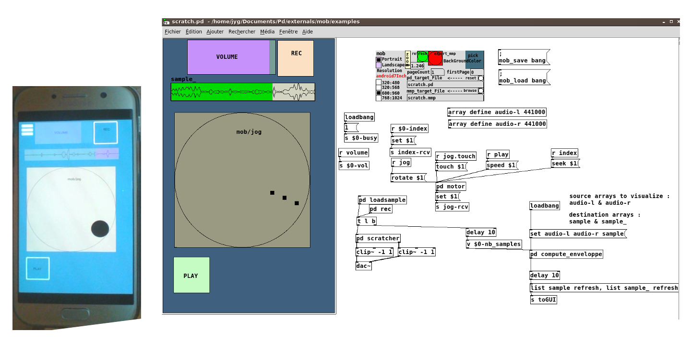

Abstract
mob achieves two goals : a collection of special multitouch gui-widgets; an helper for quickly creating MobMuPlat "apps".
- The gui-widgets include faders, xy slider, knob, jog, menu, lcd widgets. It requires pd 0.51 + iemguts + iemlib external libs. You can use it as an extension library for your existing desktop pd-patches.
- The [mob] helper is aimed to replace the javascript MobMuPlat Editor for creating on-the-fly MobMuPlat apps from within puredata. It requires pd 0.52.

Another way to create MobMuPlat apps
MobMuPlat (see http://danieliglesia.com/mobmuplat/) is an app that let you run pd patches on iOS / Android mobile devices. In order to create GUIs, you can use the MobMuPlat native mode or use a special java app (MobMuPlat Editor) for designing your interface files (*.mmp).
[mob] lets you build those .mmp files directly from the patch you want to use on mobile platform, in one click, without the need of using MobMuPlat Editor. What you get should be what you see !
Why not use simply mobmuplat native mode ?
Native mode is a special feature of MobMuPlat app that enables the direct rendering of your pd patches with all native guis (vsl, hsl, tgl, etc..), but doesn't let you access to MobMuPlat enhanced gui features (grid, xy slider, xy multitouch, lcd panel, etc..), nor use of multiple pages.
With [mob] you can access to most of those features, in a faster way than with the MobMuPlat Java Editor. Furthermore, if you think your widgets are displayed too small or too big on your target mobile device, you can easily adjust the scale factor (hard zooming).
[mob] converts native pd-guis (hsv, vsl, hradio, vradio, toggle, bang, cnv, array) and text comments into mmp.widgets in the .mmp file. It comes with enhanced guis (vfader, hfader, button, xy_slider, jog, menu, xy_nultitouch, knob, lcd) that are also converted to mmp.widgets.
[mob] includes a RJDJ-based preset saving mechanism.
Requirements :
- pd >= 0.52 on development platform
- mrpeach/binfile external
- iemguts + iemlib external libs
- (optional) for multitouch support : https://github.com/jyg/multitouch + hidio
Note that current version of pd on MobMuPlat is 0.48-0. Don'use in your patch : [savestate], [pdcontrol], [slop~] ; beware of [declare]'s different behaviour ; [value] has no second inlet, if you need it, use [mob/value] instead.

Instructions
Installation
Copy this folder (named 'mob') into the externals directory of your desktop puredata installation (pd >= 0.52).
Usage
Have first a look at mob/tutorial folder.
Open and edit the patch you want to export to MobMuPlat with pd >= 0.52.
Add the [mob] object on it. Check the background color, the layout size, the number of pages, etc.. You can adjust the scale factor with the "zoom" slider.
All the native pd GUIs will be exported. They may interact with the patch only with their rcv and snd channel names (wired connections not tested).
Save your patch. Click on red button, [mob] creates dynamically the needed wrappers in the patch, and creates a *.mmp auxiliary file.
Both files (*.pd and *.mmp) are copied into mob/export folder.
Create a zip with all files and subfolders of mob/export and download it to your mobile device, opening it with MobMuPlat app.
Alternatively, you may copy all files/subfolders of mob/export to your mobile device (in the MobMuPlat directory)
That's all !
See the "examples" folder for more infos.

Mob Version v2
- Implémentation multitouch v2
- Simplification du processus d’export
  - dossier mob/export dont il suffit de zipper le contenu pour le transférer vers le périphérique cible

todo
- Abandonner ParseAbstraction : revenir au système de création dynamique d’abstractions, pas de sous-patches OK
- intégrer tous les mob/guis
  - hfader OK added Touch on/off outlet
  - vfader OK added Touch on/off outlet
  - knob OK
  - jog OK
  - button OK (native MMPBUTTON remplacé par MMPLCD de manière à récupérer xy )
    - TODO : pouvoir peindre d’une certaine couleur on touchdown
  - xy_slider OK (cohérence du comportement entre MMP et tcl/tk)
  - xy_multi OK
  - lcd OK
  - menu OK
  - tgl ????
  - cnv longyueur texte
  - dialog NON
  - sarray NON
  - grid
- supprimer dépendance à iemlib/iem_receive via dynamic patching
- Export vers Open Stage Control : objet mob/osc basé sur mob/mob
- Export vers POF:objet mob/pof basé sur mob/mob
- intégrer nouvelles propriétés array (couleur, width)
- refaire doc
- vérifier déclenchement [get_pos( et gestion multitouch pour les différents objets
- gestion des rj save/load : interne dans pd 0.52 (savestate) , exporté sous forme de fichiers texte dans export/mob/data au moment de l’export

