# GitHub Repo: <https://github.com/jygogo/clouddevopscicd>

#### 2 branches (bluedeployment & greendeployment)

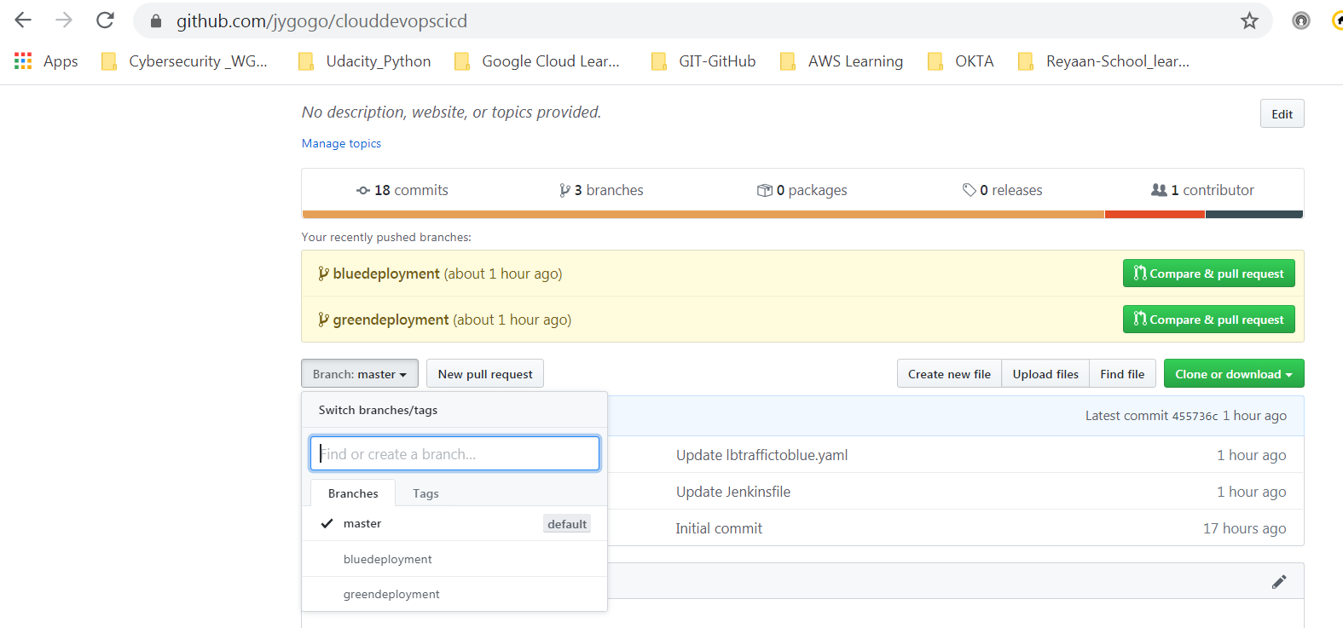

# Create Kubernetes Cluster in EKS

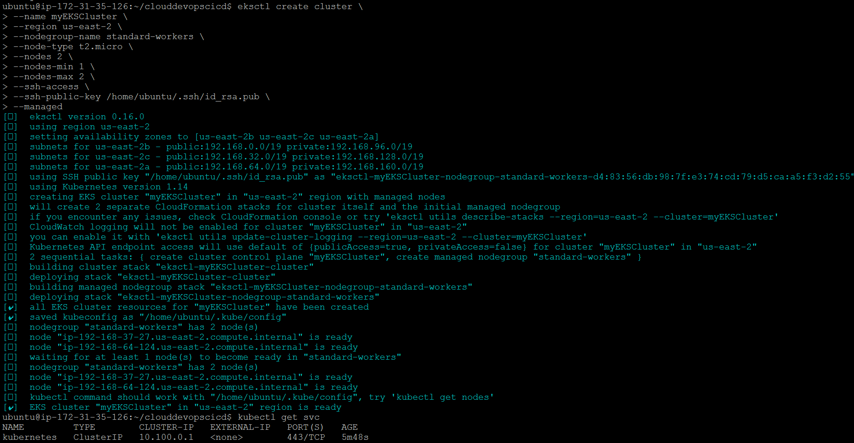

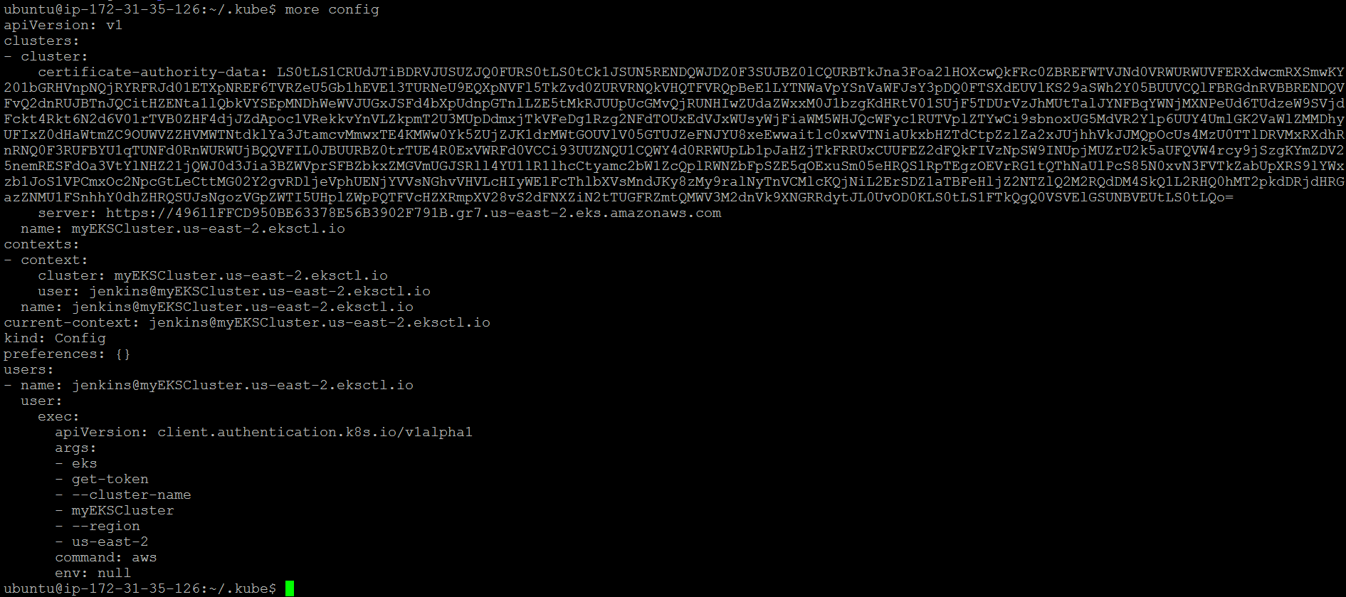

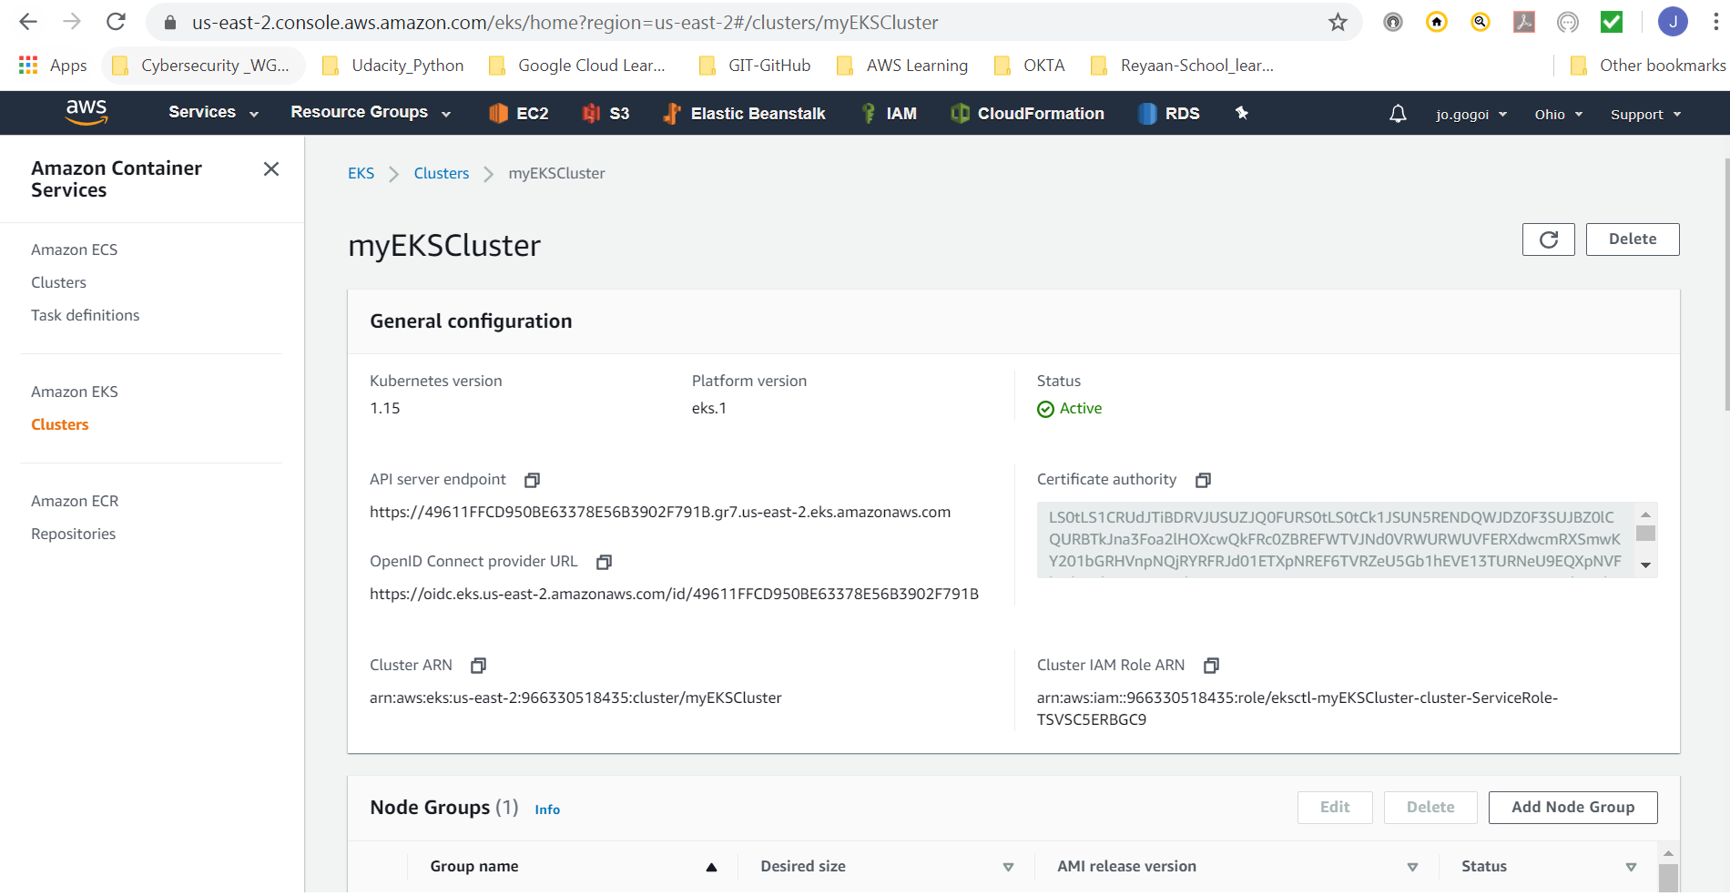

# Create CI CD Flow

### Create multibranch pipeline:

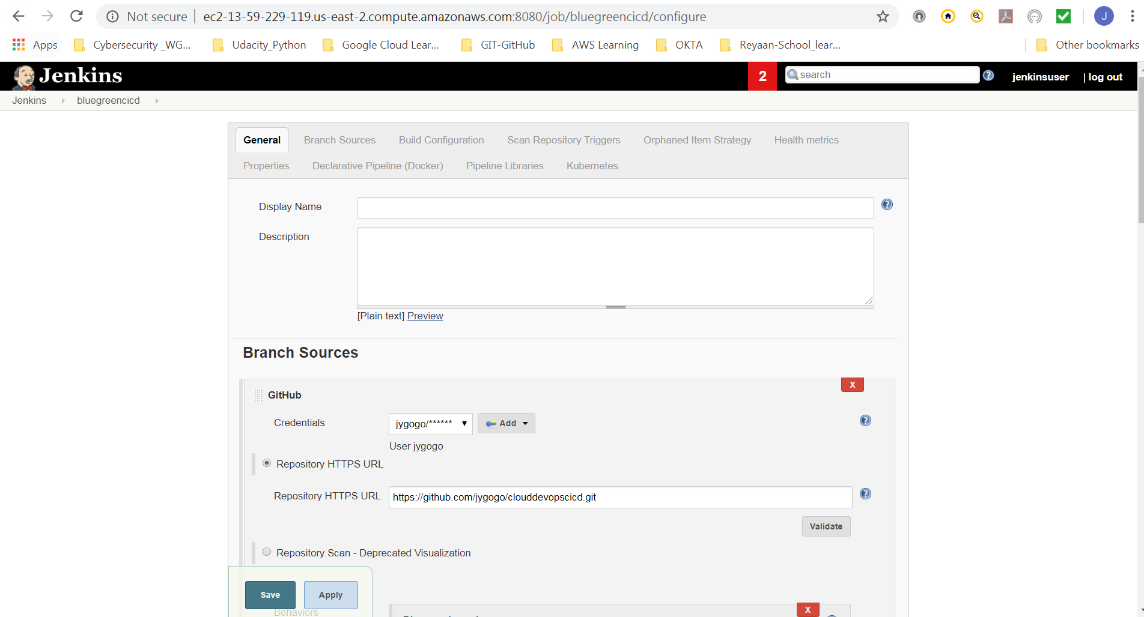

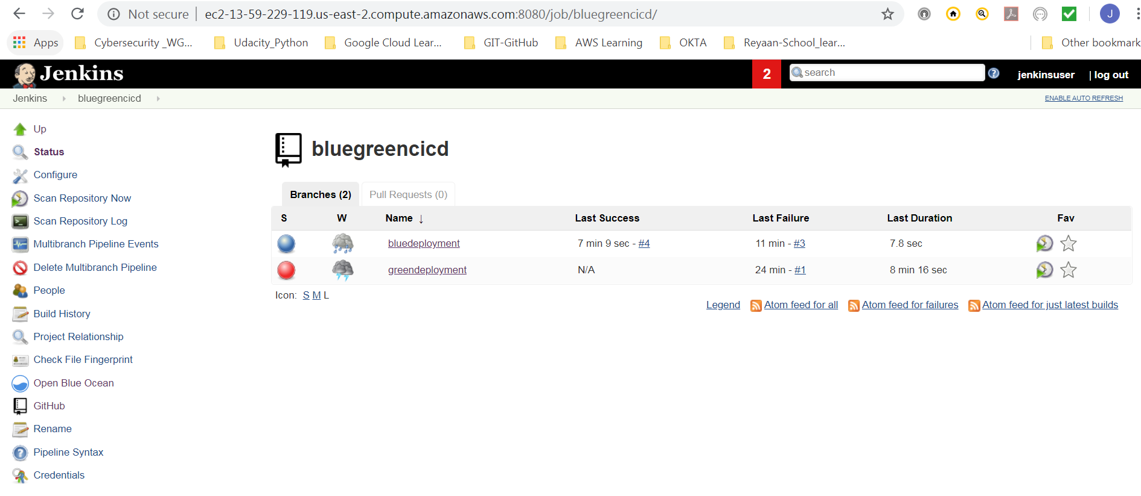

### Scan GitHub repository for branches (2 Branches – bluedeployment, greendeployment)

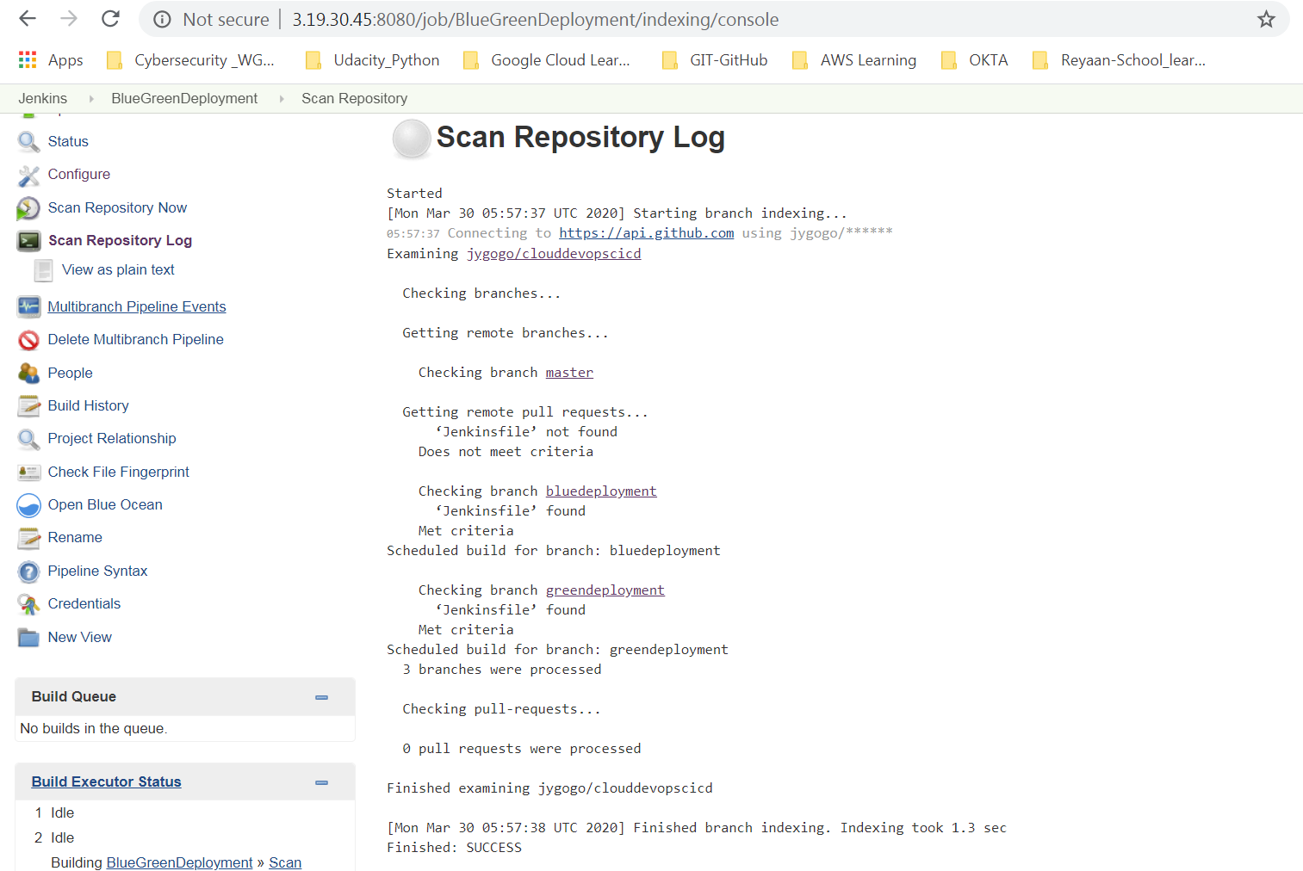

# Execute Jenkins job for bluedeployment branch

### Lint test:

#### Failure:

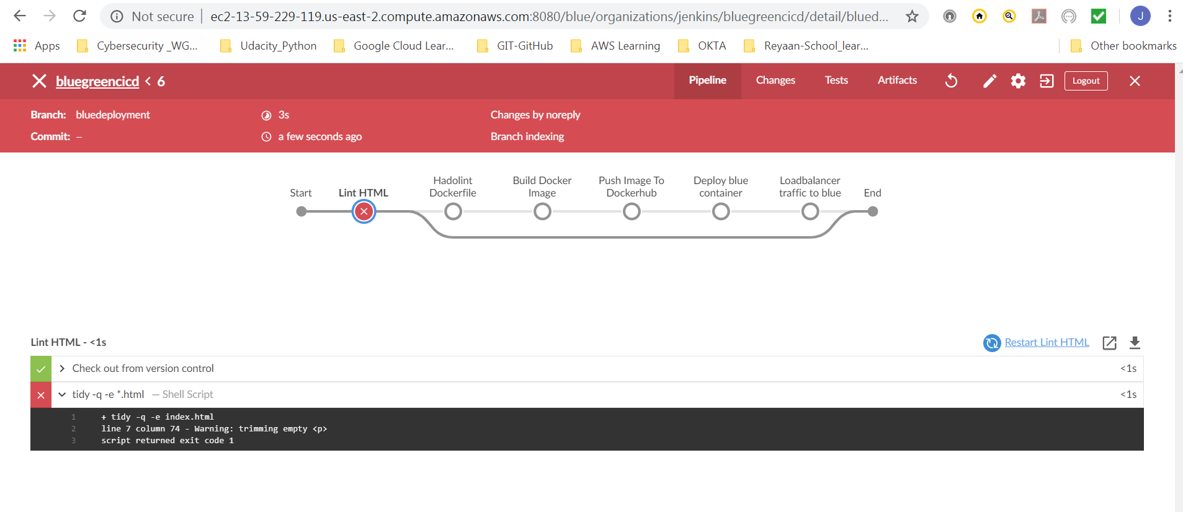

#### Success:

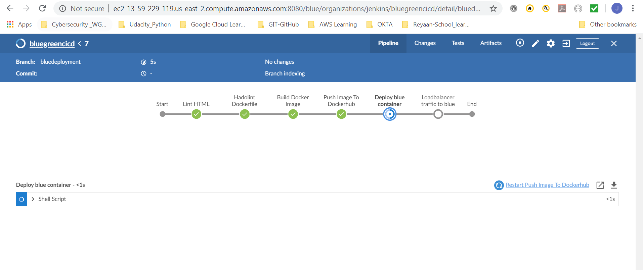

### Complete Deployment

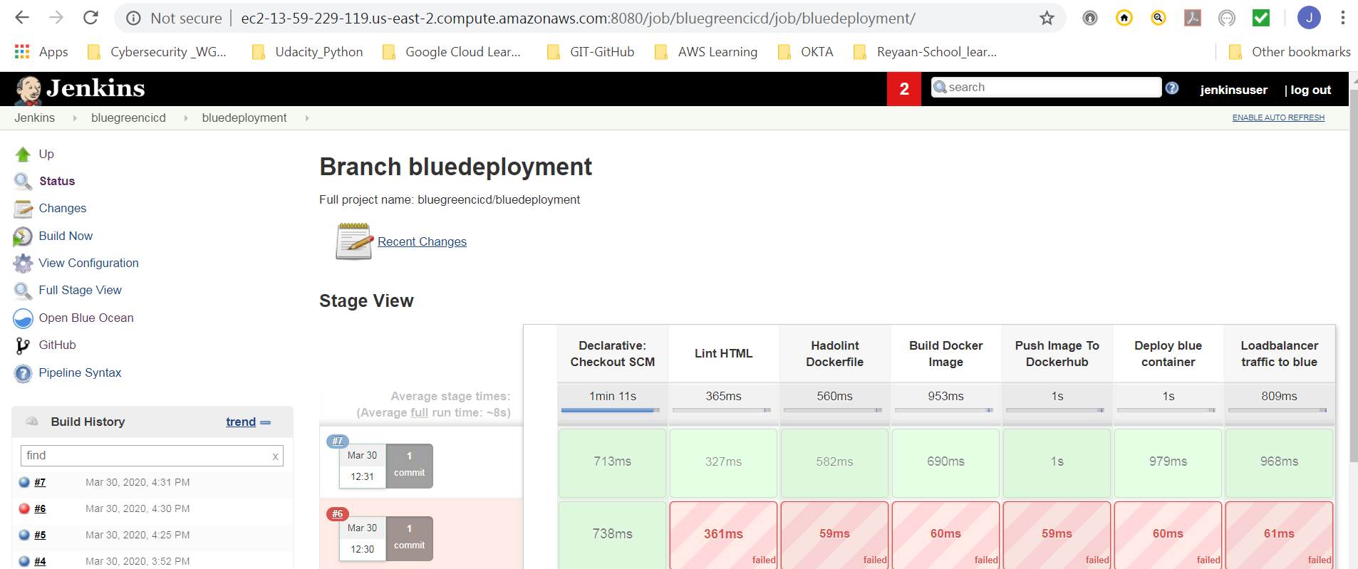

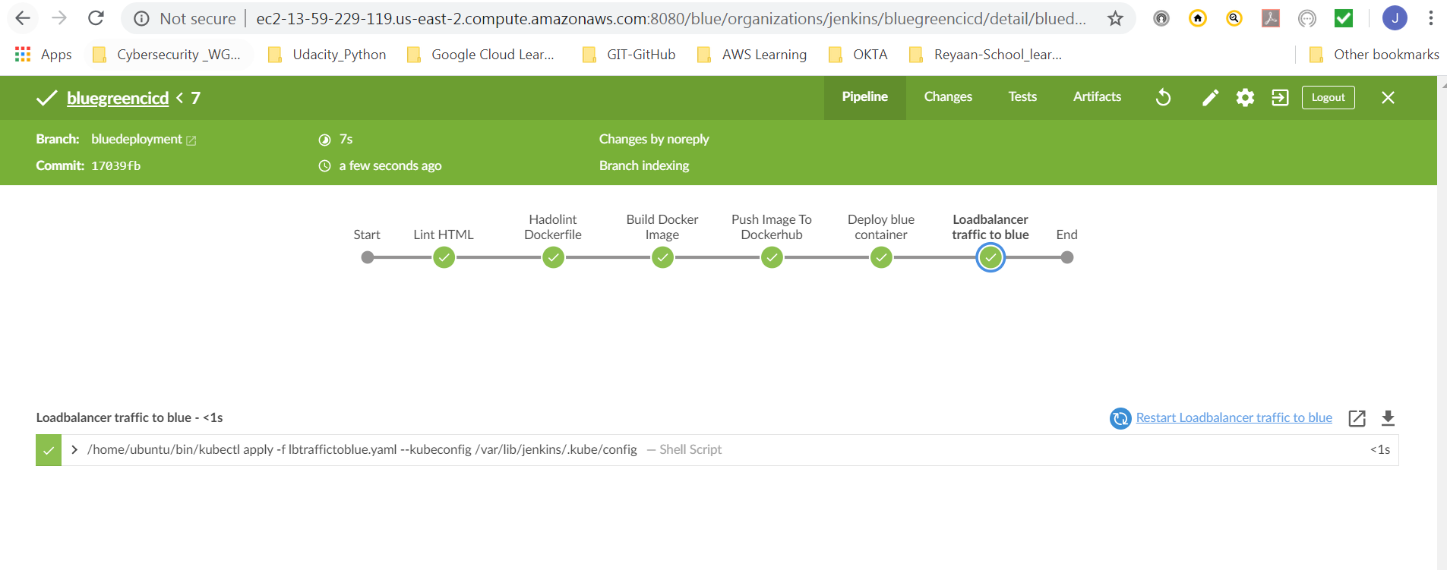

# Blue Deployment Result:

### URL to blue deployment

<http://aa9f5e2c6c06b4bfea47de1cd3e16a63-664399545.us-east-2.elb.amazonaws.com:8080/>

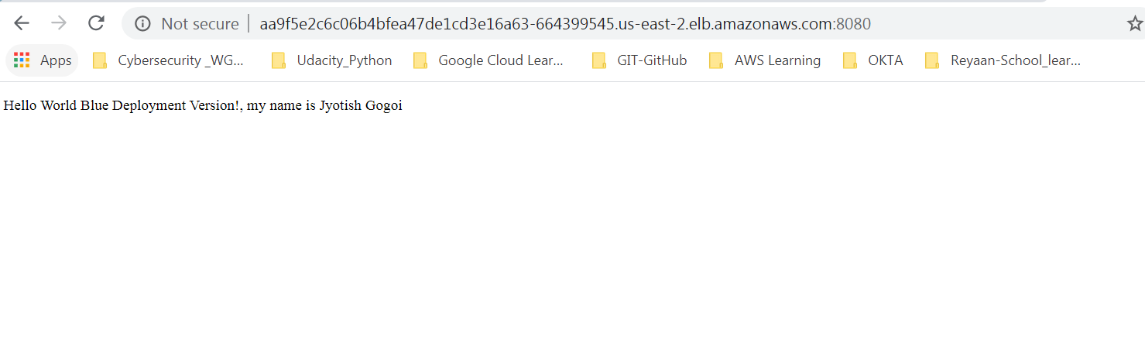

Docker hub Image for tag blue

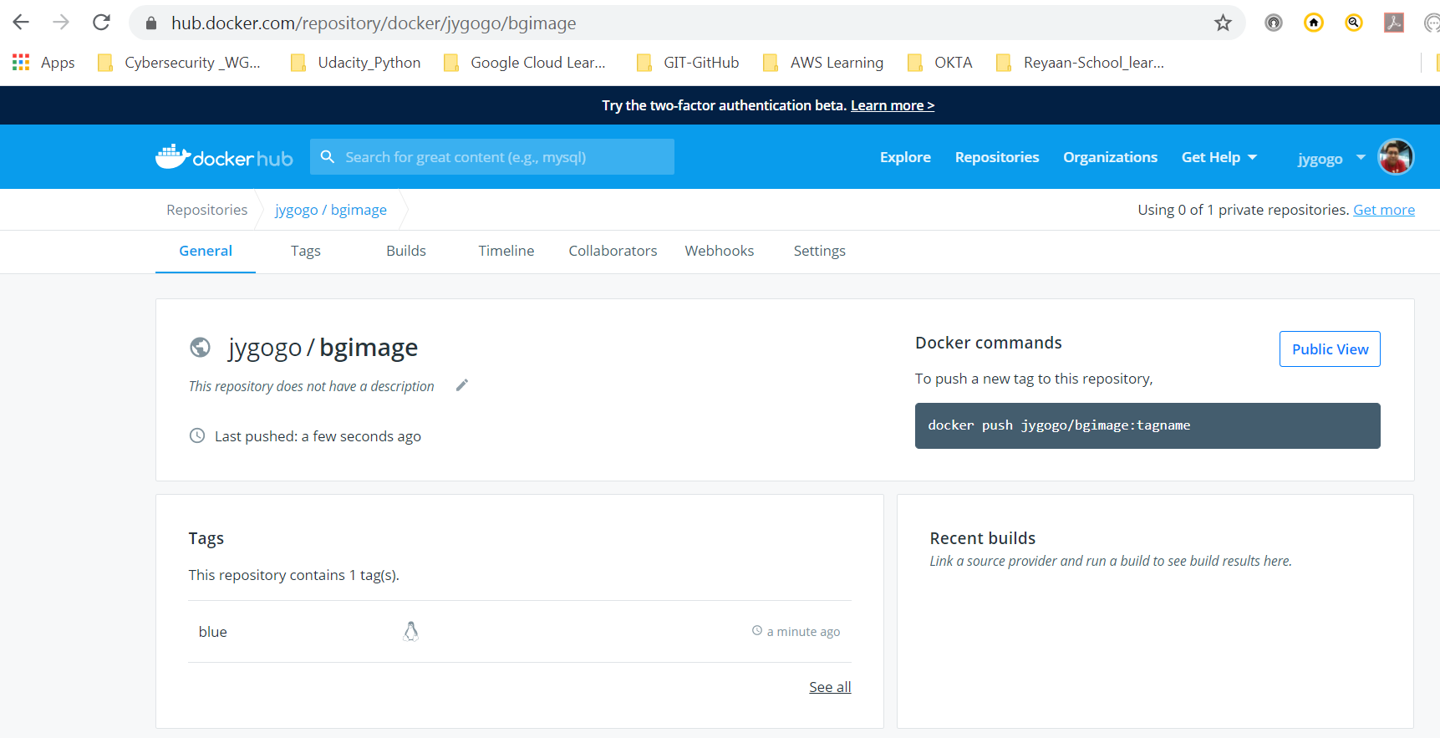

# Execute Jenkins job for greendeployment branch

### Lint test:

#### Failure:

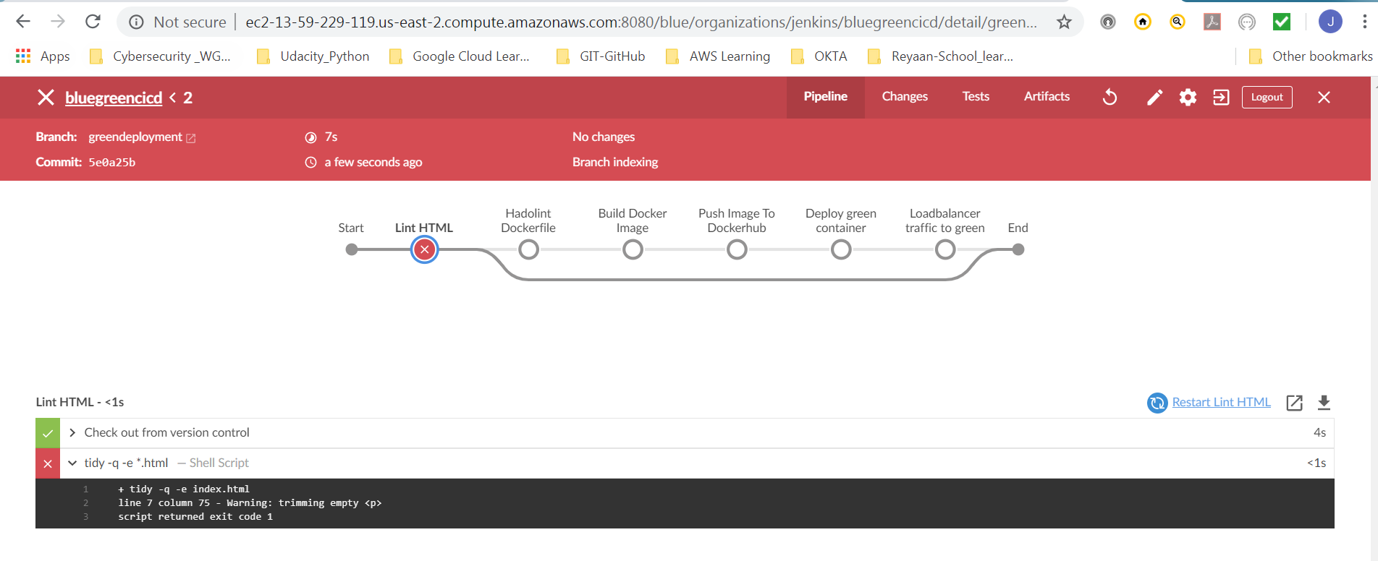

#### Success:

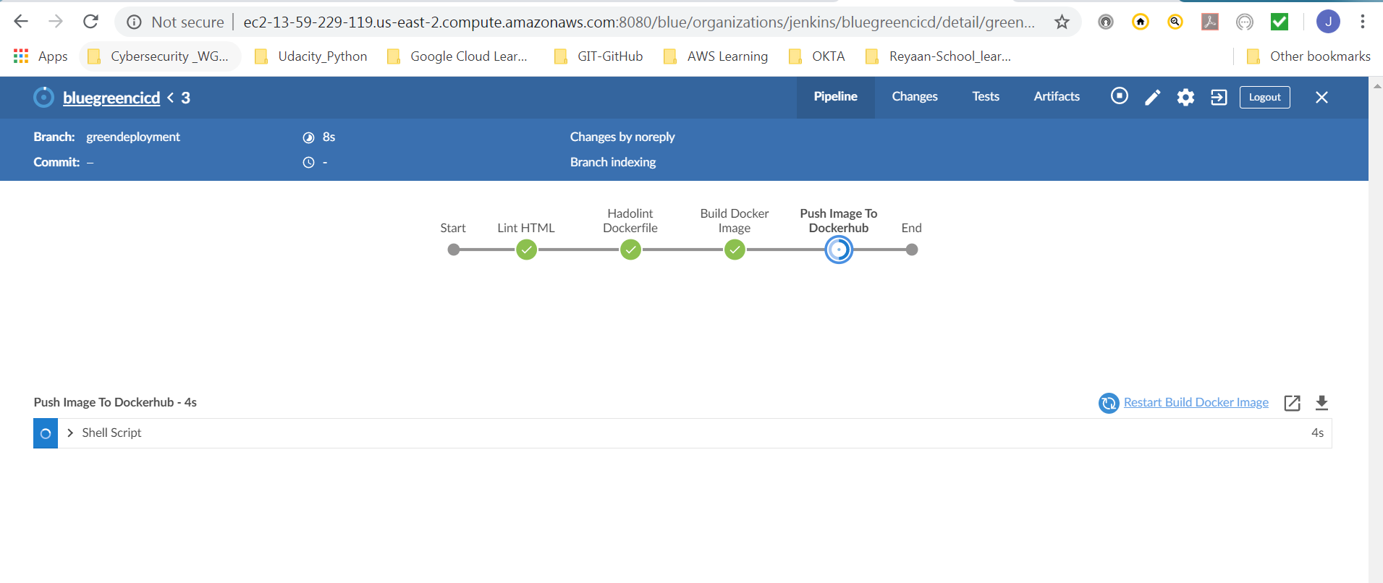

### Complete Deployment pipeline

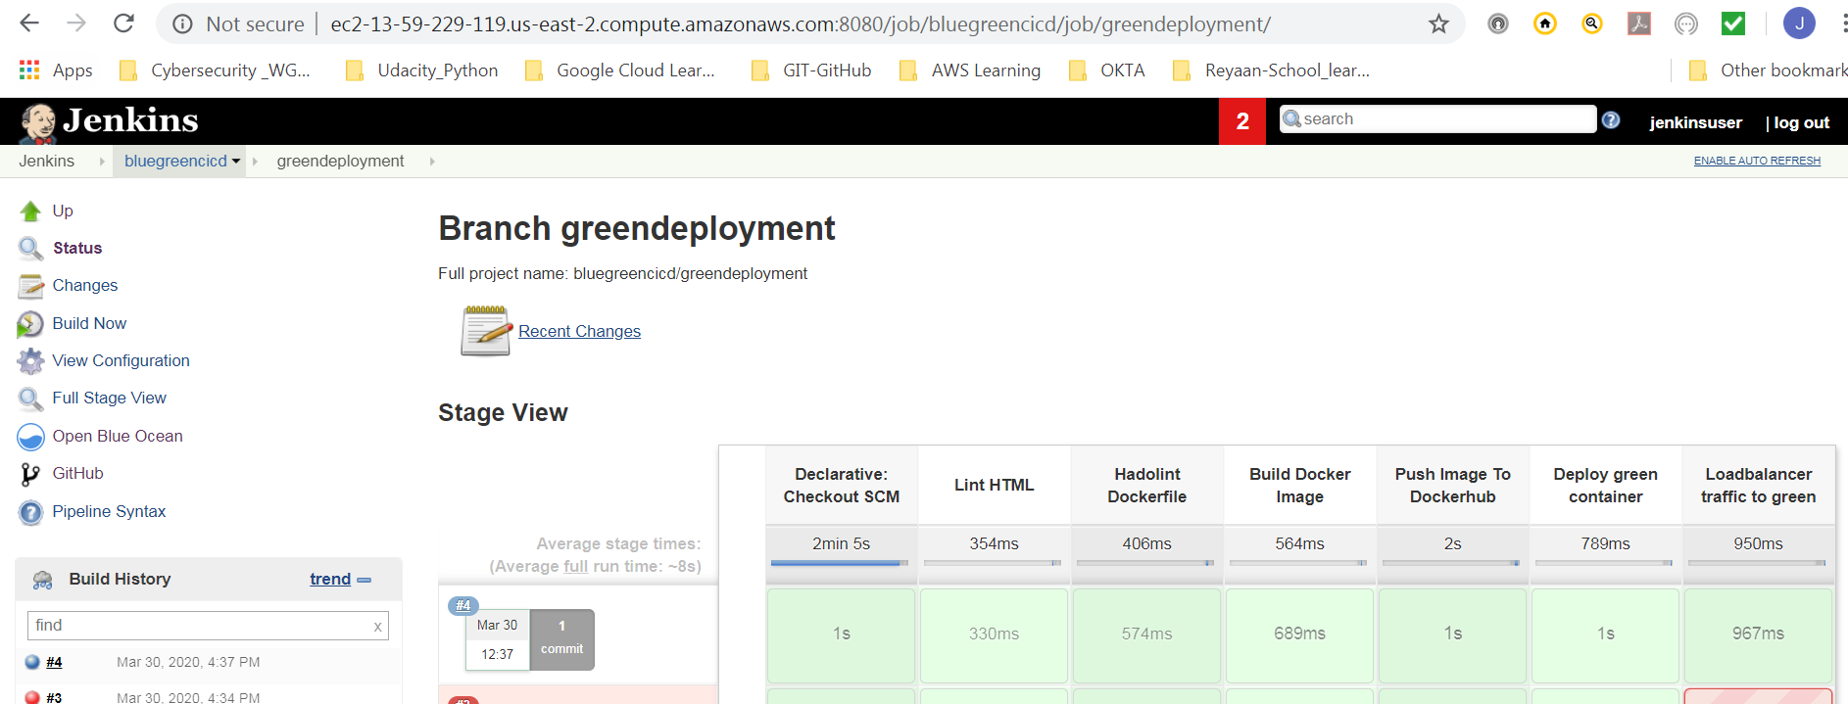

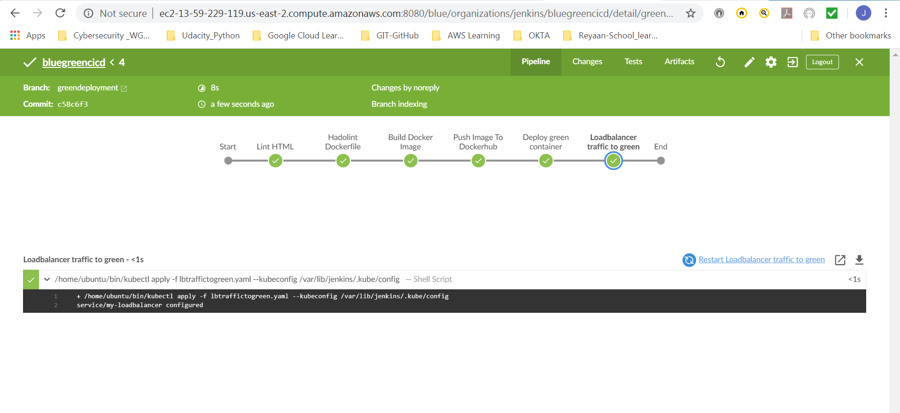

# Green Deployment Result:

### URL to green deployment

<http://aa9f5e2c6c06b4bfea47de1cd3e16a63-664399545.us-east-2.elb.amazonaws.com:8080/>

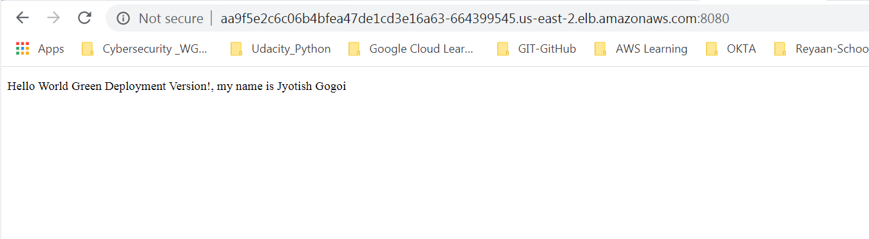

Docker hub Image for tag green

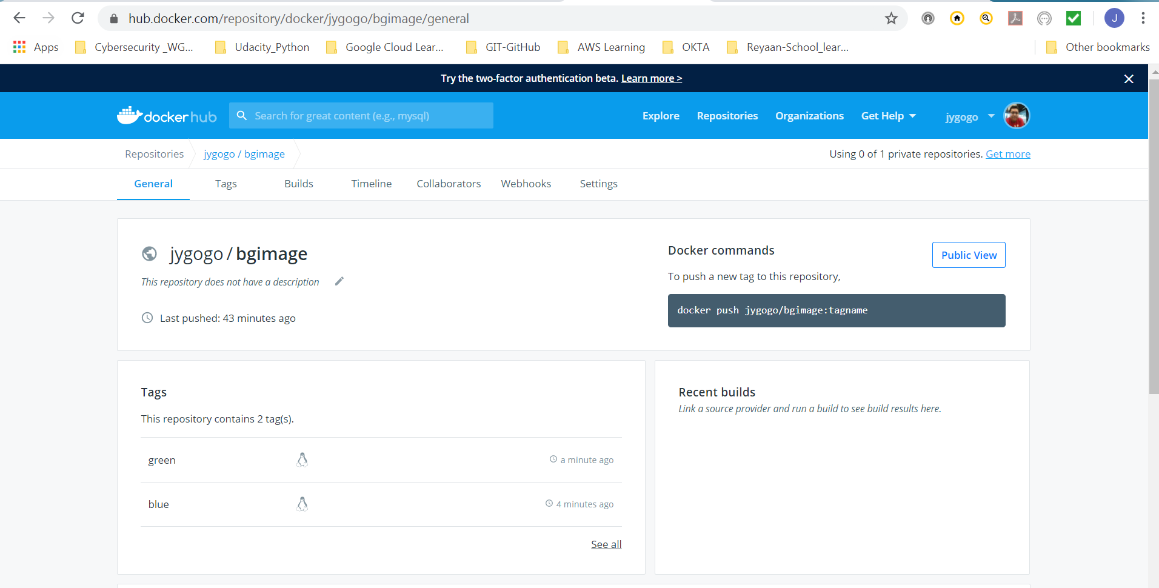

# Pod and load balancer info

