ENSF 694 – Summer 2024

**Principles of Software Development II**

**University of Calgary**

**Lab Assignment 2**

Student Name: Yael Gonzalez

Instructor: M. Moussavi, PhD, Peng

Submission Date: July 10, 2024

# Part I – Algorithm Development

## Exercise A: Duplicating string library functions

### Source code

/**

 *  File Name: lab2exe_A.cpp

 *  Assignment: ENSF 694 Lab 2 Exercise A

 *  Created by: Mahmood Moussavi

 *  Completed by: Yael Gonzalez

 *  Submission Date: July 10, 2024

 */

int my_strlen(const char \**s*);

/**

 *  Duplicates strlen from <cstring>, except return type is int.

 *  REQUIRES:

 *     s points to the beginning of a string.

 *  PROMISES:

 *     Returns the number of chars in the string, not including the

 *     terminating null.

 */

void my_strncat(char \**dest*, const char \**source*, int *n*);

/**

 *  Duplicates my_strncat from <cstring>, except return type is void.

 *  REQUIRES:

 *     dest and source each point to the beginning of a string.

 *     n > 0, where n is the number of characters to be concatenated

 *     from source onto dest.

 *     source strlen >= n.

 *     dest >= dest + n, i.e., enough space in dest to contain its

 *     current length plus the added characters.

 *  PROMISES:

 *     concatenates up to n characters from the source string to the

 *     end of the dest string.

 */

#include <iostream>

#include <cstring>

using namespace std;

int main(void)

{

    char str1[7] = "banana";

    const char str2[] = "-tacit";

    const char *str3 = "-toe";

    /* point 1 */

    char str5[] = "ticket";

    char my_string[100] = "";

    int bytes;

    int length;

    /* using my_strlen function */

    length = my_strlen(my_string);

    cout << "\nLine 1: my_string length is " << length;

    /* using sizeof operator */

    bytes = sizeof(my_string);

    cout << "\nLine 2: my_string size is " << bytes << " bytes.";

    /* using strcpy libarary function */

    strcpy(my_string, str1);

    cout << "\nLine 3: my_string contains: " << my_string;

    length = my_strlen(my_string);

    cout << "\nLine 4: my_string length is " << length << ".";

    my_string[0] = '\0';

    cout << "\nLine 5: my_string contains:\"" << my_string << "\"";

    length = my_strlen(my_string);

    cout << "\nLine 6: my_string length is " << length << ".";

    bytes = sizeof(my_string);

    cout << "\nLine 7: my_string size is still " << bytes << " bytes.";

    /* my_strncat append the first 3 characters of str5 to the end of my_string */

    my_strncat(my_string, str5, 3);

    cout << "\nLine 8: my_string contains:\"" << my_string << "\"";

    length = my_strlen(my_string);

    cout << "\nLine 9: my_string length is " << length << ".";

    my_strncat(my_string, str2, 4);

    cout << "\nLine 10: my_string contains:\"" << my_string << "\"";

    /* my_strncat append ONLY up ot '\0' character from str3 -- not 6 characters */

    my_strncat(my_string, str3, 6);

    cout << "\nLine 11: my_string contains:\"" << my_string << "\"";

    length = my_strlen(my_string);

    cout << "\nLine 12; my_string has " << length << " characters.";

    cout << "\n\nUsing strcmp - C library function: ";

    cout << "\n\"ABCD\" is less than \"ABCDE\" ... strcmp returns: " << strcmp("ABCD", "ABCDE");

    cout << "\n\"ABCD\" is less than \"ABND\" ... strcmp returns: " << strcmp("ABCD", "ABND");

    cout << "\n\"ABCD\" is equal than \"ABCD\" ... strcmp returns: " << strcmp("ABCD", "ABCD");

    cout << "\n\"ABCD\" is less than \"ABCd\" ... strcmp returns: " << strcmp("ABCD", "ABCd");

    cout << "\n\"Orange\" is greater than \"Apple\" ... strcmp returns: " << strcmp("Orange", "Apple") << endl;

    return 0;

}

int my_strlen(const char \**s*)

{

    const char *e = *s*;

    // Move the pointer 'e' to the last char (stops at '\0')

    while (*e)

        e++;

    return (int)(e - *s*); // e (end) - s (start) = string length

}

void my_strncat(char \**dest*, const char \**source*, int *n*)

{

    // Move the pointer 'dest' to the last char (stops at '\0')

    while (\**dest*)

*dest*++;

    // Iterate n times. For each cycle, assign value of source to dest

    // and move both pointers

    for (int i = 0; i < *n*; i++)

    {

        \**dest* = \**source*;

*dest*++;

*source*++;

    }

    // After adding n values of source to dest, make sure to return a

    // c-string, i.e., add a '\0' at the end.

    \**dest* = '\0';

}

### Program output

## Exercise B: Understanding Recursion

### Source code

/**

 *  File Name: lab2exe_B.cpp

 *  Assignment: ENSF 694 Lab 2 Exercise B

 *  Created by: Mahmood Moussavi

 *  Completed by: Yael Gonzalez

 *  Submission Date: July 10, 2024

 */

#include <iostream>

#include <assert.h>

using namespace std;

int sum_of_array(const int \**a*, int *n*);

/**

 * REQUIRES:

 *   n > 0, and elements a[0] ... a[n-1] exist.

 * PROMISES:

 *  Return value is a[0] + a[1] + ... + a[n-1].

 */

int main()

{

    int a[] = {100};

    int b[] = {100, 200, 300, 400};

    int c[] = {-100, -200, -200, -300};

    int d[] = {10, 20, 30, 40, 50, 60, 70};

    int sum = sum_of_array(a, 1);

    cout << "sum of integers in array a is: " << sum << endl;

    sum = sum_of_array(b, 4);

    cout << "sum of integers in array b is: " << sum << endl;

    sum = sum_of_array(c, 4);

    cout << "sum of integers in array c is: " << sum << endl;

    sum = sum_of_array(d, 7);

    cout << "sum of integers in array d is: " << sum << endl;

    return 0;

}

int sum_of_array(const int \**a*, int *n*)

{

    if (*n* == 0)

        return 0;

    return \**a* + sum_of_array(*a* + 1, *n* - 1);

}

## Exercise D: A Recursive Method for Fibonacci Sequence

### Source code

#### fibonacci.h

/**

 *  File Name: fibonacci.h

 *  Assignment: ENSF 694 Lab 2 Exercise D

 *  Created by: Mahmood Moussavi

 *  Completed by: Yael Gonzalez

 *  Submission Date: July 10, 2024

 */

#ifndef FIBONACCI_H

#define FIBONACCI_H

#include <stdio.h>

#include <time.h>

#include <stdlib.h>

#include <iostream>

#include <iomanip>

#include <chrono>

using namespace std;

#define N 2

void plotMethodComparison(int* *x*, double \**y1*, double \**y2*, int *size*);

/**

 * Function to plot the algorithm time analysis.

 *

 * REQUIRES:

 *  x points to an array of integers representing the x-axis data.

 *  y1 points to an array of doubles representing the y-axis data for the first method.

 *  y2 points to an array of doubles representing the y-axis data for the second method.

 *  size is the number of data points.

 * PROMISES:

 *  Plots a comparison of the algorithm time analysis for two methods using the provided data.

 */

void plotMethod(const char* *Title*, int* *x*, double \**y*, int *size*);

/**

 * REQUIRES:

 *  Title is the title of the plot.

 *  x points to an array of integers representing the x-axis data.

 *  y points to an array of doubles representing the y-axis data.

 *  size is the number of data points.

 * PROMISES:

 *  Plots the provided data with the given title.

 */

void multiplyMatrix(int *a*[N][N], int *b*[N][N], int *result*[N][N]);

/**

 * Function to multiply two matrices of size N x N.

 *

 * Source:

 * https://en.wikipedia.org/wiki/Matrix_multiplication_algorithm

 *

 * REQUIRES:

 *  a and b are NxN matrices to be multiplied.

 *  result is an NxN matrix to store the result of the multiplication.

 * PROMISES:

 *  Multiplies matrices a and b, storing the result in the result matrix.

 */

void powerMatrix(int *base*[N][N], int *exp*, int *result*[N][N]);

/**

 * Power of Matrix recursive method.

 *

 * Source:

 * https://www.geeksforgeeks.org/program-for-nth-fibonacci-number/

 * https://robwilsondev.medium.com/bigo-and-beyond-how-to-compute-fibonacci-sequence-efficiently-with-matrix-exponentiation-d9924545fe54

 *

 * REQUIRES:

 *  base is an NxN matrix to be exponentiated.

 *  exp is the exponent.

 *  result is an NxN matrix to store the result of the exponentiation.

 * PROMISES:

 *  Computes the power of the base matrix raised to the exp, storing the result in the result matrix.

 */

int fibonacciRecursive(int *n*);

/**

 * Function to calculate the nth Fibonacci number using recursive matrix exponentiation

 *

 * REQUIRES:

 *  n > 0, where n is the n-th number of the Fibonacci sequence.

 * PROMISES:

 *  Returns the nth Fibonacci number using recursive matrix exponentiation.

 */

int fibonacciIterative(int *n*);

/**

 * Function to calculate the nth Fibonacci number iteratively

 *

 * Source:

 * https://www.geeksforgeeks.org/program-for-nth-fibonacci-number/

 *

 * REQUIRES:

 *  n > 0, where n is the n-th number of the Fibonacci sequence.

 * PROMISES:

 *  Returns the nth Fibonacci number using an iterative approach.

 */

double measureTime(int (\**fibonacciFunc*)(int), int *n*);

/**

 * Function to measure the time taken by a function to calculate the nth Fibonacci number

 *

 * REQUIRES:

 *  fibonacciFunc is a pointer to a function that calculates the nth Fibonacci number.

 *  n > 0, where n is the position of the desired Fibonacci number.

 * PROMISES:

 *  Measures and returns the time taken by the fibonacciFunc to calculate the nth Fibonacci number.

 */

int* printTimeTable(const *string* *Title*, int (\**fibonacciFunc*)(int), double *result*[], int *n*, int *maxN*, int *n_stepsize*, int *N_value*[]);

/**

 * REQUIRES:

 *  Title is the title of the table.

 *  fibonacciFunc is a pointer to a function that calculates the nth Fibonacci number.

 *  result is an array to store the measured times.

 *  n is the initial position of the Fibonacci number.

 *  maxN is the maximum position of the Fibonacci number.

 *  n_stepsize is the step size for n.

 *  N_value is an array to store the positions of Fibonacci numbers.

 * PROMISES:

 *  Prints a table of times taken by fibonacciFunc to calculate Fibonacci numbers from n to maxN, with step size n_stepsize.

 */

#endif

#### fibonacci.cpp

/**

 *  File Name: fibonacci.cpp

 *  Assignment: ENSF 694 Lab 2 Exercise D

 *  Created by: Mahmood Moussavi

 *  Completed by: Yael Gonzalez

 *  Submission Date: July 10, 2024

 */

#include "fibonacci.h"

int main(void)

{

    double recursive_result[50] = {0.0};

    double iterative_result[50] = {0.0};;

    int N_value[50] = {0};

    // Uncomment for analyzing each method separately

    // printTimeTable("Recursive Matrix Exponentiation Method", fibonacciRecursive, recursive_result, 0, 46, 1, N_value);

    // printTimeTable("\nIterative Method", fibonacciIterative, iterative_result, 0, 46, 1, N_value);

    // plotMethod("Recursive Matrix Exponentiation Method", N_value, recursive_result, 47);

    // plotMethod("Iterative Method", N_value, iterative_result, 47);

    // Uncomment for analyzing both methods together

    printTimeTable("\nRecursive Matrix Exponentiation Method", fibonacciRecursive, recursive_result, 0, 10000, 500, N_value);

    printTimeTable("\nIterative Method", fibonacciIterative, iterative_result, 0, 10000, 500, N_value);

    plotMethodComparison(N_value, iterative_result,  recursive_result, 21);

    return 0;

}

void multiplyMatrix(int *a*[N][N], int *b*[N][N], int *result*[N][N])

{

    for (int i = 0; i < N; i++)

    {

        for (int j = 0; j < N; j++)

        {

*result*[i][j] = 0; // Set all values of result matrix to 0

            for (int k = 0; k < N; k++)

            {

*result*[i][j] += *a*[i][k] * *b*[k][j]; // Perform matrix multiplication algorithm

            }

        }

    }

}

void powerMatrix(int *base*[N][N], int *exp*, int *result*[N][N])

{

    if (*exp* == 1) // Base case

    {

        std::copy(&*base*[0][0], &*base*[0][0] + N * N, &*result*[0][0]); // result = base

        return;

    }

    int half[N][N] = {0}; // Initialize half matrix with Zeroes

    powerMatrix(*base*, *exp* / 2, half); // half = A^(n/2), where 'A' is 'base', and 'n' is 'exp'

    multiplyMatrix(half, half, *result*); // result = A^(n/2) * A^(n/2)

    if (*exp* % 2 != 0) // If it's odd multiply result by A

    {

        int temp[N][N] = {0}; // Initialize half matrix with Zeroes

        multiplyMatrix(*result*, *base*, temp); // temp = A^(n/2) * A^(n/2) * A

        std::copy(&temp[0][0], &temp[0][0] + N * N, &*result*[0][0]); // result = temp

    }

}

int fibonacciRecursive(int *n*)

{

    if (*n* == 0)

    {

        // std::cout << setw(12) << 0; // Uncomment to print Fibonacci num value

        return 0;

    }

    if (*n* == 1)

    {

        // std::cout << setw(12) << 1; // Uncomment to print Fibonacci num value

        return 1;

    }

    int base[N][N] = {{1, 1}, {1, 0}};

    int result[N][N] = {0};

    powerMatrix(base, *n* - 1, result);

    // std::cout << setw(12) << result[0][0]; // Uncomment to print Fibonacci num value

    return result[0][0];

}

int fibonacciIterative(int *n*)

{

    int a = 0, b = 1, c = 0;

    if (*n* == 0)

    {

        // std::cout << setw(12) << a;  // Uncomment to print Fibonacci num value

        return a;

    }

    for (int i = 2; i <= *n*; i++)

    {

        c = a + b;

        a = b;

        b = c;

    }

    // std::cout << setw(12) << b; // Uncomment to print Fibonacci num value

    return b;

}

double measureTime(int (\**fibonacciFunc*)(int), int *n*)

{

    const auto start_time = std::chrono::*high_resolution_clock*::now();

*fibonacciFunc*(*n*);

    const auto end_time = std::chrono::*high_resolution_clock*::now();

    const std::chrono::duration<double> time_diff = end_time - start_time;

    return time_diff.count() * 1000.0; // measure in miliseconds

}

int* printTimeTable(const *string* *Title*, int (\**fibonacciFunc*)(int), double *result*[], int *n*, int *maxN*, int *n_stepsize*, int *N_value*[])

{

    std::cout << *Title* << "\n";

    // Uncomment to print Fibonacci num value

    // std::cout << setw(12) << "Fibonacci Num" << setw(12) << "N" << setw(12) << "Time (ms)" << "\n";

    std::cout << setw(12) << "N" << setw(12) << "Time (ms)" << "\n";

    for (int i = 0; *n* <= *maxN*; *n* += *n_stepsize*, i++) {

        double time = measureTime(*fibonacciFunc*, *n*);

*result*[i] = time;

        std::cout << setw(12) << *n* << setw(12) << *result*[i] << endl;

*N_value*[i] = *n*;

    }

    return *N_value*;

}

void plotMethodComparison(int* *x*, double \**y1*, double \**y2*, int *size*)

{

*FILE* * gnuplotPipe = popen ("C:\\msys64\\ucrt64\\bin\\gnuplot.exe -persistent", "w");

    const char* name = "Fibonacci Time Analysis";

    fprintf(gnuplotPipe, "set title '%s'\n", name);

    fprintf(gnuplotPipe, "set xlabel 'n-th Fibonacci number'\n");

    fprintf(gnuplotPipe, "set ylabel 'running time (ms)'\n");

    fprintf(gnuplotPipe, "set key top center horizontal\n");

    fprintf(gnuplotPipe, "plot '-' with linespoints pt 5 ps 1 lc 'blue' title 'Iterative', \

        '-' with linespoints pt 7 ps 1 lc 'red' title 'Recursive (Power of Matrix)'\n");

    // Iterative

    for (int i = 0; i < *size*; i++)

    {

        fprintf(gnuplotPipe, "%d %f\n", *x*[i], *y1*[i]);

    }

    fprintf(gnuplotPipe, "e\n");

    // Recursive

    for (int i = 0; i < *size*; i++)

    {

        fprintf(gnuplotPipe, "%d %f\n", *x*[i], *y2*[i]);

    }

}

void plotMethod(const char* *Title*, int* *x*, double \**y*, int *size*)

{

*FILE* * gnuplotPipe = popen ("C:\\msys64\\ucrt64\\bin\\gnuplot.exe -persistent", "w");

    fprintf(gnuplotPipe, "set title '%s'\n", *Title*);

    fprintf(gnuplotPipe, "set xlabel 'n-th Fibonacci number'\n");

    fprintf(gnuplotPipe, "set ylabel 'running time (ms)'\n");

    fprintf(gnuplotPipe, "set key top center horizontal\n");

    fprintf(gnuplotPipe, "plot '-' with linespoints pt 5 ps 1 lc 'blue' title '%s'\n", *Title*);

    for (int i = 0; i < *size*; i++)

    {

        fprintf(gnuplotPipe, "%d %f\n", *x*[i], *y*[i]);

    }

}

### Output

Printing the first 50 N-th numbers of the Fibonacci sequence, we observe that both methods, Iterative and Recursive, return the correct values of Fibonacci until N = 47, where we start to get data overflow due to type int:

When plotting the value of N against the running time in milliseconds in the span where we get correct values of the Fibonacci sequence (i.e., N from 0 to 46), we don’t see a clear pattern for the time complexity analysis:

However, when plotting a wider range of N-th Fibonacci numbers (e.g., from 0 to 10,000) and a larger step size of N (e.g., 500), we can observe the expected time complexity behavior for each of the methods, where Iterative displays O(n) and Recursive by Matrix Exponentiation displays O(log2(n)):

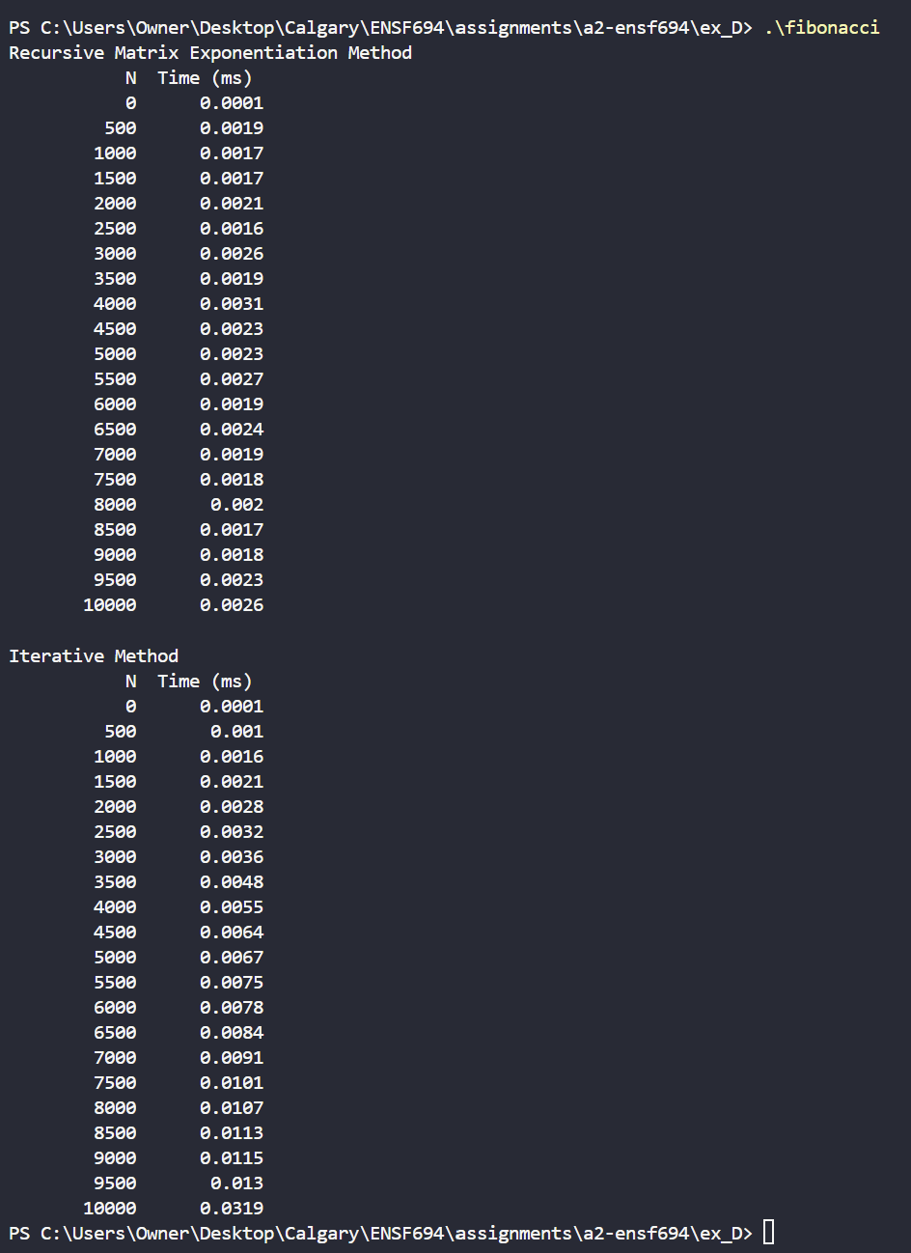

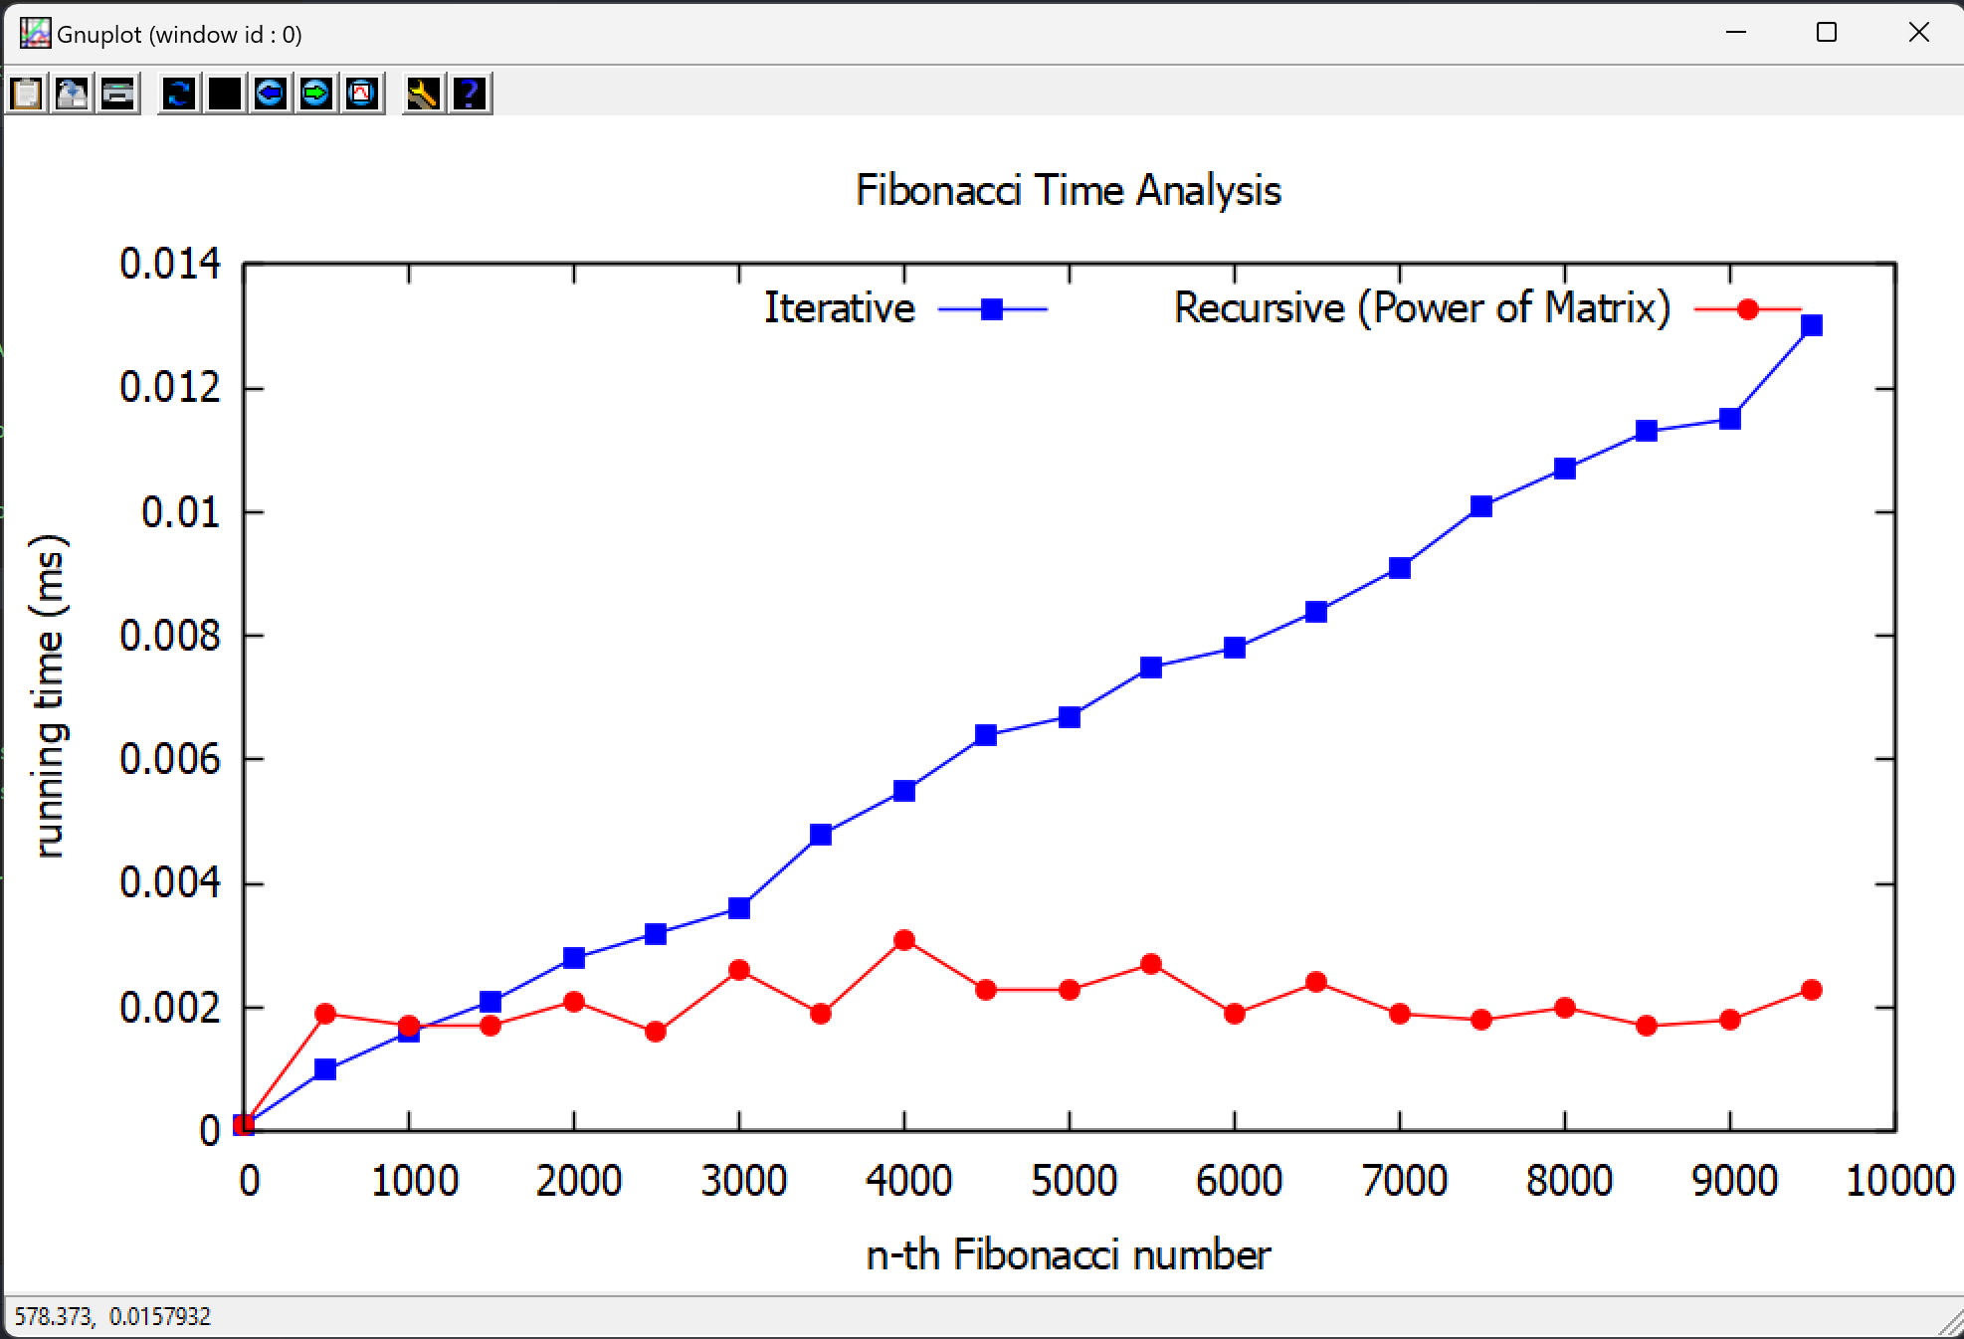

## Exercise E: Using Different Sorting Techniques

### Source code

#### compare_sorts.h

//

//  compare_sorts.h

//  Compare Sort Methods

//

//  Created by Mahmood Moussavi on 2024-06-06.

//  Completed by Yael Gonzalez on 2024-07-08.

//

#ifndef compare_sorts_h

#define compare_sorts_h

#include <iostream>

#include <fstream>

#include <cstring>

#include <cstdlib>

#include <cctype>

#include <chrono>

const int MAX_WORD_SIZE = 20;

const int MAX_UNIQUE_WORDS = 10000;

void to_lower(char \**str*);

/* REQUIRES: str points to valid c-string terminated with a '\0'

 * PROMISES: changes any upper case character to a lowercase.

 */

void strip_punctuation(char \**word*);

/* REQUIRES: word points to valid c-string terminated with a '\0'

 * PROMISES: strips out any non-alphanumeric characters. Also keeps

 * hyphens.

 */

bool is_unique(char *words*[MAX_UNIQUE_WORDS][MAX_WORD_SIZE], int *num_words*, const char \**word*);

/* REQUIRES: words refer to a 2-D arry of character, and each row is a valid

 * c-string terminated with a '\0'

 * PROMISES: returns true if words in in the arra are unique. Otherwise, returns false

 */

void quicksort(int \**indices*, char *words*[MAX_UNIQUE_WORDS][MAX_WORD_SIZE], int *left*, int *right*);

/* REQUIRES: indices points to an arry of integer, holidng index numbers,

 * words refer to a 2-D arry of character, and each row is a valid c-string terminated with a '\0'

 * PROMISES: uses quick sort algorithm to sort the words in ascending order.

 * Source: https://www.programiz.com/dsa/quick-sort

 */

int partition(int \**indices*, char *words*[MAX_UNIQUE_WORDS][MAX_WORD_SIZE], int *left*, int *right*);

/* REQUIRES: indices points to an arry of integer, holidng index numbers,

 * words refer to a 2-D arry of character, and each row is a valid c-string terminated with a '\0'

 * PROMISES: finds the partition position to be used in the quicksort pivot

 * Source: https://www.programiz.com/dsa/quick-sort

*/

void shellsort(int \**indices*, char *words*[MAX_UNIQUE_WORDS][MAX_WORD_SIZE], int *size*);

/* REQUIRES: indices points to an arry of integer, holidng index numbers,

 * words refer to a 2-D arry of character, and each row is a valid c-string terminated with a '\0'

 * PROMISES: uses shell sort algorithm to sort the words in ascending order.

 * Source: Slide "14_More on Algorithms & Complexity Analysis" created by Mahmood Moussavi

 */

void bubblesort(int \**indices*, char *words*[MAX_UNIQUE_WORDS][MAX_WORD_SIZE], int *size*);

/* REQUIRES: indices points to an arry of integer, holidng index numbers,

 * words refer to a 2-D arry of character, and each row is a valid c-string terminated with a '\0'

 * PROMISES: uses bubble sort algorithm to sort the words in ascending order.

 * Source: Slide "14_More on Algorithms & Complexity Analysis" created by Mahmood Moussavi

 */

void read_words(const char \**input_file*, char *words*[MAX_UNIQUE_WORDS][MAX_WORD_SIZE], int &*num_words*);

/* REQUIRES: words refer to a 2-D arry of character, and each row is a valid c-string

 * terminated with a '\0'

 * PROMISES: opens an input file, reads each word from the file, and saves the word with

 * no punctuations, all lowercase, into array of words, and updates numbers of words to

 * assure they are less than MAX_UNIQUE_WORDS

 */

void write_words(const char \**output_file*, char *words*[MAX_UNIQUE_WORDS][MAX_WORD_SIZE], int \**indices*, int *num_words*);

/* REQUIRES: words refer to a 2-D arry of character (number of rows: num_words),

 * and each row is a valid c-string terminated with a '\0'

 * PROMISES: opens an output file, writess the word referred by order of indecies into the

 * output file.

 */

void sort_and_measure_quicksort(char *words*[MAX_UNIQUE_WORDS][MAX_WORD_SIZE], int* *indices*, int *num_words*, void (\**sort_func*)(int *, char [MAX_UNIQUE_WORDS][MAX_WORD_SIZE], int, int), const char \**sort_name*);

/* REQUIRES: words refer to a 2-D arry of character, and each row is a valid c-string

 * terminated with a '\0', num_words refers to number of words in the 2-D array, sort_func

 * points to a quicksort function.

 * PROMISES: uses std::chrono::high_resolution_clock::now, before and after call to the sort

 * function

 */

void sort_and_measure_shell_bubble(char *words*[MAX_UNIQUE_WORDS][MAX_WORD_SIZE], int* *indices*, int *num_words*, void (\**sort_func*)(int *, char [MAX_UNIQUE_WORDS][MAX_WORD_SIZE], int), const char \**sort_name*);

/* REQUIRES: words refer to a 2-D arry of character, and each row is a valid c-string

 * terminated with a '\0', num_words refers to number of words in the 2-D array, sort_func

 * points to a shell or bubble sort function.

 * PROMISES: uses std::chrono::high_resolution_clock::now, before and after call to the sort

 * function

 */

#endif /* compare_sorts_h */

#### compare_sorts.cpp

/**

 *  File Name: compare_sorts.cpp

 *  Assignment: ENSF 694 Lab 2 Exercise E

 *  Created by: Mahmood Moussavi

 *  Completed by: Yael Gonzalez

 *  Submission Date: July 10, 2024

 */

#include "compare_sorts.h"

int main() {

    const char *input_file = "feynman.txt"; // Change this to your input file

    char words[MAX_UNIQUE_WORDS][MAX_WORD_SIZE];

    int num_words;

    read_words(input_file, words, num_words);

    int indices[num_words];

    for (int i = 0; i < num_words; ++i) {

        indices[i] = i;

    }

    sort_and_measure_quicksort(words, indices, num_words, quicksort, "Quick Sort");

    write_words("output_quicksort.txt", words, indices, num_words);

    sort_and_measure_shell_bubble(words, indices, num_words, shellsort, "Shell Sort");

    write_words("output_shellsort.txt", words, indices, num_words);

    sort_and_measure_shell_bubble(words, indices, num_words, bubblesort, "Bubble Sort");

    write_words("output_bubblesort.txt", words, indices, num_words);

    return 0;

}

void to_lower(char \**str*) {

    while (\**str*) {

        \**str* = std::tolower(\**str*);

        ++*str*;

    }

}

void strip_punctuation(char \**word*) {

    char *src_word = *word*;

    while (*src_word) {

        if(isalnum(*src_word) || *src_word == '-') {

            \**word* = *src_word;

*word*++;

        }

        src_word++;

    }

    \**word* = '\0';

}

bool is_unique(char *words*[MAX_UNIQUE_WORDS][MAX_WORD_SIZE], int *num_words*, const char \**word*) {

    for (int i = 0; i < *num_words*; i++) {

        if (strcmp(*words*[i], *word*) == 0) {

            return false;

        }

    }

    return true;

}

void quicksort(int \**indices*, char *words*[MAX_UNIQUE_WORDS][MAX_WORD_SIZE], int *left*, int *right*) {

    if (*left* < *right*) {

        // Find the partitoin index (pi) such that:

        // - Elements smaller than pivot are on left of pivot

        // - Elements greater than pivot are on righ of pivot

        int pi = partition(*indices*, *words*, *left*, *right*);

        // Recursive call on the left of pi

        quicksort(*indices*, *words*, *left*, pi - 1);

        // Recursive call on the right of pi

        quicksort(*indices*, *words*, pi + 1, *right*);

    }

}

int partition(int \**indices*, char *words*[MAX_UNIQUE_WORDS][MAX_WORD_SIZE], int *left*, int *right*) {

    // Select the rightmost element as pivot

    int pivot = *indices*[*right*];

    // pointer for greater element

    int i = (*left* - 1);

    // traverse each element of the array

    // compare them with the pivot

    for (int j = *left*; j < *right*; j++) {

        if (strcmp(*words*[*indices*[j]], *words*[pivot]) <= 0) {

            // if element smaller than pivot is found

            // swap it with the greater element pointed by i

            i++;

            // swap element at i with element at j

            std::swap(*indices*[i], *indices*[j]);

        }

    }

    // swap pivot with the greater element at i

    std::swap(*indices*[i + 1], *indices*[*right*]);

    // return the partition point

    return (i + 1);

}

void shellsort(int \**indices*, char *words*[MAX_UNIQUE_WORDS][MAX_WORD_SIZE], int *size*) {

    // Start with a big gap, then reduce the gap

    for (int gap = *size* / 2; gap > 0; gap /= 2) {

        // Perform a gapped insertion

        for (int i = gap; i < *size*; i++) {

            int temp = *indices*[i];

            int j;

            for (j = i; j >= gap && strcmp(*words*[*indices*[j - gap]], *words*[temp]) > 0; j -= gap) {

*indices*[j] = *indices*[j - gap];

            }

*indices*[j] = temp;

        }

    }

}

void bubblesort(int \**indices*, char *words*[MAX_UNIQUE_WORDS][MAX_WORD_SIZE], int *size*) {

    for (int i = 0; i < *size* - 1; i++) {

        for (int j = 0; j < *size* - 1 - i; j++) {

            // Compare the words at the current indices

            if (strcmp(*words*[*indices*[j]], *words*[*indices*[j + 1]]) > 0) {

                // Swap the indices if out of order

                int temp = *indices*[j];

*indices*[j] = *indices*[j + 1];

*indices*[j + 1] = temp;

            }

        }

    }

}

void read_words(const char \**input_file*, char *words*[MAX_UNIQUE_WORDS][MAX_WORD_SIZE], int &*num_words*) {

    std::*ifstream* infile(*input_file*);

    if (!infile) {

        std::cerr << "Error opening input file.\n";

        exit(1);

    }

    char word[MAX_WORD_SIZE + 1];

*num_words* = 0;

    while (infile >> word) {

        strip_punctuation(word);

        to_lower(word);

        if (word[0] != '\0' && *num_words* < MAX_UNIQUE_WORDS && is_unique(*words*, *num_words*, word)) {

            std::strncpy(*words*[*num_words*++], word, MAX_WORD_SIZE);

        }

    }

    infile.close();

}

void write_words(const char \**output_file*, char *words*[MAX_UNIQUE_WORDS][MAX_WORD_SIZE], int \**indices*, int *num_words*) {

    std::*ofstream* outfile(*output_file*);

    if (!outfile) {

        std::cerr << "Error opening output file.\n";

        exit(1);

    }

    for (int i = 0; i < *num_words*; ++i) {

        outfile << *words*[*indices*[i]] << '\n';

    }

    outfile.close();

}

void sort_and_measure_quicksort(char *words*[MAX_UNIQUE_WORDS][MAX_WORD_SIZE], int* *indices*, int *num_words*, void (\**sort_func*)(int *, char [MAX_UNIQUE_WORDS][MAX_WORD_SIZE], int, int), const char \**sort_name*) {

    const auto start_time = std::chrono::*high_resolution_clock*::now();

*sort_func*(*indices*, *words*, 0, *num_words* - 1);

    const auto end_time = std::chrono::*high_resolution_clock*::now();

    const std::chrono::duration<double> time_diff = end_time - start_time;

    std::cout << "Sorting with " << *sort_name* << " completed in " << time_diff.count() << " seconds.\n";

}

void sort_and_measure_shell_bubble(char *words*[MAX_UNIQUE_WORDS][MAX_WORD_SIZE], int* *indices*, int *num_words*, void (\**sort_func*)(int *, char [MAX_UNIQUE_WORDS][MAX_WORD_SIZE], int), const char \**sort_name*) {

    const auto start_time = std::chrono::*high_resolution_clock*::now();

*sort_func*(*indices*, *words*, *num_words*);

    const auto end_time = std::chrono::*high_resolution_clock*::now();

    const std::chrono::duration<double> time_diff = end_time - start_time;

    std::cout << "Sorting with " << *sort_name* << " completed in " << time_diff.count() << " seconds.\n";

}

### Program output

# Part II – Complexity Analysis

## Exercise A

In order of performing best to worst based on their growth rate:

1. – This is O(1/N). The growth rate decreases exponentially as N increases, approaching 0. For large N, it grows very slowly.
2. **37** – This is O(1). It is a constant, meaning its growth rate does not change regardless of N. It remains fixed and performs better than O(√N) for all N > 1369.
3. – This is O(). The growth rate is sublinear, i.e., it’s faster than a constant but slower than linear.
4. **N** – This is O(N). It has linear growth, so it increases proportionally with N.
5. – This is O(NlogN). The growth rate is linear times a logarithmic factor, making it grow slightly faster than linear but still much slower than polynomial growth rates.
6. – This is O(). The growth rate is exponential, but slower than O() because the exponent is halved.
7. – This is O(). It has exponential growth, so it doubles with each increment of N. This is the fastest-growing rate among the given expressions.

The analysis can be visualized in the plot below:

## Exercise B

A blackboard with a black and white background with a black and white background with a black and white background with a black and white background with a black and white background with a red circle and a

Order of performing best to worst based on their growth rate:

1. > (4) > (2) > (5) > (3) > (6)

Best Worst