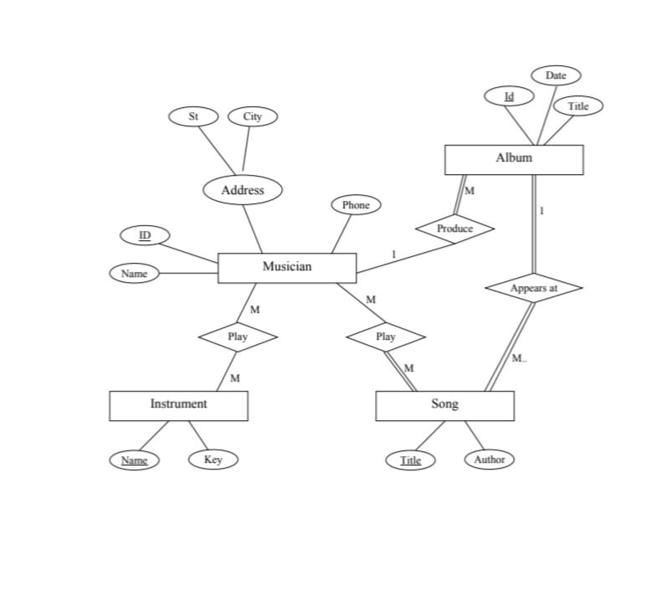

1. Entities and Attributes:
Entity | Attributes
Musician | ID, Name, Phone, Address (St, City)
Instrument | Name, Key
Song | Title, Author
Album | ID, Title, Date

2. Relationships and Cardinalities:
Entities | Relationship | cardinality
Musician - Instrument | Play | M : M
Musician - Song | Play | M : M
Song - Album | Appears at | M : 1
Musician - Album | Produce | 1 : M

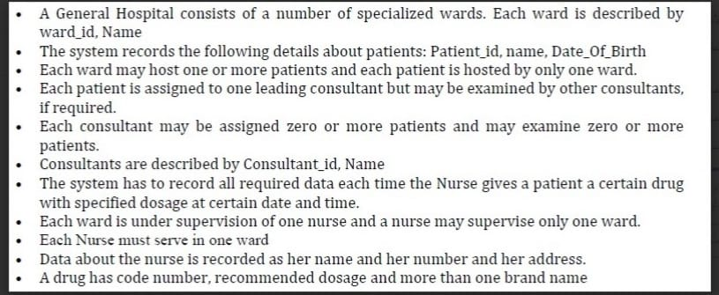

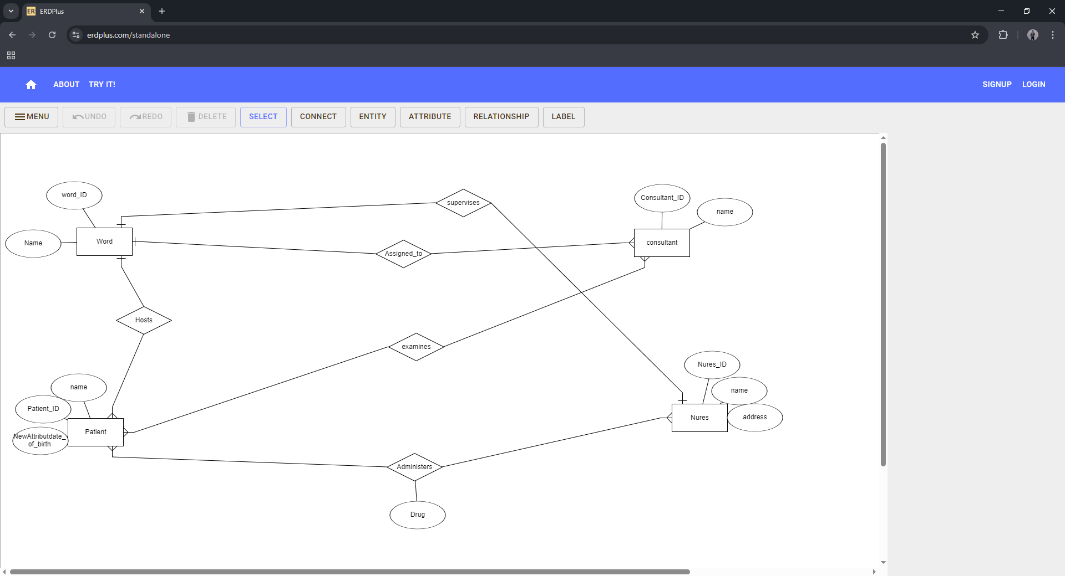

1. Entities and Attributes:
Word | Word_ID , name
Patient | Patient_ID , name , date_of_birth
consultant | Consultant_ID , name
Nures | Nures_ID , name , address
Drug | Code_number , recommended_dosage , brand_names(multi-valued)

2. Relationships and Cardinalities:
Entities | Relationship | cardinality
Hosts | Ward- patient | 1 : M
Assigned_to | Patient-consultant | M : 1
examines | Consultant-Patient | M : M
supervises | Nurse -Word | 1 : 1
Administers | Nurse-Patient-Drug | M : M

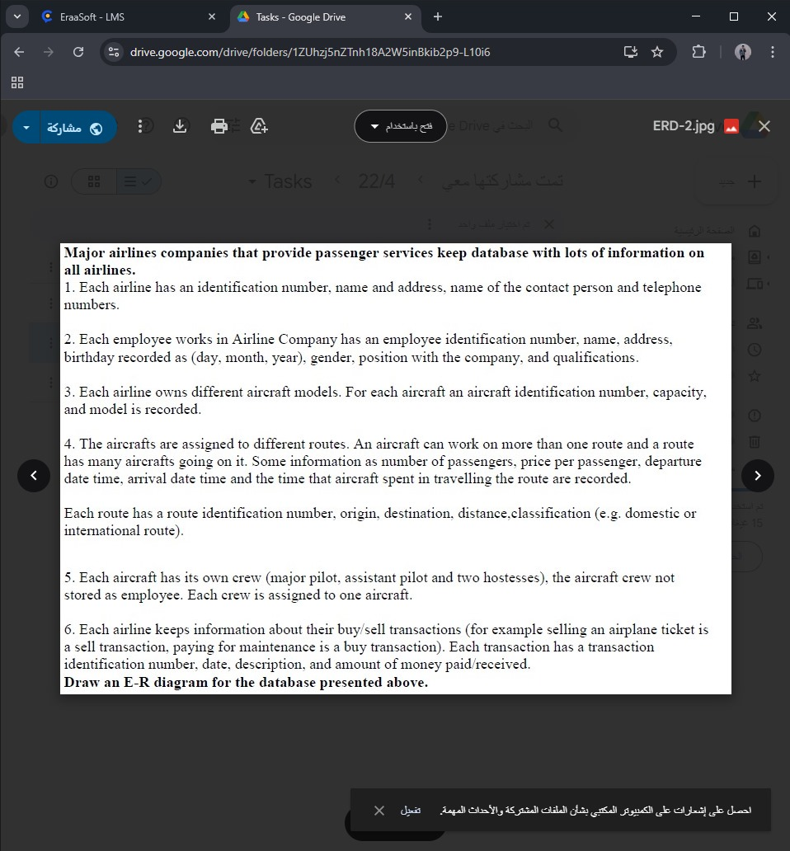

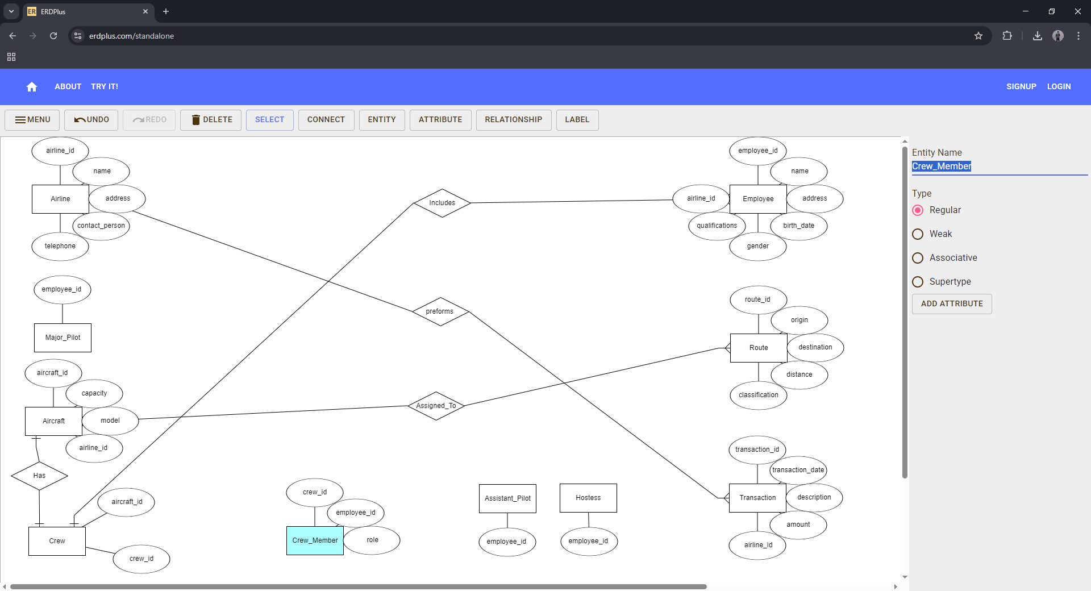

1. Entities and Attributes:
Airline | airline_id, name, address, contact_person, telephone
Employee | employee_id , name, address, birth_date, gender, qualifications, airline_id
Major_Pilot | employee_id
Assistant_Pilot | employee_id
Hostess | employee_id
Aircraft | aircraft_id , capacity, model, airline_id
Route | route_id , origin, destination, distance, classification
Crew | crew_id , aircraft_id
Crew_Member | crew_id , employee_id , role
Transaction | transaction_id , transaction_date, description, amount, airline_id

2. Relationships and Cardinalities:
Aircraft - Route | Assigned_To | M : M
Aircraft - Crew | Has | 1 : 1
Crew - Employee | Includes | 1 : M
Patient - Consultant | Assigned_to | M : 1
Consultant - Patient | Examines | M : M
Airline - Transaction | Performs | 1 : M

