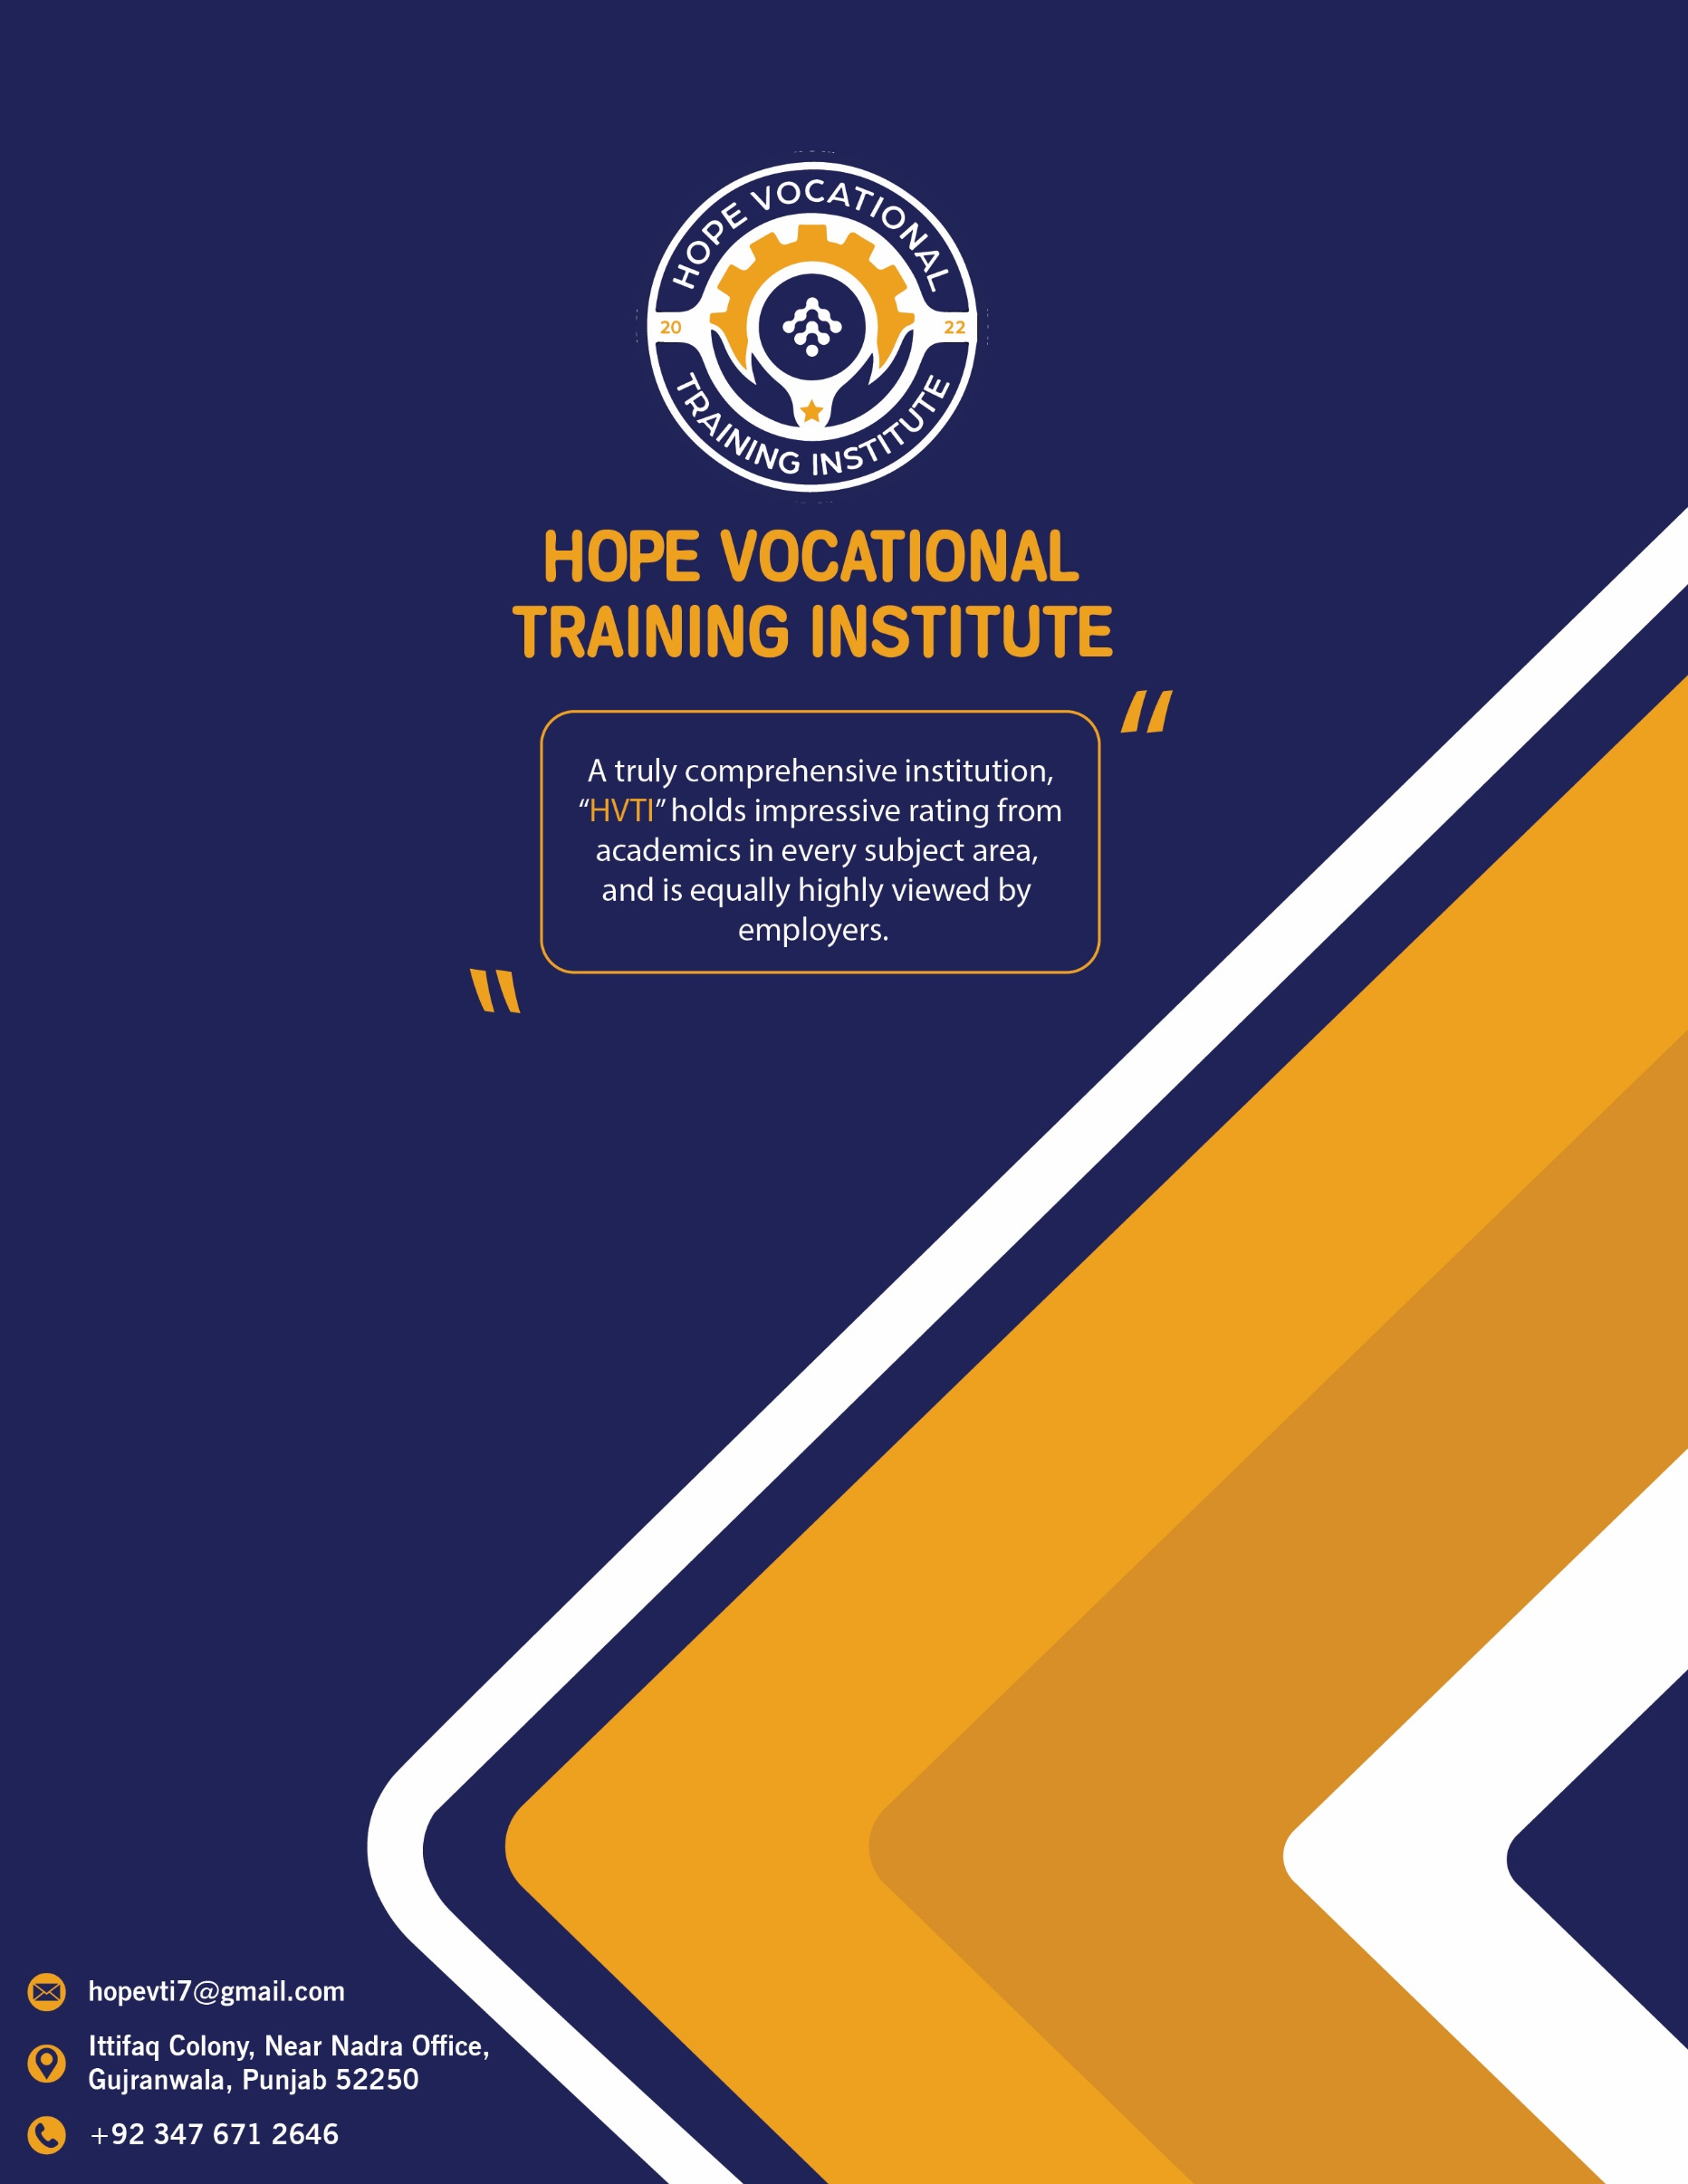

**Index**

**Introduction……………………………………………………………………. Page 2**

**Training Objectives………………………………………………….………. Page 3**

**Staff Details…………………………………………………………………….. Page 4**

**Courses Offered………………………………………………………………. Page 5**

**Admission Criteria…………………………………………………………… Page 9**

**Documents Required………………………………………………………. Page 9**

**Fee Schedule…………………………………………………………………… Page 10**

**Other Information…………………………………………………………… Page 10**

**­­­­**

**INTRODUCTION**

HVTI (Hope Vocational Training Institute) is a modern; State-of-the-Art soft skills training center established in 2022. HVTI is located at Gujranwala for the vibrant industrial clusters in and around Gujranwala, Gujrat, Sialkot, Daska, Wazirabad and Shiekupura. The objective is to provide the Gujranwala and neighboring industries to fulfil the shortage of skilled workforce.

**Vision**

To be center of excellence in provision of the premier knowledge management institute on technology upgradation and related quality skills for the world of work.

**Our Mission**

Is to be the first choice vocational training institute.

* To manage demand base vocational training for empowering Youth.
* To assist student in making educational and career Decisions.
* To providing suitable opportunities for all the students to start earning a reasonable livelihood.

**TRAINING OBJECTIVES**

In accordance with the declaration of intent, Hope Vocational Training Institute shall pursue the following objectives:

HVTI offers the End User Computing Qualification as a learnership or skills program which is partially funded by the Seta. End User Computing also available as individual courses eg. Excel, Word, PowerPoint etc. from beginner to expert.

We offer a structured Skills Program. The purpose of the program is primarily focused on up skilling unskilled employees. Empowered with these newly acquired skills, employees will now have the opportunity to apply for skilled/semi-skilled positions within the company, ultimately supporting and or enhancing business productivity.

This program may be implemented for empowerment in the practical nature. The main purpose being, that employees will become functionally literate and practically enlightened.. It is the starting point for articulation and movement up the NVQF. It enables an employee to progressively advance towards a qualification and it should support career or talent management.

**Why Join Hope Vocational Training Institute?**

We aim to provide professional education and computer training programs. Further, we commit to providing training and development programs that will improve individual, team and organizational performance.

We ensure that set objectives are understood and communicated to learners throughout training to enhance learning, and ensure continuous measurement and evaluation of all training initiatives.

We meet the skills shortage needs that our country faces, and train learners to the exacting Pakistan National Vocational Qualifications Framework (NVQF) approved standards. Moreover, we provide a basis for further personal development, promote occupational and social develop

. We also assist learners with skills needs analyses prior to training.

We strive to provide continual constructive feedback to learners during training and ensure that all training will be outcomes-based; aligned to NVQF standards. We provide a Statement of Results and a certificate of accomplishment to learners that have been assessed as competent at the end of the training session, as well as provide ongoing support and help to learners after completion of training.

**Courses Details:**

HVTI provides training on short courses through individual unit standards or the following:

1. Skills Programs

2. Vendor (Industry) Specific Programs

**SKILLS PROGRAMMES**

1. **Skills Programs:**

A skills program is a set or cluster of unit standards gathered from a qualification, combined to form a short course with credits.

**Why Skills Program?**

The skills program are often implemented to meet the needs of the employer to enhance employees’ knowledge for a particular skill.

A skills program can culminate into a qualification when an interested learner continues to pursue the completion of the remaining unit standards. On completion of the course, learners that were assessed receive a Statement of Results from the Seta and a certificate of Competence from HVTI.

Like the Learnerships, skills programs are implemented by employers for both employed and unemployed learners.

**2. Vendor (Industry) Specific Programs:**

HVTI customizes skills programs to accommodate clients’ by integrating unit standards with their industry specific training.

**Category-A**

**(6 Months Course Criteria)**

* 1. **E-Commerce-Level 2**
  2. [**Mobile Application Developer**](http://www.navttc.org/downloads/curricula/cur/ict/Mobile%20Application%20Developer%20%5bCS%5d.pdf)
  3. [**Web Designer**](http://www.navttc.org/downloads/curricula/cur/ict/Web%20Designing%20%5bCS%5d.pdf)
  4. **Office Management**
  5. **Application Development**
  6. **Software & Hardware**

|  |  |
| --- | --- |
| (6-Months Course) Entry Level | Min. 2 years working experience with Mid Level of understanding English Language and SCC  OR  One year working/ Hands-On experience with Min. Inter- level Education |
| Duration of Course | 06 Months  (Single Semester of 20 Weeks teaching delivery) |
| Total Training Hours | 600 Hours  30 Hours per Week |
| Training Methodology | Practical 80%  Theory 20% |
| Internship | 1 Month |
| Medium of Instruction | English / Urdu |

**Category- B**

**(3 Months Course Criteria)**

1. **E-commerce**
2. **Application Development**
3. **Software & Hardware**
4. **Print Media**
5. [**IT Office Assistant**](http://www.navttc.org/downloads/curricula/cur/ict/IT%20Office%20Assistant%20%5bCS%5d.pdf)
6. **Sales Management**
7. **Customer Service via Phone and Email**
8. **Excellence in Technical Customer Service**
9. **Marketing Essentials**
10. **Workshop Management**
11. **Auto CAD (Civil, Mechanical)**

|  |  |
| --- | --- |
| Entry Level: | Matric with Science + Computer Skill |
| Total Duration of Course: | 3 Month |
| Total Training Hours: | 400 Contact Hours |
| Training Methodology: | 80 % Practical  20 % Theory |
| Medium of Instruction: | Urdu / English |
| Internship | 3 Weeks |

**EMPLOYABILITY OF PASS OUT**

After passing the course the student may be able to become helpful skilled workforce and may join the following sectors:

|  |  |  |
| --- | --- | --- |
| Self-Employment | Engineering Sector | Design & Development Sector |
| Education Sector | Textile Industry | ICT Industries |
| FMCG | Automobile Industry | Online Trading |

**Admission Criteria**

1. Applicant must have passed Matriculation along with Science Subjects securing 40% marks overall.
2. Applicant with higher qualification can also apply.
3. Applicant should not be less than 18 Years of age at date of admission.
4. Candidates for admission must fill their Application forms neat and complete in all respects in their own hand writing. The Prospectus and Application Form can be obtained from the Reception Counter of the Institute.
5. The candidates applying for admission must attach necessary documents as required in respective Application Form.
6. Application Form, and the documents attached with the Application Form shall not be returned.
7. Incomplete Application Forms will not be acceptable.

**Documents Required**

1. Copy of Matriculation (Marks Sheet / Certificate) Website Result Print out is not acceptable.
2. Migration Certificate (Original) of Students belonging to province other than Punjab. (i.e Sindh, Baluchistan and NWFP)
3. 3 Photographs, ID Cards Photocopies of Self and Father/ Guardian. In case of non-availability of ID, B-form must be attached
4. Provisional Certificate if student date of birth is not present in Matric Marks Sheet.
5. Domicile Certificate

**Fee Schedule**

|  |  |  |  |
| --- | --- | --- | --- |
| Sr. No | Description | Dues | When to Pay |
| 1 | Registration Fee | 1,000 | At the time of admission |
| 2 | Exams Fee | 2,000 | At the time of admission |
| 3 | 6 Months Tuition Fee | 40,000 | At the time of admission  (2 Installments) |
| 4 | 3 Months Tuition Fee | 25,000 | At the time of admission |

**Other Information**

**Classrooms**  
Comfortable class rooms for lectures, theory and discussions.

**Computer Labs**  
We have a state-of-the-art computer lab equipped with 40 computers.

**Workshop**

A complete workshop with state of the Art latest Equipment to accommodate 100 students simultaneously.

**Staff at HVTI**

1. **Mr. Muhammad Usman (Principal/ Focal Person )**
2. **Mr. Muhammad Faizan (Technical Advisor/ Marketing/HR)**
3. **Mr. Muhammad Khubaib (Finance/Accounting)**
4. **Mr. Ammar Ali (Course Coordinator)**
5. **Mr. Shahzeb Rasheed (Instructor E- Commerce)**
6. **Mr. Mustansar Iqbal (Instructor Office Management)**
7. **Mr. (Instructor Amazon Virtual Assistance)**
8. **Mr. Ali Sajjad (Instructor Web and graphic Designing)**
9. **Mr. Arslan (Instructor Advance Web Application Development)**

**Address and Location**

**Main Branch**

**Hope Vocational Training Institute**

**N-5 Ittifaq Colony, Near Nadra Office,**

**Opposite Citizen Factory, Gujranwala**

**Web: www.hopevti.edu.pk**

**Email: hopevti7@gmail.com**

**Facebook: facebook.com/HVTIgrw**

**Contact: +92 347 671 2646, +92 321 784 1708**