**ECE 5256 Digital Image Process Final Project**

Jiayin Lu

1. **Create Database**
2. Create two sane size image databases for preprocessing.
3. One database called my_datasets_1 contains 72*5 images which are 128*128 RGB image of five different types of objects. The other one called my_datasets_2 contains 72*3*5 images which are 128*128 RGB image of five different types of objects.
4. The image database for classification are found from <https://www1.cs.columbia.edu/CAVE/software/softlib/coil-100.php>
5. **Specify the architecture of CNN**
6. Create four convolution layers. Frist one contains 16 different filters whose kernel is 3*3 matrix with paddling. Second one contains 32 different filters whose kernel is 3*3 matrix with paddling. Third one contains 64 different filters whose kernel is 3*3 matrix with paddling. The last layer contains two parts of same convolution processing. After each convolution, doing the max pooling whose stride is 2 shrink 3*3 pixels to one pixel with paddling is to extract the feature of images.
7. Dropout function is used to resolve the overfitting. The 0.5 means the probability of keeping the neuron’s data is 50%.

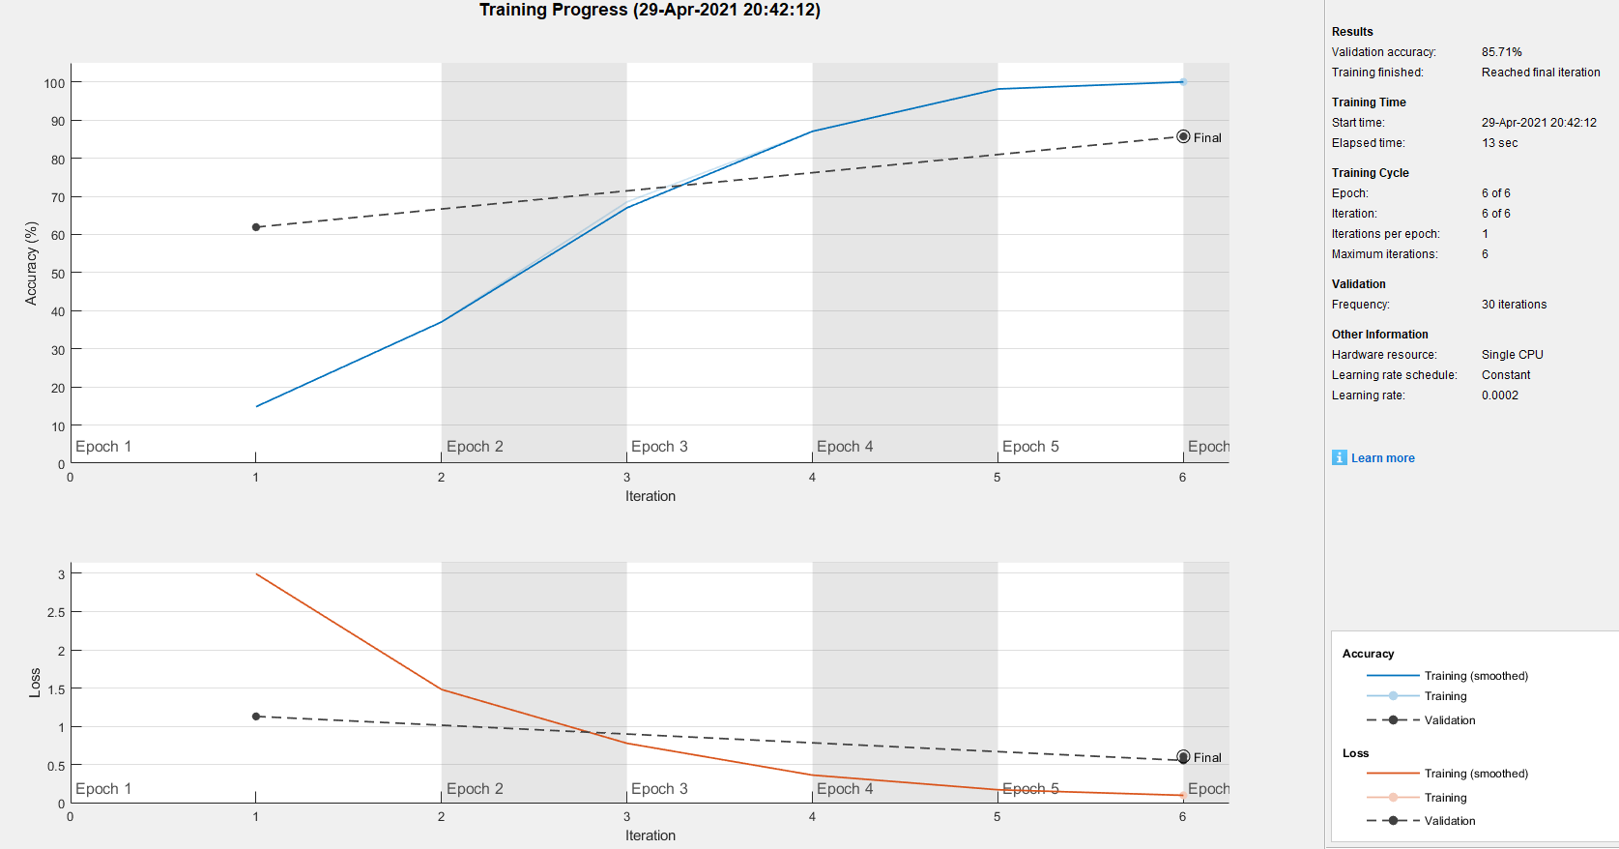

Figure 1 processing result for MerchData without using dropout

1. Learning rate is used to control the learning speed during training processing. When select learning rate is 10^(-4) , the training curve is not close to the accuracy of 100%, so change the learning rate to 2*10^(-4) to resolve it. The results are shown in Figure 2 .

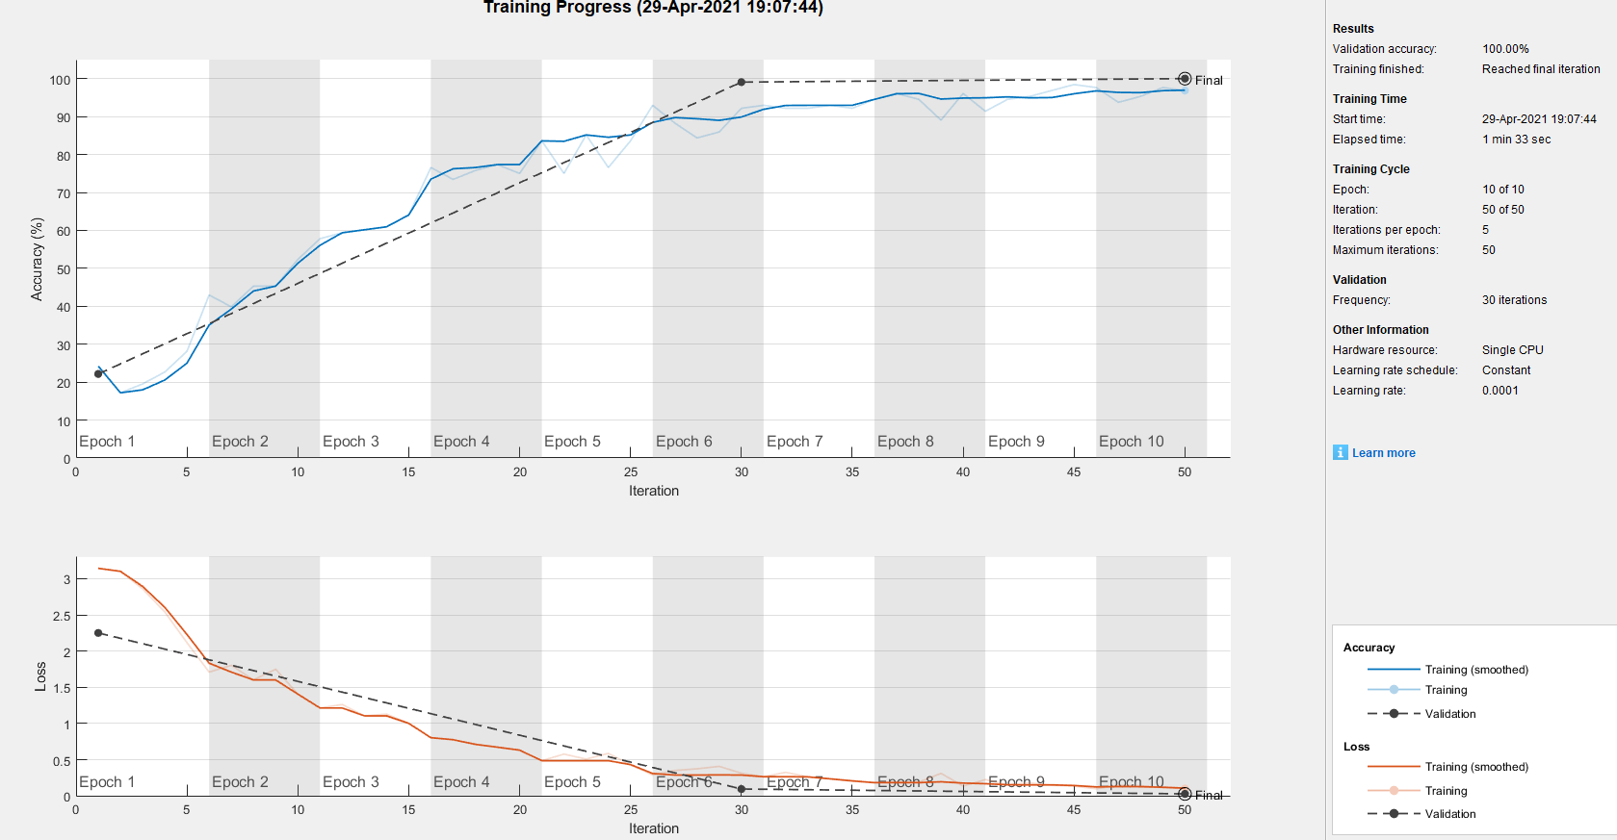

Figure 2 processing result for my_datasets_2 with learning rate 10^(-4) and max epoch 10

1. When the max epoch is 10, the ventilation curve is a constant of with 100% accuracy after 6 epoch, so change max epoch to 6, since training many epochs need too much time to process. The result is shown as in Figure 2.
2. **Determine Image outside the database (in dip_fp_1)**

According to the figure 3, the accuracy of classifying the images which are outside the database is not high, but it seemly works.

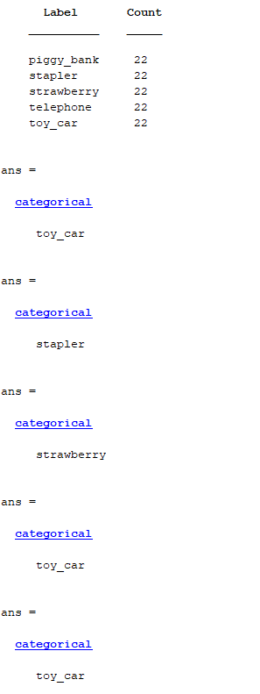

Figure 3 the results of classifying the images which are outside the database (correct order is same as the label’s order)

1. **Results**

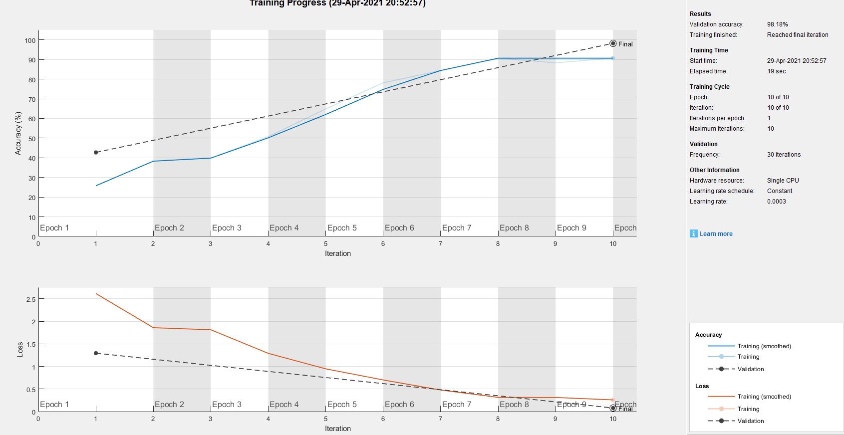

Figure 4 processing result for my_datasets_1 with learning 3*10^(-4) and max epoch 10

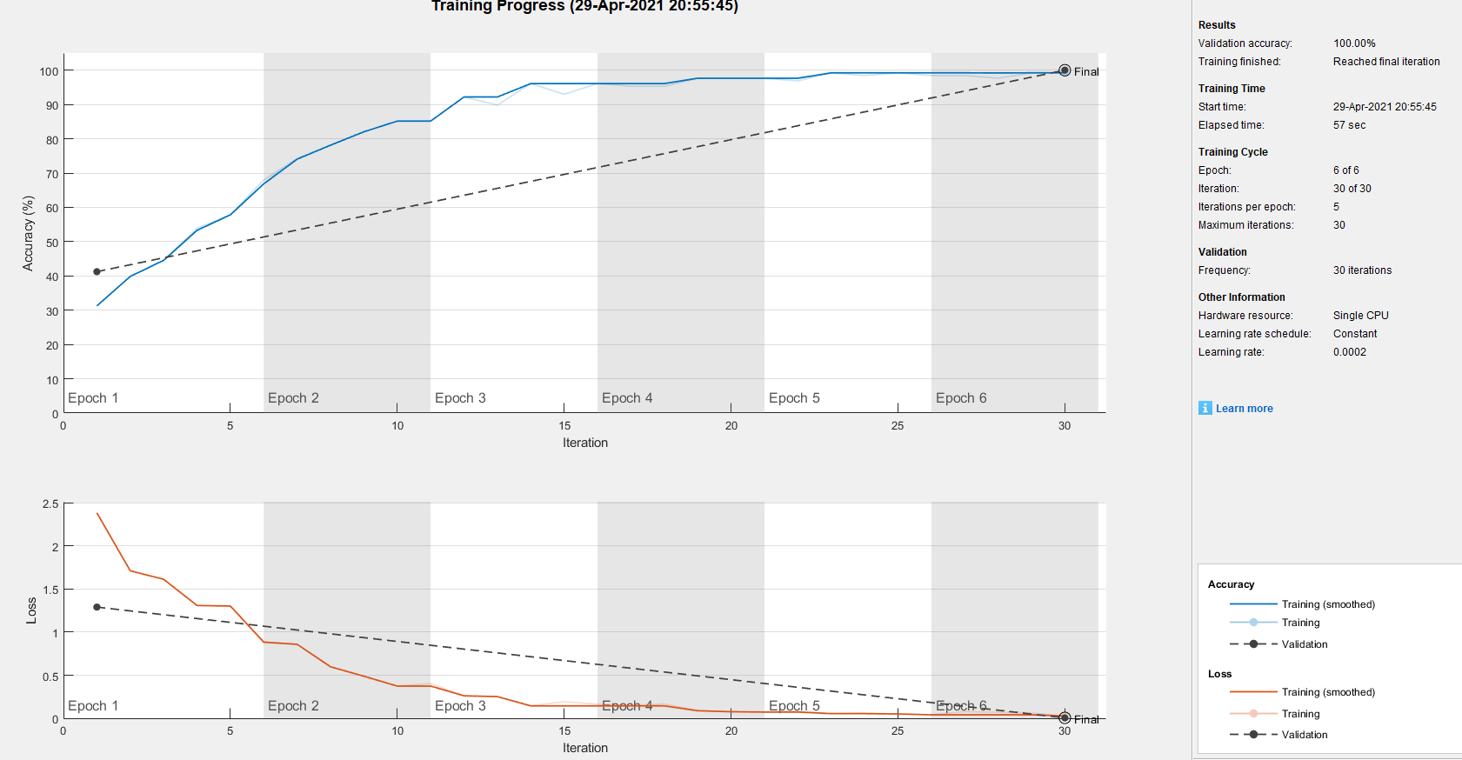

Figure 5 processing result for my_datasets_2 with learning 2*10^(-4) and max epoch 6

1. **Discussion**
2. For my_datasets_1, the CNN needs more epochs to train the database to get the good accuracy, but as for my_datasets_2, the CNN only needs 6 epochs to get 100% accuracy.
3. For the Part 4, to get high accuracy of classifying the images outside the database, there are a lot of different images from all kinds of source to training in CNN. The images in my_datasets_1 are found from one large objects images database. Even the accuracy of the validation is high during simulating, the images used to train are too similar to each other. Therefore the actual accuracy for determining images outside the database is low.
4. **Reference**

<https://www1.cs.columbia.edu/CAVE/software/softlib/coil-100.php>