[(sin x) / ((cos x/4) (sin x/2))]

x = 13×pi

[(cos x /sec x) + (sin x × cos x /cot x)]

x = 30 degrees

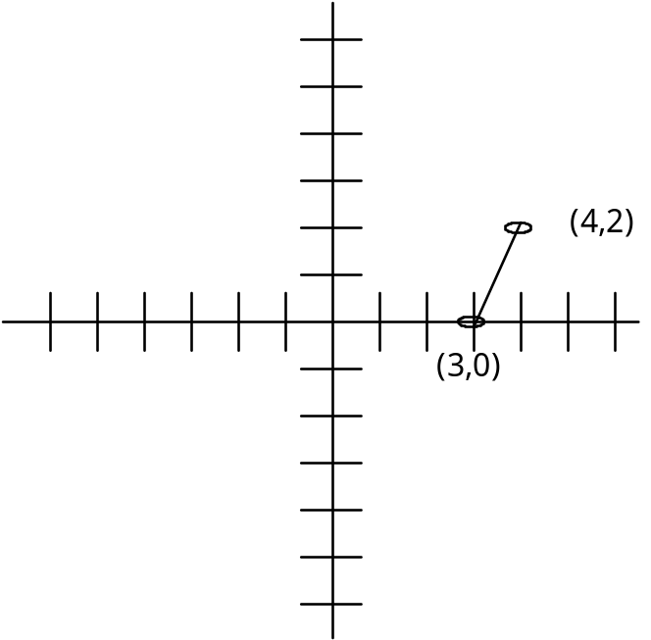

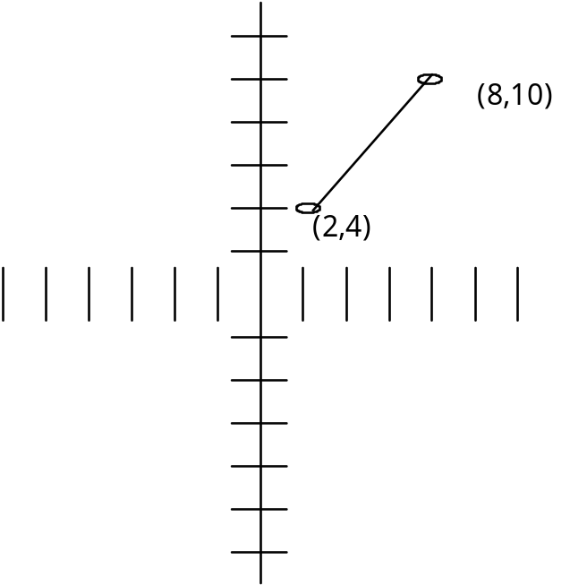

(3 - 4i)²

(-2 + 5i)²

2048, 1386, 3198

4096, 9138, 1999

[ (16^{1/2} × 3²) / 2⁴]

[ sqrt ( 3! + sqrt (81))
__________________
sqrt (2⁵ – 3³) ]

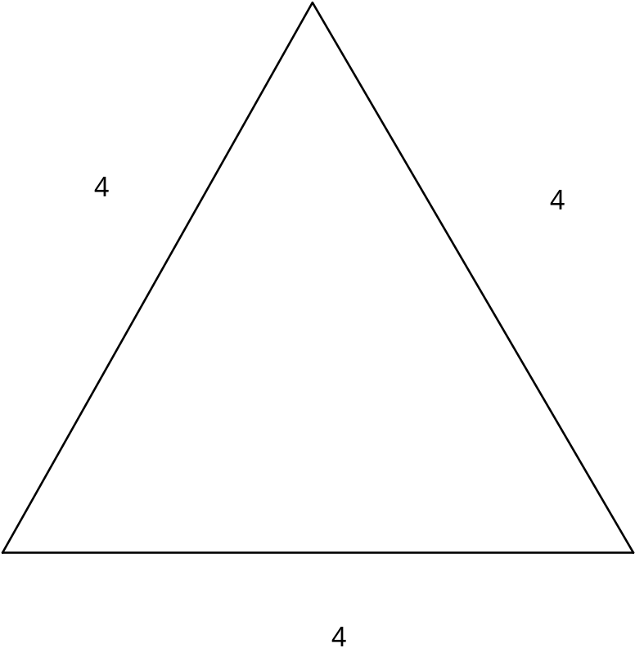

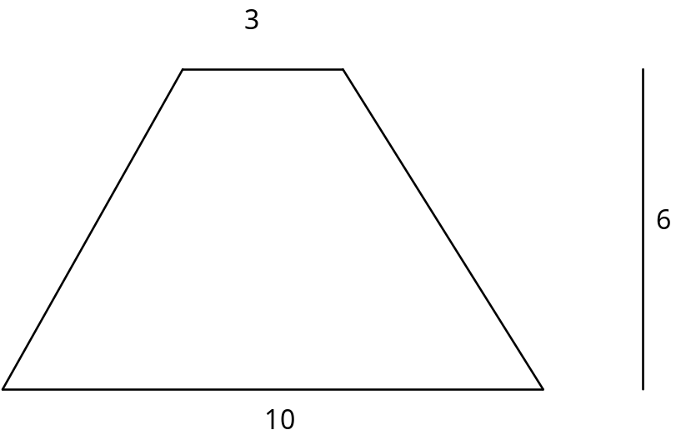

[4x + y = 7, x – 4y = 6]

Solve for y

[3x + 2y = -5, x + 8y = 13]

Solve for y

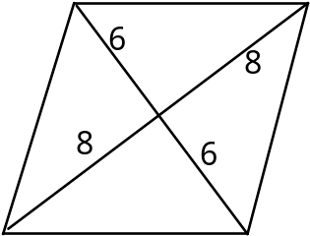

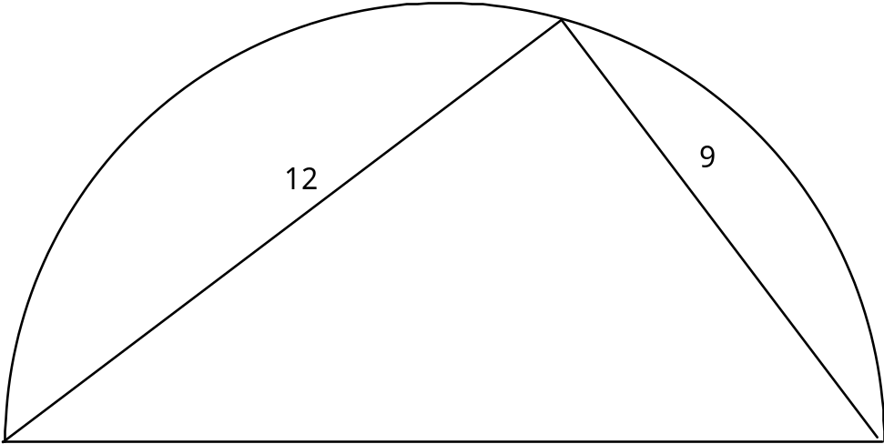

x⁶ – ((x³ + 2×x!) / x²)

Evaluate the expression for x = 2

ln (sqrt ( 6x + 9)) = ln (sqrt (8x – 13))

Solve for x

8 is 40% of x

Solve for x

13 is 5%

Solve for x

[ x² – 5x – 24]

[ x² + 3x – 28]

[ x² – 25x + 144]

[ x² + 20x – 156]

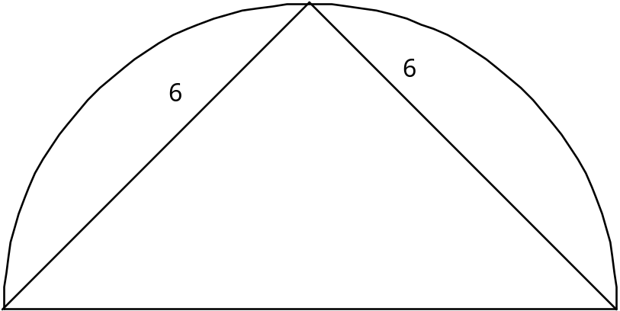

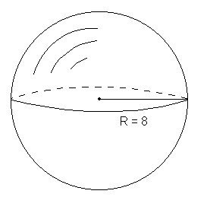

[ lim x -> 0 (sin (-5x) / (8x)) ]

lim x -> inf (58x³+95x²+13x–8)
_____________________
(-87x³–9x²+11x– 6)

[ sqrt ( 5² – x²) / ( 1 + x)]

x = –4

[ x^{x} + cos (pi×x) + x! ×sin (pi×x)]

x = 3

