UTC ROUND – HANDOUT FOR BONUS #3 MOC MASTERS 2003

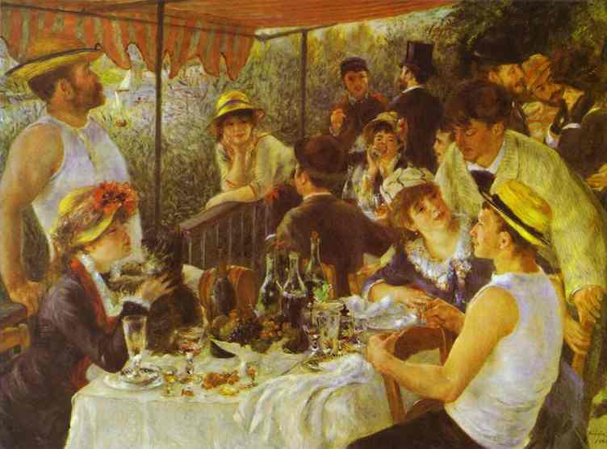

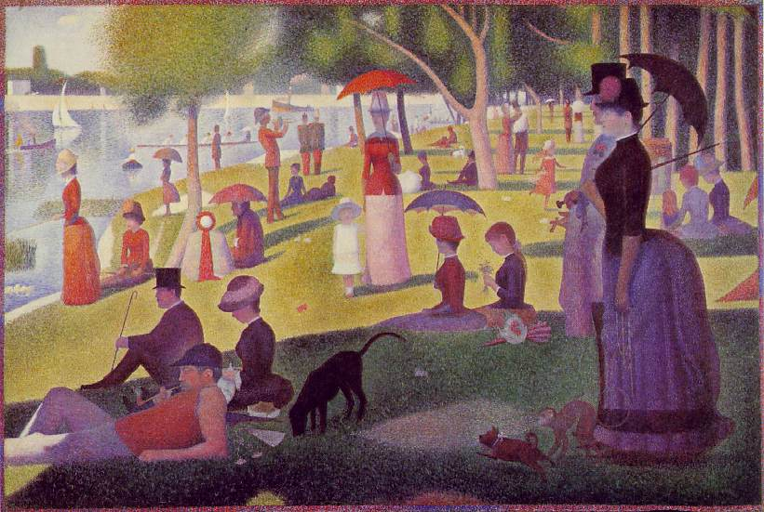
1.

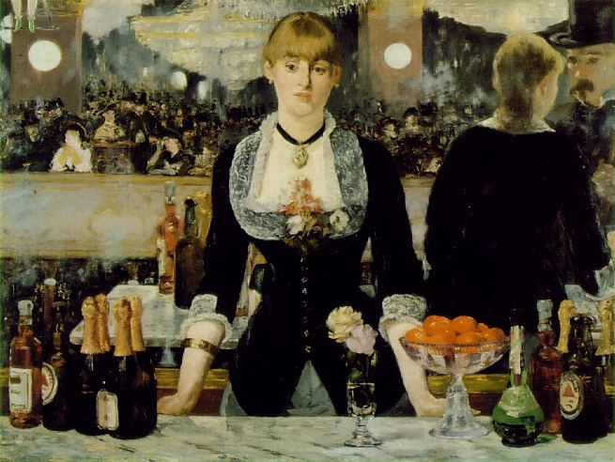
2.

3.

These paintings are all French and painted during the 1880’s.

Answers:

- Luncheon of the Boating Party by Renoir
- A Sunday Afternoon on the Island of La Grande Jatte by Seurat

- A Bar at the Folies-Bergeres by Manet

