UTC ROUND – VISUAL FOR BONUS #7 MOC MASTERS 2003

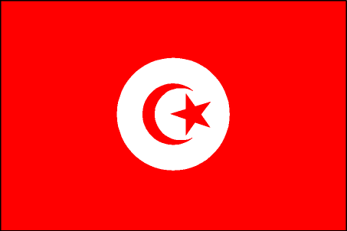
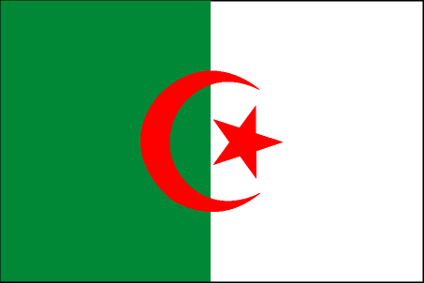

1. 2.

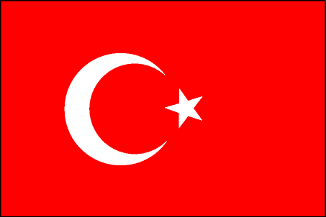
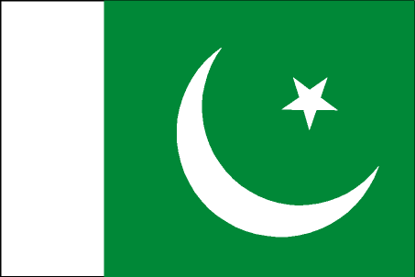
3. 4.

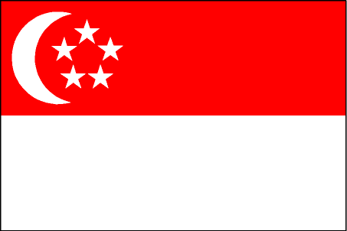
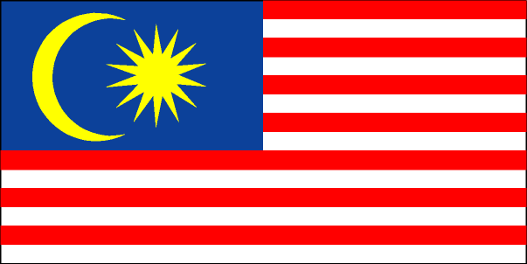
5. 6. 6.

The Crescent Moon is used frequently as a symbol of Islam. Name the country that flies each of the flags shown FFPE.

Answers:

- Algeria
- Tunisia

- Turkey
- Pakistan
- Singapore
- Malaysia

