MOON PIE 2004 – NW SHOALS -- Bonus 10 Handout.
Identify both the artist and the work for 5 points per painting.

1. 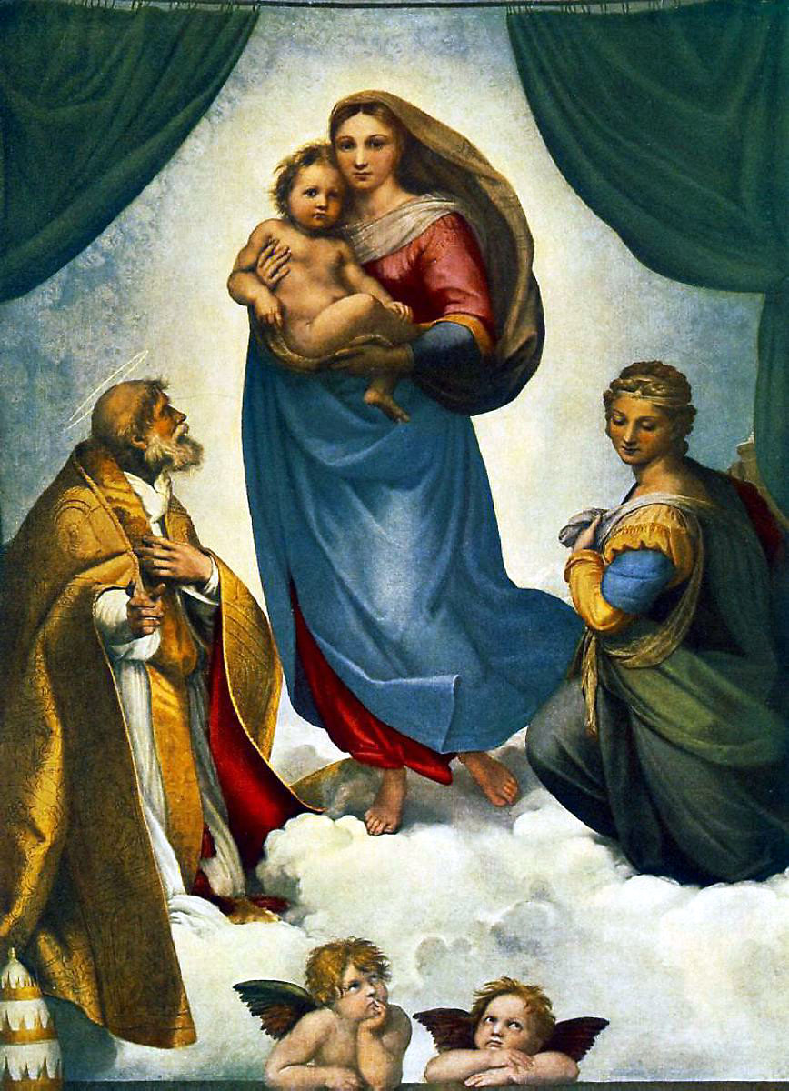 2. 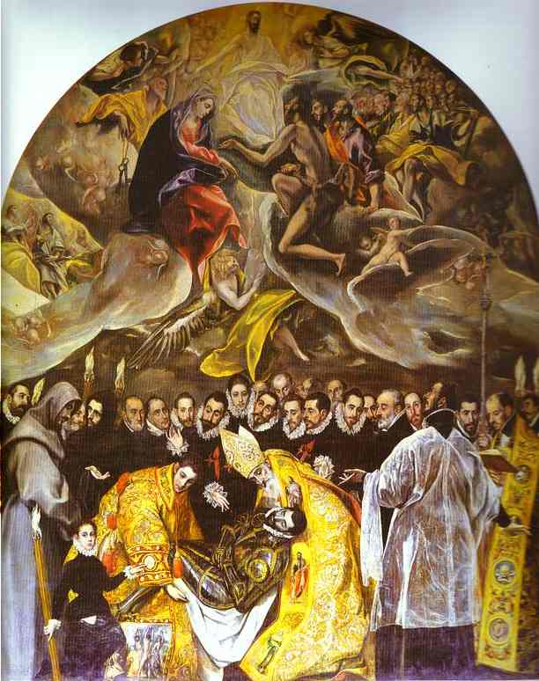

3. 