Name __________________

Pop Culture

Match the athlete with the sport she is famous for playing:
_____ Stacy Dragila A. Auto Racing
_____ Jennie Finch B. Basketball
_____ Michelle Kwan C. Figure Skating
_____ Misty May D. Golf
_____ Danica Patrick E. Gymnastics
_____ Carly Patterson F. Soccer
_____ Maria Sharapova G. Softball
_____ Diana Taurasi H. Tennis
_____ Abby Wambach I. Track And Field
_____ Michelle Wie J. Volleyball

_____ Count It

_____ Don’t Count It
Name __________________

Nonfiction

Match the work with its author and year of publication:
Author Year
_____ The Affluent Society _____
_____ Das Kapital, Volume One _____
_____ Inquiry into the Nature and Causes of the Wealth of Nations _____
_____ On The Principles of Political Economy and Taxation _____
_____ Treatise On Money _____

Authors: Years:
A. John Kenneth Galbraith 1. 1776
B. John Maynard Keynes 2. 1817
C. Karl Marx 3. 1867
D. David Ricardo 4. 1930
E. Adam Smith 5. 1958

_____ Count It

_____ Don’t Count It
Name __________________
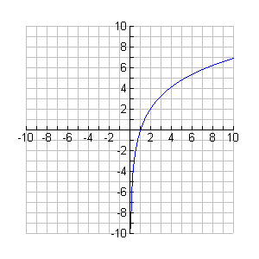
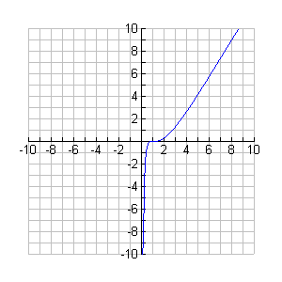
Algebra
Match the graph with its equation:

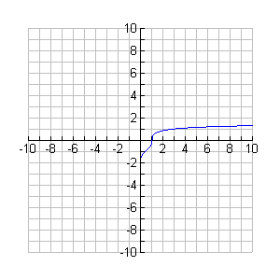
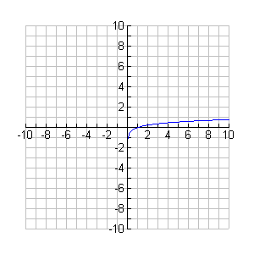

Equations:
A. y=ln (x³)
B. y=ln³x
C. y=ln 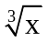
D. y=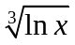

_____ Count It

_____ Don’t Count It
Name __________________

World Literature

Match the character from Dante’s Inferno with his role in the story and his role outside the story:

Inside Dante’s work Outside Dante’s work
_____ Antaeus _____
_____ Cerberus _____
_____ Charon _____
_____ Judas _____
_____ Minos _____
_____ Virgil _____

Inside: Outside:
A. Ferries Dante across Acheron 1. Apostle of Jesus
B. Guides Dante 2. King of Crete
C. Head is being consumed by Satan 3. Latin poet
D. Lowers Dante into Circle Nine 4. Offspring of Echidna & Typhon
E. Punishes gluttons in Circle Three 5. Son of Erebus & Nyx
F. Sentences souls to eight lower circles 6. Son of Poseidon & Gaia killed by Hercules

_____ Count It

_____ Don’t Count It
Name __________________
Art
Match the picture with its title, artist, and year:
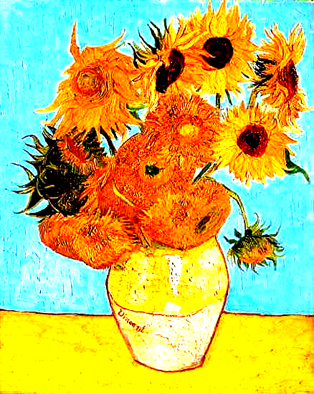
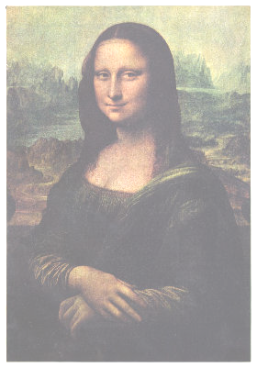

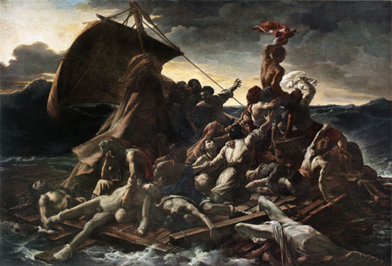
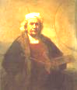

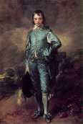
Titles: Years:
A. The Blue Boy K. 1506
B. Mona Lisa L. 1661
C. Raft of the Medusa M. 1770
D. Self-Portrait N. 1819
E. Sunflowers O. 1888

Artists:
F. Gainsborough
G. Gericault
H. Rembrandt
I. Van Gogh
J. Leonardo da Vinci
_____ Count It
_____ Don’t Count It
Name __________________
Biology

Light

? H⁺
Electron Transport Chemiosmosis

? ?

?
Carbon Fixation

?

By each question mark, put a letter (A-E) to show which chemical is used by or is created by the above reactions during photosynthesis:

A. Adenosine Triphosphate
B. Carbohydrates
C. Carbon Dioxide
D. Nicotinamide Adenine Dinucleotide Phosphate
E. Oxygen

_____ Count It

_____ Don’t Count It
Name _____________________
DESPERATION SHOT

Match each person with the year he died. Each year has been put into one of three categories to make the matching a little bit easier.

_____ Andrea Amati A. 1600 (Fine Arts)
_____ Hans Christian Andersen B. 1625 (Fine Arts)
_____ Johann Sebastian Bach C. 1650 (Politics/Nonfiction)
_____ Honore de Balzac D. 1675 (Fine Arts)
_____ Jan Brueghel the Elder E. 1700 (Politics/Nonfiction)
_____ Charles II of Spain F. 1725 (Politics/Nonfiction)
_____ William Cowper G. 1750 (Fine Arts)
_____ Rene Descartes H. 1775 (Politics/Nonfiction)
_____ Joseph Heller I. 1800 (Literature)
_____ Friedrich Nietzsche J. 1825 (Fine Arts)
_____ Peter The Great K. 1850 (Literature)
_____ Peyton Randolph L. 1875 (Literature)
_____ Antonio Salieri M. 1900 (Politics/Nonfiction)
_____ Haile Selassie N. 1925 (Politics/Nonfiction)
_____ George Bernard Shaw O. 1950 (Literature)
_____ Sun Yat-sen P. 1975 (Politics/Nonfiction)
_____ Jan Vermeer Q. 2000 (Literature)

TIEBREAKER: According to the National Center for Education Statistics, how many high schools were there in the United States at the beginning of the 2002 school year?

DESPERATION SHOT

ANSWERS: ALGKBEICQMFHJPOND 22,599

