VETO 2004 Tossups by Rico’s Roughnecks

- Some believe that it is actually 1,840 kilometres short of what it actually claims. It becomes Bridge Street and later Holland Street by the time it reaches past Newmarket, 56 kilometres from its southernmost starting point, and eventually becomes Highway 11 as it passes Barrie; ending in Rainy River. This may mean the undoing of – for 10 points – what famous Ontario street dubbed the “longest street in the world”? (Geography 1)

Answer: Yonge Street

- It is divided up into twelve sections with Section 12 stating the official document name and Section 1 defining the meaning of the word “Dominion”. Based on resolutions passed by Imperial Conferences held in the years 1926 to 1930, it allowed Parliament to pass legislation on the Canadian constitution until the passing of the Canada Act in 1982. For 10 points, name this December 1931 act of the British Parliament which gave birth to the British Commonwealth of Nations. (History 1)

Answer: The Statute of Westminster

- Swiss inventor George De Mestral, with the help of Alfred Gonet, devised an artificial prototype of this common household item after De Mestral took a walk with his dog and noticed the annoying cockleburrs that stuck on his pants and his dog’s coat. Taking a closer look at the burrs under a microscope, he noticed they had little hooks that caught in the loops of thread on his clothes. Derived from the French words for “velvet” and “hook” this is – for 10 points – what zipperless fastener made up of thousands of tiny hooks and loops? (Science, Math, Technology 1)

Answer: Velcro

- In 1722, he received his doctorate at age 18 for his thesis on the theory of sound. Two years later, he jointly chaired the mathematics department at the Academie de Clavin in Geneva along with Giovanni Calandrini; being called Castor & Pollux by their joking friends. His famous works include an unusually disjoint quartic curve known as the Devil’s curve and an unproven paradox of a theorem by Colin Maclaurin. For 10 points, name this Swiss mathematician most famous for his rule which states that the solutions for ax + cy = e & bx + dy = f are given by determinant solutions. (Science, Math, Technology 2)

Answer: Gabriel Cramer

- SportsFan magazine editor Greg Wyshynski dubbed this 1988 Canadian series the 6th worst sports show in TV history. Guest appearances by prominent athletes such as Ric Flair and Sting couldn’t help save the show’s cheesy plot of Robert Randall, a mild-mannered school teacher moonlighting as a professional wrestler known as The Masked Maniac while being a good single dad to his two young children, played by the late Lyle Alzado. For 10 points, name this sub-par sitcom whose title suggests that Alzado was being taught how to be an actor through experience. (Popular culture, games, sports 1)

Answer: Learning the Ropes

- Fred Beavis was the only “acting” one in 1978. George Gurnett, William H. Boulton, John George Bowes, Francis Henry Medcalf, Alexander Manning, Robert John Fleming and Samuel McBride held it on two separate occasions. The longest-serving one occurred from 1980 to 1991 with Art Eggleton holding the post. For 10 points, name this prominent position currently held by David Miller. (General Knowledge 1)

Answer: Mayor of Toronto (accept clear-knowledge equivalents)

- Throughout his 21-year career, he was a Pulitzer Prize nominee five times; and was a finalist in 2001 for his eyewitness account of a suicide bombing in Jerusalem by a man wearing a camera case. But Israeli police reports show that the bomber actually had a guitar with him, contradicting his take on the story. His most infamous fabrication was his 2000 photo of a Cuban hotel worker who, in his words, died fleeing Cuba by boat; it was later revealed that the woman is alive and well in the U.S. For 10 points, name this ex-USA Today reporter that was the subject of a major investigation in early 2004 alleging that he embellished many of his major stories. (Current Events 1)

Answer: Jack Kelley

- Born in Melville, Saskatchewan in April 1935, she started out working with her husband operating a mobile home park before embarking on a more significant career in 1969 where she was active in the Surrey Chamber of Commerce and the Newton Ratepayers’ Association. As a politician, her provincial cabinet appointments included Minister of Municipal Affairs, Minister of Transportation & Highways, and in 1990 Deputy Premier under Bill Vander Zalm. For 10 points, name this Social Credit who became British Columbia’s Acting Premier upon Vander Zalm’s resignation in 1991; becoming the first woman Premier of Canada. (History 2)

Answer: Rita Margaret Johnson

- His first writing job was contributing a joke for the comedy/variety series The Burns & Allen Show. His one and only contribution to the classic series The Twilight Zone was writer for the episode I Sing the Body Electric. While an established science-fiction author, his collection of stories titled Dandelion Wine brought forth the naming of a crater on the Earth’s moon called Dandelion Crater. For 10 points, name this writer who wrote his most famous work on a dime-an-hour university typewriter entitled Fahrenheit 451. (Literature 1)

Answer: Ray Douglas Bradbury

- Born in 1889, he was the youngest of 8 children in a highly-stimulating household which included intense self-criticism that drove 3 of his 4 brothers to suicide. A doctor of engineering at the University of Manchester, he is more famous for writing philosophical works such as Logik, which took on an ethical and religious tone, and his most famous work which gave insight to his so-called “picture theory”. For 10 points, name this Austrian philosopher famous for his work on the Picture Theory of Language entitled Tracatus Logico-Philosophicus. (Religion, Philosophy, Mythology 1)

Answer: Ludwig Joseph Johann Wittgenstein

- Written by lifelong bachelor Herman Hupfield, it first appeared in the 1931 Broadway show Everybody’s Welcome. It went on to become a staple on the classic radio show Hit Parade for 21 weeks after the release of the film in which it was featured and voted #2 on AFI’s Top 100 Movie Songs of all-time in 2004. The film’s music arranger Max Steiner, however, wanted the song excluded but producer Hal Wallis stated it was too late to re-shoot scenes with Ingrid Bergman and Humphrey Bogart at Rick’s Café American. For 10 points, name this classic piano ballad from the memorable movie Casablanca. (Popular culture, games, sports 2)

Answer: As Time Goes By

- He began writing poetry at age 3 to cope with the death of a brother. His famous collection of poems was rejected by dozens of New York publishers until Peter Barnes of VSP Publishers made 200 copies for his friends but huge publicity ballooned the figure to 500,000 copies and eventually made the New York Times’ best-seller list. However, his short life came to an abrupt end in June 2004 suffering from dysautonomic mitochondrial myopathy. For 10 points, name this young poet of Heartsongs and prominent voice for muscular dystrophy sufferers. (Current Events 2)

Answer: Mattie Stepanek

- Like James M. Barrie’s creation Peter Pan, this book’s central character Oskar Matzerath, disgusted with the behaviour of adults, does not want to grow up anymore; and would rather play the titular object he got as a present on his 3rd birthday. In his world of bizarre and distorted realities, Oskar finds the ability to destroy windows with his scream after seeing his mother in a torrid love-making session with Jan Bronski, a sound very different from the constant beating of the title object. For 10 points, name this title instrument and book by Gunter Grass. (Literature 2)

Answer: The Tin Drum

- Mount Liamuiga, at 3,792 feet, is this country’s highest point of elevation. The smallest country in the Western hemisphere covering 269 square kilometers, it is where you can find the fortress of Brimstone Hill, dubbed the Gibraltar of the West Indies, and the place where Horatio Nelson courted and wed Fanny Nisbet. With its capitals at Basseterre and Charlestown on the two islands, this is -- for 10 points -- what former colony of Great Britain? (Geography 2)

Answer: St. Kitts and Nevis (accept: St. Kitts before reading “269”; prompt afterwards)

- He studied music at the Petrograd Conservatory from 1919 to 1925; where he wrote his 1st symphony upon graduation. His next two symphonies, the October and First of May symphonies, gave a voice to revolutionary socialism of the time. By age 30, he had already written three full-length ballets and two operas: The Nose and The Lady Macbeth of the Mtsensk District. For 10 points, name this Russian composer most famous for his Symphony No. 7 in C major, opus 60, better known as the Leningrad Symphony. (Fine Arts 1)

Answer: Dmitri Shostakovich

- On August 23, 1973 four bank employees were held captive by two machine-gun carrying bank robbers for 131 hours. Despite five days of threats and abuse, the hostages exhibited, based on media interviews, sympathy and support for their captors and fear of law enforcement who rescued them. One female captive, in particular, became engaged to one of her captors and set up a legal defense fund to aid them in their criminal trial. This “bonding” between hostage & captive was termed -- for 10 points -- what psychological condition named for the Swedish city the robbery took place? (Social Sciences 1)

Answer: Stockholm Syndrome

- In this 1953 classic, the author’s states his view on religion by saying, “Science can destroy religion by ignoring it as well as by disproving its tenets. No one ever demonstrated the nonexistence of Zeus or Thor, but they have few followers now.” Set on future Earth, mankind is offered a golden age of peace and prosperity free of ignorance, disease, and poverty, but at the cost of freedom, by a race of aliens known as the Overlords. Inspired by Pink Floyd to record a song of the same name, this is -- for 10 points -- what juvenile-titled science fiction book by Arthur C. Clarke? (Literature 3)

Answer: Childhood’s End

- For the 60th anniversary of its creation, a reconstructed replica of the Mark II version of it was completed in May 2004 by a team led by Tony Sale. Built by the British Post Office Research Station using vacuum tubes, thyratrons and photomultipliers, it was designed by mathematician Max Newman and associates of Bletchley Park to optically read cyphertext from a paper tape. For 10 points, name this early programmable computer whose Mark II model was used by Bletchley Park to break German cyphers during World War II. (Science, Math, Technology 3)

Answer: Colossus

- A chess enthusiast, he allegedly named one of his sons after the rook he was moving across the chess board upon the news of his child’s birth. In June 1941, Soviet scientists under Mikhail Gerasimov exhumed his skeleton to find out that he was indeed lame as his name suggests. Despite being a devout Muslim, he had the drinking & gambling habits of a Mongol warrior. Born near Samarkand in modern Uzbekistan, for 10 points, name this brilliant but brutal 14th-century conqueror and ruler of Central Asia famous for building pyramids comprised of the skeletons of his slain enemies. (History 3)

Answer: Tamerlane (accept: Timur Lenk or Timur i Leng or Timur the Lame)

- It was taken off the air for four months after the broadcasting of its December, 1997 first-run episode entitled Electric Hero Porigon was cited as the cause of some 700 Japanese children and adults being hospitalized due to seizures triggered by a scene having rapidly flashing red and blue lights; and resulted in the episode never being shown in North America. This incident provided the backdrop ending for The Simpsons episode 30 Minutes Over Tokyo thanks to Pikachu. For 10 points, name this popular TV series where kids are told to “catch ‘em all”. (General Knowledge 2)

Answer: Pokemon

- Its Reston subtype is the only one that has caused disease in non-human primates, but not in humans. There has only been one known human case of the recent Tai subtype but effectively killed many chimpanzees. The other three subtypes, however, have caused human disease: Ivory Coast, Sudan, and Zaire. First recognized in 1976, it is only one of two members of a family of RNA viruses called the Filoviridae to describe its thread-like structure. For 10 points, name this severe, often-fatal disease named after a river in the Democratic Republic of the Congo in Africa where it was first identified. (Science, Math, Technology 4)

Answer: Ebola virus

- He won a 1999 Gemini as Best Host for a Performing Arts Program. Despite not being a film actor, producer, director or writer, he donated all personal files to the Toronto International Film Festival Group reference library. He said upon winning an ACTRA award in 1980, “I may in fact be the proudest Irish Yugoslav from Hamilton you will ever see up here”. Proudly known as an in-depth interviewer and friend of the stars, for 10 points, name this host of CityTV’s City Lights who lost his battle with cancer in June 2004. (Current Events 3)

Answer: Brian Linehan

- Featured in the July-August 1969 issue of Musicanada, his article About Canadian Music: the PR Failure served as a catalyst in the establishment of the Encyclopedia of Music in Canada in 1981, for which he served on the Board of Directors. A retired Professor of composition and history and former Dean of the Faculty of Music at the University of Toronto, he was appointed first Director of the Institute for Canadian Music at U of T in 1984. For 10 points, name this Canadian musicologist who incorporated historical material in his compositions Sharon Fragments and Canada Dash – Canada Dot. (Fine Arts 2)

Answer: John Beckwith

- He was enlisted for the Spanish-American War and sent to the Philippines where he wrote Manila Freedom and Soldier’s Letter. After leaving the Army, he published verses and short stories for the national magazines McClure’s and Harper’s Weekly. A newspaper reporter legend of his time, he was a companion to Jack Dempsey, Babe Ruth, Arnold Rothstein, Walter Winchell, and the infamous Al Capone, from whom he may have written his most famous set of tales. For 10 points, name this humourist who gained fame with his stories of gambling, racing and the criminal world in his best-known work-turned musical Guys and Dolls.

Answer: Damon Runyon (accept: Albert Damon Runyon)

VETO 2004 Bonuses by Rico’s Roughnecks

- (General Knowledge 1) For 10 points each, which element on the periodic table gets its name from the Latin word for:

- The Earth
Answer: Tellurium (Te; Latin: tellus)

- Sky Blue.
Answer: Cesium (Ce; Latin: caesius)

- Lime.
Answer: Calcium (Ca; Latin: calcis)

- (Current Events 1) June 28, 2004 witnessed one of the tightest election races in decades. Identify the following winning candidates of the 2004 Canadian Election for the stated number of points.

- The city of Toronto was a “sea of red” dominated by the Liberals with the exception of the Toronto-Danforth riding. For 5 points, name this lone Toronto NDP winner narrowly beating incumbent Liberal Dennis Mills.
Answer: Jack Layton

- For 10 points, the only independent seat went to this winner of the Surrey North riding in B.C. and former Conservative.
Answer Chuck Cadman

- For 15 points, the Charleswood-St. James riding near Winnipeg elected Canada’s first paraplegic MP in Canadian Federal Parliament history. Name him.
Answer: Steven John Fletcher

- (Fine Arts 1) This bonus involves the following audio clue. Listen and answer the following questions for ten points each. (Play CD Track #1)

- Name the 20th century Austrian composer of this piece entitled Der Mondfleck or The Moonfleck.

Answer: Arnold Schoenberg

- This piece comes from what larger 1913 Schoenberg work based on expressionist poems by Albert Giraud.

Answer: Pierrot Lunaire

- Schoenberg was one of the three men which made up the Second Viennese School of composition that focused on atonal or free-tonal music. Name one of the other two.

Answer: Alban Berg or Anton Webern

- (History 1) It's time for a Canadian railway trilogy. For 10 points each, identify these personalities associated with the construction of the Canadian Pacific Railway. All of them are members of the Canadian Railway Hall of Fame.

- Name the Scottish-born engineer who in 1858 proposed a coast to coast railway spanning British North America. Prior to the actual construction of the CPR he was responsible for surveying the route which the railway would follow. He is better known however for his promotion of the concept of Standard Time.

Answer: Sir Sanford Fleming

- Name the financier and former Hudson's Bay Company trader who was largely responsible for financing the completion of the CPR. Thanks to his efforts, he was given the honour of driving in the last spike at Craigellachie in November of 1885.

Answer: Donald Smith (accept: Lord Strathcona & Mount Royal)

- After a successful career working for various railroads in the United States, this American became General Manager of the Canadian Pacific Railway in December 1881. Under his effective management, he finished the railway ahead of the government's schedule, and made the CPR into a paying proposition throughout the 1880s and 1890s.

Answer: Sir Cornelius Van Horne

- (General Knowledge 2) 30-20-10: Identify the herb.

- A member of the parsley family, this herb is probably native to central Asia or southeastern Europe. The ancient Greeks used it as a cure for hiccups while the Romans credited it with fortifying powers, and fed it to their gladiators. With the fall of the Roman Empire, the plant was left in a semi-naturalized state throughout Western Europe.

- Both the seed heads and the feathery leaves are used as flavourings. The herb, whose Latin name is Anethum graveolens, is more aromatic than its close relative, fennel.

- The herb is used found in sauces, or in dishes like potato salad, but is probably most familiar to North Americans as a flavouring for pickled cucumbers.

Answer: dill

- (Pop Culture, Sports, Games 1) For 10 points each, answer the following questions about the hit TLC series Trading Spaces.

- Name its midriff-exposing host.

Answer: Paige Davis

- How much money is given to both couples to help budget their interior design creations?

Answer: $1,000 (USD)

- The show is based on what original BBC series? It’s the British equivalent to Trading Spaces.

Answer: Changing Rooms

- (Social Sciences 1) Answer these questions relating to the study of criminology for the stated number of points.

- For 5 points, Strain Theory, originally developed by Emile Durkheim and Robert Merton, believes that delinquent behaviour most likely occurs in which socio-economic class of people?

Answer: lower-class (accept clear-knowledge equivalents)

- For 10 points, 19th-century Italian criminologist Cesare Lombroso coined this term to describe the belief that criminals are biological throwbacks to more primitive ancestors who exhibit savage tendencies.

Answer: atavism

- For 15 points, name either of the two men who pioneered the ecological approach in determining urban crime using a theory known as Concentric Zone Theory where the highest level of crime is in a region called the Zone of Transition.

Answer: Robert Park or Ernest Burgess

- (Science, Math, Technology 1) Anyone who has played Dungeons & Dragons is familiar with the five Platonic solids. However, let's see how familiar you are with the 13 Archimedean solids. For 10 points each, given the description, name the Archimedean solid.

- Also called the cubus simus, this Archimedean solid consists of 32 triangles and 6 squares, with 60 edges and 24 vertices.

Answer: snub cube

- One of the simplest of the Archimedean solids, this one is also called the dymaxion or heptaparallelohedron. It consists of six squares and eight triangles.

Answer: cuboctahedron

- This Archimedean solid has 26 faces, consisting of 8 triangles, and 18 squares. Although this solid is sometimes also called the truncated icosidodecahedron, this name is inappropriate since true truncation would yield rectangular instead of square faces.

Answer: small rhombicuboctahedron

- (Literature 1) Given the 1st line of a Stephen King novel, name the novel for the stated number of points.

  - (5 points) “’'Daddy, I'm tired’ the little girl in the red pants and green blouse said fretfully.”

Answer: Firestarter

  - (10 points) “In a small town, the opening of a new store is a big thing.” (Hint: part of the title is in this opening line)

Answer: Needful Things

- (15 points) “Jessie could hear the back door banging lightly, randomly in the October breeze blowing around the house.”

Answer: Gerald’s Game

- (Current Events 1) Last Tuesday, Jeopardy! crowned its first million-dollar champion by the name of Ken Jennings amassing $1,004,960 over the course of his 30-day reign and is still playing! For 15 points each:

  - If he wins 14 more games, Ken will have shattered Thom McKee’s syndicated game show record for most wins at 43. On what game show, hosted by Wink Martindale, did Thom perform this amazing feat in 1980?

Answer: Tic Tac Dough

  - At this pace, if he wins another 35 games, he will become the all-time money winner in American game shows currently being held by fellow NAQTer Kevin Olmstead. Within $100,000 what record-setting amount did Kevin win on Who Wants to be a Millionaire? thanks to a progressive jackpot set in 2001?

Answer: $2,180,000 (accept: between $2,080,000 to $2,280,000)

- (History 2) 30-20-10. Name the World War II operation.

  - The capture of Biscari airfield resulted in an atrocity when American troops killed seventy-three Prisoners of War, supposedly inspired by Patton.
  - General Eisenhower's first task in preparing for this operation was the reduction of the nearby island of Pantelleria, a small, volcanic island of forty-two square miles in area. It had been effectively closed to foreigners since 1926 while the Italians improved its defenses.
  - It was the name given to the Allied invasion of Sicily on July 10, 1943 which started the Italian campaign.

Answer: Operation Husky

- (Geography 1) Given the current name of a country, give its former name for 10 points each.

  - Indonesia.

Answer: Dutch East Indies

  - Suriname.

Answer: Dutch Guiana

  - United Arab Emirates.

Answer: The Trucial States

- (Literature 2) Answer the following questions about Geoffrey Chaucer’s work The Canterbury Tales for 10 points each.

  - How many people are going on the pilgrimage to Canterbury?

Answer: 31 (there were 30 pilgrims plus the host who doesn’t tell any tales)

  - What prize did the pilgrim telling the best tale win, paid for by the rest of the group?

Answer: A free dinner

  - Which tale tells about three men who set off to kill Death, but end up being killed by Death?

Answer: The Pardoner’s Tale

- (Fine Arts 2) Study the following 20th-century modern works of art and identify the artist for 10 points each. If you need a clue, it’s worth 5 points. (See back attachment)

  - 10: Painting #1 is entitled Four Seasons: Spring, 1992.
5: This modern artist from California expanded the two-dimensional limitations of the canvas by including additional three dimensional objects to accompany her painting in such works as Yellow and Black Boats.

Answer: Jennifer Bartlett

  - 10: Painting #2 is an untitled work painted in 1981.
5: He was a friend of Andy Warhol's and attempted to unite the mediums of graffiti art and canvas painting. In 1988, he died at the tender age of 28.

Answer: Jean-Michel Basquiat

  - 10: Sculpture #3 is entitled Spiders and can be seen at New York’s Rockerfeller Center.
5: This French/American Abstract Expressionist sculptor expresses the theme of “pain” in her dreamlike room-sized installations which include various abstract objects created of varying materials.

Answer: Louise Bourgeois

15. (Social Sciences 2) Economics is exciting, and there's no part of economics that's more thrilling than foreign exchange rate regimes. Given the description, for 10 points identify each of the types of exchange rate regimes.

- In this regime, the central bank establishes and maintains a fixed ration between the domestic currency and another currency. Domestic notes can be issued, but the amount of notes issued depends on the exchange rate and the amount of foreign reserves. This regime was used by Hong Kong before unification with China and by Estonia before admission to the European Union.

Answer: currency board

- In this regime, a parity value is established with another currency and the central bank conducts monetary policy to maintain parity. However, the parity value is changed at intervals in order to compensate for differences in economic performance. Examples of countries using this regime include Costa Rica and Nicaragua.

Answer: crawling peg

- Under this regime, the currency value is determined in the interbank market. However, the monetary authority may intervene periodically to maintain stability without any pre-announced path for the currency value. Examples of countries following this regime include India and Slovakia.

Answer: managed float or dirty float

- (Pop culture, Sports, Games 2) A few questions about the game of duplicate contract bridge for 10 points each. If there's a bridge player on your team, you should have no problems with this one.

- In duplicate bridge, what score would you receive for making a contract of 6 spades, undoubled and vulnerable? You have 10 seconds.

Answer: 1430

- What event, named after the island nation where it was originally held, is often considered to be the world championship of duplicate bridge?

Answer: The Bermuda Bowl

- What bidding system, popularized by C. C. Wei, uses an opening bid of 1 club to indicate most strong hands?

Answer: Precision Club (prompt on: Strong club)

- (Geography 2) For 5 points each and a 5-point bonus for all correct, name the 5 states or regions which made up the former federation of French Indo-China which lasted from 1893 to 1945.

Answer: Annam, Cambodia, Cochin China, Laos, Tonkin

- (Literature 3) Given a line of poetry and a clue about the poet, name the Romantic poet for 10 points each.

- "I am by birth a Genovese; and my family is one of the most distinguished of that republic. My ancestors had been for many years counselors and syndics; and my father had filled several public situations with honour and reputation." She grew up learning from her father's peers, including Hazlitt, Lamb and Coleridge. She began writing her greatest novel at the age of 18.

Answer: Mary Shelley

- "O my Luve's like a red, red rose, / That's newly sprung in June: / O my Luve's like the melodie, / That's sweetly play'd in tune." He was born the son of a poor tenant farmer and was the father of several illegitimate children.

Answer: Robert Burns

- "And said I that my limbs were old, / And said I that my blood was cold, / And that my kindly fire was fled, / And my poor withered heart was dead, / And that I might not sing of love?" His job resume included a lawyer's apprentice, a sheriff's deputy, and a Clerk of the Court.

Answer: Sir Walter Scott

- (Religion, Philosophy, Mythology 1) Some general questions about World Religion for the stated number of points.

- For 5 points, Nanak is the founder of this religion which comes from the Hindi word meaning “disciples”.

Answer: Sikhism

- For 10 points, name any 2 of the 3 gods of Taoism collectively known as the Three Star Gods.

Answer: any 2 of: Shou Hsing, Lu Hsing, Fu Hsing

- For 15 points, name any 3 of the 5 pillars of Islam.

Answer: any 3 of: Shahada, Salat, Hajj, Zakat, Sawn

- (Science, Math, Technology 2) How well do you know your stars? Answer the following questions about stellar magnitudes for 10 points each.

- Which of the following stars is the brightest in terms of apparent or visible magnitude: Alpha Centauri, Arcturus, Canopus, or Vega?

Answer: Canopus

- Which of the following stars is the brightest in terms of absolute magnitude? Arcturus, Canopus, Sirius, or Vega?

Answer: Canopus

- Absolute magnitude is a measure of the inherent brightness of a celestial object. The absolute magnitude of a star is defined as the apparent magnitude the star would have at a fixed distance. What is that distance?

Answer: 32.6 light years (accept: 10 parsecs)

- (General Knowledge 3) We all know our ABCs, but other writing systems also have a specific order to their alphabets. For 5 points per answer:

- What are the first three letters of the Hebrew alphabet?

Answer: aleph, beth, gimel

- What are the first three letters of the Arabic alphabet?

Answer: alif, ba, ta

22. (Fine Arts 3) For 10 points each, identify the following works by 20th-century German composer Carl Orff.

A. Inspired by a Brothers Grimm fairytale, what is the title of this 1943 opera about a clever farm girl who outwits a king?

Answer: Die Kluge (accept: The Wise Woman)

B. Also inspired by a Brothers Grimm story, this 1938 opera is about four villagers who steal the moon from a neighbouring village. When they die and are each buried with their piece of the moon, the moonlight wakes up the dead (who enjoy bowling), and St. Peter has to return it to the sky in order to restore peace and quiet. What is the title of this opera?

Answer: Der Mond (accept: The Moon)

C. Inspired by 13th century manuscripts from a Benedictine monastery, this cycle of often-bawdy songs extolling the existence of mankind was first performed in 1939. In 1983, a version of the score was recorded by Philip Glass and former Doors keyboardist Ray Manzarek.

Answer: Carmina Burana
Bonus Question #14 Art
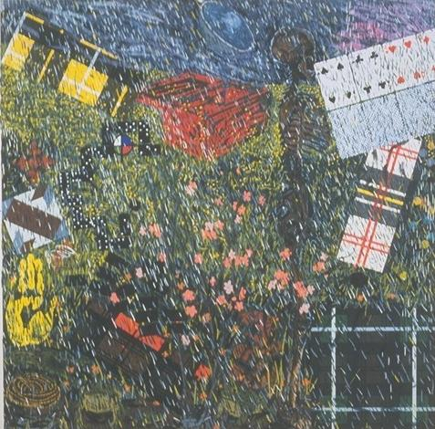 Painting #1

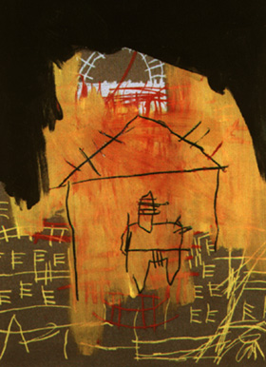 Painting #2

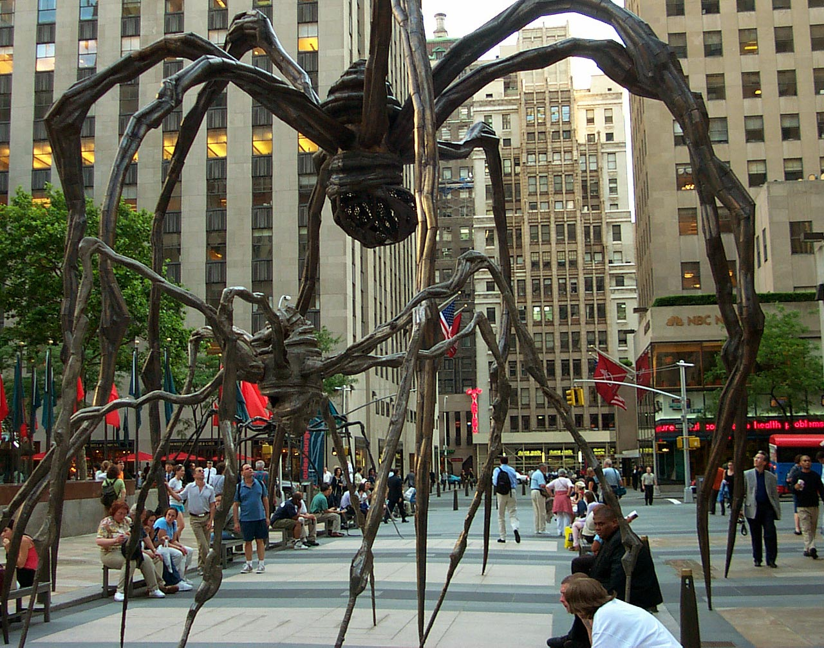 Sculpture #3

