VETO 2010

SFU “Bridge” Question Packet

Authors: Brittany, Geoff, Ross

Tossups

1. This man was once voted the laziest member of parliament in a survey conducted by the Hill Times. Prior to this, and after completing his post-secondary education at the University of Ottawa, he returned to Edmonton and operated a successful coffee shop. He ran for and won the parliamentary seat representing Edmonton-Strathcona in 1997, and held that riding until he was ignominiously defeated by Linda Duncan of the New Democratic Party in the 2008 federal election. For ten points, who is this former chair of the Conservative caucus who was arrested for drunk driving and cocaine possession on September 11, 2009?  
   **Answer: Rahim Jaffer**
2. In the opening act, the chorus begins by singing The Three Main Rules of Discipline and Eight Points of Attention. In the second act, Pat sings an aria of her hopes for the future, of modesty and good neighbourliness, based on the values of the American heartland. For 10 points, name this opera composed in 1987 by John Adams focusing on the visit of an American president to a communist country.  
   **Answer: Nixon In China**
3. The causes of this event are still a matter of some debate to this day, but the general themes leading to it included the infringement of religious and social privileges, hysteria over Christian missionary activity, and the prospect of military service overseas. The proximate cause related to the ammunition of the P53 Enfield muzzle-loading rifle. Rumours spread quickly that the greases used on the cartridges of the rifle were ritually unclean, which quickly resulted in objections by both Muslims and Hindus alike. For ten points, what is this event that lead to end of both the Mughal Empire and the British East India Company?  
   **Answer: The Sepoy Rebellion** (Also accept the Sepoy Mutiny, the Indian Mutiny and the Indian Rebellion of 1857)
4. This body part plays a critical role in erythropoietic functions until the fifth month of gestation.  Malpighian corpuscles make up the white pulp which plays a role in active immune response. Unique within the gut, it is derived from mesenchymal tissue. The red pulp mechanically filters old red blood cells and stores a reserve of monocytes.  Trauma and jabbing injuries can lead it to rupture, forcing emergency removal. For ten points, name this purple organ located in the upper left abdomen.   
   **Answer: Spleen**
5. Taking its title from General James Wolfe's statement about his Highland soldiers prior to the Battle of the Plains of Abraham, this novel begins as Alexander MacDonald visits his alcoholic brother Calum in Toronto. Jumping back and forth through time from the present back to 1779 when Alexander's ancestors first moved to Cape Breton, this novel has been selected as the greatest Atlantic Canadian book of all time. For ten points, identify this 1999 novel by Alistair MacLeod.

**Answer: No Great Mischief**

1. Key towns located here include Skidegate and Old Masset. Originally named in honour of the consort of King George III, on December 11, 2009, Premier Gordon Campbell announced that legislation will be introduced in mid-2010 to officially rename the islands. The legislation received royal assent on June 3, 2010, formalizing the name change. For 10 points, name this large island archipelago in northern British Columbia.  
   **Answer: Haida Gwaii** (prompt on Queen Charlottes before “Originally named”)
2. Originally developed to prove that there is no formula for the fifth degree roots of a polynomial, its central idea is to study the permutations of the roots of a polynomial having the property that any algebraic equation satisfied by the roots is also satisfied by the permutation of the roots. In modern mathematics, it is generally approached by studying the automorphisms of field extensions and can be used to prove many problems about compass and straightedge construction. For ten points, name this branch of mathematics first developed by its namesake Frenchman who died in a duel at age 20.

**Answer: Galois Theory**

1. The theme song for this television show first appeared as track six on Great Big Sea’s album “Fortune’s Favour”, and although its first season consisted of only 12 episodes, it has been renewed for a second. Characters on this show include Des, a fashion challenged graffiti artist, Leslie, a constable with the Newfoundland police department, and Walter, Jake’s best friend and divorce attorney. Starring Sean McGinley and Allan Hawco, it is the only St. John’s based crime procedural currently airing. For ten points, name this CBC television series that follows crime investigators Malachy and Jake Doyle.

**Answer: Republic of Doyle**

1. In the various editions of the Dungeons & Dragons game, this being is the Prince of the Lower Aerial Kingdoms, and rules the 503rd layer of the Abyss known as Torremor. This is rather peculiar since this being spends most of its time on the uppermost layer, which seems to be named after it. In the Assyro-Babylonian mythology, this being was the king of the demons of the wind and the son of the god Hanbi. It is depicted as having the body of a man, the head of a lion or dog, eagle-taloned feet, wings, and a scorpion’s tail. For ten points, who is this demon that was made famous in the “The Exorcist” as the being possessing Regan MacNeil?  
   **Answer: Pazuzu**
2. This grandson of a cobbler started his career working for a socialist newspaper in New York City. He returned to his home in 1925 and founded a newspaper of his own the following year. He soon entered politics, and was campaign manager for Sir Richard Squires. Later in life he famously lost his cool after his policy of free university tuition for the province’s students was denounced in 1965 by a young Rex Murphy as a sham. For 10 points, who was this self-styled last Father of Confederation, and first Premier of the Province of Newfoundland and Labrador?  
   **Answer: Joseph “Joey” Roberts Smallwood**
3. George Lucas directed a visual adaptation of it in 1967. The wordplay is typical of the author's works, with the use of anyone and noone as proper nouns. The set form helps illustrate the poem's theme of life's routine nature. The second verse begins: "Women and men(both little and small) \ cared for anyone not at all \ they sowed their isn't they reaped their same \ sun moon stars rain". For 10 points, name this poem written by E. E. Cummings that details the lives of those in a nameless town with up so floating many bells down.  
   **Answer: anyone lived in a pretty how town**
4. Some believers maintain that girls who do not follow this practice are *manmat* and and that it is prohibited in the Rehat Maryada.Guru Gobind Singh, made it mandatory for Sikh females to use it when he administered Amrit to them. They were originally intended to replace the original surname, which was often a caste name. Meaning ‘princess’ in Punjabi, for ten points, name the female equivalent of the name Singh.  
   **Answer: Kaur**
5. Sometimes known as Sai Zhenzhu, she was born in 1892 in Hillsboro, West Virginia, but moved to China as a missionary in 1914. Her works include ``Satan Never Sleeps'', ``Peony'', and ``China Sky'', and she was the first American woman to win a Nobel prize for literature. For ten points, name this American woman who won the 1932 Pulitzer Prize for her novel ``The Good Earth''.

**Answer: Pearl S. Buck**

1. According to Paul Anka, this song was recorded in 1983 and was intended to be a duet on his *Walk A Fine Line* album under the title "I Never Heard". Sa-Fire later recorded the song for her 1991 album, *I Wasn't Born Yesterday.* The album of the same name was released by Epic Records on October 26, 2009 featuring six previously unreleased recordings. The album was originally meant to complement an eponymous London concert series. For ten points, name this 2009 Michael Jackson single.  
   **Answer: This Is It**
2. Despite the name of this phonetic phenomenon, it is not as geographically restricted as its name may suggest. In fact, it is common in New England, parts of the upper Midwest and the Fens region of England. It is evident when many English speakers that naturally employ this phenomenon are perceived as saying “aboot” rather than “about”. For ten points, what is this phonetic phenomenon common to people living north of the 49th parallel in which diphthongs are “raised” before voiceless consonants?  
   **Answer: Canadian Raising**
3. Of this man’s writings, only one survives in its entirety: *De Agri Cultura*. At a high point in his political career, he opposed the repeal of a law that restricted the availability of luxuries for women, namely the Oppian law. That law was repealed despite his objections. Throughout his life and career he espoused the qualities of thrift, austerity and public virtue, much to the annoyance of his political opponents, which included Scipio Africanus. Elected to the censorship with his long time friend, Lucius Valerius Flaccus in 184 BCE, for ten points, who was this Roman statesman whose motto was “*Carthago delenda est*”, or “Carthage must be destroyed”?   
   **Answer: Marcus Porcius Cato Censorius or Cato Major** (accept variations such as Cato the Elder and Cato the Censor)
4. Two notable producers of synthetic imitations are the companies Kyocera and Inamori of Japan. It is a mineraloid gel containing as much as twenty percent water which is deposited at relatively low temperatures within rock fissures. It can be clear, white, pink, green, brown to black. Reds against black are the most rare, whereas white and greens are the most common. It is also the October birthstone. For ten points name Australia's national gemstone.  
   **Answer: Opal**
5. This 1931 painting was revisited in a variation prefixed by *The Disintegration* in 1954, showing the earlier famous work systematically fragmenting into smaller elements, and a series of rectangular blocks which reveal further imagery underneath. In this painting, a smaller orange clock in the lower left corner is covered with ants. For ten points, name this work of Salvador Dali featuring melting clocks.  
   **Answer: The Persistence of Memory** (Spanish: *La persistencia de la memoria*; Catalan: *La persistència de la memòria*).
6. The originator of this concept doubted its practical consequences. Over 150 years after the concept was initially developed, this concept received new attention from adherents of the New Classical Economics School. The concept was first described in the 1820 paper, *Essay on the Funding System*. It holds that taxpayers make no distinction between whether current government spending is financed by current taxation or by bonds that will be repaid with future taxation; taxpayers adjust their saving and expenditure behavior accordingly. For ten points, what is this controversial economic concept developed by the same classical economist that worked on the Theory of Comparative Advantage?  
   **Answer: Ricardian Equivalence** (Also accept Barro-Ricardo Equivalence)
7. This man has an impeccably international lineage. His paternal grandmother was a baroness in Imperial Russia. His mother is of Dutch background, and she was interned by the Imperial Japanese Army in present-day Jakarta. Thanks in part to his background, this man speaks five languages: English, Dutch, French, German and Spanish. This fact may have been helpful when he was a member of the European Parliament for the East Midlands from 1999 to 2004. For ten points, who is this man who leads the Liberal Democratic Party of the United Kingdom and who currently holds the post of Deputy Prime Minister?  
   **Answer: Nicholas William Peter “Nick” Clegg**
8. According to this theorem, the Hawking radiation of a black hole is independent of the material that originally entered the black hole, thus leading to the black hole information paradox. Although some theories add magnetic charge as a fourth characteristic, this theorem postulates that black holes can be completely characterized by three externally observable parameters: electric charge, angular momentum, and mass. For ten points, name this theorem, which postulates that all matter that falls into a black hole is permanently inaccessible to external observers.

**Answer: No-Hair Theorem**

1. This woman’s earliest honour was winning the Miss Tiny Tot of Dallas Pageant at the age of six months. Her film career started when she was living in Italy with her family, during which time she landed a role as an extra on the films *Hemingway’s Adventures of a Young Man*, and *Barabbas*. Her first major role was as Odile de Caray in the 1966 film *Eye of the Devil*. Sadly, her fame comes more from her death than from her filmography. For ten points, who was this woman who was Roman Polanski’s second wife, and a victim of Charles Manson family?  
   **Answer: Sharon Tate**
2. In Alan Moore's ''The League of Extraordinary Gentlemen'' the protagonist of this 1678 novel is enlisted as one of Prospero's men. Prior to the publication of Alan Moore's graphic novels, the protagonist of this novel was best known for his travels in which he encountered characters such as Apollyon, Faithful, and Mr. Worldly Wiseman. Beginning in the City of Destuction and following Christian's travels to the Celstial City, for ten points identify this John Bunyan novel.

**Answer: The Pilgrim's Progress**

1. Examples of this geographical feature include the Tonga, the Kuril, and the Kermadec. Found at the boundaries of converging tectonic plates where one subducting slab begins to descend beneath another oceanic lithospheric slab. Explored by Piccard and Walsh, the Challenger Deep is the deepest point of one of these oceanic features. Named shortly after the close of World War 1, for ten points, name this type of oceanic feature, the most famous of which is the Marianas.

**Answer: (Oceanic)** **Trench**

**Bonus Questions:**

1. **Moderator: Hand out the page labelled “Bonus 1 Images”**

For ten points each, identify the glacial landform. You have 15 seconds.

1. **Answer: Esker**
2. **Answer: Drumlin**
3. **Answer: Lateral Moraine (prompt on Moraine)**
4. For ten points each, identify the work by Naomi Klein.

a) Her first book, it is divided into four sections including "No Space", "No Choice", and "No Jobs"

**Answer: No Logo**

b) Subtitled "The rise of disaster capitalism", this book argues that governments have orchestrated crises in order to push through unpopular reforms

**Answer: The Shock Doctrine**

c) Her second book, it is a collection of newspaper articles written in the aftermath of No Logo's publication

**Answer: Fences and Windows**

1. **Moderator: Hand out the page labelled “Bonus 3 Images, parts A and B” and read the following:**

For five points each and 5 for getting all correct, answer the following questions:

a) Within ten cents, what is the total amount of sales tax payable on the identified item in Ontario as of July 1, 2010?  
**Answer: $27.17** (Accept any answer in the range $27.07-27.27)  
  
b) Within ten cents, what is the total amount of sales tax payable on this item in Nova Scotia as of July 1, 2010?  
**Answer: $31.35** (Accept any answer in the range $31.25-31.45)  
  
**Moderator: Hand out the page labelled “Bonus 3 Images, part C” and read the following:**  
c) Within one cent, what is the total amount of sales tax payable on a purchase four of the depicted items in British Columbia as of July 1, 2010?  
**Answer: Nothing** (this item is not subject to sales taxes in BC)  
  
**Moderator: Hand out the page labelled “Bonus 3 Images, parts D and E” and read the following:**  
  
d) What is the total amount of sales tax payable on a purchase of two of the depicted items in British Columbia between January 1 and June 30, 2010?  
**Answer: $0.25** (Accept any answer in the range $0.24-0.26)

e) What is the total amount of sales tax payable on a purchase of two of the depicted items in British Columbia as of July 1, 2010?  
**Answer: $0.60** (accept any answer in the range $0.59-0.61)

4)Arguably one of the most recognizable statues in modern sculpture, for 5-10-15 points, identify details about The Thinker.  
a) For five points, identify the sculptor of this work.  
**Answer: Auguste** **Rodin**   
  
b) For ten points, name the monumental portal this piece was part of, which was commissioned by the Musée des Arts Décoratifs to act as a door to the museum.  
**Answer: Gates of Hell**  
  
c) For fifteen points, name the literary work the Gates of Hell are based upon.  
**Answer: The Divine Comedy**

**5)** For ten points each, name the post-transition metal element from clues.  
a) Named from the Greek for "a green shoot or twig") from the bright green spectral emission lines. Stable isotopes exist with masses of 203 and 205.  
**Answer: Thallium**  
  
b) Perhaps named for a corruption of the German for white mass. Its isotope with mass 209 is technically radioactive, but has a half-life longer than the estimated age of the universe.  
**Answer: Bismuth**  
  
c) Initially used unintentionally in alloys 5000 years ago, it is a commercially important element with 321000 tons produced in 2006, with half being used in electronics. The metal itself plays no known biological role in humans.  
**Answer: Tin**

6) For ten points each, answer the following related questions about twentieth century novels.

a) Published in 1961, this novel Joseph Heller novel follows a number of characters based on the island of Pianosa.

**Answer: Catch-22**

b) Published in 1923, this uncompleted satirical novel follows its titular character as he travels about World War One era Austria-Hungary.

**Answer: The Good Soldier Svejk**

c) For ten points, name the author of The Good Soldier Svejk.

**Answer: Jaroslav Hasek**

7) For the stated number of points, state whether the named financial instruments are traditionally exchange-traded, trade in the over-the-counter (OTC) market, both or neither.

a) For five points: Futures contracts.

**Answer: Exchange-traded**

1. For five points: Shares or stock of private corporations.

**Answer: Neither**

1. For ten points: Bankers’ acceptances.

**Answer: Over-the-counter (OTC)**

1. For ten points: Swaptions.

**Answer: Over-the-counter (OTC)**

8) Identify the ancient Greek politicians from clues for ten points each.

1. This man was a leader of the Athenians at the Battle of Marathon in 490 BC and went on to lead an expedition to punish the Greek islands that had supported the Persians. The failure of this expedition caused his political downfall.

**Answer: Miltiades the Younger**

1. This man ranted against the actions of Philip II of Macedon in his famous Philippics. In the end, he outlived both Philip II and Alexander.

**Answer: Demosthenes**

1. This turncoat was a prominent politician and general of Athens, before defecting to Sparta after the failed Sicilian Expedition during the Peloponnesian Wars. Later he consorted with the Persians to curry their favour. After his return to Athens, disastrously, he deferred command of the Athenian fleet to his helmsman at the Battle of Notium, which was soundly defeated by the Spartans.

**Answer: Alcibiades**

9) **Moderator: Hand out the page labelled** “**Bonus 9 Images**”

For ten points each, name the mathematical entity. You have 15 seconds.

**a) Answer: Euler's identity (also accept: Euler's equation)**

**b) Answer: Euler-Mascheroni constant**

**c) Answer: Euler’s totient function**

10) For ten points each, identify the departments of the Public Service of Canada from the subsidiary agencies.  
  
a) Canadian Space Agency, Canada Tourism Commission, The Competition Bureau, and Measurement Canada  
**Answer: Industry** **Canada**  
  
b) Canada Border Services Agency, Canadian Security Intelligence Service, Correctional Service of Canada, and National Parole Board  
**Answer: Public Safety Canada**  
  
c) Service Canada, Canada Student Loans Program, Employment Insurance Program, Canada Pension Plan, and Canada Mortgage and Housing Corporation  
**Answer: Human Resources and Social Development Canada**

11) Depending on your tastes, you may find Gaudi gaudy, but knowing his works will get you 10 points each here.

a) His masterwork, his massive Roman Catholic church that has been under construction in Barcelona since 1882 and is not expected to be complete until at least 2026.  
**Answer: Temple Expiatori de la Sagrada Família**  
  
b) Locally nicknamed 'The Quarry', this building built during the years 1905–1910, being considered officially completed in 1912. It is located at 92, Passeig de Gràcia in the Eixample district of Barcelona.  
**Answer: Casa Milà** (also accept La Pedrera)  
  
c) A garden complex with architectural elements situated on the hill of el Carmel in the Gràcia district of Barcelona, built in the years 1900 to 1914.  
**Answer: Park Güell** (Parc Güell)

12) For ten points each, answer these questions about the Yukon.  
  
a) Within 15%, provide the estimated population of the Yukon as of 2009.  
**Answer: 33,442** (accept between 28,425 and 38,458)  
  
For ten points, name the national park containing Canada's highest point Mount Logan and a large part of the Yukon's southwest which is also a UNESCO World Heritage Site.  
**Answer: Kluane** **National Park and Reserve**  
  
For ten points, all or nothing, name three of the ten largest towns in the Yukon.  
**Accept any three of: Whitehorse, Dawson, Watson Lake, Haines Junction, Carmacks, Ibex Valley, Mount Lorne, Ross River, Pelly Crossing, Mayo**

13) For ten points each, identify the novel or novella by Franz Kafka

a) This novel follows a land surveyor, known only as 'K', as he attempts to contact an official named Klamm

**Answer: The Castle**

b) This novel follows Karl Rossmann as he arrives in New York and travels across America to Oklahoma

**Answer: Amerika (also accept The Man Who Disappeared)**

c) In this novella, Gregor Samsa awakens one morning to find himself transformed into a hideous insect

**Answer: The Metamorphosis**

14) For ten points each, identify these terms from traditional Celtic religion and mythology.

a) This term refers to the festival traditionally held to commemorate the end of summer and the harvest. It was celebrated on the same days on which Hallowe’en and All Saints Day are now celebrated.

**Answer: Samhain**

1. This deity was the god of agriculture, forests and alcoholic drinks.

**Answer: Sucellus**

1. These figures were burned in effigy, allegedly for the purposes of human sacrifice, if Gaius Julius Caesar is to be believed. They remain important in neopagan ceremonies and festivities.

**Answer: Wicker man or wicker men**

15) For ten points each, name the biochemical cycle.  
a) The metabolic pathway in which lactate produced by anaerobic glycolysis in the muscles moves to the liver and is converted to glucose, which then returns to the muscles and is converted back to lactate.  
**Answer: Cori cycle**  
  
A series of biochemical reactions that take place in the stroma of chloroplasts in photosynthetic organisms. The first step involves a reaction catalyzed by RuBisCO.  
**Answer: Calvin-Benson cycle** or **Reductive Pentose Phosphate cycle**  
  
Citrate synthase, aconitase, isocitrate dehydrogenase, alpha-ketoglutarate dehydrogenase, succinyl-CoA synthetase, succinate dehydrogenase, fumarase, and malate dehydrogenase are the catalytic enzymes of this cycle.  
**Answer: citric acid cycle or tricarboxylic acid (TCA) cycle or Szent-Györgyi-Krebs cycle**

16)For ten points each, answer the following questions about a famous Canadian band.  
a) Name the band that consists of the trio of Geddy Lee,Alex Lifeson, andNeil Peart.  
**Answer: Rush**  
  
b) Name the upcoming nineteenth studio album for Rush, featuring the June 2010 single Caravan.  
**Answer: Clockwork Angels**  
  
c) Their eighth studio album released in 1981, it is Rush’s best selling album containing the songs Tom Sawyer, Limelight, and Red Barchetta.  
**Answer: Moving Pictures**

17) For ten points each, identify these politicians that ceased to hold high office this year so far.

a) This man resigned as Prime Minister of Japan after the furore over breaking his promise to move the Futenma Marine Corps Airbase in Okinawa.

**Answer: Yukio Hatoyama**

1. Thanks to the proposed tax on the profits of resource companies, and the stalling of the proposed emissions trading scheme in the Senate, this man was unceremoniously dumped from the position of Prime Minister of Australia by a leadership ballot in the Australian Labour Party caucus.

**Answer: Kevin Rudd**

1. This man ceased to be President of Poland when the Tupolev Tu-154 taking him and his party to a memorial for the Katyn Massacre crashed near Smolensk.

**Answer: Lech Kaczynski** (prompt on incomplete answer)

18) For ten points each, identify the terms relating to social psychology.

a) This term describes the uncomfortable feeling resulting from holding two contradictory ideas or beliefs. The individual is then motivated to either change their beliefs, or rationalize them.

**Answer: Cognitive dissonance**

1. In an effort to minimize or eliminate feelings of cognitive dissonance, people may exhibit this pathological ego defence mechanism, postulated by Freud, in which facts that are too uncomfortable to accept are simply rejected as untrue, despite possibly overwhelming evidence. This defence mechanism is exhibited frequently by conspiracy theorists, and “birthers” in the United States.

**Answer: Denial**

1. In the novel *Nineteen Eighty-Four*, this term is used to describe the holding of two contradictory beliefs simultaneously. It may be considered to be the opposite of cognitive dissonance.

**Answer: Doublethink**

19) For ten points each, identify the following questions about astronomy:

a) First observed by John Bevis in 1731, this nebula is the strongest persistence source of X-rays and gamma rays in the sky.

**Answer: Crab Nebula**

b) At the centre of the Crab Nebula lies one of these radiation sources, currently spinning 30.2 times per second.

**Answer: Pulsar**

c) Also known as M1, the Crab Nebula was the first object to be catalogued for this set of astronomical objects published in 1771.

**Answer: Messier objects**

20) Identify these people connected with the 1837 rebellion in Upper Canada for the stated number of points.

a) For five points, this Scotsman was the first mayor of the City of Toronto, and a prominent leader of the reformists.

**Answer: William Lyon Mackenzie**

1. For ten points, this man was the lieutenant governor of Upper Canada during the rebellion. Upon returning to England in 1838, he was made a baronet. Parts of his name now adorn two hamlets in Southern Ontario, two streets in Oakville, and two in St. Catharines, Ontario.

**Answer: Sir Francis Bond Head**

1. For fifteen points, this Dutchman was allegedly a veteran of the Napoleonic Wars. During the rebellion, he led the rebels at the Battle of Montgomery’s tavern. Perhaps his military experience was exaggerated. After the rebels’ defeat, he was imprisoned and died soon after.

**Answer: Anthony van Egmond**

21) For 5-5-10-10 points each, name the teams playing in these recent World Cup games from the description:  
a) In the final game, a goal was finally scored after 116 minutes by Iniesta.  
**Answer: Netherlands** v. **Spain**  
  
b) In the third place playoff, the final score was 2-3.  
**Answer: Uruguay** v. **Germany**  
  
c) In this game, there was controversy over refereeing after a disallowed goal by Frank Lampard where the ball was seen to cross the goal line when shown on television broadcast replays.  
**Answer: England** v. **Germany**  
  
d) Hopes of an African team reaching the final were dashed in this quarter-final game that ended in a penalty shoot-out. A controversial intentional handball denied a sure goal by Dominic Adiyiah.  
**Answer: Ghana** v. **Uruguay**

22) 30-20-10 Identify the period of Japanese history from clues.  
For 30 points: This period saw a blossoming of Chinese influence on Japanese society. The *Man’yōshū* or “Collection of Ten Thousand Leaves” was compiled during this peiod.

For 20 points: This period of Japanese history was contemporary with part of the Tang Dynasty in China. Buddhism was encouraged and spread widely. It was immediately preceded by the Asuka period.

For 10 points: This period shares its name with a prefecture and its prefectural capital, which is also home to the world’s largest statue of the Buddha Vairocana in the Tōdai-ji complex.

**Answer: The Nara Period**

**Bonus 1 Images**

1. 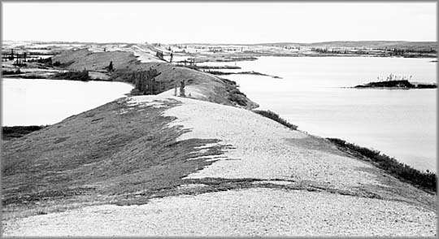
2. 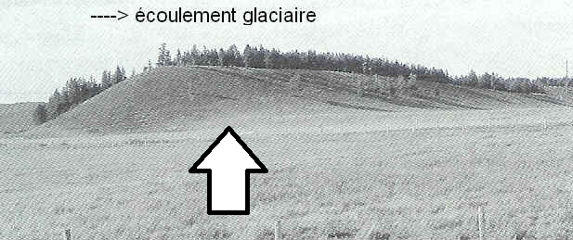
3. 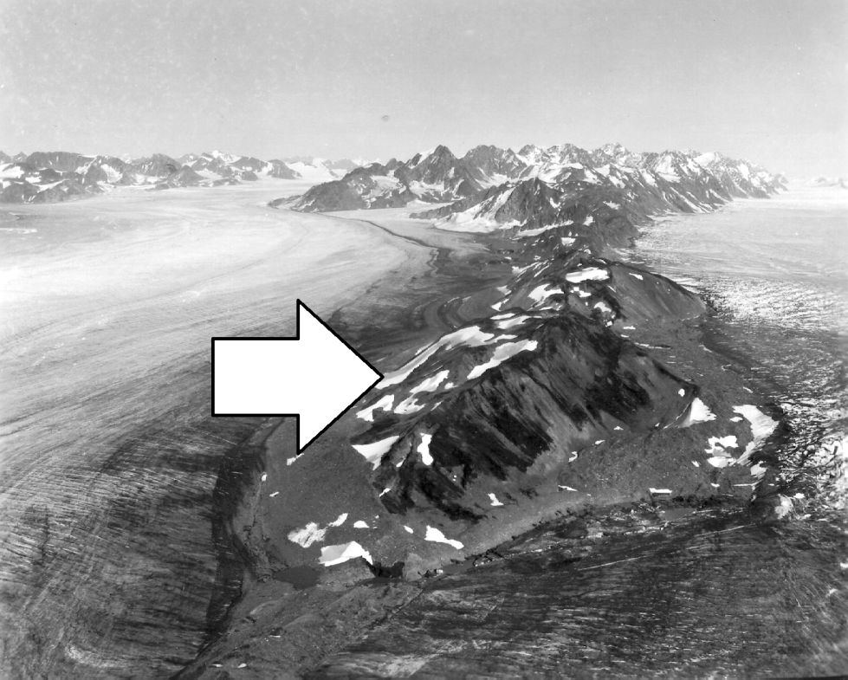

**Bonus 3 Images, Parts A and B**



**Bonus 3 Images, Part C**



**Bonus 3 Images, Parts D and E**



**Bonus 9 Images**

1. e^{i \pi} = - 1\,\!

b)



c)

