**VETO 2010**  
**Packet by UTS (Josh Alman, Michael Olijnyk, Bosco Leung)**

**Tossups**

1. Shortly after finishing school, this person became a representative to Dac’s ruling council. His ship, originally designed by Industrial Light and Magic, is the cylindrical model of a cruiser only built on his home planet, and is called *Home One.* This man was captured and forced to serve temporarily under Governor Tarkin after all of Dac, also known as Mon Calamari, was invaded. FTP, name this red faced admiral from the Star Wars universe, who, according to a Sporcle quiz, only knows that “it’s a trap!”

ANSWER: Admiral ***Ackbar***

2. Hölder's theorem states that this function does not satisfy any algebraic differential equation. If the real part of its argument is positive, then the integral this function is defined as converges absolutely, and by evaluating it using integration by parts, one finds that for any complex number z, this function evaluated at quantity z plus 1 equals z times this function evaluated at z. FTP, identify this function, defined on z as the integral from 0 to infinity of t to the quantity z minus 1, times e to the negative t, dt, an extension of the factorial function.

ANSWER: the ***Gamma*** function (accept the ***Euler integral of the second kind***)

3. The decomposition of sulfuryl chloride into sulfur dioxide and chlorine gas has this order, as does the exothermic decomposition of hydrogen peroxide into water and oxygen gas. A reaction of this order has a half life that is independent of the starting concentration, and a rate constant measured in units of inverse seconds. A plot of the natural logarithm of a reactant concentration versus time will give a straight line in, FTP, a reaction of what order, characterized by the rate equation “rate equals k times the concentration of a reactant”?

ANSWER: ***First***-order reaction

2. The commander of the attacking force in this battle was shot six times just after crossing the river. That commander, colonel Van Rennselaer, believed that his much more numerous militia were better trained than the regular troops of his army. The attacker's cannons began opening fire from Fort Gray on the British forces defending this battle's namesake village. Intending to drive the Americans off of their foothold on Canadian soil, the British commander personally led a charge but was shot in the chest. FTP name this battle in which Major-General Isaac Brock was killed, the first major battle of the War of 1812.

ANSWER: Battle of ***Queenston Heights***

3. This man is published in the thirty-third issue of MAD magazine, where he defined new fundamental units of length and force. When he taught the *Concrete Mathematics* course at Stanford, he told his students he would try to teach a course “that was hard instead of soft.” He used to send a check for two dollars and fifty-six cents to anyone who found an error in one of his books, though he stopped in 2008 due to bank fraud. Regardless, these checks were rarely cashed, and are considered some of the most prized trophies in computer science. FTP, name this creator of the TeX (“tech”) typesetting system, and author of *The Art of Computer Programming.*

ANSWER: Donald ***Knuth*** (“Ke-nuth”)

4. In one South Park episode, this man is summoned to take over the world after Moses is captured in a conch shell. The son of Hammedatha the Agagite, and husband of Zaresh, he died by being hanged from the gallows that he himself had built. Of course, those gallows were not initially built for him, but rather for the cousin of the Queen of Persia. This man was killed on the thirteenth of Adar, and his ears are eaten, in the form of yummy cookies, on the Jewish holiday of Purim every year. FTP, name the antagonist of the book of Esther.

ANSWER: ***Haman***

5. This suggestion was first explained in note 233 of its namesake philosopher’s collection of notes, *Pensées.* It was satirized in Terry Pratchett’s *Hogfather*, where a philosopher uses it, but is nonetheless punished in the afterlife. Voltaire rejected it, stating that “the interest I have to believe a thing is no proof that such a thing exists.” However, this argument was not offered as a proof of the existence of God, but rather, as an explanation as to why a person should believe that God does exist. FTP, name this probabilistic argument named after a 17th century French philosopher.

ANSWER: ***Pascal’s Wager*** (prompt on ***Pascal***)

6. This Canadian won the Padma Vibhushan in 2001 for strengthening the ties between India and the United States. He believed that the market power of corporations plays a large role in increasing inflation, but argued against using price controls in most situations of excessive market power when the market is nevertheless efficient. He supported the use of consumption taxes, and proposed a project, called “investment in men,” which aimed at empowering citizens through education. FTP, name this Canadian-American who once served as the American ambassador to India, the author of *The New Industrial State* and *The Affluent Society*.

ANSWER: John Kenneth ***Galbraith***

7. Two task forces were created in 2009 to build the platform for this political organization. A leader of a different political party, David Swann, said that the electorate would be "uneasy" with its "irresponsible economic policies". Paul Hinman was the first person elected from this party, and Heather Forsyth, a former minister joined this party in 2010. Polls show that this political party is dominating its polity's electorate as the traditionally prominent conservative party fell to only 25% support, even though it espouses similar ideas. One of the aforementioned task forces looked into controversial changes to its polity's oil royalty scheme. Its leader described herself as "pro-choice", despite being called Canada's "Sarah Palin". FTP, name this political party led by Danielle Smith, named after the provincial flower of Alberta.

ANSWER: ***Wildrose*** Alliance Party of Alberta

8. Settlement of this polity began in the 1st millennium AD and its oldest building is the Roman fortress of Babylon. This city was expanded after its conquest by Gawhar al-Siqilli and was given its current name, which mean victorious, after Caliph al-Muizz li Din Allah arrived from Mahdia. It became its polity's capital city after the previous capital of Fustat was burned to prevent its capture by the Crusaders. It declined after Vasco da Gama discovered the sea route to India, but was at one point the seat of both the Ayubbid and Fatimid Caliphates. The British controlled this city for the first part of the 20th century but departed after a 1952 Revolution led by Gamul Abdel Nasser. FTP, name this largest city of Africa, the capital of Egypt.

ANSWER: ***Cairo***

9. In the Harry Potter universe, this is the most magically powerful number. It is also the number Harry Potter wears on the back of his Quidditch robes. Chapter four of book seven is called “the *this many* Potters,” and in that book it is revealed that Lord Voldemort initially tried to split his soul into this many parts. Ginny Weasley is the “*this number”*th child of Arthur and Molly Weasley, which makes just enough Weasley children for a full Quidditch team. FTP, how many years must one complete at Hogwarts to graduate?

ANSWER: ***Seven***

10. In the prokaryotic version of this process, guanosine triphosphate is used as an energy source.  IF1, IF2 and IF3 are responsible for starting this process in prokaryotes, while RF-1, RF-2 and RF-3 are responsible for ending it.  The sequence that acts as a starting point of this process in eukaryotes differs from its counterpart in a formyl group.  In addition to involving aminoacyl-tRNA synthetases, this process occurs at an organelle with A,P and E sites.  FTP, name this process in which a polypeptide is produced from a sequence of mRNA.

ANSWER: **translation**

11. After this composer began his relationship with Countess Marie d’Agoult, he composed *Harmonies poetiques et religieuses*  and the set of three *Apparitions*. While he was in Rome, this composer wrote the *Dante Symphony* and he was also appointed Kapellmeister Extraordinaire when he was in Weimar.  In addition to the concert piece *Sonnambula-fantasy*, this composer is also responsible for the Mephisto Waltz and *Liebestraume No. 3*.  FTP, name this composer of *Piano Sonata in B Minor* who pioneered the development of the symphonic poem and is of Hungarian origin.

ANSWER: Franz **Liszt**

12. Matthew Flinders popularized the current name for this country, whose current governor general is Quentin Bryce.  In 1967, a prime minister of this country, Harold Holt, mysteriously disappeared while swimming near Portsea, Victoria.  In the rare occasions that it fills, Lake Eyre is the largest lake in this country, whose highest peak is Mt. Kosciuszko, and longest river is the Murray. FTP, name this Commonwealth nation which served as a penal colony for the British, whose capital is Canberra.

ANSWER: Commonwealth of **Australia**

13. Palafiltos, settlements built on stilts, still exist on this lake, which saw a namesake battle during the war of independence in the country in which this lake is located.  The meteorological phenomenon known as Catatumbo lightning occurs at this lake, which saw a collision between an oil tanker and the General Rafael Urdaneta Bridge, which spans the outlet of this lake.  FTP, name this brackish lake which saw a duckweed infection in 2004, contains large deposits of crude oil and flows into the Gulf of Venezuela.

ANSWER: Lake **Maracaibo**

14. When this man was only two years old, his father was ousted from power and he was forced to take refuge with the Gaulantians. He was taken as a hostage to Alexandria where he married the stepdaughter of Ptolemy I. He went to war against his brother-in-law Demetrius and took control of Macedon but was driven out two years later by Lysimachus. The city of Tarentum called for his aid against a certain people and he defeated them at the battles of Heraclea and Asculum with the help of twenty elephants. FTP, name this king of the Molossians, an enemy of the Romans, the namesake of a certain "victory".

ANSWER: ***Pyrrhus of Epirus*** (prompt on ***Pyrrhus***)

15. This leader was the draftsman on a law relating to local loop unbundling and served as the Secretary of the All-Party Parliamentary Group on National Parks. He launched a "We can cut Crime" campaign and defended his country's Human Rights Act from political attacks. He argued for free market solutions to Europe's problems in *The Orange Book* and said that there will need to be "savage" spending cuts in his own country. He clashed with Chris Huhne over Trident, his country's nuclear missile program, but defeated him to become party leader. He agreed to enter his current post after assurances from his partner that there would be a national referendum on the Alternative Voting System, even though that other leader called him a joke. FTP, name this leader of the Liberal Democratic Party, David Cameron's deputy Prime Minister.

ANSWER: Nick ***Clegg***

16. This polity's eastern region contains the Bitlis and Hakkari mountains, and its central region is occupied by a large salt lake, Lake Tuz. The city of Bingöl in the east of this polity takes its name from the many glaciers located around it. The towns of Aydin and Izmir are famous for olive oil production and one of this country's most populous provinces is Bursa. This country's largest lake is located in the Anti-Taurus mountains, Lake Van. Important historical regions in this country include Cappadocia and Pontus. FTP, name this country where one might find the Anatolian plateau, whose capital straddles the Bosphorus.

ANSWER: Republic of ***Turkey***

17. After the protagonist of this novel was injured at the Third Battle of Ypres, he is thought to be dead and is rewarded posthumously with a Victoria Cross; however, he survives and is cared for by a nurse named Diana Marfleet. Later on, he earns his M.A. in History and returns to his hometown, Deptford, in an attempt to determine the fate of Mary Dempster. FTP, name this novel, the first of Robertson Davies’ Deptford Trilogy, the entirety of which is told in the form of a letter written by Dunstan Ramsay upon his retirement from Colborne College.

ANSWER: ***Fifth Business***

18. Prior to coming to power, this leader wrote a biography of church reformer Jan Huss and he got his start in politics with a one hundred pound weekly wage from MI-5. Notable pieces of his propaganda include him taking off his shirt and wrestling lion cubs. He led a march on his country's capital city that brought him to power and was originally a member of his country's socialist party. He instigated the Corfu Incident and passed the Acerbo Law to solidify his political dominance. He signed the Lateran Treaty with Pope Pius XI creating the Vatican City and his nation conquered Abyssinia in 1936. FTP, name this Prime Minister of Italy who signed the Pact of Steel with Adolf Hitler, known as "Il Duce".

ANSWER: Benito ***Mussolini***

19. Members of the landing party of the protagonist in this novel are captured, and one man, Levain is shot and killed. Subsequently, the survivors are sold into slave labor, where the protagonist meets Zira, who teaches him the language of her species. After he convinces her that he is in fact an intelligent life form, he is freed by Zira’s fiancé, Cornelius and delivers a speech in front of the planet’s President. Unfortunately, many object to his actions, especially Dr. Zaius, and he is forced to flee back to Earth with a young woman, Nova. FTP, name this novel in which Ulysse Mérou, whose story is discovered by Jinn and Phyllis, is sent on a mission by Professor Antelle, by Pierre Boulle.

ANSWER: ***Planet of the Apes*** (accept “***La Planète des singes”*** or ***“Monkey Planet”)***

20. A character in this play is put into stocks at a nobleman’s home, and another is told to reduce the number of knights in his entourage. That same character encounters a Bedlam Beggar, to whom he rants about the corruption of the world. The beggar is then forced to defend a blinded man from a servant, Oswald. In addition to the titular character, accompanied by the Fool, running out into a storm after his daughters refuse him shelter, the illegitimate son of Gloucester plots to replace his brother Edgar as his father’s heir. FTP, name this Shakespearean play in which the title character attempts to distribute his kingdom among his three daughters, Goneril, Regan and Cordelia.

ANSWER: ***King Lear***

21. In one scene of this novel, the protagonist discovers the attempted suicide of his wife and watches as two hospital workers pump her stomach with a device he calls “the snake”. Another character, in this novel compares the taste of raindrops on her tongue to wine and rubs a dandelion under his chin. The protagonist is shocked when a woman chooses the path of self-immolation, igniting the kerosene that had been sprayed on her home. After his boss, Captain Beatty, threatens to track down Professor Faber, the protagonist kills him with a flamethrower. FTP, name this novel in which Guy Montag meets a group of men who have memorized entire books and whose title is the combustion point of paper, a novel by Ray Bradbury.

ANSWER: ***Fahrenheit 451***

22. Director Mark Waters described this film as "Clueless meets Heathers." Although set in Chicago, it was partly shot in Toronto, featuring the University of Toronto’s Convocation Hall, and Sherway Gardens. Although this movie came out in 2004, a video game based off of it was released for the PC and DS in April of this year. The main character is on her school’s math team, and wins a notable competition by discovering that a certain limit does not exist. FTP, name this movie written by and co-starring Tina Fey in which Regina George is hit by a bus.

ANSWER: ***Mean Girls***

**Boni**

1. *Hand-out Document 1* You’ve just been given a page with drawings of four different graphs. For 5/10/20/30, state whether each can be embedded on a sphere without edge crossings, and on a torus without edge crossings. For instance, if one of these were the null graph, you would tell me that it could be embedded both on the sphere and the torus. You have 15 seconds.

ANSWER: A: ***Sphere – yes, Torus – yes*** (both required for each part)

B: ***Sphere – no, Torus – yes***

C: ***Sphere – no, Torus – no***

D: ***Sphere – no, Torus – yes***

2. *Hand-out Document 2* You’ve just been given a diagram of the physiology of the an important functional unit of the human body. FTPE:

[10] First, name this functional unit.

ANSWER: the ***Nephron***

[10 + 10] Next, FTPE, identify the parts of the nephron pointed to by arrows 1 and 8.

ANSWER: ***1*** is the ***Bowman’s Capsule*** (do not accept glomerulus)

***8*** is the ***Loop of Henle*** (accept the hairpin bend of the ***Loop of Henle***, or similar)

3. *Hand-out Document 3* You’ve just been given a copy of a Hertzprung-Russel Diagram. FTPE:

[10] In which temperature range, designated by the letters at the bottom, would one find our Sun?

ANSWER: ***G***

[10] Point to an area on this diagram where would one find a White Dwarf.

ANSWER: *They should point somewhere on the line from the F on the temperature scale to the single L on the luminosity scale.*

[10] Point to where Bellatrix is located on this diagram.

ANSWER: *They should point close to the intersection of 25,000 Kelvin and 10,000L.*

4. Identify these Greek myth units from Age of Mythology, FTPE:

[10] This creature, also from Phoenician mythology, is a horse with a fishlike hindquarter. When a player who worships Poseidon builds both a temple and a dock, one of these spawns at the dock. When killed, it respawns at the dock again.

ANSWER: ***Hippocampus***

[10] Although this unit’s special attack does not work on other myth units, it instantly kills any unit that is thrown. Polyphemus is one of these.

ANSWER: ***Cyclops***

[10] This unit can be made in the heroic age by players who worship Dionysis. For every three kills it gets, it grows a new head.

ANSWER: ***Hydra***

5. *Hand-out Document 4* You’ve just been given seven copies of the first article of the Universal Declaration of Human Rights, each in a different language. Identify six of the seven languages, for five points each. You have 15 seconds.

ANSWER: ***1*** is ***French,***

***2*** is ***Croatian***

***3*** is ***Afrikaans,***

***4*** is ***Japanese,***

***5*** is ***Arabic,***

***6*** is ***Mayan,***

***7*** is ***Greek***.

6. *Hand-out Document 6* You’ve just been given a print screen of the main page of English Wikipedia as it appeared yesterday, with some words blacked out. Identify the three designated blacked-out words or terms, FTPE. You have 10 seconds.

ANSWER: ***A*** is ***Degrassi: The Next Generation***

***B*** is ***Math***ematics

***C*** is ***Simple English***

7. Zoroastrianism is a religion based on the teachings of this prophet. FTPE:

[10] Name this prophet who “thus spake.”

ANSWER: ***Zarathustra*** (accept ***Zoroaster***)

[10] The first recorded history of Zoroastrianism was in this mid-fifth century work by Herodotus.

ANSWER: ***The Histories*** (do not accept without the “the”)

[10] One feature of Zoroastrianism discussed in *The Histories* is the exposure of the dead. In Zoroastrianism, dead bodies are considered unclean, and so they are placed on top of one of these towers to be exposed to the sun and birds of prey, in order to putrefy all the contaminant evils.

ANSWER: Tower of ***Silence***

8. Answer the following about a phenomenon in physics, FTPE

[10 points] Application of this phenomenon include MRI machines and a namesake type of spectroscopy.

ANSWER: **nuclear magnetic resonance** (accept “**NMR**”)

[10 points] This fundamental property of elementary particles gives rise to NMR.

ANSWER: **spin**

[10 points] This Galician-born American physicist won the 1944 Nobel Prize in Physics for his discovery of NMR.

ANSWER: Isidor Isaac **Rabi**

9. Answer the following about Beethoven’s symphonies.

[10 points] This symphony, also called the Choral Symphony, is in D minor and is Beethoven’s last.

ANSWER :Symphony **No. 9** in D minor

[10 points] This symphony in C minor comprises of four movements: an opening sonata, an andante, a fast scherzo and a finale.  It is known for the four note theme, commonly referred to as fate knocking on the door.

ANSWER: Symphony **No. 5** in C minor

[10 points] The 1st symphony of Beethoven was dedicated to this Austrian baron, one of his early patrons.

ANSWER: Gottfried **van Swieten**

10. Answer the following about a certain short story FTPE,

[10 points] In this famous short story by Nikolai Gogol, the protagonist seeks the help of authorities in recovering the lost titular article of clothing.

ANSWER: *The* ***Overcoat*** (accept “*The* ***Cloak***”)

[10 points] After the death of this protagonist of *The Overcoat*, he is rumoured to haunt areas of St. Petersburg in a quest to take overcoats from other people.

ANSWER: **Akaky** Akakievich Bashmachkin

[10 points] This tailor of Akaky declares his original overcoat to be irreparable and goes around to shops in St. Petersburg with him in an attempt to procure materials for a new overcoat.

ANSWER: **Petrovich**

11. Answer the following about a significant work of literature, FTPE

[10 points] This epic poem, the national epic of Finland, was compiled by Elias Lönnrot from Finnish and Karelian folklore.

ANSWER: ***Kalevala***

[10 points] This shaman-like character is the protagonist of *Kalevala*.

ANSWER: **Väinämöinen** (accept “**Wainamoinen***”)*

[10 points] The sister of this main rival of Väinämöinen chooses to drown herself instead of marrying him.

ANSWER: **Joukahainen**

12. Answer the following questions about a Canadian author, FTPE,

[10 points] This Spanish-Canadian author of *Beatrice and Virgil* and *Self* is most famous for his novel *Life of Pi*, which won the 2002 Man Booker Prize.

ANSWER: Yann **Martel**

[10 points] Pi, short for Piscine Molitor Patel, the protagonist of *Life of Pi* is stuck in a boat with this Bengal tiger.

ANSWER: **Richard** **Parker** (accept either)

[10 points] Martel’s most recent novel, *Beatrice and Virgil*, dealt with this historical event.

ANSWER: **Holocaust** (accept “**Shoah**”)

13. Answer the following questions about an American author, FTPE

[10 points] This Harlem author of the play *Color Struck* is best known for her 1937 novel *Their Eyes Were Watching God*.

ANSWER: Zora Neale **Hurston**

[10 points] This protagonist of *Their Eyes Were Watching God* is acquitted of murder at the end of the novel, after she shoots Tea Cake in self-defense.

ANSWER: **Janie** Crawford

[10 points] After her acquittal, Janie returns to this city in Florida despite Tea Cake’s friends forgiving of her.

ANSWER: **Eatonville**

14. *Rolling Stone* called it a "great vampire squid wrapped around the face of humanity". FTPE,

[10 points] Name this eponymous investment bank sometimes called the "Baron of Broad Street", whose name sounds like a precious commodity one might trade.

ANSWER: ***Goldman Sachs***

[10 points] This successor to Hank Paulson is the current C.E.O. of Goldman Sachs, and famously claimed that he was doing "God's work".

ANSWER: Lloyd ***Blankfein***

[10 points] The SEC sued Goldman Sachs and this employee, alleging that they misrepresented facts a synthetic Collateralized Debt Obligation, Abacus 2007-AC1

ANSWER: Fabrice ***Tourre***

15. This man’s show was recently introduced as the Carell Chorale. FTPE:

[10] Name this man, who runs www.TallWomenLiftingHeavyThings.com, and whose namesake Report (“Re-PORE”) airs Monday through Thursday right after the Daily Show.

ANSWER: Stephen ***Colbert*** (“COLE-bear”)

[10] This recurring segment on the Colbert Report features a list of things that Colbert advises us to watch out for. It featured the Toronto Raptors, and Barack Obama once made a contribution to the list, though not in person.

ANSWER: ***On Notice!***

[10] Colbert sometimes reads passages from this book, which he supposedly wrote, on his show. It is a science-fiction novel whose main character is Tek Jensen.

ANSWER: Stephen Colbert's ***Alpha Squad 7***

16. If you’re into wavedashing, you might be disappointed. FTPE, name these characters from Super Smash Brothers Brawl:

[10] This character is well-known for his electric knee, and namesake punch.

ANSWER: ***Captain Falcon*** (prompt on ***Falcon***)

[10] This “soft” character produces namesake fruits during her final smash.

ANSWER: ***Peach***

[10] This captain of a namesake ship has a side+B (side bee) move that transports him slightly upward, unlike his fellow spaceys.

ANSWER: ***Wolf***

17. Answer the following about volcanoes, FTPE

[10 points] This area in the Pacific Ocean is known for a large number of volcanoes that are on the edge of the Pacific plate.

ANSWER: Pacific **Ring of Fire**

[10 points] This active stratovolcano in Italy erupted in 1928 and was used by Mussolini as an excuse for propaganda operations.

ANSWER: Mount **Etna** (accept "**Muncibeddu**", "**Mongibello**")

[10 points] Volcanoes found on the Hawaiian Islands are predominantly of this type, formed by low-viscosity lava that flows far from the vent.

ANSWER: **shield** volcano

18. Name some capitals of the Roman Empire, none of which is Rome FTPE

[10] This eponymous city was the capital of the Eastern Roman Empire until it fell to the Turks in 1453.

ANSWER: ***Constantinople***

[10] During the tetrarchy, this German city was the capital of Constantius Chlorus, the Western Caesar. It was founded by Augustus and also features the notable Black Gate.

ANSWER: ***Trier*** or ***Augusta Treverorum***

[10] This Serbian city served as the capital of Galerius during the Tetrarchy period.

ANSWER: ***Sirmium***or ***Sremska Mitrovica***

19. It conquered Chimu and was founded by Manco Capac. FTPE,

[10] Name this South American Empire which created the city of Maachu Pichu.

ANSWER: ***Inca*** Empire

[10] The Inca Empire collapsed after Pizarro defeated and captured the emperor Atahualpa following this battle.

ANSWER: Battle of ***Cajamarca***

[10] Before meeting the Spanish at Cajamarca, the Inca Empire had been severely weakened because of an ongoing civil war between Atahualpa and this half-brother of his.

ANSWER: ***Huascar***

20. It occurred after an alliance between Saigo Takamori and Kido Takayoshi. FTPE,

[10] Name this eponymous event which brought an end to the Tokugawa Shogunate, restoring Imperial rule to Japan in 1867.

ANSWER: ***Meiji Restoration***

[10] Following the Meiji Restoration, some forces still loyal to the Shogunate attempted to set up this breakaway Republic.

ANSWER: Republic of ***Ezo***

[10] The aforementioned Saigo Takamori was the leader of this domain, which also names an 1877 armed Samurai revolt against the Meiji government.

ANSWER: ***Satsuma***

21. Toronto Police recently added two more suspects to their "Most Wanted" list from this event. FTPE,

[10] Name this 2010 event which saw many global leaders gather in Toronto to take pictures and eat nanimo bars.

ANSWER: ***G-20*** Summit

[10] This Toronto police chief has been criticized for giving orders that saw nearly 1000 people imprisoned over the course of the summit.

ANSWER: Bill ***Blair***

[10] During the G-8 summit, this world leader rudely claimed that when his nation hosted the summit in the future, it would do it for one tenth the cost of Canada's.

ANSWER: Nicholas ***Sarkozy***

22. Answer the following about rivers, FTPE

[10 points] This longest river of Africa has two tributaries, one of which originates from Lake Victoria and the other from Lake Tana.

ANSWER: **Nile** River

[10 points] With a length of 1047 km, this river originates from the Barania Góra and has itsmouth in [Gdansk Bay](http://en.wikipedia.org/wiki/Gda%C5%84sk_Bay) ANSWER: **Vistula** River

[10 points] This African river, whose major tributary, the Olifants River, is the second longest river in Africa that drains into the Indian Ocean.

ANSWER: **Limpopo** River

**Document 1:** Determinewhether each graph below can be embedded on a sphere without edge crossings, and on a torus without edge crossings.

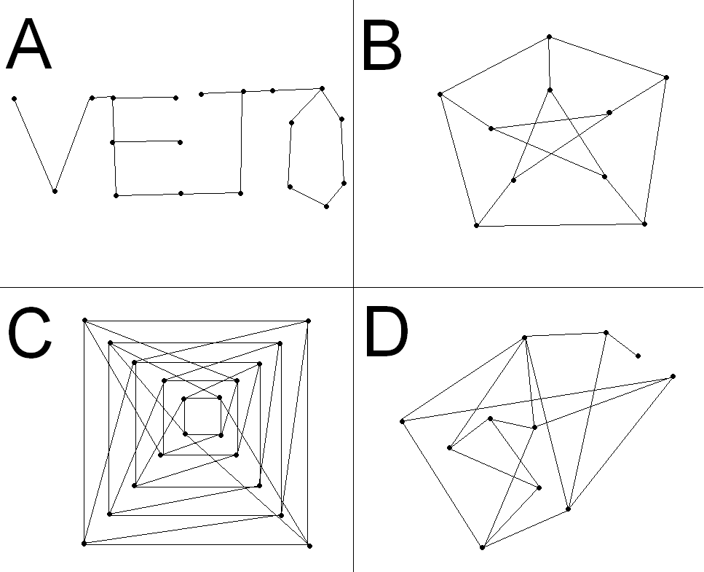

**Document 2:**

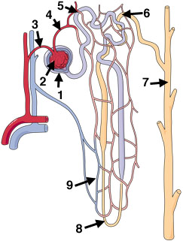

**Document 3:**

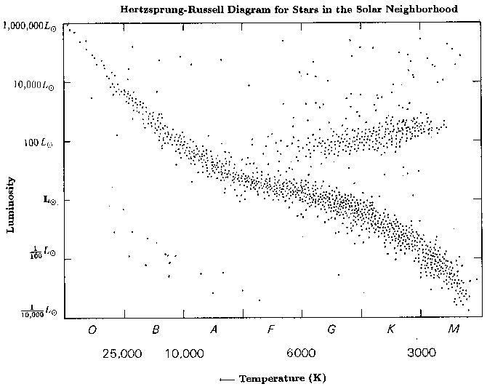

**Document 4:** Identify six of the seven languages.

1



2



3



4



5



6



7



**Document 5:** Yesterday’s Wikipedia!

