To use the simulator, simply launch the “Pack Simulator.exe”
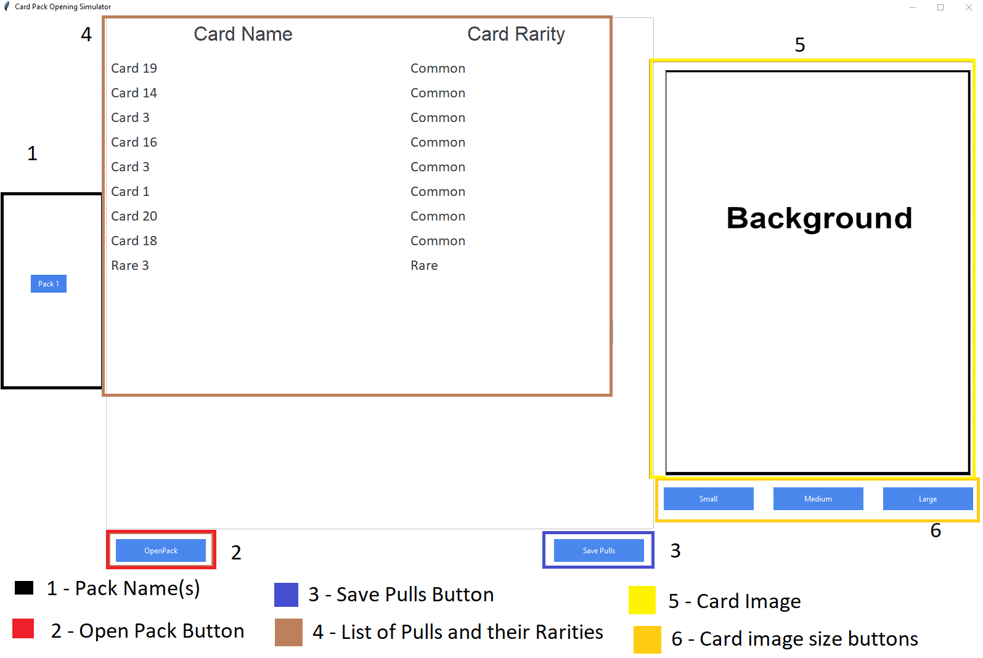
- This is the list of available packs. The ones listed in this image are default packs. You can add/edit any of these packs as will be explained later. Press any of these buttons to change which pack you are going to get pulls from.
- Press this button to open a pack.
- Press this button to save what cards you pulled into a text file. It will be saved in the Pack's folder inside the “Pulls” folder. For example: if you saved pulls from “Blue-Eyes” it will be in “[Pack Simulator File Path]/Pack Simulator/Packs/Blue-Eyes/Pulls”. It will be a time-stamped text file that will contain the list of cards from that pull you did in the simulator.
- This is the list of cards you pulled from the pack once you clicked (2) Open Pack.
- This is the card art. Card art is not necessary for the pack simulator to function.
- These buttons can change what size the card art is. By default it's medium.

Adding New Packs

To add a new pack, you must open up the “Packs.csv” file. Here is an example of what happens if you open it with Openoffice Calc
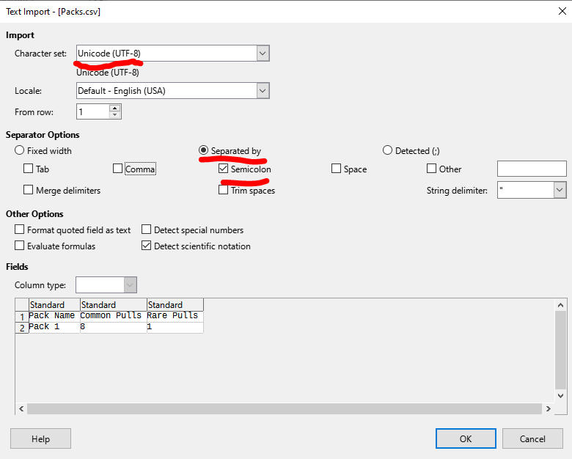

You will want these options when opening it using Openoffice Calc or Excel to see the data properly. When saving, make sure to use the same settings. Especially the “Semicolon” option as the program's code is looking for those SPECIFICALLY when looking for pack information
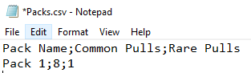
This is how it will look like if you open it with notepad or any other text editor.
To add a new pack, simply add a new line following the exact same format. For example:
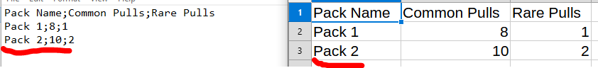
The information, in order of appearance, is the Pack Name, the number of commons you will receive per pack (drawn from the “Commons.csv” file in the pack's folder), and the number of rare or higher pulls you get per pack (drawn from “Rares.csv”,”Super Rares.csv”,”Ultra Rares.csv”, and “Secret Rares.csv” files in the same folder as “Commons.csv”).

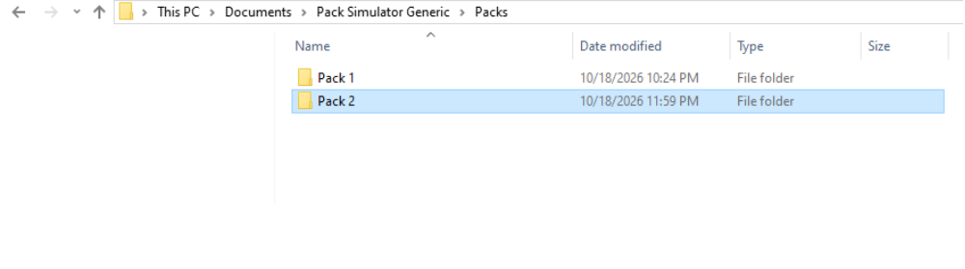
You must also have a folder within that has the same name in the “Packs” folder
And within the pack folder you must have these files (you do not need the “pulls” folder. That will be created if it does not exist):
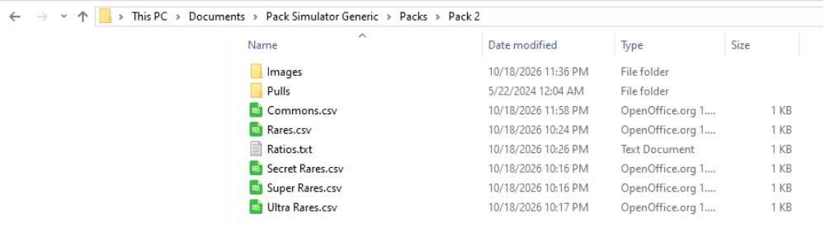

Even if you do not plan on having any cards of any given rarity for your pack (such as no super rares or ultra rares) you can leave the entries in the files empty but the file(s) must exist.

You must also edit the “ratios” file in order for the different rarities to be pulled. The higher the number of each rarity, the more often that card rarity will appear when doing pulls.

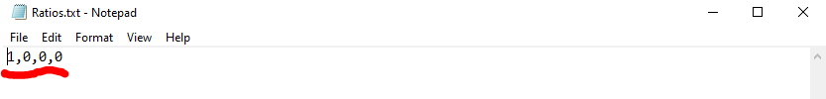
Each number, in order, is the frequency in which that given rarity will appear. In order, the numbers represent: Rares, Super Rares, Ultra Rares, and Secret Rares. In this example, as there are only rares and commons, there is only a number 1 for rares and 0s for every other rarity. They can all be 0s or you can set each rarity you're not using to 0. So you can have only rares or rares and super rares. If any of the numbers are greater than 0 you must have entries in the Rares, Super Rares, Ultra Rares, or Secret Rares files (at least 1).

You can edit the card files (commons, rares, super rares, ultra rares, secret rares) the same way as you did with the packs file.

Here are examples of how it looks in notepad and OpenOffice Calc:
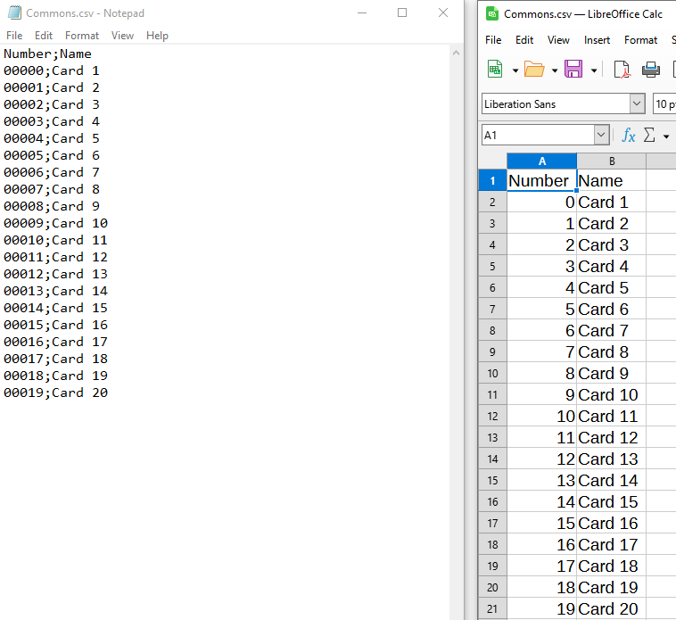

The numbers in front of the cards are needed for when the program eventually looks for images for said cards. While the program will work properly if there are identical numbers or numbers with no corresponding images, it is recommended to use unique numbers for each card and have corresponding images for each number. For these examples the numbers have leading zeros (0). That was a personal choice, and they can be changed to any numbers desired. If you choose to use leading 0s as well, please also make sure to restore them in your spreadsheet editing program as many of them will delete them by default. You can do this in OpenOffice Calc like this:
Similar spreadsheet programs should have similar options but they may be in different locations.
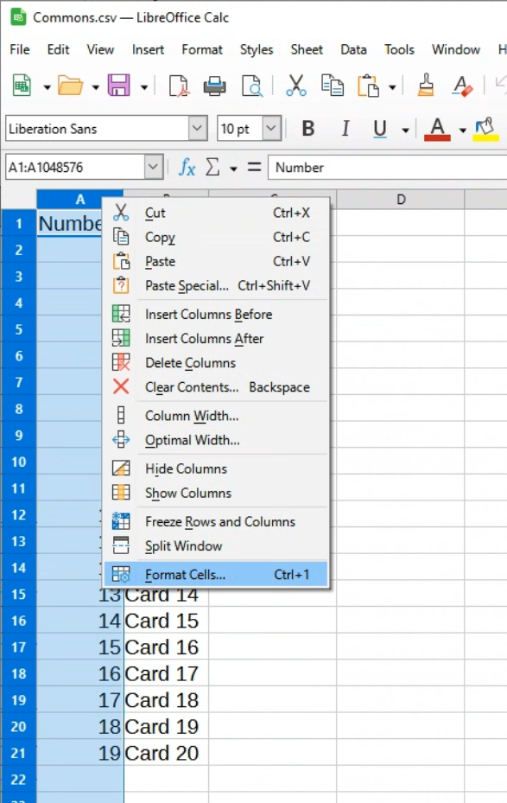
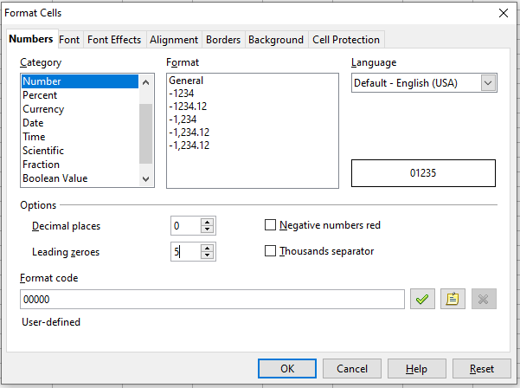
The purpose of the numbers is to look for a corresponding image in the “…/Pack Simulator/Packs/[Pack Name]/Images/[Rarity]” folder. Like so:
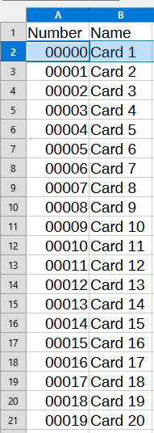

If everything has been set up as explained, the result should be this:
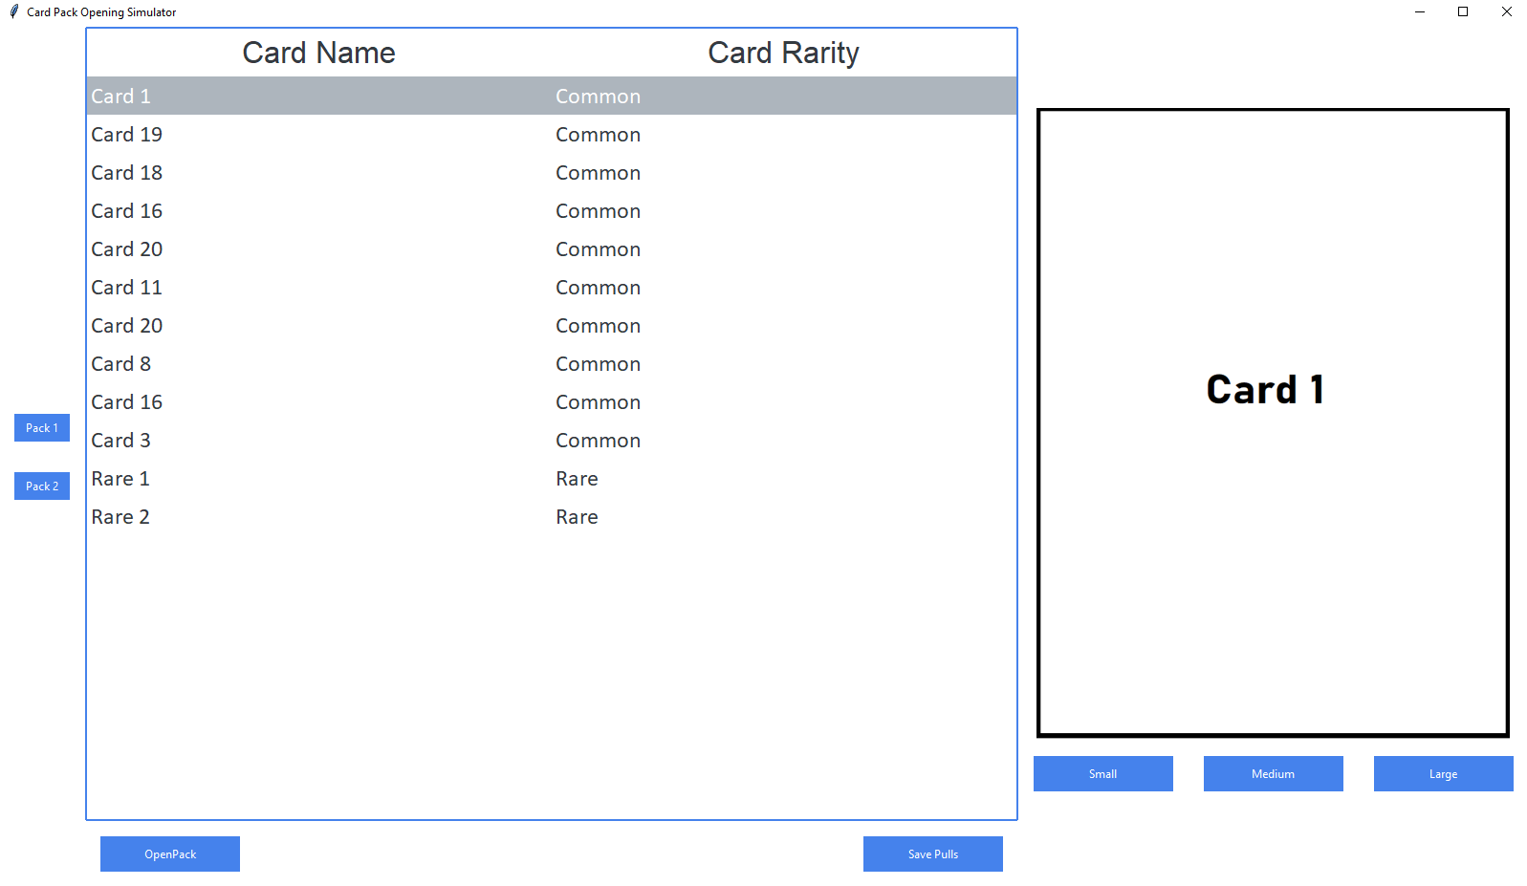
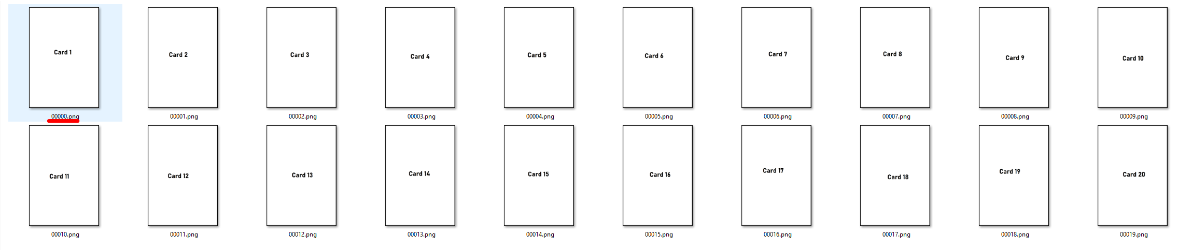

If you do not have corresponding images, the image will revert to the default card_back.jpg file. This will happen if ANY card image is missing and it happens to pull that missing card. If one card it pulls has no corresponding image, the remaining cards pulled will revert to the default image.

Images can be in .png OR .jpg

