LAB#02

LAB TASK

Write a program which takes an integer value (k) as input and prints the sequence of numbers from k to 0 in descending order. 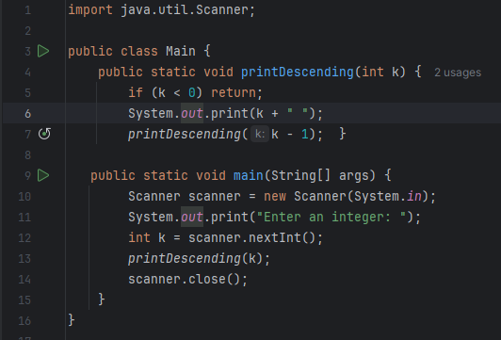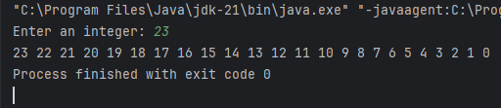

2Write a program to reverse your full name using Recursion. 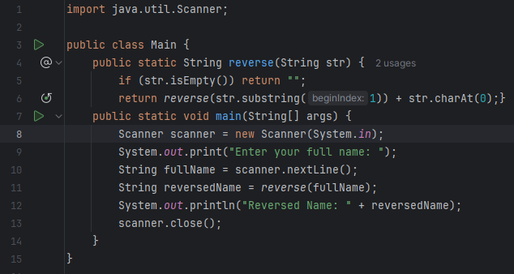

3. . Write a program to calculate the sum of numbers from 1 to N using recursion. N should be user input. 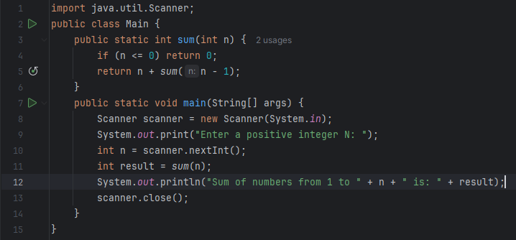

4Write a recursive program to calculate the sum of elements in an array.

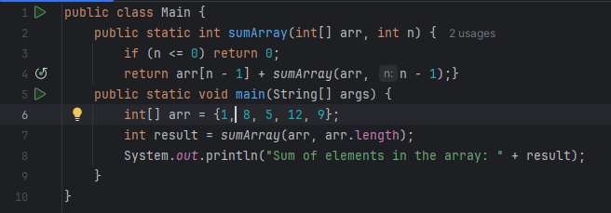

5 Write a recursive program to calculate the factorial of a given integer n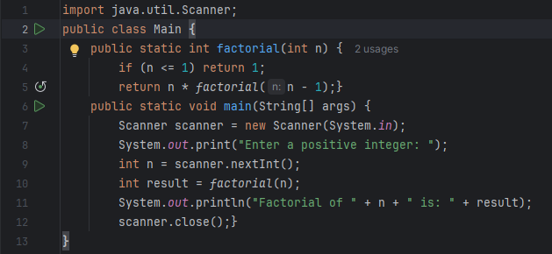

6. Write a program to count the digits of a given number using recursion. 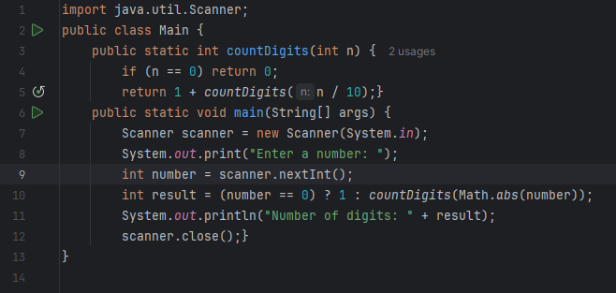

HOME TASK

1. Write a java program to find the N-th term in the Fibonacci series using Memoization. 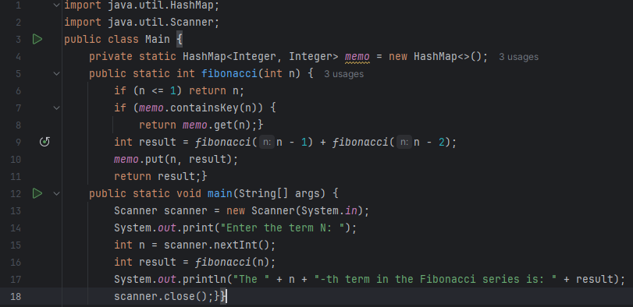

2. Write a program to count the digits of a given number using recursion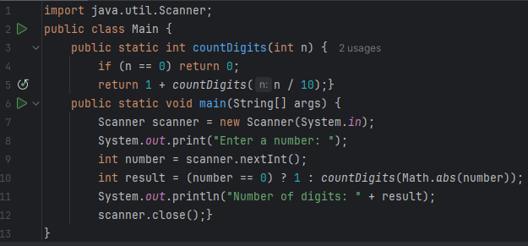

3. Write a java program to check whether a given string is a palindrome or not. A palindrome is a string that reads the same forwards and backwards. Print "YES" if the string is a palindrome, otherwise print "NO".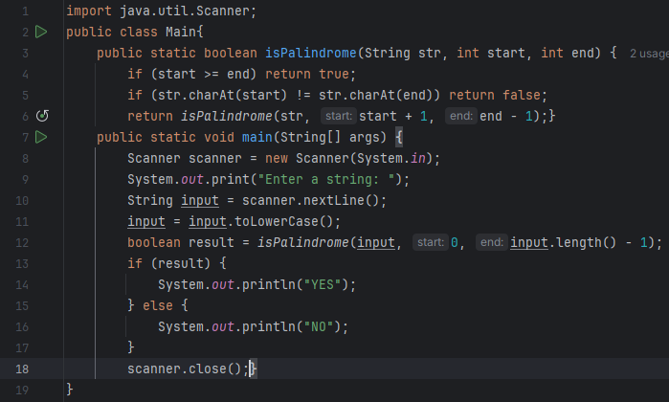

4 Create a Color class that has red, green, and blue values. Two colors are considered equal if their RGB values are the same