

PixelAura+

A Project Report Submitted to
Dr. Subhash University
In Fulfillment of the Requirements for The Master of Computer Application
By

Kathi Ajay Naranbhai (240220320014)

Under the Guidance of Prof. Sunny Goswami

MARCH-2026

School of Computer Application, Dr. Subhash University- Junagadh.



CERTIFICATE

This is to certify that project work embodied in this project report titled “PixelAura+” was carried out by (Kathi Ajay Naranbhai) at School of Computer Application for fulfillment of Master of Computer Application to be awarded by Dr. Subhash University. This project work has been carried out under my guidance and supervision and it is up to my satisfaction.

Date: 00/03/2026
Place: Junagadh
Signature and Name of Guide Signature and Name of Dean
Prof. Sunny Goswami DR. RINKU VIPULBHAI CHAVDA

Seal of Institute

TABLE OF CONTENTS

Sr. No. | Particular |  | Page No.
 | Title Page |  | i
 | University Certificate |  | ii
 | Table of Contents |  | vii
Chapter 1 | Introduction
 | 1.1 | Existing System | 1
 | 1.2 | Need for the New System | 3
 | 1.3 | Objective of the New System | 4
 | 1.4 | Problem Definition | 6
 | 1.5 | Project Profile | 7
 | 1.6 | Core Components | 8
 | 1.7 | Assumptions and Constraints | 10
 | 1.8 | Advantages and Limitations of the Proposed System | 12
Chapter 2 | Requirement Determination & Analysis
 | 2.1 | Requirement Determination | 14
 | 2.2 | Targeted Users | 17
Chapter 3 | System Design
 | 3.1 | Use Case Diagram | 18
 | 3.2 | Class Diagram | 20
 | 3.3 | Activity Diagram | 21
 | 3.4 | Data Dictionary | 23
Chapter 4 | Development
 | 4.1 | Coding Standards | 30
 | 4.2 | Screen Shots | 57
Chapter 5 | Agile Documentation
 | 5.1 | Agile Project Charter | 70
 | 5.2 | Agile Roadmap / Schedule | 71
 | 5.3 | Agile Project Plan | 72
 | 5.4 | Agile User Story (Minimum 3 Tasks) | 73
 | 5.5 | Agile Release Plan | 74
 | 5.6 | Agile Sprint Backlog | 75
 | 5.7 | Agile Test Plan | 76
Chapter 6 | Proposed Enhancements |  | 77
Chapter 7 | Conclusion |  | 78
 | Bibliography and References |  | 79

Chapter 1 Introduction
  - Existing System
The existing system refers to the currently available social media platforms that allow users to share images, interact with posts, and connect with other users. Popular applications such as Instagram provide features like user registration, image posting, likes, comments, and profile management.
In the existing systems, users can upload photos, apply basic filters, like posts, and follow other users. These platforms mainly focus on visual content sharing and social interaction. However, many existing solutions are complex, resource-heavy, and not customizable for learning or small-scale deployment purposes.
Additionally, existing systems often have limitations such as restricted control over data, lack of transparency in algorithms, and limited customization for developers or institutions. For academic or beginner-level projects, these platforms cannot be modified or studied internally because their backend logic and database structure are not accessible.
Therefore, while existing systems are feature-rich and widely used, they are not suitable for understanding internal workflows such as database management, like mechanisms, user authentication, and post-handling logic, which creates a need for a simplified and customizable alternative like PixelAura+.

1.2 Need for the New System
Although existing social media platforms such as Instagram provide advanced features for image sharing and user interaction, they are not suitable for academic learning, experimentation, or small-scale application development. These platforms are closed systems where developers and learners do not have access to internal logic, database structures, or core functionalities.
There is a strong need for a new system that is simple, customizable, and easy to understand while still offering essential social media features. Students and developers require a platform where they can learn how image-based applications work internally, including user authentication, post management, like functionality, and database relationships.

The new system, PixelAura+, is designed to overcome these limitations by providing a lightweight, transparent, and developer-friendly environment. It allows full control over the source code and database, enabling easy modification and enhancement of features based on requirements.
Additionally, PixelAura+ focuses on improved performance, better data control, and a simplified user experience. The system is ideal for learning purposes, project development, and demonstrating core concepts of modern web applications.
Thus, the need for a new system arises to provide an accessible, flexible, and educational alternative to existing large-scale social media platforms
1.3 Objective of the New System
The main objective of the new system, PixelAura+, is to develop an image-based social media application similar to Instagram that enables users to share content and interact with posts in a simple and efficient manner. The system aims to provide essential social networking features while maintaining a clean and user-friendly interface.
The key objectives of PixelAura+ are as follows:
- To allow users to register and securely log in to the system.
- To enable users to upload images and create posts.
- To provide like functionality for user interaction with posts.
- To allow users to delete their own posts when required.
- To display real-time like counts for each post.
- To design a responsive and visually appealing user interface.
- To maintain a structured and secure database for users, posts, and likes.
- To create a customizable platform suitable for learning and development purposes.

Overall, PixelAura+ aims to demonstrate the core working principles of a modern social media platform while offering flexibility, simplicity, and scalability for future enhancements.

1.4. Problem Definition
In the current digital era, image-based social media platforms have become an important medium for communication and content sharing. However, existing platforms such as Instagram are complex, closed-source, and not suitable for academic learning or small-scale development. Users and developers do not have access to internal system logic, database structures, or core functional workflows.
For students and beginner developers, understanding how features like image uploading, post management, like mechanisms, and user authentication work at the backend level is difficult due to the lack of transparency in existing systems. Additionally, building a fully functional social media application from scratch requires proper planning, structured design, and efficient data handling, which is often challenging without a simplified reference system.
The problem is to design and develop a customizable, easy-to-understand, and efficient image-sharing platform that provides essential social media functionalities while allowing full access to the system architecture and database. The system must be secure, user-friendly, and scalable, enabling users to interact with content effectively.
PixelAura+ addresses this problem by offering a lightweight Instagram-like platform that demonstrates core social media functionalities in a controlled and educational environment. Similar to Instagram that enables users to share content and interact with posts in a simple and efficient manner. The system aims to provide essential social networking features while maintaining a clean and user-friendly interface.
The key objectives of PixelAura+ are as follows:
- To allow users to register and securely log in to the system.
- To enable users to upload images and create posts.
- To provide like functionality for user interaction with posts.
- To allow users to delete their own posts when required.
- To display real-time like counts for each post.
- To design a responsive and visually appealing user interface.
- To maintain a structured and secure database for users, posts, and likes.
- To create a customizable platform suitable for learning and development purposes.

Overall, PixelAura+ aims to demonstrate the core working principles of a modern social media platform while offering flexibility, simplicity, and scalability for future enhancements.

1.5. Project Profile

Project Title | Pixel Aura +
Software Used | VISUAL STUDIO CODE
Browser | CHROME
Front End | HTML, CSS, JavaScript
Back End | MySQL Workbench, Python + Django
Project Description | Social Media Platform
Scope | This project will automate students, small users. Same Like a social Media. Add Post, like, Share. A project To add In Resume.

1.6. Core Components
The Pixel Aura+ system is composed of several core components that work together to provide a smooth and interactive image-based social media experience. Each component plays a vital role in ensuring system functionality, performance, and usability.
1. User Authentication Module: This component manages user registration and login processes. It ensures secure access to the system by validating user credentials and maintaining session management.
2. User Profile Module: Allows users to view and manage their profile information. It displays user details and their uploaded posts.
3. Post Management Module: This module enables users to upload images, create posts, view posts, and delete their own posts. It handles image storage and post-related data in the database.
4. Like System: The like system allows users to like or unlike posts. It updates the like count dynamically and ensures that a user can like a post only once.
5. Database Management System: Stores and manages all system data, including user details, posts, and likes. It ensures data consistency and efficient retrieval.
6. User Interface (UI): Provides a responsive and visually appealing interface for interacting with the system. It ensures ease of use and smooth navigation.
7. Backend Logic: Handles server-side operations such as data processing, validations, and communication between the frontend and database.

1.7 Assumptions and Constraints
During the design and development of the Pixel Aura+ system, certain assumptions and constraints have been considered to ensure smooth implementation and realistic system expectations.
Assumptions
- Users have basic knowledge of using web-based applications.
- The system will be accessed through a modern web browser.
- Users will have a stable internet connection.
- Each user will have a unique account for accessing the system.
- The system is intended for academic and learning purposes.
- The number of users is limited and manageable.
Constraints
- The system supports only image-based posts.
- Advanced features such as reels, stories, and live streaming are not included.
- Real-time notifications are not implemented.
- The system depends on server availability for proper functioning.
- Security features are limited to basic authentication mechanisms.
- The application is designed for small-scale usage and not for large commercial deployment.

1.8 Advantages and Limitations of the Proposed System
The proposed system, Pixel Aura+, offers several benefits while also having certain limitations due to its scope and design. These are described below:
Advantages
- Simple and user-friendly interface.
- Allows users to upload images and interact with posts through likes.
- Secure user authentication and session management.
- Structured database design for users, posts, and likes.
- Full access to source code and database for learning and customization.
- Lightweight system with faster performance.
- Easy to modify and extend with additional features.
- Suitable for academic projects and skill development.
Limitations
- Limited features compared to commercial social media platforms.
- No support for video posts or stories.
- Absence of real-time notifications.
- Basic security mechanisms only.
- Not optimized for large-scale or high-traffic environments.
- No advanced content moderation or admin dashboard.

Chapter 2: Requirement Determination & Analysis
  - Requirement Determination
Requirement determination involves identifying the functional and non-functional needs of the system to ensure it meets user expectations. For the Pixel Aura+ project, requirements were identified by analyzing existing image-based social media platforms and understanding the core features required for an Instagram-like application. The focus was on simplicity, usability, and learning-oriented design.
- Functional Requirements
The functional requirements define the services and operations that the system must perform.
- User Registration and Login
The system must allow users to create an account and log in using valid credentials. This ensures secure access and personalized user interaction within the platform.
- Image Upload and Post Creation
Users should be able to upload images and create posts. Each post must be stored securely in the database along with user details.
- Post Feed Display
The system should display all posts in a structured feed format. Users can view images uploaded by themselves and others.
- Like and Unlike Functionality
Users must be able to like or unlike posts. The system should update and display the like count accurately for each post.
- Post Deletion
Users should have the option to delete their own posts. This ensures content control and better user experience.
- Data Storage and Management
The system should store user, post, and like information in a structured database. This helps maintain data consistency and quick retrieval.
- Non-Functional Requirements
These requirements describe the qualities and constraints of the system.
- Usability
The application should be simple and easy to use, even for first-time users. Clear navigation and responsive design are required.
- Performance
The system should respond quickly to user actions such as liking or uploading posts. Delays should be minimal to ensure smooth interaction.
- Security
Basic security mechanisms must be implemented to protect user credentials and data. Unauthorized access should be prevented.
- Compatibility
The system should work properly on modern web browsers and devices. This ensures accessibility across different platforms.

  - Targeted Users
The Pixel Aura+ system is designed for a specific group of users who require a simple and interactive image-sharing platform for learning and experimentation. The target users are identified based on usability, purpose, and system scope.
- Students
Pixel Aura+ is primarily intended for students who are learning web development and database concepts. It helps them understand how social media platforms work internally.
- Beginner Developers
The system is suitable for beginner-level developers who want to practice building Instagram-like applications. It allows them to explore features such as authentication, image upload, and likes.
- Academic Institutions
Educational institutions can use Pixel Aura+ as a demonstration project. It serves as a practical example for teaching full-stack development concepts.
- Small User Groups
The system can be used by a limited number of users for testing and learning purposes. It is not intended for large-scale commercial use.
- UI/UX Designers
Designers can use the platform to test interface layouts, user experience flows, and visual design concepts for social media applications.
- Software Trainers and Mentors
Trainers and mentors can use Pixel Aura+ to demonstrate real-world system architecture, explain workflows, and guide students in building similar platforms.

Chapter 3 System Design
  - Use Case Diagram
Admin
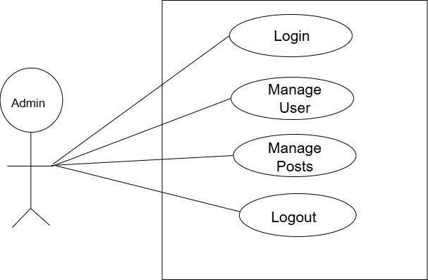

User/Client
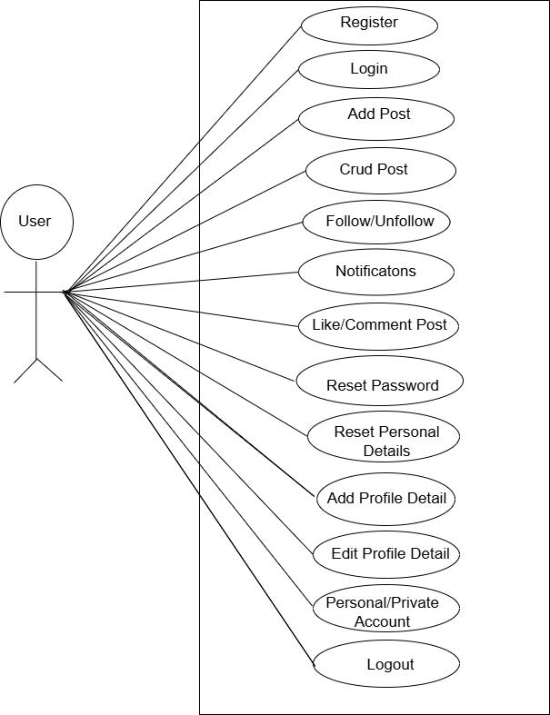

  - Class Diagram

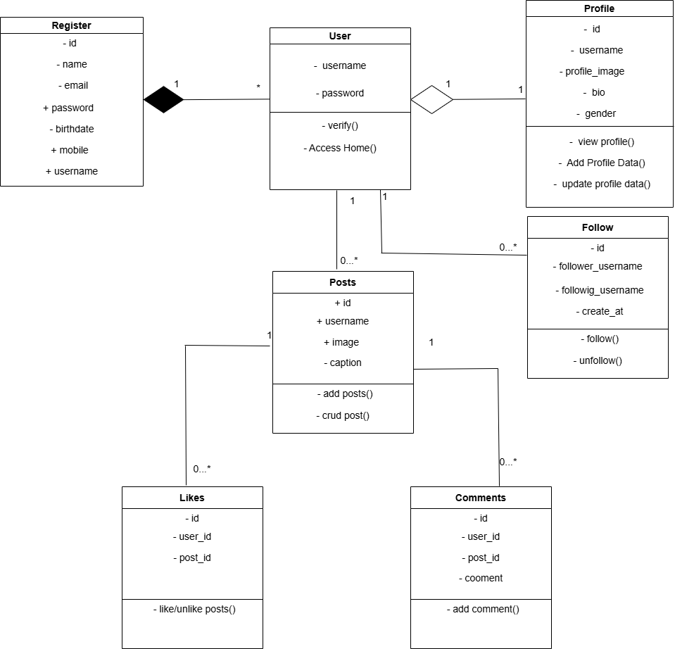

  - Activity Diagram
Admin
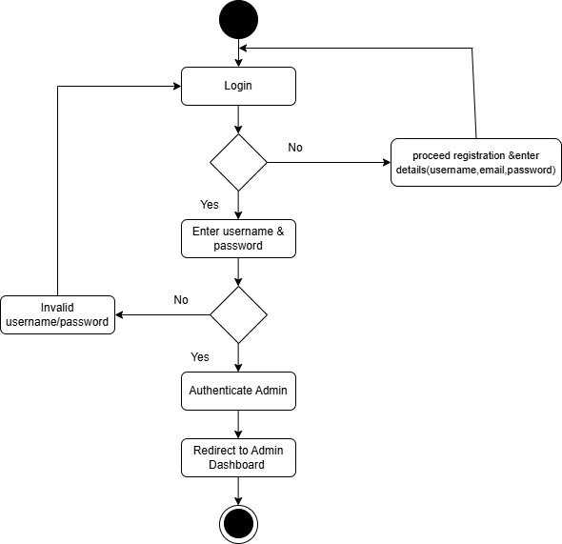

USER
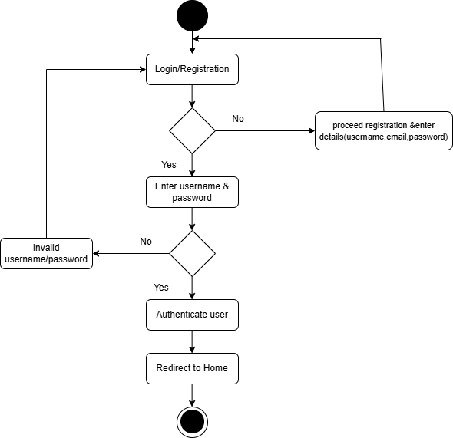
3.4 Data Dictionary
Client/User

Register

Column | Type | Null | Default | Comments
id (Primary) | int(11) | No
name | varchar(45) | No
email | varchar(45) | No
password | varchar(40) | No
birthdate | varchar(45) | No
mobile | varchar(45) | No
username | varchar(45) | No

Posts

Column | Type | Null | Default | Comments
id (Primary) | int(11) | No
image | long text | No
username | varchar(45) | No
caption | Long text | No

Profile

Column | Type | Null | Default | Comments
id (Primary) | int(11) | No
username | varchar(45) | No
image | Long text | No
bio | Long text | No
gender | varchar(10) | No

Follows

Column | Type | Null | Default | Comments
id (Primary) | int(11) | No
Follower_username | varchar(45) | No
Following_username | varchar(45) | No
Created_at | timestamp | Yes | current_timestamp()
Likes

Column | Type | Null | Default | Comments
id (Primary) | Int(11) | No
Post_id | Int(11) | No
User_id | Int(11) | No
Created_at | timestamp | Yes | current_timestamp()

Notifications

Column | Type | Null | Default | Comments
id (Primary) | int(11) | No
User_id | Int(11) | No
message | varchar(255) | No
Is_read | Tinyint(1) | No
Created_at | timestamp | Yes | current_timestamp()

Comments
Column | Type | Null | Default | Comments
id (Primary) | int(11) | No
Post_id | Int(10) | No | NULL
User_id | Int(10) | No | NULL
Comments | Long text | No | NULL
Created_at | timestamp | Yes | current_timestamp()

Chats
Column | Type | Null | Default | Comments
id (Primary) | int(11) | No
sender | varchar(30) | No | NULL
receiver | varchar(30) | No | NULL
message | Long text | No | NULL
Created_at | timestamp | Yes | current_timestamp()

Chapter 4 Development

  - Coding Standards (User)
Register
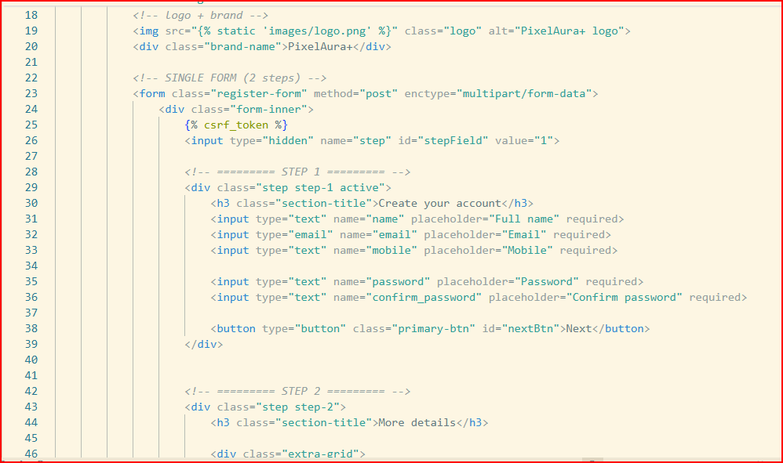
Login
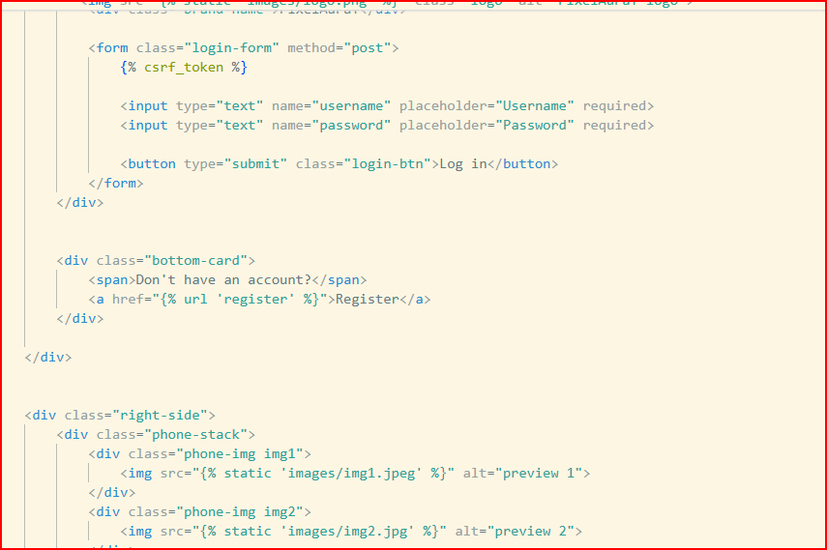

Home
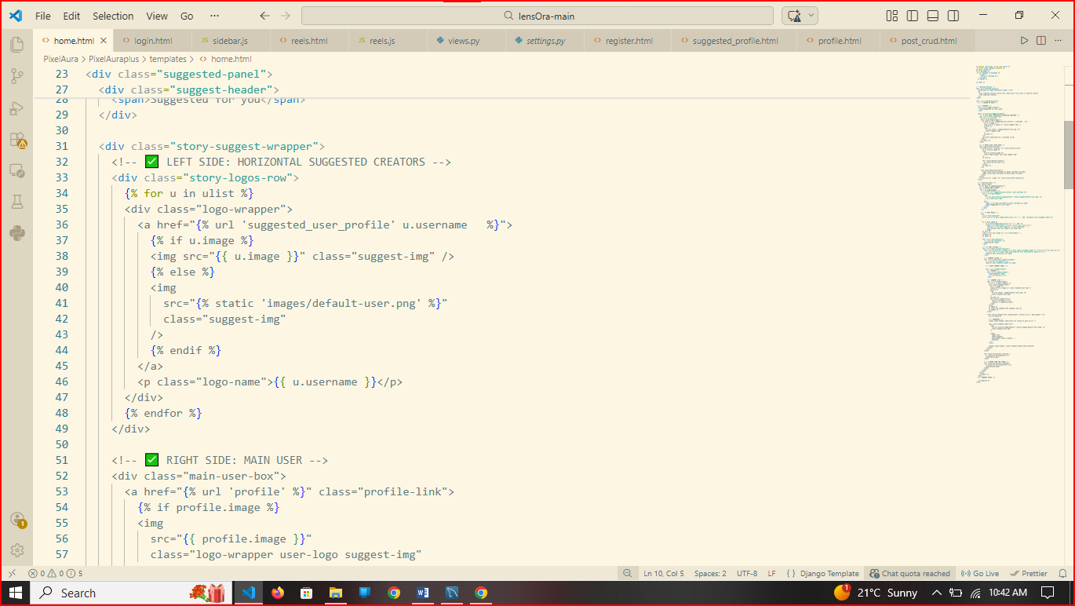

Settings
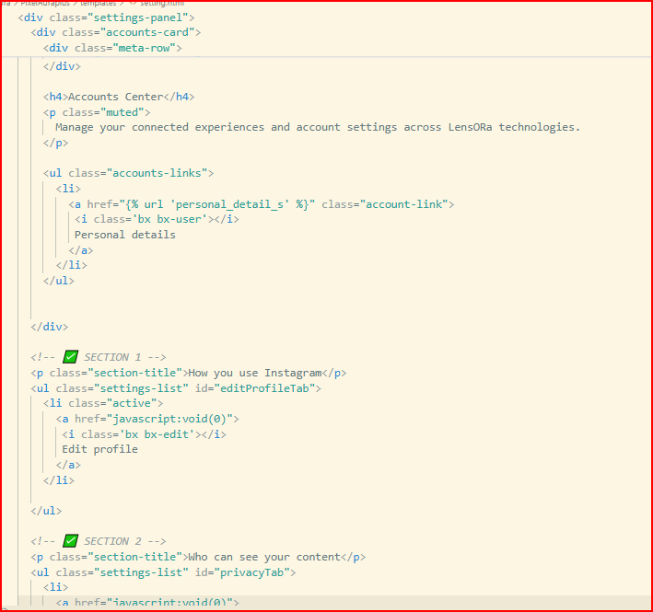

Profile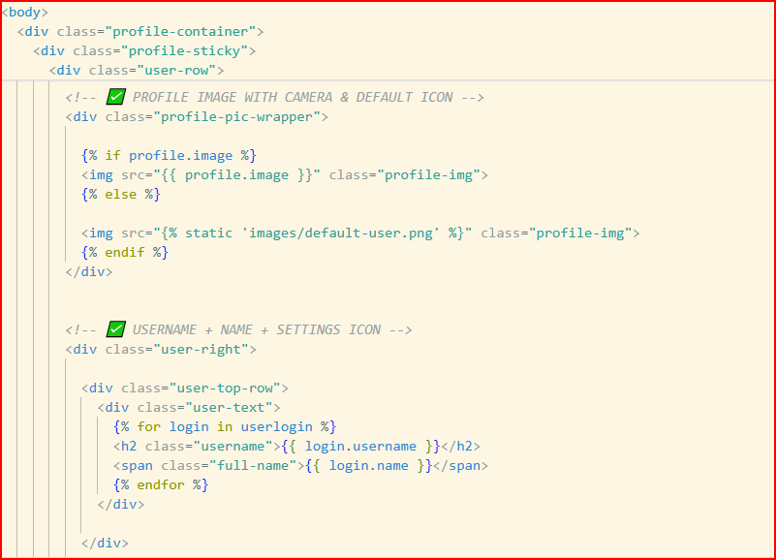

4.2 Screenshots
Register
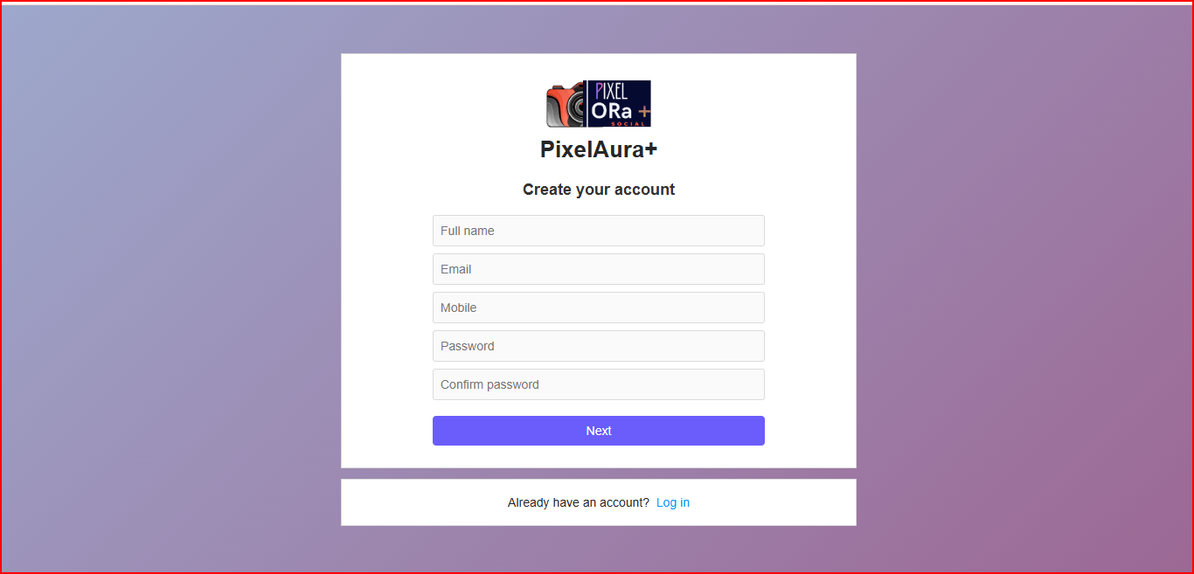
Login
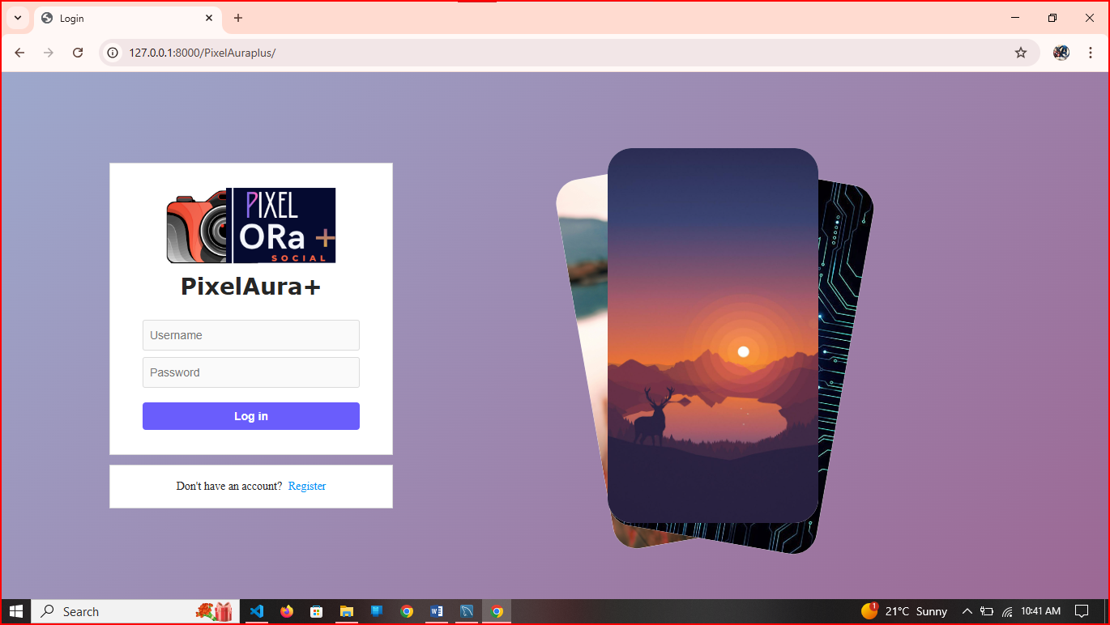

Home
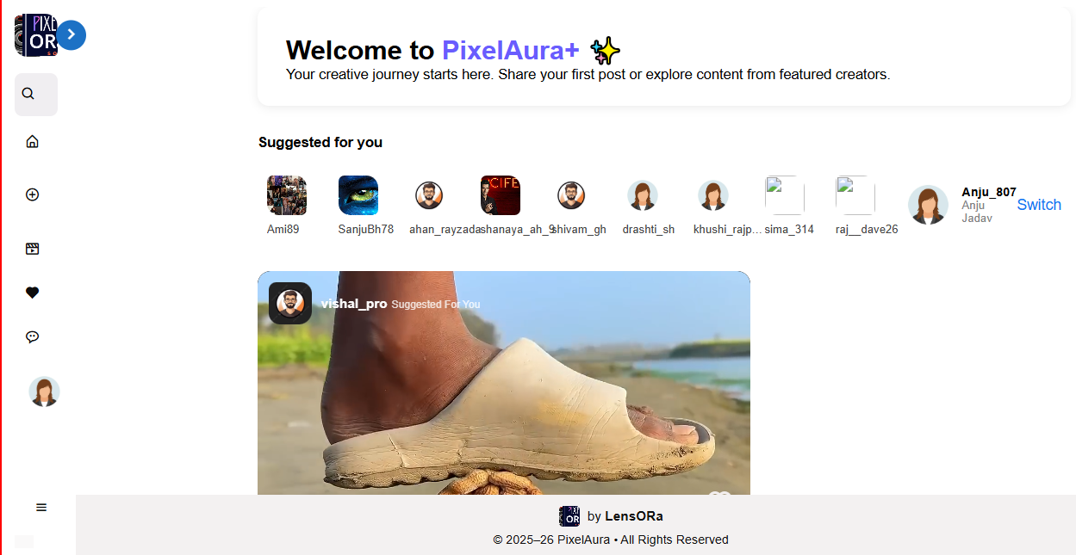

Add Post
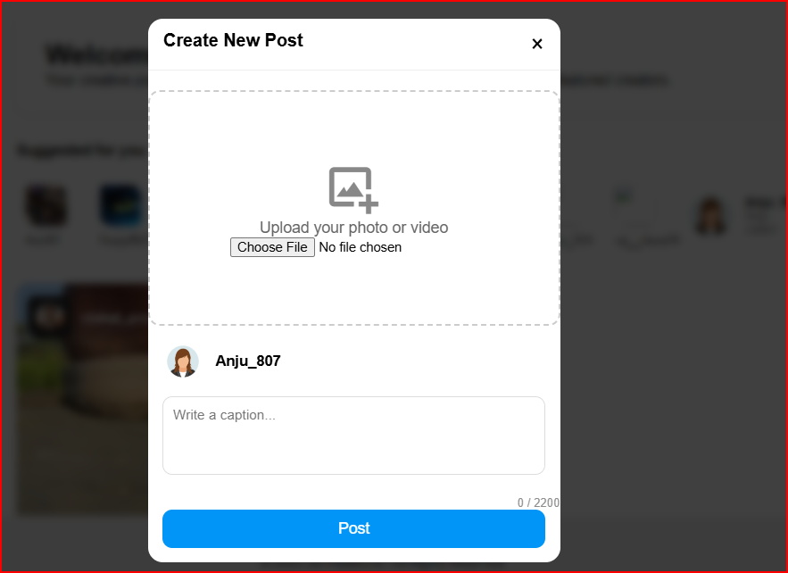

Profile
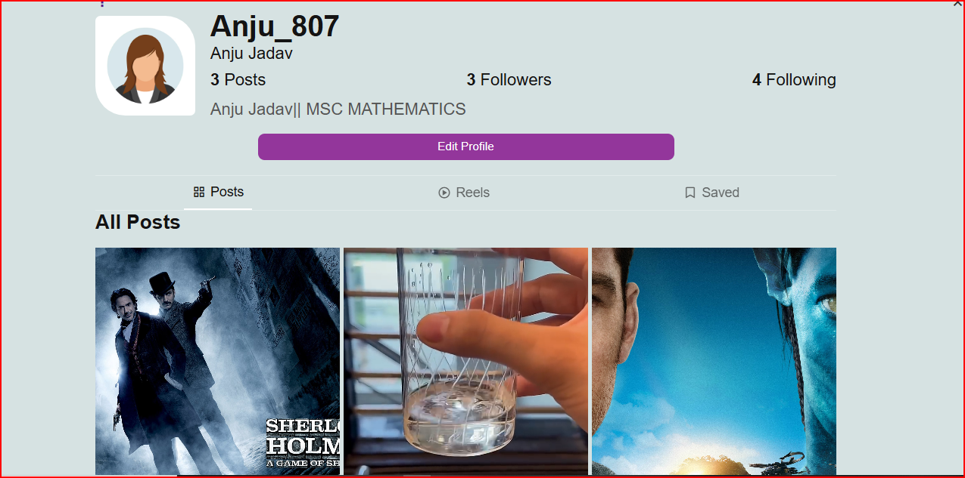

Settings
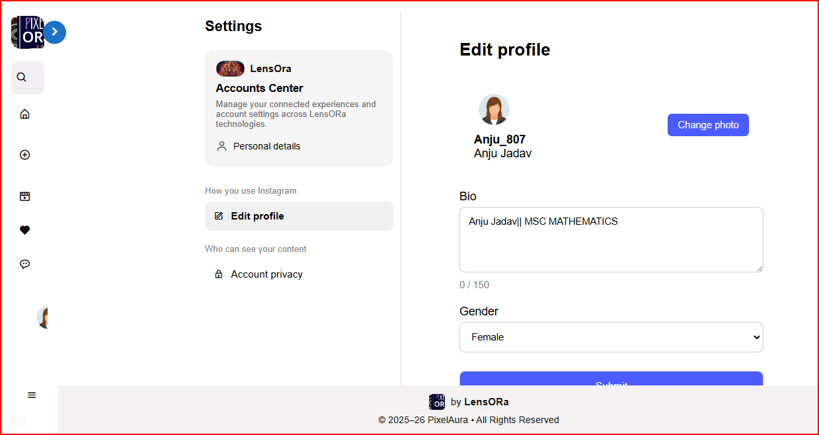

Chapter 5: Agile Documentation
Agile methodology is an iterative and incremental approach to software development that focuses on flexibility, collaboration, and continuous delivery of valuable features. The Hostel Management System project has been developed using agile principles to ensure effective communication, quick adaptation to changes, and frequent delivery of functional modules.
  - Agile Project Charter
Project Title: PixelAura+

Project Description:
The PixelAura+ PixelAura+ is a web-based social media application developed using Python with Django and MySQL Workbench, designed to enable users to create profiles, like content, comment, and follow other users. The system aims to simplify social interaction, enhance user engagement, and provide a secure platform for digital content sharing. It reduces manual effort in managing user interactions and ensures efficient handling of user data and platform activities.

Project Objectives:
    - Automate user account management and profile handling.
    - Simplify content sharing, post creation, and interaction processes.
    - Provide a transparent system for likes, comments, and follower management.
    - Enhance accessibility through a secure and user-friendly online platform. Accessibility through a secure online platform.

Stakeholders:
    - Admin: Manages User, Content.
    - User/Client: Add Post, Like and Comment, Follow, Add profile, chat

Scope:
The PixelAura+ project aims to provide a social media platform that allows students and small users to share posts, interact with others, and manage profiles in a secure and user-friendly environment.
Team Members:
Product Owner: [Pro. Sunny Goswami]
Scrum Master: [Ajay Kathi]
Developers: [Ajay Kathi]
QA/Testers: [Ajay Kathi]
Assumptions: Project will follow Scrum, with 2-week sprints.
Constraints: Limited budget, must be completed in 4 months.

  - Agile Roadmap / Schedule

Iteration / Sprint | Duration | Main Deliverables
Sprint 1 | Week 1 | Requirement gathering, database design, and setup.
Sprint 2 | Week 2 | UI/UX design, database schema design.
Sprint 3 | Week 3 | User registration, login, profile module
Sprint 4 | Week 4 | Post creation, feed display, image upload
Sprint 5 | Week 5 | Likes, comments, follow system
Sprint 6 | Week 6 | Reel, Suggests User
Sprint 7 | Week 7 | Profile, Chat, Notification
Sprint 8 | Week 8 | Admin

  - Agile Project Plan

Purpose:
This Agile Project Plan outlines how the PixelAura+ social media platform will be developed using Agile Scrum practices, ensuring iterative progress, continuous feedback, and timely delivery of system features.

Include:
- Methodology: Scrum
- Sprint Duration: 1 weeks
- Total Sprints: 8
- Tools:
      - Jira — Task tracking and sprint management
      - Trello — Workflow organization
      - GitHub — Version control and collaboration
      - Zoom — Team communication and sprint meetings

- Key Meetings:
        - Sprint Planning - Define sprint goals and assign tasks
        - Daily Standups - Track daily progress and resolve blockers
        - Sprint Reviews & Retrospectives- Evaluate sprint outcomes and improve workflow

- Roles and Responsibilities:
- Scrum Master: Facilitates Agile processes, removes obstacles, and ensures Scrum practices are followed
- Product Owner: Manages product backlog, prioritizes features, and gathers user requirements
- Developers: Design, build, and integrate system functionalities
QA (Quality Assurance): Tests features, identifies bugs, and ensures system quality

  - Agile User Story (Minimum 3 Tasks)

User Story 1: User/Client Registration and Login

As a User/Client, I want to register and log in so that I can access my home Page.
Tasks:
- Create registration form for User.
- Implement login validation and session management.
- Display Home Page after successful login.

User Story 2: Add Post

As a User/Client, I want to Add Post. Which is save to Database.
Tasks:
- Create Add Post Page.
- User can add Post, Write Caption.

User Story 3: Setting

As a User, I want to Edit Bio, Change My Personal Detail, Change Password, and Private Account.

Tasks:
- Create a setting Link or Page.
- Where Links for Profile, Personal Detail, Account Privacy.
- User Do Edit Bio, Change My Personal Detail.

User Story 5: Like, Comment, Follow System
As a user I want to like, comment and follow other user.
Tasks:
1. Implement like and comment features for posts.
2. Develop a follow/unfollow system between users.
3. Display interaction counts (likes, comments, followers).

User Story 4: Admin

As an Admin, I want To Mange User, Posts and Login to My Dashboard.
Tasks:
- As Per Technology Stack Login Page is Default.
- Authenticate admin and redirect to admin Dashboard.
- User Admin Functionality.

5.5 Agile Release Plan

Release | Sprint | Features Included
Release 1 | Sprint 1–2. | Requirement gathering, project setup, UI/UX design, database schema finalization.
Release 2 | Sprint 3–4 | User registration, login, authentication, profile setup, post creation, feed display.
Release 3 | Sprint 5–6 | Likes system, comments module, follow/unfollow system, reels feature, user suggestions.
Release 4 | Sprint 7–8 | Chat/messaging, notifications, admin panel, testing, bug fixing, deployment, final documentation.

5.6 Agile Sprint Backlog
Purpose:
The Sprint Backlog lists the tasks and user stories that must be completed during the current sprint. It helps the team track progress, assign responsibilities, and ensure timely delivery of sprint goals.

Release | Task | Assignee | Status
Post Creation | Design post upload UI. | Dev A | In Progress
Post Creation | Implement image upload feature. | Dev B | To Do
Feed Display | Fetch posts from database | Dev C | In Progress
Feed Display | Display posts in user feed | Dev A | To Do
User Interaction | Add like and comment buttons | Dev B | To Do

5.7 Agile Test Plan
Purpose:
The Agile Test Plan defines how testing will be conducted in each sprint to ensure the PixelAura+ system is reliable, secure, and user-friendly. Testing is performed continuously to detect defects early and maintain high software quality.
Test Types:
    - Unit Testing — Test individual components and functions
    - Integration Testing — Verify interaction between modules
    - UI Testing — Ensure proper layout, responsiveness, and usability
    - User Acceptance Testing (UAT) — Confirm system meets user expectations.
Testing Tools:
- Manual Test Cases — Functional and usability testing

Sprint-wise Testing Plan:
- Sprint 1: Test user registration and login functionality
- Sprint 2: Test profile creation and account management
- Sprint 3: Test post creation, image upload, and feed display
- Sprint 4: Test likes, comments, and follow system
- Sprint 5: Test reels, search, and user suggestion features
- Sprint 6: Test chat, notifications, and messaging system
- Sprint 7: Perform system integration testing
- Sprint 8: Conduct final UAT, performance testing, and bug fixing

Chapter 6 Proposed Enhancements

Automated Room Allocation System

PixelAura+ successfully implements core social media functionalities such as user registration, profile management, post sharing, likes, comments, and following, several enhancements can be introduced in the future to improve performance, usability, security, and scalability. These proposed upgrades aim to make the platform more interactive, intelligent, and competitive with modern social networking applications.
1. Advanced Messaging and Real-Time Chat
A future enhancement includes integrating a real-time messaging system that allows users to send instant messages, share media, and create group chats.
This feature can be implemented using Firebase, enabling fast communication, typing indicators, message read receipts, and online status visibility, which significantly improves user engagement. Digital Complaint & Maintenance Portal

Stories and Live Streaming Feature
A Stories module can be added to allow users to share temporary photos and videos that disappear after 24 hours.
Additionally, a Live Streaming feature can allow creators to broadcast live content, interact with followers in real time, and increase platform activity and audience interaction.
3. AI-Based Content Recommendations
Artificial Intelligence (AI) can be integrated to provide personalized content recommendations based on user interests, interaction history, and behavior.
This can help users discover relevant posts, trending topics, suggested profiles, and hashtags, improving content visibility and platform engagement.
4. Enhanced Privacy and Security Controls
To strengthen user trust and data protection, additional privacy options can be introduced, including:
- Private and public account settings
- Post visibility control (friends-only, followers-only)
- Two-factor authentication (2FA)
- Account activity logs
- Advanced reporting and blocking tools
5. Push Notifications and Alerts
A push notification system can be added to alert users about:
  - New followers
  - Likes and comments
  - Mentions and tags
  - Direct messages
  - Platform announcements
6. Content Analytics and Creator Dashboard
A Creator Dashboard can provide insights into:
- Post reach and impressions
- Engagement metrics (likes, comments, shares)
- Follower growth trends
- Best-performing content
This feature helps content creators analyze performance and improve content strategies.
7. Monetization and Advertisement System
PixelAura+ can introduce monetization options, such as:
- Sponsored posts
- In-app advertisements
- Paid subscriptions
- Creator tipping systems
These features can support platform revenue generation and creator income opportunities.

Chapter 7 Conclusion

The PixelAura+ project successfully demonstrates the design and development of a modern social media platform that enables users to register, create profiles, like content, comment, and follow other users. The system has been built using Python with Django for the backend and MySQL Workbench for database management, ensuring a robust, scalable, and efficient architecture.
Throughout the development process, the project followed agile methodology, allowing features to be built incrementally through multiple sprints. This approach supported continuous improvement, rapid feedback integration, and better alignment with user requirements. Core functionalities such as authentication, post management, interaction systems, and profile handling were implemented effectively, resulting in a user-friendly and interactive platform.
The project also highlights the importance of software engineering best practices, including modular development, database normalization, testing strategies, and version control. These practices contribute to improved code maintainability, system reliability, and future scalability.
In conclusion, PixelAura+ serves as a strong foundation for a full-scale social networking application. With future enhancements such as AI-based recommendations, real-time messaging, mobile app development, and advanced security features, the platform has the potential to evolve into a feature-rich and competitive social media solution. This project not only fulfills its intended objectives but also provides valuable learning and practical experience in web development, database management, and Agile project execution.

Bibliography and References

- https://www.instagram.com/
- https://docs.djangoproject.com/en/6.0/

