Presentation on

**BOOKS STORE**

**ANALYSIS**

Presented By:

Dudhal Jyoti (311)

Gawade Pallavi(317)

Randhir Kajal(360)

More Snehal(350)

**Department of Computer Engineering**

**Contents**

1. Introduction

2.Objective

3.Approach

4.References

5.Overall Description

* System Architecture
* User Interface
* Operating Environment

7.Algorithems

* K-means
* Linear Regression

1.Introduction:

BookStore analysis is a system that is designed to improve accuracy and to enhance safety and efficiency of books in the Bookstore. It is a computer based system which helps the Book seller to improve inventory management, cost, safety etc.

The system will also give report showing the list of products sell after a specified year before the product eventually sell.The BookStore analysis has been developed to override the problems prevailing in the practicing the manual system. This system is supported to eliminate and in some cases reduce the hardships faced by this existing system.Moreover this system is designed to carry out operations in a smooth and effective manner.

2. Objective:

The problem arises with the  book dealer about  the data analysing of

Data about BookStore such as Year wise Reviews of books and Rating of the

books is not known ?

The BookStore analysis serves many purposes, including the safe and

effective dispensing of Books. Due to BookStore analysis we can easily find

Name of top 30 books that have highest sold

3.Approach:

SYSTEM DEVELOPMENT LIFE CYCLE

The systems development life cycle is a projects managements

technique e that divides complex project into smaller,more easily managed

segments or phases.Segmenting projects allows managers to verify the

successful completion of project phases before allocating resources to

subsequent phases.Software development projects typically include

initiation,planning,design,development,testing,implementation

maintenance phases.However,the phases may be divided directly depending

on the organization involved. For example,initial project activities might be

designated as a request,requirements definition,and planning phases,or

initiation,concept development,and planning phases.End users of system under

development should be involved in reviewing the output of each phase to ensure

the system is being built to deliver the needed functionality.

4. References:

https://www.w3school.com

https://www.youtube.com/watch?v=WGf7gXbCTp4

https://www.youtube.com/watch?v=IMGzzK9W

[https*://*www*.*Geeksforgeeks*.*com](https://www.geeksforgeeks.com)

[https://colab.research.google.com/ - :~:text=Colab%20notebooks%20execute%20code%20on,the%20power%20of%20your%20machine.](https://colab.research.google.com/#:~:text=Colab%20notebooks%20execute%20code%20on,the%20power%20of%20your%20machine.)

<https://www.tutorialspoint.com/google_amp/google_amp_link.htm>

5.Overall Description

* System Architecture:

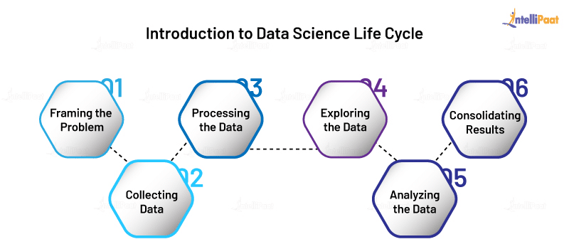

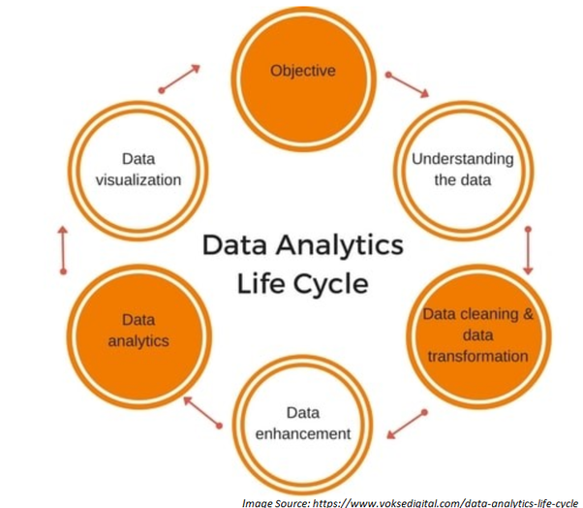

* User Interface:

Laptop’s,desktop System

* Operating Environment:

Processor-Intel core i3/i5/i7

Ram-4GB/8GB

Operating System-windows 10/7/8/Ubuntu/Fedora

7.Algorithems:

K-means:

***k*-means clustering** is a method of [vector quantization](https://en.wikipedia.org/wiki/Vector_quantization), originally from [signal processing](https://en.wikipedia.org/wiki/Signal_processing), that is popular for [cluster analysis](https://en.wikipedia.org/wiki/Cluster_analysis) in [data mining](https://en.wikipedia.org/wiki/Data_mining). *k*-means clustering aims to [partition](https://en.wikipedia.org/wiki/Partition_of_a_set) *n* observations into *k* clusters in which each observation belongs to the [cluster](https://en.wikipedia.org/wiki/Cluster_(statistics)) with the nearest [mean](https://en.wikipedia.org/wiki/Mean), serving as a prototype of the cluster. This results in a partitioning of the data space into [Voronoi cells](https://en.wikipedia.org/wiki/Voronoi_cell). *k*-Means minimizes within-cluster variances (squared Euclidean distances), but not regular Euclidean distances, which would be the more difficult [Weber problem](https://en.wikipedia.org/wiki/Weber_problem): the mean optimizes squared errors, whereas only the geometric median minimizes Euclidean distances. Better Euclidean solutions can for example be found using [k-medians](https://en.wikipedia.org/wiki/K-medians_clustering) and [k-medoids](https://en.wikipedia.org/wiki/K-medoids).

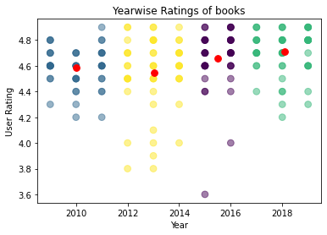

Linear Regression:

In [statistics](https://en.wikipedia.org/wiki/Statistics), **linear regression** is a [linear](https://en.wikipedia.org/wiki/Linearity) approach to modeling the relationship between a scalar response (or [dependent variable](https://en.wikipedia.org/wiki/Dependent_variable)) and one or more [explanatory variables](https://en.wikipedia.org/wiki/Explanatory_variable) (or [independent variables](https://en.wikipedia.org/wiki/Independent_variable)). The case of one explanatory variable is called [simple linear regression](https://en.wikipedia.org/wiki/Simple_linear_regression). For more than one explanatory variable, the process is called **multiple linear regression**.[1] This term is distinct from [multivariate linear regression](https://en.wikipedia.org/wiki/Multivariate_linear_regression), where multiple correlated dependent variables are predicted, rather than a single scalar variable.

