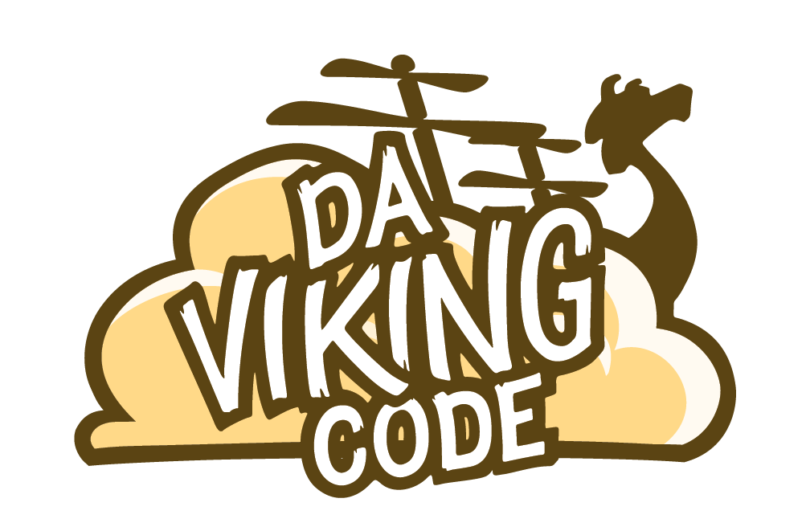
http://davikingcode.com

$P Point-Cloud Recognizer

The $P Point-Cloud Recognizer is a 2-D gesture recognizer designed for rapid prototyping of gesture-based user interfaces. In machine learning terms, $P is an instance-based nearest-neighbor classifier with a Euclidean scoring function, i.e., a geometric template matcher. $P is the latest in the dollar family of recognizers that includes $1 for unistrokes and $N for multistrokes. Although about half of $P's code is from $1, unlike both $1 and $N, $P does not represent gestures as ordered series of points (i.e., strokes), but as unordered point-clouds. By representing gestures as point-clouds, $P can handle both unistrokes and multistrokes equivalently and without the combinatoric overhead of $N. When comparing two point-clouds, $P solves the classic assignment problem between two bipartite graphs using an approximation of the Hungarian algorithm.

This is an adaptation of the original C# code for working with Unity.

In the demo, only one point-cloud template is loaded for each of the 16 gesture types. You can add additional templates as you wish, and even define your own custom gesture templates.

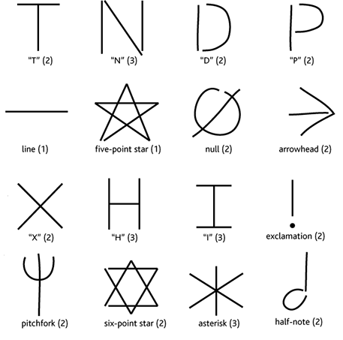
Setup :

Import the package via Unity Asset Store. You will get a PDollar folder with a demo. An explanation of what you will get in the sub-folder :

- Prefabs : One prefab named GestureOnScreen which is basically a Line Renderer for displaying user gesture.
- Resources : 16 pre-made gestures saved as xmls.
- Scene : The demo scene.
- Scripts : The demo script and the PDollar algorithm.

The Demo Script is attached to the Main Camera and the prefab GestureOnScreen must be linked to this Demo Script.

Features :
Using the PDollar algorithm you can recognize features with multi-strokes and register new one. You can register new gestures running Unity demo directly or on mobile. They will be saved at Application.persistentDataPath. Note you can’t save the xml generated on Unity Web Player.

Support & issues : https://github.com/DaVikingCode/PDollar-Unity
Contact : hello@davikingcode.com

