Department of computer science & Engineering
University of Nebraska—Lincoln
Invoice Management System
CSCE 156 – Computer Science II Project
Jonghyun Yoo and Tristan Sladek
11/7/2018
Version 1.2

This document describes an invoice management system written from scratch in an object-oriented environment to replace a legacy system in use at Cineclark entertainment group.

Revision History
Version | Description of Change(s) | Author(s) | Date
1.0 | Initial draft of this design document | Tristan Sladek and Jonghyun Yoo | 2018/09/10
1.1 | Phase 2 Initiated:  - Added Invoice Object  - Modified Customer  - Added Reader and Writer for Invoice Data and Reports | Tristan Sladek and Jonghyun Yoo | 2018/10/01
1.2 | Phase 3 Initiated:  - Added Database MySQL  Phase 4 & 5 Initiated:  - Added Database Connectivity  - Added Linked List | Tristan Sladek and Jonghyun Yoo | 2018/11/06

Contents
Revision History 1
1. Introduction 4
1.1 Purpose of this Document 4
1.2 Scope of the Project 4
1.3 Definitions, Acronyms, Abbreviations 4
1.3.1 Definitions 4
1.3.2 Abbreviations & Acronyms 4
2. Overall Design Description 4
2.1 Alternative Design Options 4
3. Detailed Component Description 4
3.1 Class/Entity Model 4
3.1.1 Component Testing Strategy 5
3.2 Class/Entity Model 5
3.2.1 Component Testing Strategy 5
3.3 Database Interface 5
3.3.1 Component Testing Strategy 5
3.4 Design & Integration of Data Structures 5
3.4.1 Component Testing Strategy 5
3.5 Changes & Refactoring 5
4. Additional Material 5
5. Bibliography 6

Introduction
This document outlines a project that is a replacement of an invoice management system at Cineclark entertainment group. The system is Java application that uses information stored in a database.

Purpose of this Document
The purpose of this document is to display the technical design of the invoice management system. This document shows test cases and implementation of the program over its multiple phases. This document also describes the SQL database used to store information for later use by the Java application.

Scope of the Project
This application is to replace a legacy invoice management system for Cineclark entertainment group. The main purpose of the program is to manage two categories of products: tickets and services. The application will use objects to gather information, print reports, and store information in an SQL database.

Definitions, Acronyms, Abbreviations

Definitions
Invoice – a list of goods sent or services provided, with a statement of the sum due for these; a bill.
PersonID – an identification that is a combination of letters and numbers assigned to each person in the data.
CustomerID – an identification that is in form of ‘CXXX’ where X represents a number assigned to each customer
ProductID – an identification that is a combination of letters and numbers assigned to each product in the data.
Class – a template which is used to create and define objects to deal with real world objects
Constructor – a special method used to initialize an object

Abbreviations & Acronyms
SQL – Structured Query Language
OOP – Object Oriented Programing
XML – Extensible Markup Language
JDBC – Java Database Connectivity
API – Application Programing Interface

Overall Design Description
Object Oriented Programing takes entities such as information about a person or customer and creates objects with methods in classes. With these objects, data can be sorted, manipulated, added, or even deleted to create what a user wants.
This program reads information from flat files, or from a database and uses it to produce reports and keep track of data in an OOP environment. The information can be exported in both JSON and XML format and can easily be stored & indexed using a SQL database.

Alternative Design Options
When reading in information it was extremely tempting to write a data reader that would be able to read in / write from any of the three file types provided during testing regardless of which was called using the same method. Though this would have worked, It was a bad overall choice because It would not scale well if more data was introduced, and would require the entire method being modified in the future instead of smaller subsequent methods being changed individually if something had to change. That topped with it requiring a bit of logic to even determine what to output, it was a bad idea overall and did not follow OOP ideals.

Detailed Component Description
This section will provide more detailed information about our program’s various components.

Database Design
This ER diagram represents the tables present in our MySQL database. It shows the relationships between tables in our database and displays each primary key/foreign key. Our table stores each type of product individually based on their product type in different tables, the tables have a 1-1 relationship with a product code in the product table. Using this information, you can grab a list of products from the set of tables and know exactly what kind of product you’re getting.
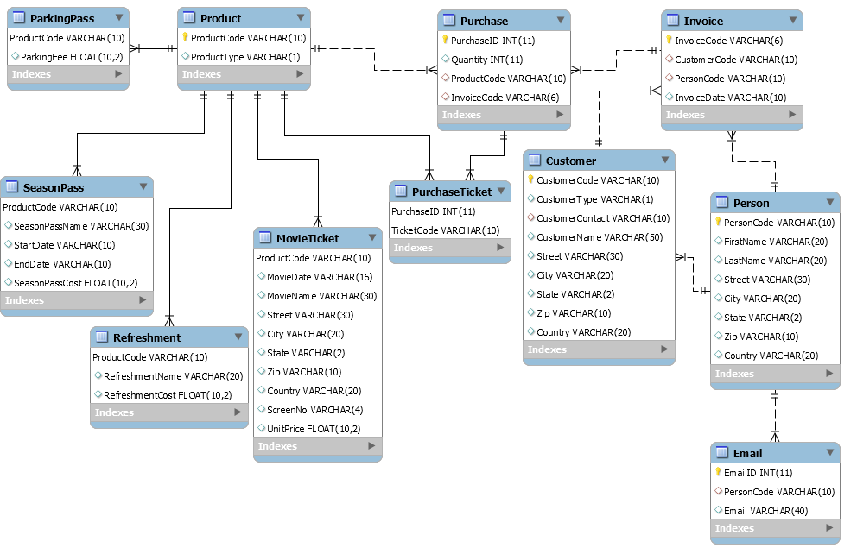

Class/Entity Model

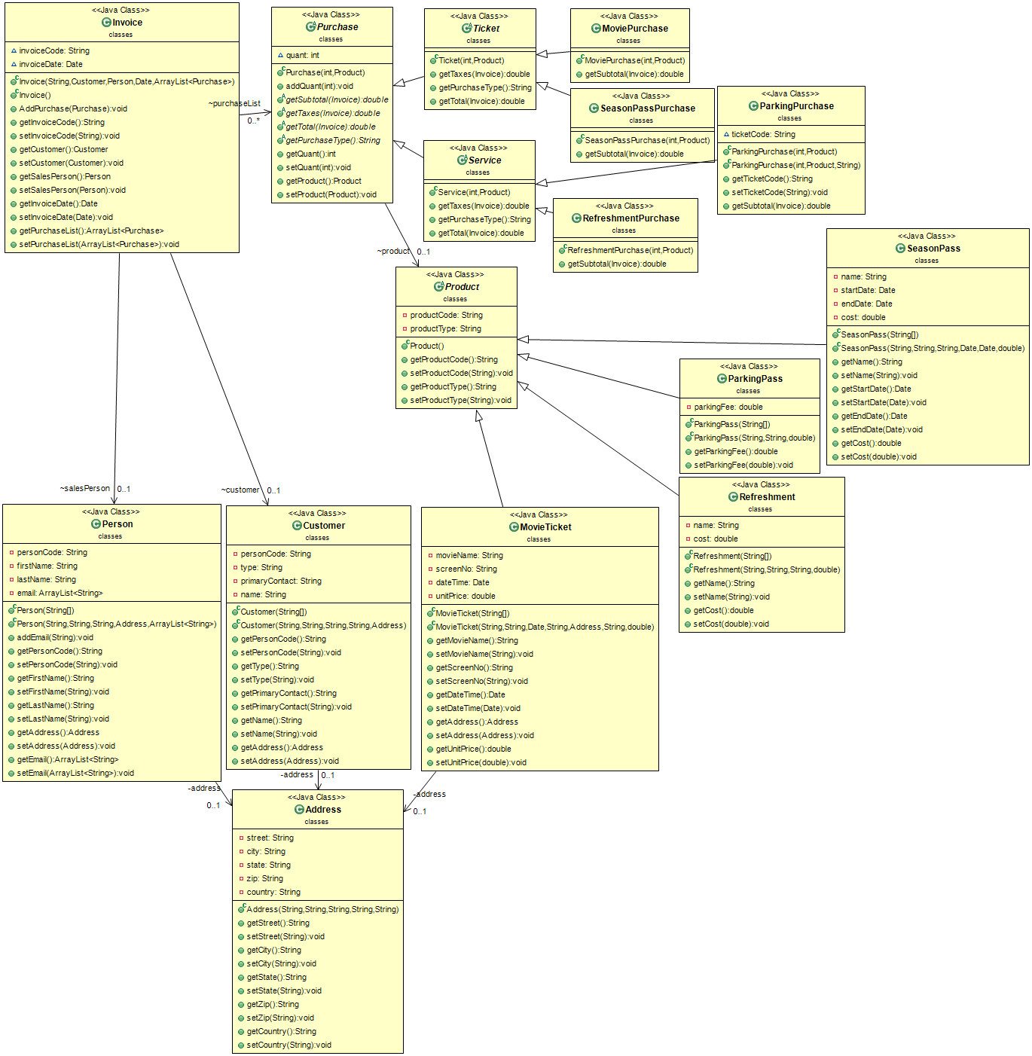
Figure 1: A UML diagram of our class structure and how these entities interact with each other.

Database Interface
In Phase IV the application was connected to our database to read in information from SQL rather than flat files. This was done using JDBC. Our driver made the connection with our database, read in each set of tables using queries, and constructed objects which were then added into a list. The information being read in was checked for bad data and was handled on read in the application itself. After these objects were created, our program was able to function just like it had using the flat files.

Component Testing Strategy
The objects being read in from the database were compared to the information inside of the database before the read had happened. This information confirmed the objects were reading in the proper information from the database.

Design & Integration of Data Structures
We designed a linked list of Invoice Nodes that self-sorted when created by comparing the invoiceID of objects around them when added to the node list. When the node returned an invoiceID greater than the invoiceID of the node being added, it was inserted into the list at that point. The surrounding nodes were updated to reflect this change. We chose InvoiceID because it was going to be a unique field every time, so it was an easy field to compare on.

Component Testing Strategy
We tested our ADT by adding information to the linked list that was not sorted by InvoiceID. This forced the program to sort itself as the information was being added to the linked list. The result set we had returned to us showed that our list was working properly.

Bibliography
The ObjectAid UML Explorer for Eclipse. (n.d.). Retrieved November 7, 2018, from http://www.objectaid.com/

