4008BIO: Structure, Function and Analysis of Biomolecules
Lab 1: Pipetting

Introduction to Basic Laboratory Skills

This lab will introduce you to some of the basic techniques routinely used in the laboratory:

- Introduction to, and correct use of, laboratory glassware and pipettes

- Making solutions and preparing dilutions

Learning outcomes

- Identify commonly used vessels and pipettes in the laboratory
- Identify the appropriate pipette to deliver the most accurate volume for the task required
- Prepare straight forward dilutions from a concentrated stock solution

In this practical session you will be comparing the accuracy and precision of automatic pipettes to that of other measurement equipment.
In order to be able to compare these different types of equipment, you will need to work on the principle that 1ml of pure water has a mass of 1g.

Automatic pipettes

These can be fixed volume, but most are an adjustable variety. Different pipettes have different ranges of volumes which they can accurately dispense; examples include 100-1000µl, 10-100µl and 2-20µl.

There are a number of different makes of automatic pipette in the laboratories. They have slight differences but the general method of use is the same.

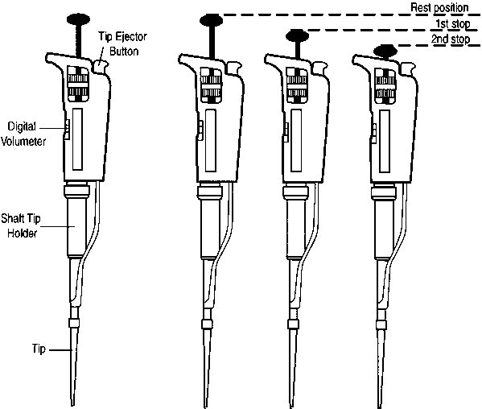
Instructions for pipetting liquids using a micropipette

- Always choose the correct pipette for the volume you need to measure and also ensure you have the correct tip (blue, yellow or white) for the pipette.
- Fit the tip to the end of the shaft. Press down and twist slightly to ensure an airtight seal.
- Micropipette plungers have 3 positions:
  - Rest position
  - First stop
  - Second stop
- Hold the pipette in a vertical position and depress the plunger to the first stop. Air equal to the volume of the setting (e.g. 100μl) is displaced.
- Holding the plunger at the first stop, immerse the tip into the liquid. Gently release the plunger back to the rest position and wait for the liquid to be sucked up into the tip. The volume of liquid in the tip will equal the volume of the setting of the micropipette.
- Place the tip at an angle (10° to 45°) against the wall of the vessel receiving the liquid. Depress the plunger to the second stop to expel all the liquid.
- Move the end of the tip away from the liquid and release the plunger to the rest position.
- Eject the tip directly into the appropriate waste container by pressing the eject button.

Laboratory Practical
Part 1
Pipettes- accuracy and repeatability

- Place a beaker on a three-place balance and press the zero (tare) button.
- Pour out some distilled water into another beaker and, using the various types of pipette that are available to you measure out 1ml using each of the pipettes

Table 1 - use this table to list all of the pipettes you have used, if you’re not sure of the type of pipette/name then ask

Pipette type | Volume to measure
100 – 1000ul automatic pipette | 1 ml

- Record the weight of the water in Table 2. Repeat with each pipette five times. Calculate the mean and standard deviation (you can do this using Excel).
- Standard deviation is a simple statistical method to monitor the reproducibility of a series of replicate measurements. It is calculated by the following equation:

σ = √ (Σ(x-X) ²)/n-1)

Where: σ is standard deviation from the mean
Σ is the sum of….
x is the measurement
X is the mean of the measurements
n is the number of measurements
√ is the square root of….

Table 2

Pipette | Mass of water (g) | Mean | Standard deviation

Q1. Considering the results in Table 2, rank the pipettes in order of accuracy (closest to the expected value) and repeatability (least variation). Use the numbers 1-3, where 1 is the highest accuracy or repeatability, and enter your values into Table 3.

Table 3

Pipette | Accuracy | Repeatability

Q2. What factors, apart from the accuracy of the glassware/pipette, may influence the results you have found and what could be done to overcome them?

When we perform experiments, it is important that we carry them out to a high level of both accuracy and precision. In many of the experiments you carry out, pipetting will be required and therefore if this is not done correctly this can mean things do not work as expected – the results may not be accurate. It is also important that are results are precise; if we repeat them again we should get the same result.

- Choose a pipette which will dispense 10ul and take some blue paper towel.
- Dispense 10ul of water on to the blue paper towel, five times on different areas (produce five spots of water).
- All of the spots should be the same size, if they are varied this would indicate that you are not pipetting correctly. If this is the case as a demonstrator to watch your pipetting technique.

Part 2
Dilutions

In many laboratory practicals, you may need to dilute a stock solution to produce a particular concentration. For example, if you were provided with a 1g/l (1000mg/l) stock solution of tartrazine, how would you dilute this to make 100 ml of a 10 mg/l solution?

There are two approaches to calculating the dilution needed

Calculation Method 1
C1x V1 = C2 xV2 or V1=(C2xV2) ÷ C1

- C2 is the concentration you want
- V2 is the volume you want.
- C1 is the original concentration of your stock solution
- V1 is the volume you need to take from the stock solution

Use this formula to calculate the volume of the 1g/l tartrazine stock solution that you must use in the problem above.

Calculation Method 2
The starting concentration of tartrazine is 1g/l (1000mg/l) and the final concentration required is 10mg/l. Therefore the concentration of stock solution is 100X greater than the desired final concentration. Therefore you must dilute the stock 100 x (ie by 1 in 100). The final volume you want is 100ml, so the tartrazine stock must represent 1/100 of this volume.

Use this method to solve the problem given above.

Q1. You are provided with a stock solution of 1g/l of tartrazine.
Using the three 100 ml volumetric flasks provided you need to prepare:

- 7 mg/l tartrazine
- 10 mg/l tartrazine
- 12 mg/l tartrazine

Work out the volume of tartrazine you need to pipette into the volumetric flask for each of the above concentrations. Check with a demonstrator, then prepare the solutions by transferring the required volume into the volumetric flask using an appropriate pipette, and filling the flask up to the calibration mark with water. Remember to add the last few drops of water with a pipette or dropper, so that the liquid meniscus is level with the calibration mark (see below). Stopper the flasks and mix thoroughly.

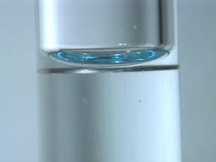

Show your calculations here:

a)

b)

c)

How well have you performed these dilutions?

When using something like tartrazine we can check concentration by checking the colour, whilst a spectrophotometer can be used to do this, when performing experiments it’s important to also make sure things look like we’d expect as we go along.
Before moving on to checking your solutions of tartrazine with a spectrophotometer, perform the task below that just requires you to visually check that your dilutions seem appropriate.

- Label three eppendorfs 10⁻¹, 10⁻² and 10⁻³, add 900µl of water to each, check the volume by eye, they should be the same. If not then empty out and repeat.
- Add 100µl of tartrazine (stock) to the first eppendorf and mix, check the volume by eye and observe the colour.
- Remove 100µl from the Eppendorf labelled 10⁻¹ and add to the Eppendorf labelled 10⁻², mix, check the volume and colour in comparison to the others.
- Remove 100µl from the Eppendorf labelled 10⁻² and add to the Eppendorf labelled 10⁻³, mix, check the volume and colour in comparison to the others.

We have calibrated a spectrophotometer so you can check the concentration of tartrazine in your solutions, demonstrators will show you how to use these. Record your results in Table 4.

Table 4

Calculated concentration (mg/l) | Instrument reading (mg/l) | Difference between calculated and measured value | % error  Difference x 100  Calculated concentration
7
10
12

Questions:
- How close to the calculated concentration values were your prepared dilutions?

- What do you think are the major sources of error in this experiment?

- What is the concentration of tartrazine expressed in mM terms in the 10mg/l solution?

To answer this question:
Firstly, you need to know the relative molecular mass (RMM) of tartrazine, where can you find this information?

Secondly you need to remember that a 1 molar (1M) solution of any chemical is made by dissolving the RMM of the substance measured in grams (g) in 1 litre (l) of water (or other appropriate solvent).

An example:
If the RMM of a chemical is 200, then 200g dissolved in 1l of water will make a 1M solution. Remember that a 1mM solution is 1000x less concentrated than a 1M solution.

The RMM of tartrazine is ………………………………..

Part 3
Preparing solutions

When working in the lab you will be required to prepare solutions of different concentrations and using a variety of different units. In the dilutions task above you were looking at weight/volume and molarity as the units, sometimes however we also use percentage as the concentration.

To calculate this you need to remember that we work on the principle that 1ml of pure water is equal to 1g.

When preparing a solution we need to consider what volume we need, whilst we like to work with volumes where it’s easy to figure out the maths, we also don’t want to waste materials or reagents. For example when we think of molar solutions we are thinking of one litre volumes, this doesn’t mean we have to make up a litre, we can adjust the quantities accordingly so we have the same final concentration but in a small volume.

For this next task we would like to you to prepare 10mls of a 10% (w/v) saline (NaCl) solution. Make sure you perform the required calculation before you attempt to measure/weigh anything out, also consider the final volume required (hint: if you add a solid to your volume of liquid does the volume remain the same?)

Final volume required =

Mass of sodium chloride required =

Do you need to know the RMM for this calculation?

Use bullet points to indicate how you prepared this solution:

Once you have prepared the 10% solution, you then need to prepare 1ml solutions of saline at the following concentrations 5%(w/v), 2.5% (w/v), 1.25% (w/v) and 1% (w/v).

Describe below how you have done this (hint: you don’t need to revisit the balances again)

As indicated above, concentration can be presented in a variety of different units. Sometimes you will need to convert weights and volumes into different units, this can be confusing especially with balances. Have a go at the questions below to make sure you feel comfortable with expressions of different types of units.

1ml = 1000µl

0.1ml = µl

0.05ml = µl

1g = mg

500mg = g

500mg= µg

0.004g on the display of a balance = mg

You need to weigh out 75mg on a balance where a reading of 1.0000g is equal to 1g, what would the reading be for 75mg?

You need to weigh out 80µg on a balance where a reading of 1.0000g is equal to 1g, what would the display on the balance be?

