4008BIO: Structure, Function and Analysis of Biomolecules
Lab 2: Spectrophotometry

Lab 2: Introduction to Spectrophotometry

Learning Outcomes: On completion of this practical class, a student should be able to:

- use correctly, reproducibly and safely, various items of equipment (especially automatic pipettes, vortexes and a spectrophotometer)

- run an absorption spectrum of a coloured complex in the visible range

- prepare a calibration curve

- determine the concentration of an unknown by its colour intensity

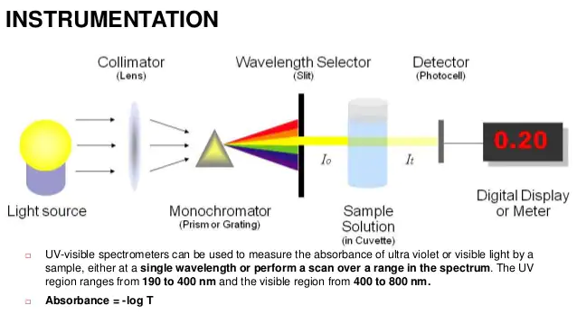

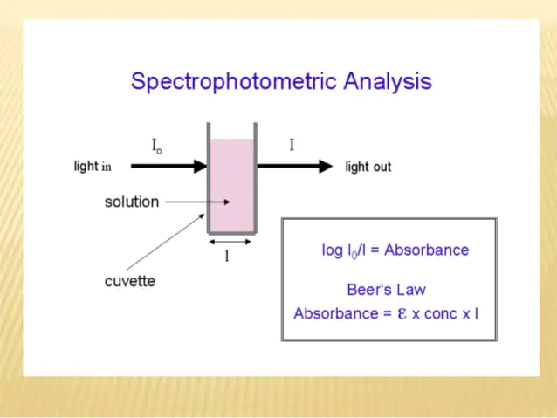
Experiment 1
Determination of the Absorption Spectrum of a Dye

Before setting up the experiment, make sure the spectrophotometer is switched on to warm up.

1. Place around 10ml of the dye (referred to as the standard dye solution) into a test tube. This is your stock of standard dye for experiments 1 and 2. This may already have been aliquoted into a screw cap Universal for you. Be careful not to mistake the standard dye solution for the unknown concentration of dye X.

2. Pipette 1ml of standard dye solution from the test tube into a cuvette (the “test” cuvette). Remember that 1ml = 1000µl

3. Pipette 1ml of water into another cuvette (the “blank” cuvette). You can pour the solutions into the cuvette rather than pipetting it as long as you are very careful. The cuvette needs to be between half full and two thirds full.

4. Read the absorbance of the dye in the spectrophotometer over the wavelength range 500 – 700nm, using water as a “blank” reference solution to zero the instrument. To do this;

- Insert the “blank” cuvette into the spectrophotometer set at 500nm. Zero the instrument.
- Remove the “blank” cuvette and replace with the “test” cuvette – read the absorbance.
- Remove the “test” cuvette and change the wavelength to 510nm.
- Repeat the process at every wavelength.

Remember that the instrument must be set to zero at each wavelength.

5. Record the results in Table 1 below or in an Excel spreadsheet.

6. Construct an absorption spectrum by plotting the absorbance (y axis) against wavelength (x axis).
Label this Figure 1 and give it a Title.

7. Determine the wavelength at which you get maximum absorption: λmax (nm).
This value of λmax (nm) will be used in Experiment 2.
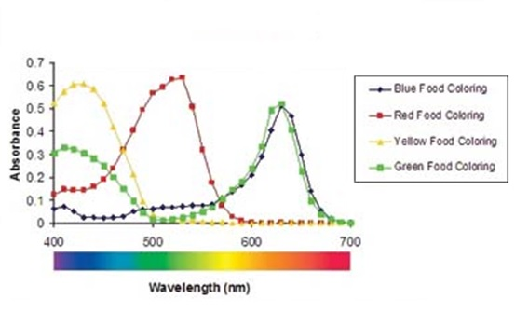
Example absorbance spectra for food colourings. The lambda max for the red food colouring is around 540nm and for the blue food colouring it is around 630nm. Note that there are no units for absorbance

Table 1: Absorption Curve Data for the dye - Record your absorbance values here or in Excel

Wavelength (nm) | Absorbance | Wavelength (nm) | Absorbance | Wavelength  (nm) | Absorbance
500 |  | 570 |  | 640
510 |  | 580 |  | 650
520 |  | 590 |  | 660
530 |  | 600 |  | 670
540 |  | 610 |  | 680
550 |  | 620 |  | 690
560 |  | 630 |  | 700

Absorption spectrum is plotted in Figure 1. λ_{max} = _______________ nm
Experiment 2
Preparation of a Calibration Curve for the Dye and Determination of an Unknown Concentration

You are supplied with:

- Standard Dye solution – you have about 9ml left in the test tube from Experiment 1
- A dye solution of unknown concentration labelled 'X'. Using an automatic pipette, place 2.5ml of the unknown dye solution X into a test tube. Label the test tube “X”.

You are going to dilute the standard dye solution to produce a calibration series whose colour intensity you can measure in the spectrophotometer. The concentration of the standard dye is 5μg/ml.

- Set up a series of test tubes as shown in Table 2 below. Label these carefully at the top.

Perform all dilutions in duplicate (a and b). The solutions S₀ are the blanks (containing only water), S₁ – S₅ are the standards, which will be used to construct a calibration curve; X is the unknown. There should be 13 test tubes in total.

Accurate pipetting and proper mixing of the solutions is crucial in order to create a good calibration curve.

Table 2: Calibration Curve Method for Dye solution

Test tubes  (duplicates) | S₀  a/b | S₁  a/b | S₂  a/b | S₃  a/b | S₄  a/b | S₅  a/b | X  a/b
Final [dye] (μg/ml) | 0 | 1 | 2 | 3 | 4 | 5 | ?
Add the following reagents:
Standard Dye Solution (ml) | 0.0 | 0.5 | 1.0 | 1.5 | 2.0 | 2.5 | -
Distilled water (ml) | 2.5 | 2.0 | 1.5 | 1.0 | 0.5 | 0.0 | -
Unknown dye solution (X ) (ml) | - | - | - | - | - | - | 2.5

- Read the absorbance in the spectrophotometer at the wavelength (λmax) determined in Experiment 1.
As before use one of the S₀ cuvettes as a blank and zero the spectrophotometer using this cuvette. Then read the absorbance of all the other solutions (standards and unknown) following the guidance below. Record the readings in Table 3.

As you are now working with the sample wavelength for all the measurements you no longer need to zero the spectrophotometer between each reading. Once you have measured the absorbance of a solution pour it back into the test tube which is came from. Tap any remaining solution from the cuvette onto a tissue. Avoid touching the clear faces of the cuvette with your fingers as your fingerprints will increase the absorbance. Wipe the cuvette with a tissue if it is wet or dirty. Take care to place the cuvette in the spectrophotometer with the clear sides orientated with the light beam. If in doubt please ask.

- Plot a calibration curve (absorbance on y-axis, dye concentration on x-axis) using the results from the standards (S₀ to S₅). Label this graph Figure 2 and give it a title. Don’t forget to label the axes and include units as appropriate.

You can plot your data using either R or Excel – see the example calibration curve at the end of this document

NB: Plot ALL OF THE INDIVIDUAL values NOT means. Put in the line of best fit through ALL the data points.

- Determine the absorption values for the two unknown dye-containing cuvettes (Xa and b). Using the calibration curve and these values, determine the dye concentration in Xa and Xb. Record the results in Table 3. Calculate the average to give the concentration of solution X as a % of the Standard.

Table 3: Calibration Curve Data for Standard Dye at _______ nm (insert wavelength)

Record the absorbance values here or in Excel. Record the wavelength that you have used for the measurements (lamda max).

Tube | S₀ | S₁ | S₂ | S₃ | S₄ | S₅ | X
Final Standard Dye conc. (μg/ml) | 0 | 1 | 2 | 3 | 4 | 5 | --
Absorbance at
nm Series a
Absorbance at
nm Series b

Use the values for S₀ to S₅ to plot your calibration curve (Figure 2). Remember to put ONE line of best fit to all the data points.

Calculate the concentration values for X_{a} and X_{b} from your calibration curve:

[Dye] in X_{a} = ________ μg/ml

[Dye] in X_{b} = ________ μg/ml

Average [Dye] in X = ________ μg/ml

When you have calculated the dye concentration in sample X, the demonstrator will inform you of the expected concentration.

Now compare YOUR result with the EXPECTED

Expected concentration of X ………………………..μg/ml

My measured concentration of X…………………………..μg/ml

Difference (ie expected – measured) …………………………….μg/ml.

Percentage error ie Difference x100 …………………………….%
Expected

How close to the expected value was YOUR measurement?

What ERRORS do you think may account for any difference from the expected value?

Tidying up

Always tidy up before you leave the lab

Make sure a tutor has checked your graphs and calculations before you leave. Make sure your bench area is checked.

- Put pipette tips in the plastic discard pots
- Rinse cuvettes and put in discard pot
- Rinse test tubes and place on tray by the sink
- Switch off the spectrophotometer (if you are attending the last lab of the day)
- Leave your bench area clean and tidy
- Take off your lab coat and put it away
- Wash your hands

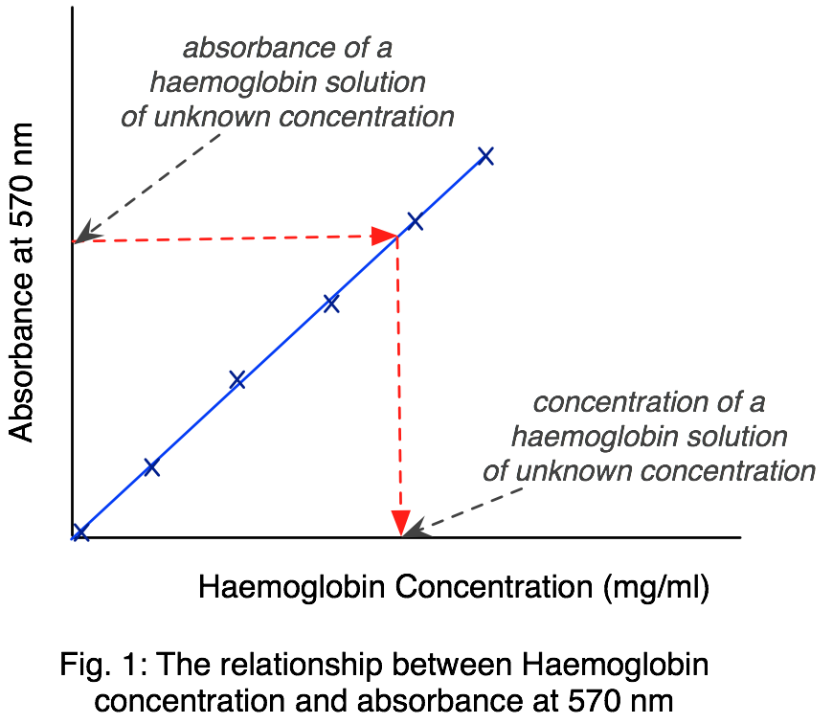

Example calibration curve. Plot of absorbance at 570nm against haemoglobin concentration in mg/ml.

Line of best fit (trendline) – linear model – the equation for a straight line

y = mx + c

Where y = absorbance, m = slope or gradient, x = concentration, and c = y axis intercept

To calculate the concentration of an unknown from its absorbance you can rearrange the equation to:

x = (y – c) / m

If the line of best fit intercepts close to 0,0 (the origin) you can force c to zero on Excel and the equations simplify to:

y = mx x = y / m m = y / x

What does the regression coefficient tell us about the data and the trendline? R²

