4008BIO: Structure, Function and Analysis of Biomolecules
Lab 4: Spectrophotometry

Lab 5: Determination of the unknown protein concentration in the cell free extract using Lowry Protein Assay

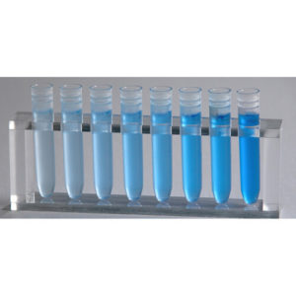



INTRODUCTION

Principles of the Lowry Protein Assay

The Lowry assay is a biochemical assay based on two chemical reactions (Figure 1). The first reaction is the reduction of copper ions under alkaline conditions and formation of a complex with peptide bonds (STEP 1). The second reactions is the reduction of Folin-Ciocalteu reagent by the copper-peptide bond complex, which subsequently causes a color change of the solution into blue with an absorption in the range of 650 to 750 nm.

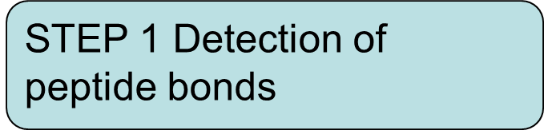
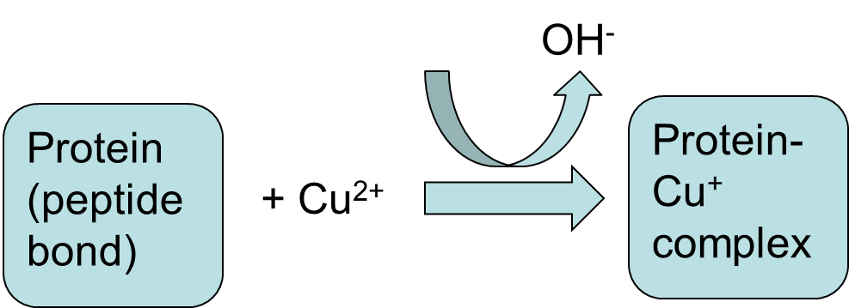

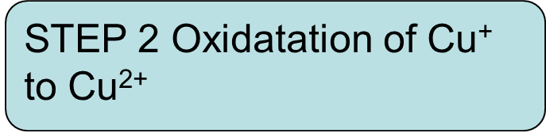

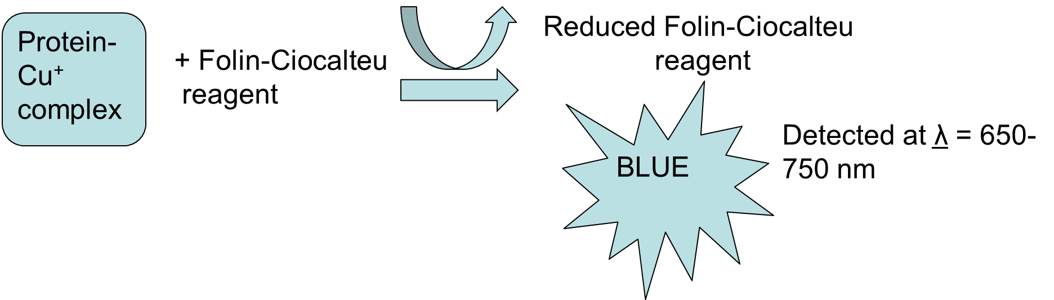

Figure 1. Principles of the Lowry protein assay

A cell free extract is prepared from a suspension of bacterial cells. These are ruptured to releases the intracellular proteins and then centrifuged to remove any cell debris. The protein concentration in the CFE is likely to be greater than the concentration of the highest calibration standard so you will need to prepare dilutions of the CFE for the assay.

Protein Estimation: Lowry Method

- Prepare the calibration curve using Bovine Serum Albumin as a standard

You will need 6 test tubes for the calibration standards and 3 test tubes for preparing the CFE dilutions . Follow the instructions in the table below in order to prepare the dilutions of standard bovine serum albumin (BSA) solution (600 µg/ml).

Test tubes | S₀ | S₁ | S₂ | S₃ | S₄ | S₅
Final [BSA] (μg/ml) | 0 | 60 | 120 | 180 | 240 | 300
Standard BSA Solution (ml) | 0.0 | 0.3 | 0.6 | 0.9 | 1.2 | 1.5
Distilled water (ml) | 3.0 | 2.7 | 2.4 | 2.1 | 1.8 | 1.5

AT THE SAME TIME prepate the dilutions of the unknown protein sample (CFE) in the test tubes. It is important that these are prepared in parallel.

The final volume in the 6 test tubes with the calibration standards will be 3ml (3000ul). Take care with your pipetting. Mix the solutions using a vortex mixer (whirlymixer) or by inversion.

2. Perform dilution on the cell free extract (the unkown protein sample), following the instructions below:

Label 3 test tubes: x10, x50 and x100

Make dilutions of the CFE in these 3 remaining test tubes:

For x10 dilution : take 300 ul of CFE + 2700 ul Water (0.3ml of CFE and 2.7ml of water)

For x50 dilution : take 600 ul from x10 dilution + 2400 ul Water (0.6ml of x10 and 2.4ml of water)

For x 100 dilution: take 250 ul from x10 dilution + 2250 ul Water (0.25ml of x10 and 2.25ml of water)

Then, take 1000 ul (1ml) of each CFE dilutions and each BSA standard into fresh test tubes in DUPLICATE. You should end up with 18 test tubes in total – each containing 1000ul of either one of the standards or one of the CFE dilutions.

- To each add 5000ul (5ml) of alkaline copper solution, mix and wait for 10 minutes

- After 10 minutes, add 500 ul (0.5ml) Folin + Ciocateu’s reagent and mix well. Keep at room temperature for 30 minutes.

- Read the absorbance at 750 nm*. Measure the absorbance by transferring the solution from each test tube to the cuvette. Use one of the So standards to the blank/zero the spectrophotometer. Work from the lowest concentrations to the highest (pale blue to dark blue). Tap any residual solution from the cuvette on to some tissue papare and dry the outside of the cuvette if necessary.

*If your spectrophotometer is unable to read absorbance at 750 nm, use 700 nm, but make sure that you use the same wavelength next time you are carrying out this procedure in this series of labs.

Record your absorbance in the table below, S – standards

Tube | S₀ | S₁ | S₂ | S₃ | S₄ | S₅ | CFE  1:10 | CFE  1:50 | CFE  1:100
Final Standard Dye conc. (μg/ml) | 0 | 60 | 120 | 180 | 240 | 300 | ------- | ------- | ------
Absorbance at
nm Series a
Absorbance at
nm Series b

- Plot a calibration curve from the data (S₀ to S₅)

- Add a trendline and display the equation for the line and the R² value.

- Check your data with one of the lab demonstrators. If your R² value is too low you will need to repeat the analysis.

- Rearrange the equation for the trendline to find the protein concentration in the CFE dilutions from each absorbance measurement

- Multiply the diluted protein concentrations by the dilution factor.

Dilution factor = Final Volume / Volume added

Final concentration = Start concentration / Dilution factor

For example: 0.3ml of the 600ug/ml BSA standard + 2.7ml water

Dilution factor = 3 / 0.3 = 10

Final concentration = 600/10 = 60ug/ml

CFE concentration (undiluted) = concentration in the dilution x dilution factor

For example: the concentration of the x50 dilution = 80ug/ml

Original (undiluted) concentration in the CFE = 80 x 50 = 4000ug/ml = 4mg/ml

