4008BIO: Structure, Function and Analysis of Biomolecules
Lab 5: Gel Filtration

4008BIO Lab 6
Gel Filtration

INTRODUCTION

Gel Filtration (also known as Gel Permeation Chromatography or Exclusion Chromatography) allows the separation of materials on the basis of their differences in molecular size and shape; in general, of course, these properties are a direct reflection of the particular molecular mass.

In pharmacology, substances of very widely varying molecular masses are encountered. These may range from inorganic salts or simple organic molecules of molecular mass 200 Da or less through nucleotides and steroids (400 – 600 Da) to small proteins (500 - 10,000 Da), larger proteins (30,000 - 100,000 Da) and giant polymers such as DNA (several million Da). Thus, gel filtration has understandably become an important and widely used technique for separation and fractionation, especially of proteins.

In low pressure column chromatography (Figure 1), a column is used to support the stationary phase through which the moving phase, buffer, is fed from a reservoir above. Commercial columns are designed to minimise the dead space below the stationary phase material where post-column mixing of separated analytes can occur. This is achieved by means of flow adaptors and capillary tubing. Cheaper alternatives to flow adaptors include the use of a small plug of glass wool.

There are various media that may be used as stationary phase in gel filtration. They include Sephadex™ (micro-beads composed of cross-linked dextran), Bio-gel™ (micro-beads composed of cross-linked polyacrylamide) and Sepharose™ (micro-beads composed of agarose). These come in different types, eg. Sephadex G-50, G-200, Bio-gel P-2, P-10, Sepharose 4B (with different fractionation ranges) and in different grades, eg. coarse, medium, fine, superfine (with different mobile phase flow rate characteristics). This allows the analyst to select the appropriate media dependant on the size of the molecules being separated hence the term size exclusion chromatography.

Objectives
- To gain an understanding of the principles of gel filtration chromatography and its potential applications, eg. for protein purification
- To gain experience in the use of low pressure gel filtration chromatography to separate molecules of different molecular masses
- To use a spectrophotometer to detect the separated molecules in the chromatographic eluates.

This practical will be supported by a lecture and reading from
Biomedical Science Practice, Glencross, Ahmed, Wang; (2011), Oxford University Press. Chapter 13, page 321.

Figure 1: Gel filtration column chromatography equipment:
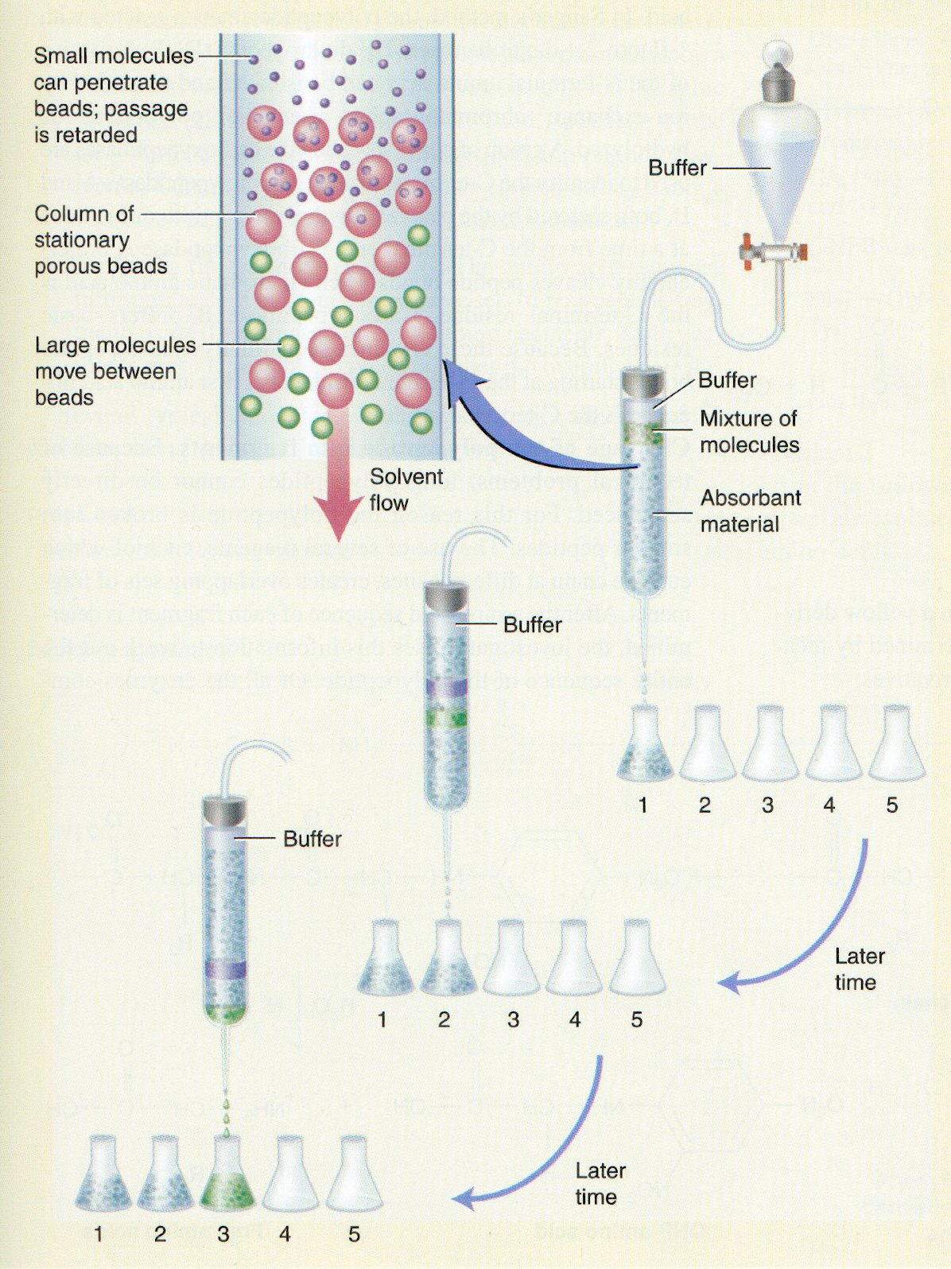

Experimental
To illustrate the principles of gel filtration, three compounds of different molecular mass and of different colours (to enable visual identification) will be used:

EXPERIMENT : Using a 30 cm x 1.0 cm column:

Chromatography column:
Commercial column, 30 x 1.0 cm (approx.)

Sephadex –G50: A prepared slurry of Sephadex G-50 is poured into the column using a small beaker. Allow the slurry to settle in the column for a few minutes – you should be able to see a clear top layer of buffer. Open the bottom tap and carefully allow some of the buffer (eluate) to run from the column into a waste beaker. Avoid letting the column run dry. Beware of trapped bubbles.

Eluate
Phosphate buffer pH 6.0

Dye mixture containing (Eppendorf tube – flip top vial)
Dextran blue (polysaccharide derivative) 2,000,000 Da BLUE.
Cytochrome c (respiratory chain protein) 13,000 Da RED.
Nitrazine yellow (an organic pH indicator) 547 Da YELLOW.

METHOD

- Fill a 24-tube rack with test tubes numbered 2, 4, 6, 8, etc (more may be required). These are for collecting fractions from the column. (The reason for numbering the tubes like this is that 2 ml fractions are to be collected).

- With the tap closed, remove most of the buffer/eluant above the gel surface using a pastette.

- Carefully pipette 0.2 ml of the dye mixture on top of the gel bed (don’t worry if you have less than 0.2ml if the dye in your Eppendorf tube, just add it all).

- Open the tap and allow the sample to drain into the bed. DO NOT LET AIR BUBBLES ONTO THE COLUMN. Close the tap.

- Wash the top of the gel and the column wall with a few drops of buffer using a pastette.

- Open the tap and allow the wash to drain into the column. DO NOT ALLOW THE GEL BED TO RUN DRY.

- Position the funnel (which also acts as a reservoir) into the top of the column and fill with buffer.

- Collect the eluate (Take care!) in a measuring cylinder in 2 ml fractions and pour these into the numbered test tubes. The progress of the three compounds down the column can be followed as they separate into three coloured bands.

- While you are collecting fractions, note the flow rate (ml/min) by timing the collection of a fraction. You only need to do this once.

- Continue collecting fractions until you have one clear tube after the third colour has been eluted.

- Note the colour of the contents of each tube.
USING THE SPECTROPHOTOMETER ASSIGNED TO YOUR GROUP
Measure the absorbance of the contents of:
(a) the dextran blue containing tubes only at 630 nm;
(b) the red cytochrome c containing tubes only at 410 nm;
(c) the nitrazine yellow containing tubes only at 464 nm.

Dilute the samples if necessary. If colours overlap, then measure at both appropriate wavelengths.

Record your results in the Results sheet provided.
Plot the elution profile and determine the various parameters asked for in the Results sheets.

QUESTIONS

(Questions 1 – 3 to be answered during laboratory)

Q1. Draw a labelled diagram to demonstrate how molecules of different molecular mass are separated by gel filtration.

Q2. This practical makes use of Sephadex G-50:
(a) What is Sephadex G-50 made of?

(b) Define ‘exclusion limit’.

(c) What is the exclusion limit of Sephadex G-50?

(d) Define ‘fractionation range’.

(e) What is the fractionation range of Sephadex G-50?

Q3. Define the following terms. Indicate how they can be estimated.

(a) gel bed volume (V_{T}):

(b) void volume (V_{O}):

(c) elution volume (V_{E}):

RESULTS: COMPLETE BEFORE YOU LEAVE THE LABORATORY

RESULTS (for Experiment 1):

- Record in the appropriate tables on the Results sheet the absorbance readings of the collected fractions of eluate. Plot a graph of the elution profile (absorbance versus cumulative volume of eluate).

- Comment briefly (in the Results sheets) upon the separation and resolution of the dye mixture seen.

- Estimate the following from the graph and enter the values in the Results sheets:
(a) the gel bed volume (V_{T});
(b) the void volume (V_{O});
(c) the elution volume (V_{E}) of cytochrome c; and
(d) Record the flow rate for the column.

Table 1: Gel filtration Elution Profile for dye mixture

Elution  Volume  (ml) | Dextran blue  (A₆₃₀) | Cyt c  (red)  (A₄₁₀) | Nitrazine  Yellow  (A₄₆₄)
2
4
6
8
10
12
14
16
18
20
22
24
26
28
30
32
34
36
38
40
42
44
46
48
50
52
54
56
58
60
62
64
66
68
70

The data are plotted in Figure 2

Table 2: Brief comments on the separation and resolution of the dye mixture achieved:

Column: | Separation | Resolution
Compounds:

1.

2.

3.

Overall comments on separation:

Table 3: Determine from the elution profile the:
Gel bed volume (V_{T}), void volume (V_{O}), elution volume for cyt C and the mobile phase flow rate:

Column: | (a)  V_{T}  (ml) | (b)  V_{O}  (ml) | (c)  V_{E} for  cyt c  (ml) | (d)  Mobile phase  flow rate  (ml/min)
Experiment 1:

Comments:

