4006BIO: Human Physiology: Homeostasis and Health
Physiology Lab 1: Surface electromyograms (EMGs)
- Record surface EMGs.
- Measure the decline in maximal force during a sustained contraction.
- Examine properties of muscular fatigue.

Lab protocol
Part A
Setup
Before electrode attachment
- Remove any jewellery from the volunteer's wrists.
- Connect the Bio Amp cable to the Bio Amp socket on the PowerLab.
- Connect the five color-coded shielded cables to the Bio Amp cable.
- Make sure the PowerLab is connected to the computer and turned on.
- Attach the green shielded cable to the dry earth strap. (If the dry earth strap has a single connector cable, see how to connect it to the Bio Amp cable.)
- Firmly attach the dry earth strap around the volunteer's wrist. The fuzzy side of the dry earth strap needs to make full contact with the skin.
- Lightly mark two small crosses on the skin overlying the volunteer's biceps muscle, and two crosses over the triceps muscle. The crosses should be 2–5 cm apart and aligned with the long axis of the arm.
Electrode attachment
- Lightly abrade the skin over the crosses with abrasive gel, then clean with an alcohol swab.
- Snap the CH1 and CH2 shielded cables onto the disposable ECG electrodes.
- Place the CH1 electrodes over the crosses on the volunteer's biceps, and the CH2 electrodes over the crosses on the volunteer's triceps. Press firmly so they adhere well. It doesn't matter which is positive and which is negative.
- Check that all 4 electrodes and the dry earth strap are properly connected to the volunteer and the Bio Amp cable before proceeding.

Experiment A1: Electromyography
Procedure
Part A1
- Ask the volunteer to sit in a relaxed position with an elbow bent to 90°, and the palm facing upwards. The volunteer should use his or her other hand to grasp the wrist of the arm from which the signal is being recorded.
- Select Start to record. Enter "biceps contraction" into the Comment panel, then select Add. Ask the volunteer to moderately contract the biceps muscle for 3–5 s by trying to bend the arm while resisting this movement with the hand grasping the wrist.
- Ask the volunteer to relax for a few seconds.
- Prepare the comment: "triceps contraction", then select Add. Ask the volunteer to moderately contract the triceps muscle for 3–5 s by trying to straighten out the arm while resisting this movement with the hand grasping the wrist.
- Ask the volunteer to relax for a few seconds.
- Repeat steps 1–5, but this time make a maximal contraction of the biceps and then the triceps muscles.
- Select Stop.
Part A2
- Ask the volunteer to sit in a relaxed position as before, (ensure their arm is not resting on anything).
- Select Start to record.
- Enter "no weights" into the Comment panel, then select Add.
- After 3–5 s, prepare the comment: "1kg" and then select Add. Place a 1kg weight on the volunteer's hand and ask them to remain as still as possible. Record for 2–3 s.
- Select Stop.
- To record the effect of increasing weights, repeat steps 2–5 and increase the number of weight blocks by 1 each time until you reach 4. Add a comment for each weight addition - e.g., 1kg, 2kg, 3kg, 4kg, etc.
Result
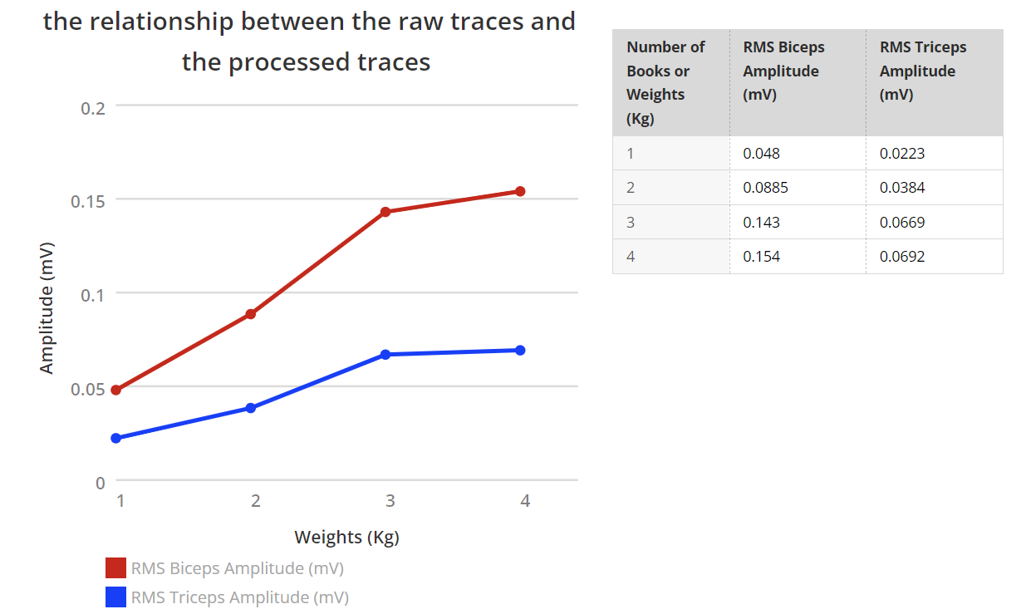
1B: Equipment Setup
Grip force transducer
- Ensure the PowerLab is connected to your computer and turned on.
- Remove the Bio Amp cable from your PowerLab.
- Connect the grip force transducer to Input 1 of the PowerLab.

Experiment 1B: Calibration
Procedure
Maximum contraction
- Select Start to record, leaving the grip force transducer undisturbed on the table for 5 s.
- Next, ask the volunteer to squeeze the grip force transducer as hard as possible, for as long as possible. You may need to select Auto Scale to view the signal.
- Enter "calibration" into the comment panel, then select Add.
- After 5 s, tell the volunteer to relax and select Stop.
Calibration
- Use the region selector to highlight a region of baseline data for zero force.
- Select the small arrow next to Value 1 in the Units Calibration panel to enter this value.
- Type "0" into its corresponding percentage value.
- Next, select an area of maximal grip force. Select the small arrow next to Value 2 in the Units Calibration panel to enter this value.
- Type "100" into the corresponding percentage value.
- Select Calibrate. The Grip Force units should now change to %. The calibration is now complete.

Experiment 1B: Muscle Fatigue
Before you begin
Ensure the volunteer can see the computer screen.
Procedure
- Select Start to record. Ask the volunteer to apply and maintain 25% of their maximal grip strength while watching the recorded trace. Enter "25%" in the Comment panel and select Add.
- After 25 s, tell the volunteer to relax and select Stop.
- Wait for 30 s to allow recovery of muscle function.
- Repeat steps 1–3 for contractions of 50%, 75%, and 100% of maximal grip strength. Add a comment for each trial.

Results
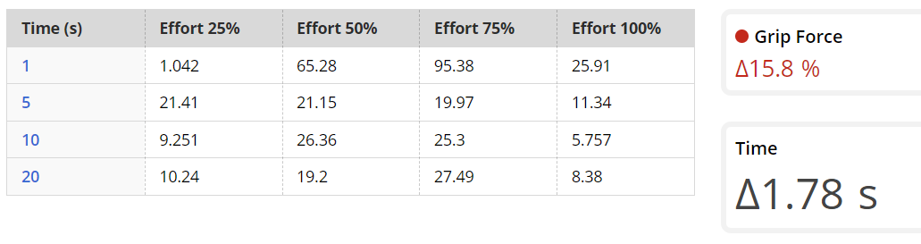
Part 1B: Force with Encouragement
Before you begin
Ensure the volunteer cannot see the computer screen.
Procedure
Encouragement
- Select Start to record, and ask the volunteer to produce a sustained maximal contraction (100% grip force).
- Enter "encouragement" in the Comment panel, but don't add it yet.
- After 8–10 s or when the force has obviously declined, select Add to enter the comment and immediately instruct the volunteer to try harder.
- After a further 8–10 s, select Add to re-enter the comment and then repeat the encouragement.
- Repeat step 4, so you have encouraged the volunteer a total of 3 times.
- A few seconds later, ask the volunteer to relax and select Stop.
Rest
- Select Start to record.
- Ask the volunteer to produce a sustained maximal contraction (100%).
- Enter "rest" into the Comment panel, but don't add it yet.
- After 8–10 s select Add to enter the comment and instruct the volunteer to relax very briefly (~0.5 s) and then return to maximal contraction.
- Repeat step 4 another 2 times, so the volunteer has rested for a total of 3 times.
- After 30–40 s, select Stop.

Results
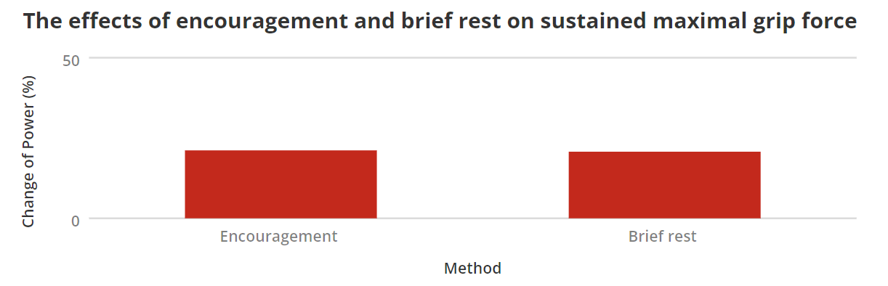
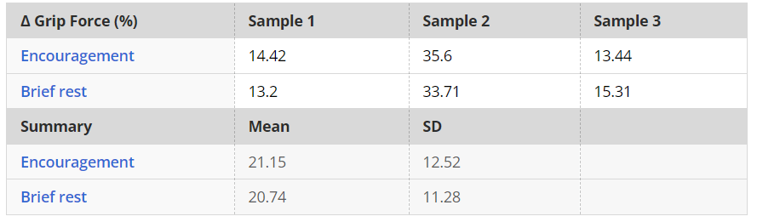

Part 1B: Visual Feedback
Before you begin
Ensure the volunteer can see the computer screen. Allow the volunteer to use their other hand if gripping the transducer has become painful.
Procedure
- Select Start to record. Ask the volunteer to produce a 50% contraction while watching the trace.
- Enter "eyes closed" into the Comment panel, but don't add it yet.
- After 20 s select Add. Ask the volunteer to close his or her eyes and attempt to maintain exactly the same contraction force for the next 20 s.
- Enter "eyes open" into the Comment panel. After the elapsed time, select Add. Ask the volunteer to open his or her eyes and adjust the contraction force back to 50%.
- When adjusted to 50%, select Stop.

(No result Backup)

