4006BIO: Human Physiology: Homeostasis and Health
Physiology Lab 2: Surface electromyograms (EMGs)
- List factors that may contribute to muscle fatigue.
- Record compound muscle action potentials from a thumb muscle (the abductor pollicis brevis) by stimulating the median nerve at the wrist.
- Calculate nerve conduction velocity from the difference in latency between responses evoked at the wrist and the elbow.
Lab protocol
Part 2
Setup
- Connect the electrode cables to EARTH, CH1 NEG and POS on the Bio Amp cable.
- Plug the Bio Amp cable into the Bio Amp input.
- Connect the stimulating bar electrode to the Isolated Stimulator output of the PowerLab:
  - the red (positive) connector to the red output.
  - the black (negative) connector to the black output.
- Make sure the PowerLab is connected and turned on.
- Remove any jewellery from the volunteer's wrists.
- Connect the earth electrode cable to the dry earth strap. Wrap the dry earth strap around the volunteer's wrist.
- With a ballpoint pen, lightly mark two small crosses on the skin above the abductor pollicis brevis muscle in the position for the recording electrodes shown in the figure. The crosses should be 2–3 cm apart.
- Lightly abrade the marked skin to reduce its electrical resistance.
- Obtain two new disposable ECG electrodes and trim the adhesive pad slightly so they will fit as shown in the figure.
- Snap the electrode cables from CH1 on the Bio Amp cable onto the electrodes.
- Place the electrodes onto the skin over the crosses so they adhere well. To reduce electrode movement, use adhesive tape to attach the cables to the skin close to the electrode.
! The red dot on the back of the bar electrode indicates the positive electrode. Orient the electrode as shown in the figure below, with the positive electrode closer to the elbow.
- Place a small amount of electrode paste on the two metal pads of the stimulating bar electrode.
- Place the stimulating bar electrode over the volunteer's median nerve at the wrist (the approximate placing is shown in the figure).
- Turn on the Isolated Stimulator (the switch should in the upward position towards ON). The Isolated Stimulator only becomes active during a recording. It is switched off internally at all other times.
Experiment 2A: Nerve stimulation
Procedure
- Ensure the pulse current is set to 8 mA in the Isolated Stimulator panel.
- Ensure the Isolated Stimulator is turned on.
- Select Start and a short pulse current will pass through the volunteer's skin. Refer to these tips if the light flashes yellow.
- The Scope panel will automatically stop recording after 100 ms. You need to select Start each time you want to stimulate the nerve.
- Take note of the twitch contractions affecting the thumb and fingers. Examine the effect of small adjustments in the position of the electrodes. Locate the electrode position that produces the largest twitches.
If you cannot obtain a response, increase the current amplitude by 2 mA, or reposition the stimulating bar electrode.
- With a ballpoint pen, lightly mark two small crosses on the skin over the median nerve at the wrist in the position that the electrode gives the most effective stimulation. The crosses should be about 4 cm apart.
- Explore the motor and sensory results of stimulating at other places in the forearm. Each time you move the electrode to another location, wipe away the residual electrode paste from the skin to prevent short-circuiting (stimulation will be ineffective if the current flows along a surface layer of electrode paste rather than through the arm).
- Try to stimulate the median nerve at the level of the elbow. You will need to apply the stimulating electrode to the skin on the medial side of the biceps tendon. You will need to press the electrode firmly to place it close to the nerve.

Experiment 2A: Evoked EMG
Procedure
- Set the pulse current to 4 mA in the stimulator panel.
- Select Start every time you want to stimulate. Recording will automatically stop after 100 milliseconds.
- Place the bar electrode over the position you have marked that gives the best contractile response when the nerve is stimulated. You will need to press the stimulus electrode firmly against your wrist to ensure that the nerve is stimulated and that the electrode doesn't move around during the activity.
- Your thumb should twitch when you apply the stimulation. If you do not obtain a response, reposition the stimulus electrode and try again.
- When the electrode is optimally placed, increase the amplitude by 2 mA and then select Start to stimulate. Keep increasing the amplitude by 2 mA increments until either of the following happens:
- You reach 20 mA.
- The response no longer increases.
- Turn the Isolated Stimulator switch off.
- Remove the stimulating bar electrode and mark with a ballpoint pen the electrode indentation in the skin nearest to the hand.
! If you cannot obtain a response, increase the pulse current to 12 or 14 mA. If there is still no response, try stimulating the ulnar nerve. In some people the abductor pollicis brevis is innervated by the ulnar nerve instead of the median nerve.

Results
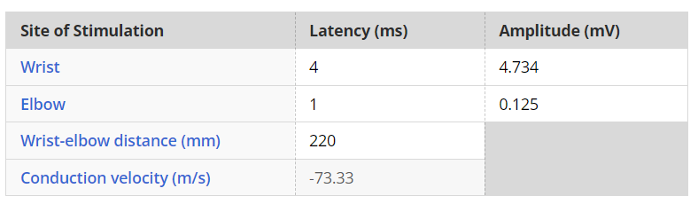
Experiment 2B: Nerve Conduction Wasn’t Conducted
Procedure
- Position the stimulating bar electrode on the medial aspect of the front of the elbow. The electrode requires firmer pressure at the elbow than at the wrist because the nerve is deeper in the tissues. The orientation of the electrode should be the same as for wrist stimulation.
- Ensure the Isolated Stimulator is turned on.
- Set the current in the stimulator panel to 8 mA.
- Select Start every time you wish to stimulate. Do this several times using low-amplitude pulses to help find the best position for the electrode.
- Your thumb should twitch when you apply the stimulation. If you do not obtain a response, reposition the stimulus electrode and try again. See a typical EMG response.
- If you still cannot obtain a response, increase the stimulator amplitude or reposition the stimulus electrode.
- When you have found the best position for the stimulating bar electrode, increase the stimulus to 15–20 mA until you get a robust EMG response.
- Turn off the Isolated Stimulator.
- Remove the stimulus electrode and mark with a ballpoint pen the electrode indentation in the skin nearest to the hand.
- Remove the other electrodes.

