4006BIO: Human Physiology: Homeostasis and Health
Physiology Lab 3: Spirometry
- Perform pulmonary function tests on a volunteer.
- Measure and analyze pulmonary function variables (such as FEV₁) using your volunteer's data.
- Appreciate how it feels to breathe with constricted airways, such as in asthma.
- Compare the pulmonary function variables between normal data and "simulated asthma" data.
Equipment setup
Setup
- Connect the Spirometer Pod to Input 1 on the PowerLab.
- The Spirometer Pod is sensitive to temperature and tends to drift during warm-up. To prevent this, turn on the PowerLab at least 5 minutes before use. Then place the Spirometer Pod on a shelf or beside the PowerLab, away from the PowerLab power supply.
- Connect the two plastic tubes from the flow head to the short pipes on the back of the Spirometer Pod.
- Attach clean-bore tubing, a filter, and a mouthpiece to the flow head.
- Make sure you have extra mouthpieces and disposable air filters for each volunteer.
Part 1A: Zeroing the Spirometer Pod
Procedure
- Leave the flow head apparatus undisturbed on the bench and select Zero Inputs. This will reset the offset of the Flow channel to zero.
- Ask the volunteer to put on the nose clip. If possible, leave the nose clip on for the entire lab to promote breathing through the mouth. This ensures that all air breathed passes through the mouthpiece, filter, and flow head.
! To calculate volume from the flow, start recording before breathing through the flow head.
- Select Start to record. The mouthpiece can now be put into the volunteer's mouth.
- Hold the flow head with two hands with the plastic tubing pointed upwards.
- Observe the data. Select Auto Scale if required. Expiration should be a downward deflection. If the signal deflects upward stop recording and swap the tubular connections on either the back of the Spirometer Pod or the flow head.
- When the volunteer has become accustomed to the apparatus, select Stop.
! Make sure the volunteer keeps the nose clip on and breathes through the mouthpiece.

Part 1A: Volume correction
Procedure
Zeroing
- Re-zero the Spirometer Pod using the Zero Inputs button. Remember that the flow head must be left undisturbed on the bench during the zeroing process.
- Select Start before you ask the volunteer to pick up the flow head and start breathing through it.
- The volunteer should remain in the same setup as on the previous page.
- Ask the volunteer to inhale and exhale normally through the flow head. That is, normal tidal breathing for 1 minute.
- Enter "volume correction procedure" into the Comment panel, then select Add.
- At the end of 1 minute, select Stop. The volunteer should continue breathing through the flow head and keep the nose clip on.
Calibrating
- Use the compression buttons and scroll bar to view the normal tidal breathing.
- Use the region selector to select the regular breathing data. Do not select the areas of zero flow at the beginning and end of the recording.
- In the Spirometry panel, select Calibrate. This will apply a volume correction to your data.
Experiment 1A: Dynamic Function Tests
Procedure
- Zero the Spirometer Pod using the Zero Inputs button. Remember that the flow head must be left undisturbed on the bench during the zeroing process.
- Select Start to record. Ask the volunteer to breathe normally for approximately 20 s.
- Prepare the comment "FVC procedure".
- Ask the volunteer to slowly inhale until no more air can be inspired and hold for no more than 1 second. Then exhale as forcefully, as fully, and for as long as possible, until no more air can be expired. During this procedure select Add to enter the comment.
- Allow the volunteer's breathing to return to normal, then select Stop.
- Your recording should resemble this.
- Repeat steps 2–5 twice more, so that you have 3 separate FVC recordings.
Results
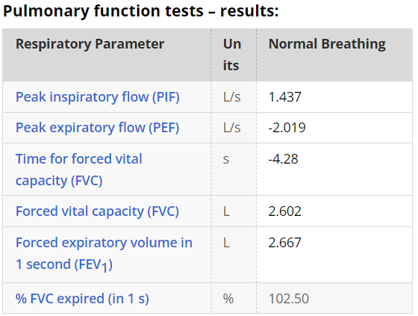
Experiment 1B: Equipment Setup
Setup
Modifications to the equipment below mimics the effects of bronchial obstructions (for example, asthma).
- Remove the filter attachment from the clean-bore tubing.
- Cover the end of the filter with duct tape.
- Use a pen or a sharpened pencil to make a hole in the duct tape approximately 5 mm in diameter.
- Reattach the filter to the clean-bore tubing.
Experiment 1B: Obstructed airways
Background: Patients with chronic lung diseases fall into three main categories;
- obstructive lung disease (or COPD)
- restrictive disease
- asthma (in which there is also obstruction to airflow)
Procedure
- Re-zero the Spirometer Pod using the Zero Inputs button. Remember that the flow head must be left undisturbed on the bench during the zeroing process.
- Select Start. Ask the volunteer to breathe normally through the flow head for 30 s.
- Select Stop and apply the volume correction procedure.
- Select Start. Ask the volunteer to breathe normally for approximately 20 s.
- Prepare the comment "obstructed FVC".
- Ask the volunteer to slowly inhale until no more air can be inspired and hold for no more than 1 second. Then exhale as forcefully, as fully, and for as long as possible, until no more air can be expired. During this procedure select Add to enter the comment.
- Allow the volunteer's breathing to return to normal, then select Stop.
- Repeat steps 4–7 twice more, so that you have 3 separate FVC recordings.
! You should use the same volunteer who performed the first activity.

Results
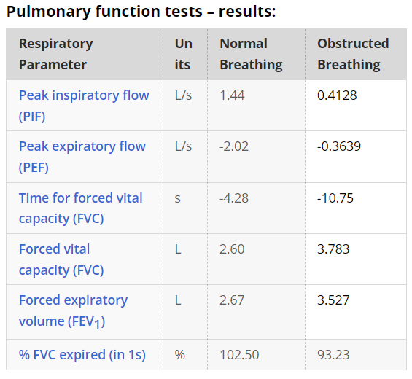
Experiment 1C: Peak Flow Meter
Procedure
- For each volunteer, attach a new disposable mouthpiece to the peak flow meter.
- Make sure that the pointer is set at zero.
- Sit or stand up straight with your head up. (Standing allows you to fill your lungs with air better.)
- Hold the peak flow meter horizontally, and keep your fingers away from the pointer.
- Take the deepest possible breath.
- Place the mouthpiece in your mouth, between your teeth. Close your lips around it.
- Blow out as hard and fast as you can! Remember that you are measuring the speed of the airflow.
- Record the value in the appropriate place in the table below.
- Move the pointer back to zero, and repeat these steps twice more. If you cough or make a mistake, do not include this as one of your three attempts.
- Repeat steps 1–9 for each member of your group.
! After you perform three consecutive blows, the readings should all be about the same. If they are not, you may not be blowing into the device correctly.

Experiment 2: Lung Volumes
- Record and analyze your own respiratory variables.
- Relate your recorded lung volumes and capacities to those of a typical person of the same sex, height, and age.
- Perform pulmonary function tests, and analyse dynamic variables from your volunteer's data.
- Appreciate how it feels to breathe with hyperinflated lungs.
Experiment 2A: Equipment Setup
Setup
- Connect the Spirometer Pod to Input 1 on the PowerLab.
- The Spirometer Pod is sensitive to temperature and tends to drift during warm-up. To prevent this, turn on the PowerLab at least 5 minutes before use. Then place the Spirometer Pod on a shelf or beside the PowerLab, away from the PowerLab power supply.
- Connect the two plastic tubes from the flow head to the short pipes on the back of the Spirometer Pod.
- Attach clean-bore tubing, a filter, and a mouthpiece to the flow head.
- Make sure you have extra mouthpieces and disposable air filters for each volunteer. Also, make sure to have a tape measure for measuring the volunteer's height.
Experiment 2A: Zeroing the Spirometer Pod
Procedure
- Leave the flow head apparatus undisturbed on the bench and select Zero Inputs. This will reset the offset of the Flow channel to zero.
- Ask the volunteer to put on the nose clip. If possible, leave the nose clip on for the entire lab to promote breathing through the mouth. This ensures that all air breathed passes through the mouthpiece, filter, and flow head.
! To calculate volume from the flow, start recording before breathing through the flow head.
- Select Start to record. The mouthpiece can now be put into the volunteer's mouth.
- Hold the flow head with two hands with the plastic tubing pointed upwards.
- Observe the data. Select Auto Scale if required. Expiration should be a downward deflection. If the signal deflects upward stop recording and swap the tubular connections on either the back of the Spirometer Pod or the flow head.
- When the volunteer has become accustomed to the apparatus, select Stop.
! Make sure the volunteer keeps the nose clip on and breathes through the mouthpiece.
Experiment 2A: Volume Correction
Procedure
Zeroing
- Re-zero the Spirometer Pod using the Zero Inputs button. Remember that the flow head must be left undisturbed on the bench during the zeroing process.
- Select Start before you ask the volunteer to pick up the flow head and start breathing through it.
- The volunteer should remain in the same setup as on the previous page.
- Ask the volunteer to inhale and exhale normally through the apparatus. That is, normal tidal breathing for 1 minute.
- Enter "volume correction procedure" into the Comment panel, then select Add.
- At the end of 1 minute, select Stop. The volunteer should continue breathing through the flow head and keep the nose clip on.
Volume correction
- Use the compression buttons and scroll bar to view the normal tidal breathing.
- Use the region selector to select the regular breathing data. Do not select the areas of zero flow at the beginning and end of the recording.
- In the Spirometry panel, select Calibrate. This will apply a volume correction to your data.

Experiment 2A: Static Measurements
Procedure
- Re-zero the Spirometer Pod using the Zero Inputs button. Remember, the flow head must be left undisturbed on the bench during the zeroing process.
- Ask the volunteer to hold the flow head with the tubes pointed upwards.
- Select Start to record.
- Enter "normal tidal breathing" into the Comment panel, then select Add.
- Prepare the comment "lung capacity procedure" in the Comment panel.
! Note: The following procedure should not be performed rapidly, but at the same speed as a regular tidal breath.
- After the tidal breathing period, ask the volunteer to inhale as deeply as possible, then exhale all the air they possibly can. At the same time select Add to enter the comment.
- Afterwards, allow the volunteer to return to normal tidal breathing.
- Select Stop.
- Your recording should resemble this. You may want to repeat the lung capacity procedure several times.
- Complete the table below to predict your volunteer's residual volume (RV). See the height units conversion table, if required.
Results
