4006BIO: Human Physiology: Homeostasis and Health
Physiology Lab 4: ECG
- Record an ECG and identify the major components.
- Explain the temporal relationship between the ECG and the finger pulse.
- Interpret events in the cardiac cycle, and relate these to features in the ECG and the finger pulse.
- Show the electrode placement to perform an 12-lead ECG.
- Describe how the different "views" of the heart are provided by the 12 leads.
Experiment 1A: Equipment Setup
Setup
- Make sure the PowerLab is connected to your computer and turned on.
- Connect the electrode cables to EARTH, CH1 NEG, and CH1 POS on the Bio Amp cable.
- Connect the Bio Amp cable to the Bio Amp input on the PowerLab.
- Connect the finger pulse transducer to Input 1 on the PowerLab.
Attaching ECG electrodes
Procedure
- Remove any jewelry from the volunteer's wrists and ankles.
- Use a pen to mark a small cross on the volunteer's skin where each electrode will be placed (that is, both wrists and the right leg).
- Lightly abrade the skin with abrasive gel, and clean the area with alcohol swabs.
- Snap disposable electrodes onto the three electrode cables.
- Attach the electrodes to the following prepared areas on the volunteer's skin:
- Place the positive electrode on the left wrist.
- Place the negative electrode on the right wrist.
- Place the earth electrode on the right leg.
- Ensure the finger pulse transducer is attached to a distal part of the volunteer's middle or index finger.
Experiment 1A: ECG and Pulse: At Rest
Procedures
The volunteer should relax and sit as still as possible to minimize signal artifacts due to movements.
- Enter the volunteer's name into the Comment panel.
- Select Start to record, then select Add.
- Use Auto Scale to see the data clearly in all channels.
- After 60 s, select Stop. Leave the ECG cables and electrodes attached to the volunteer.
- Examine the ECG recording. Compare it to a model ECG recording.
Results
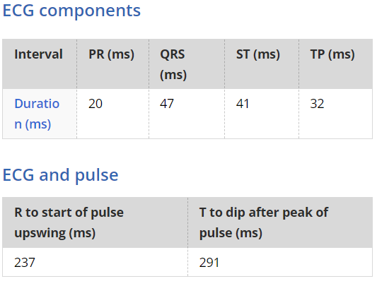
Experiment 1A: ECG and Pulse: With Exercise
Procedures
! Using the same procedure as you did for 'rest' now, using the same trace, complete 2 minutes exercise (or enough to significantly raise your heart rate) by doing some star jumps or simply jogging on the spot and then reconnect the electrodes and obtain another ECG.
- Select Start to record, then Enter the comment - 'After 2 minutes exercise', by pressing Add.
- Use Auto Scale to see the data clearly in all channels.
- After 60 s, select Stop. Leave the ECG cables and electrodes attached to the volunteer.
- Examine the ECG recording. Compare it to your resting trace.
Results
