4006BIO: Human Physiology: Homeostasis and Health
Physiology Lab 4: Blood Pressure
- Explain what is meant by systolic blood pressure and diastolic blood pressure.
- Use a sphygmomanometer and stethoscope to measure human arterial blood pressure.
- Demonstrate how measurement position affects the magnitude of the arterial blood pressure.
- Demonstrate how cuff size affects the measured blood pressure.
- Demonstrate how to measure blood pressure in the leg.

Lab Protocol
Experiment 1A: Auscultation
Palpation procedure
! Here you will palpate the pulse to estimate systolic blood pressure.
- Wrap the blood pressure cuff around the volunteer's upper arm, and just above the elbow. Ensure that the cuff fits firmly and is not loose.
- Feel for the brachial or radial pulse, then inflate the cuff by squeezing the bulb until the pulse is no longer detectable.
- The pressure on the sphygmomanometer when the pulse is no longer detectable is an estimate of the systolic blood pressure.
- Enter this value in the table.
- Deflate the cuff by turning the release valve.
! The "palpatory" estimation of systolic blood pressure can be very useful when auscultatory sounds are difficult to distinguish. For example, patients who are in shock, pregnant, or following exercise.
Results
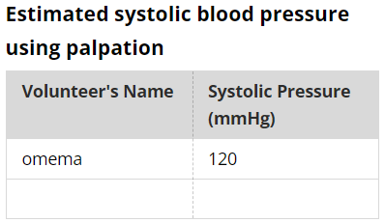
Stethoscope procedure
! You will now record the systolic and diastolic blood pressure as you listen to the Korotkoff sounds. To perform this correctly, you must be familiar with the use of a stethoscope and sphygmomanometer.
- Place the stethoscope diaphragm over the brachial artery. Inflate the cuff to 30 mmHg higher than the estimated systolic pressure (see the table above).
- Slowly reduce the pressure in the cuff (~1–2 mmHg/s) while listening through the stethoscope for Korotkoff sounds.
- The systolic pressure is the pressure at which sharp, tapping sounds are first heard.
- Continue to slowly reduce the cuff pressure. The diastolic pressure is defined as the pressure at which the sounds disappear.
- Completely deflate the cuff after diastolic pressure is determined. Never leave the cuff inflated, or partially inflated.
- For each volunteer, record two measurements of the blood pressure. Allow 1–2 minutes between measurements for recovery.
Results
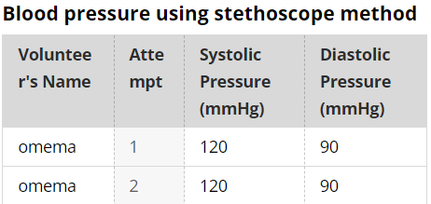

Experiment 1B: Equipment Setup
Setup
- Connect the pressure transducer to Input 1 on the PowerLab.
- Ensure the blood pressure transducer is attached to the cuff.
- Wrap the cuff around the upper arm of your volunteer, just above the elbow.
- Connect the finger pulse transducer to Input 2.
- Place the pressure pad of the finger pulse transducer against the distal segment (the tip) of the middle finger of the volunteer's hand (on the same arm as the cuff).
- Use the Velcro strap to attach it firmly, neither too loose nor too tight.

Experiment 1B: Blood Pressure and Finger Pulse
Procedure
- Use the same volunteer as in the previous activity.
- The volunteer should relax with hands in the lap, and sit as still as possible to minimize movement artifacts.
- Select Start to record. Enter the volunteer's name into the Comment panel, then select Add. The recorded pulse should look similar to this example.
- Inflate the cuff to 30 mmHg higher than the estimated systolic pressure (see the table below, for your reference). Note that the finger pulse signal disappears.
- Enter "arm at heart level" into the Comment panel, then select Add.
- Slowly deflate the cuff at a rate of 1–2 mmHg/s. Note where the finger pulse signal reappears.
- Deflate the cuff completely after the pressure falls below 50 mmHg, and select Stop.
- Now repeat the procedure with the arm above the head. Select Start to record, inflate the cuff to 30 mmHg above systolic, then allow the pressure to decrease slowly.
- Enter "arm above head" into the Comment panel, then select Add.
- Deflate the cuff completely after the pressure has fallen below 50 mmHg, and select Stop.

Results
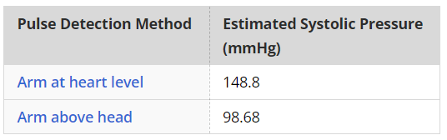

Experiment 1C: Equipment Setup
Setup
- Leave the blood pressure transducer connected to Input 1 of the PowerLab.
- Ensure the blood pressure transducer is attached to the cuff.
- Wrap the cuff around the upper arm of your volunteer, just above the elbow.
- Remove the finger pulse transducer from Input 2.
- Connect the cardio microphone transducer to Input 2. In the following activities you will place the cardio microphone over the brachial artery.
! You should locate the brachial artery by palpation. It lies slightly medial to the tendon of the biceps muscle just above the elbow. If it lies below the level of the cuff you should use a Velcro strap to secure the cardio microphone over the artery. If it lies conveniently beneath the cuff you can use the cuff to hold the cardio microphone in place over the volunteer's brachial artery.
Note: The side of the cardio microphone with the hole in it should be placed next to the skin.

Experiment 1C: Cardio Microphone
Procedure
Try to keep room noise to a minimum in these activities to avoid a noisy recording from the cardio microphone.
- Ensure the cardio microphone is positioned over the brachial artery and held in place with a Velcro strap.
- Select Start to record.
- Inflate the cuff to 30 mmHg higher than the estimated systolic pressure.
- Slowly reduce the pressure in the cuff (~2–3 mmHg/s).
- Deflate the cuff completely after the pressure has fallen below 50 mmHg or after the disappearance of the Korotkoff sounds. Enter "slow" into the Comment panel, then select Add.
- Select Stop.
- Allow 1–2 minutes for recovery.
- Repeat the procedure on the same volunteer, but modify the speed at which you release the pressure in the cuff. Enter "medium" and "fast" into the Comment panel, and select Add when deflating at the respective speeds.
Results
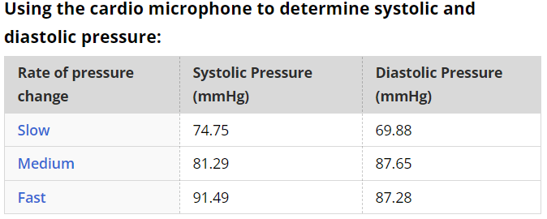

Experiment 1C: Cuff Size
Procedure
- Ensure that your volunteer is sitting comfortably, then wrap the smallest cuff available around the upper arm.
- Select Start to record. Enter "infant cuff" into the Comment panel, then select Add.
- Palpate the radial pulse and inflate the cuff to 30 mmHg higher than the pressure at which the pulse disappears.
- Slowly deflate the cuff at a rate of 2–3 mmHg/s.
- Deflate the cuff completely after the pressure has fallen below 50 mmHg, or after the disappearance of the Korotkoff sounds.
- Select Stop.
- Repeat the procedure with the other sized cuffs. Add an appropriate comment for each cuff (for example, "child cuff", "adult cuff", "leg cuff - arm"). Use the cuffs in order of size from the smallest to the largest.
Results
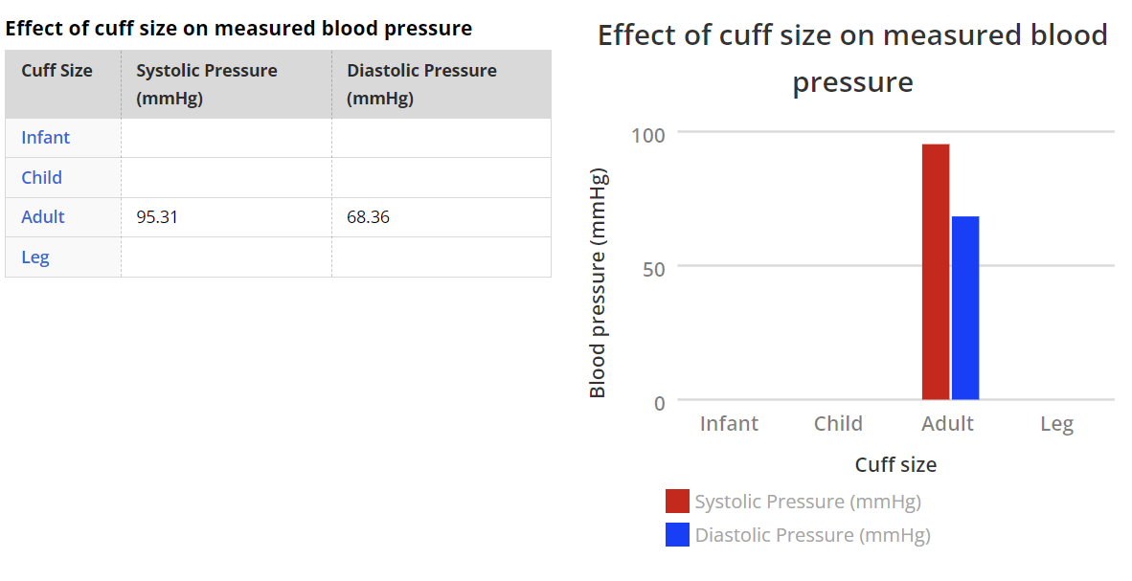
Experiment 1C: Arm Position
Procedure
- Keep the cuff around the volunteer's upper arm, and the cardio microphone over the brachial artery.
- Ensure the volunteer's arm is in a supported position at approximately the same level as the heart.
- Select Start to record, and inflate the cuff to 30 mmHg higher than the estimated systolic pressure. Enter "arm at heart level" into the Comment panel, then select Add.
- Slowly deflate the cuff at a rate of 1–2 mmHg/s.
- Deflate the cuff completely after the pressure has fallen below 50 mmHg or after the disappearance of the Korotkoff sounds.
- Select Stop.
- Repeat with the arm hanging loosely by side, and enter the comment "arm hanging loosely by side".
- Repeat with the arm raised to head level, and enter the comment "arm at head level".
- Now measure the distance from the brachial artery measurement site to the heart in centimeters (cm); approximate this using the fourth intercostal space. Enter comment "distance from heart = x cm".

Results
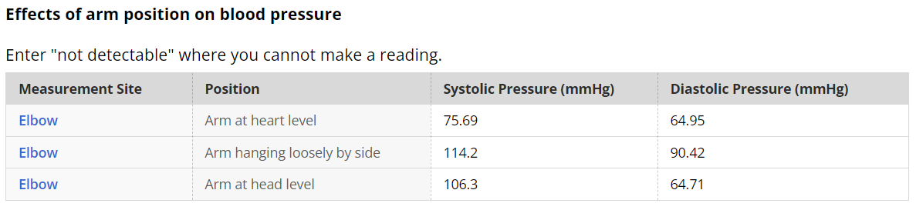

Experiment 1C: Leg Blood Pressure
Procedure
_{Thigh}
- Choose an appropriate sized cuff to wrap around the volunteer's mid-thigh.
- Place the cardio microphone over the popliteal artery behind the knee in the popliteal fossa and attach it with a Velcro strap.
- Ask the volunteer to lie with his or her back resting on the floor, with legs straight and relaxed.
- Select Start to record and inflate the cuff to 30 mmHg higher than the estimated systolic pressure. Enter "thigh - lying" into the comment panel, then select Add.
- Slowly deflate the cuff at a rate of 1–2 mmHg/s.
- Deflate the cuff completely after the pressure has fallen below 50 mmHg (or after the disappearance of the Korotkoff sounds).
- Select Stop.
- Ask the volunteer to stand. Measure the height difference between the mid position of the cuff to the level of the heart. Enter the height difference into the table below.
- Now repeat the blood pressure measurement procedure while standing. Enter "thigh - standing" into the comment panel, then select Add.
_{Calf}
- Choose an appropriately sized cuff to wrap around the volunteer's mid-calf.
- Place the cardio microphone over the dorsalis pedis artery and attach it with a Velcro strap.
- Select Start to record a calf blood pressure measurement with the volunteer lying down. Enter "calf - lying" into the comment panel, then select Add.
- Select Stop.
- Ask the volunteer to stand. Measure the height difference between the mid position of the cuff to heart level. Enter this in the table below.
- Select Start to record a calf blood pressure measurement while standing. Enter "calf - standing" into the comment panel, then select Add.
- Select Stop.

Results
