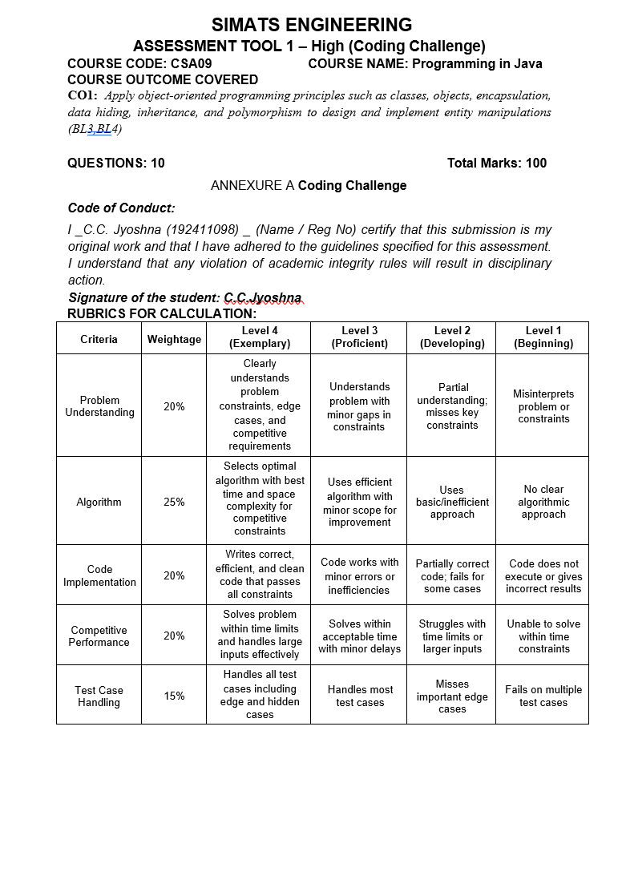
- Library Book Management using Classes & Encapsulation

Code:
class Book {
private int bookId;
private String title, author;
private double price;
private boolean issued;
Book (int id, String t, String a, double p) {
bookId = id;
title = t;
author = a;
price = p;
issued = false;
}
public void issueBook () {
if (! issued) {
issued = true;
System.out.println("Book Issued");
} else
System.out.println("Book Already Issued");
}
public void return Book () {
if (issued) {
issued = false;
System.out.println("Book Returned");
} else
System.out.println("Book Not Issued");
}
public void display () {
System.out.println(bookId + " " + title + " " + author + " " + price);
}
}
public class Library {
public static void main (String [] args) {
Book b1 = new Book (101, "Java", "James", 500);
Book b2 = new Book (102, "Python", "Guido", 600);

b1. Display ();
b1. issueBook ();
b1. return Book ();

b2. Display ();
}
}
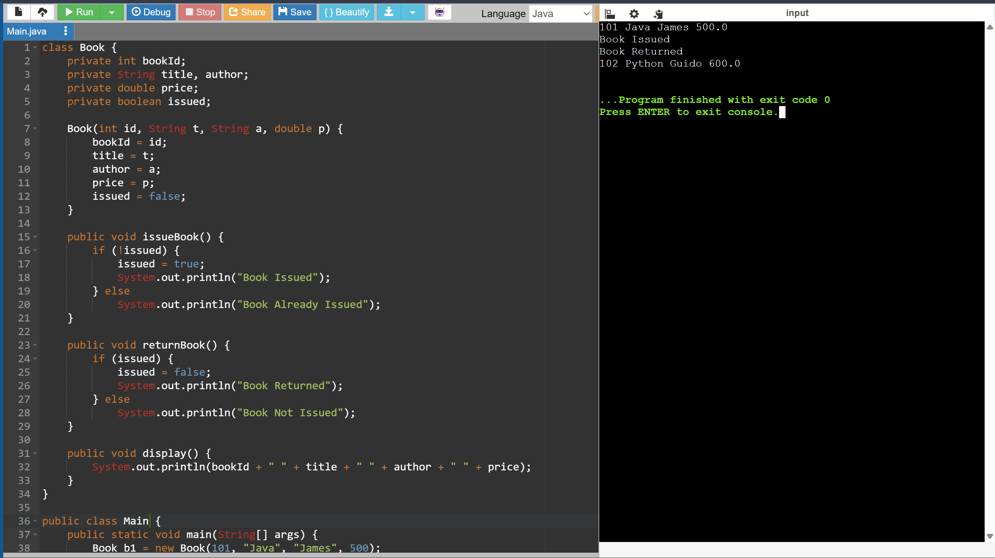

- Employee Payroll System using Inheritance

Code:
class Employee {
String name;
Employee (String name) {
this.name = name;
}
void calculateSalary () {
System.out.println("Salary");
}
}
class Permanent Employee extends Employee {
Permanent Employee(String name) {
super(name);
}

void calculateSalary () {
System.out.println(name + " Salary = 50000");
}
}
class Contract Employee extends Employee {
contract Employee (String name) {
super(name);
}
void calculateSalary () {
System.out.println(name + " Salary = 25000");
}
}
public class Payroll {
public static void main (String [] args) {
Employee e1 = new Permanent Employee ("Rahul");
Employee e2 = new contract Employee ("Anu");
e1. calculateSalary ();
e2. calculateSalary ();
}
}

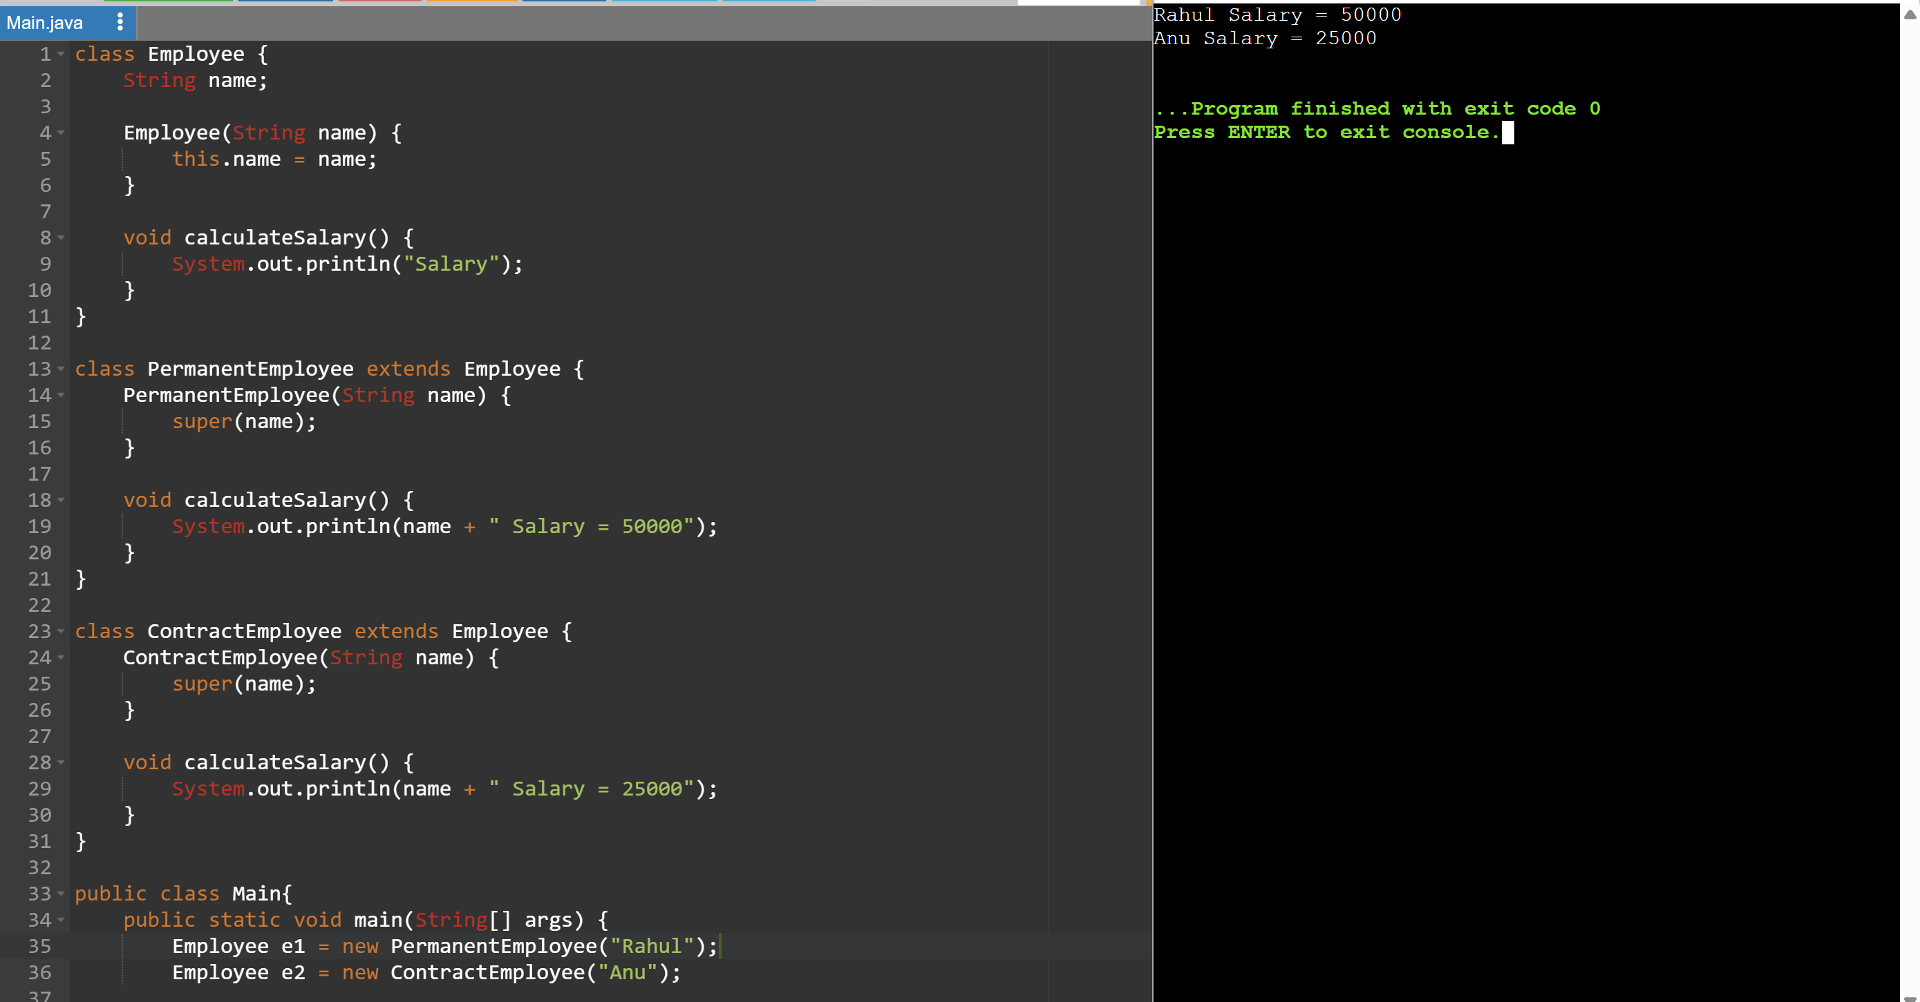

- Vehicle Rental System using Runtime Polymorphism

Code:
class Vehicle {
void calculate Rent(int days) {
}
}

class Car extends Vehicle {
void calculate Rent(int days) {
System.out.println("Car Rent = " + (days * 1000));
}
}

class Bike extends Vehicle {
void calculateRent(int days) {
System.out.println("Bike Rent = " + (days * 300));
}
}
class Bus extends Vehicle {
void calculateRent(int days) {
System.out.println("Bus Rent = " + (days * 2000));
}
}

public class Rental {
public static void main(String[] args) {
Vehicle v[] = {
new Car(),
new Bike(),
new Bus()
};

for (Vehicle x : v)
x.calculateRent(3);
}
}
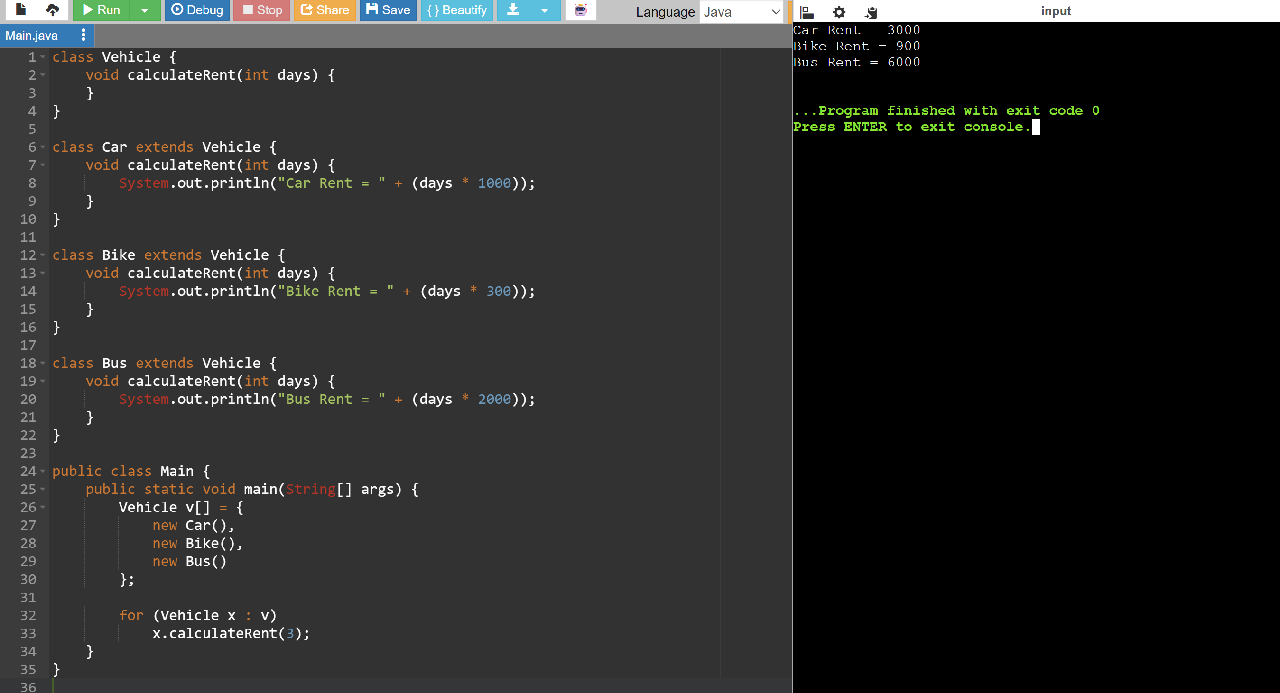

- Bank Account System using Data Hiding

Code:
class BankAccount {
private int accountNumber;
private String holderName;
private double balance;
BankAccount(int acc, String name, double bal) {
accountNumber = acc;
holderName = name;
balance = bal;
}
void deposit(double amount) {
balance += amount;
}

void withdraw(double amount) {
if (amount <= balance)
balance -= amount;
else
System.out.println("Insufficient Balance");
}

void showBalance() {
System.out.println("Balance = " + balance);
}
}

public class BankDemo {
public static void main(String[] args) {
BankAccount b = new BankAccount(101, "Rahul", 10000);

b.deposit(2000);
b.showBalance();

b.withdraw(5000);
b.showBalance();
}
}
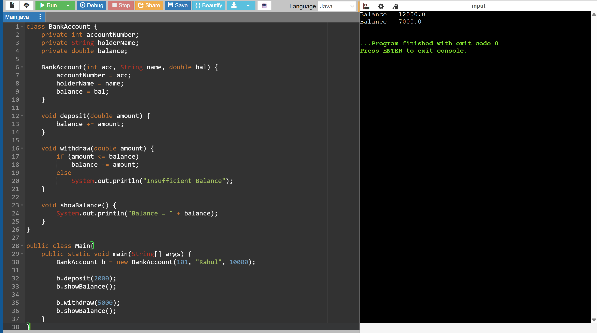

- University Admission System using Method Overloading

Code:
class Admission {
void calculateFee() {
System.out.println("Undergraduate Fee = 50000");
}
void calculateFee(String course) {
System.out.println("Postgraduate Fee = 70000");
}

void calculateFee(boolean scholarship) {
if (scholarship)
System.out.println("Scholarship Fee = 25000");
}
}

public class AdmissionDemo {
public static void main(String[] args) {
Admission a = new Admission();
a.calculateFee();
a.calculateFee("PG");
a.calculateFee(true);
}
}
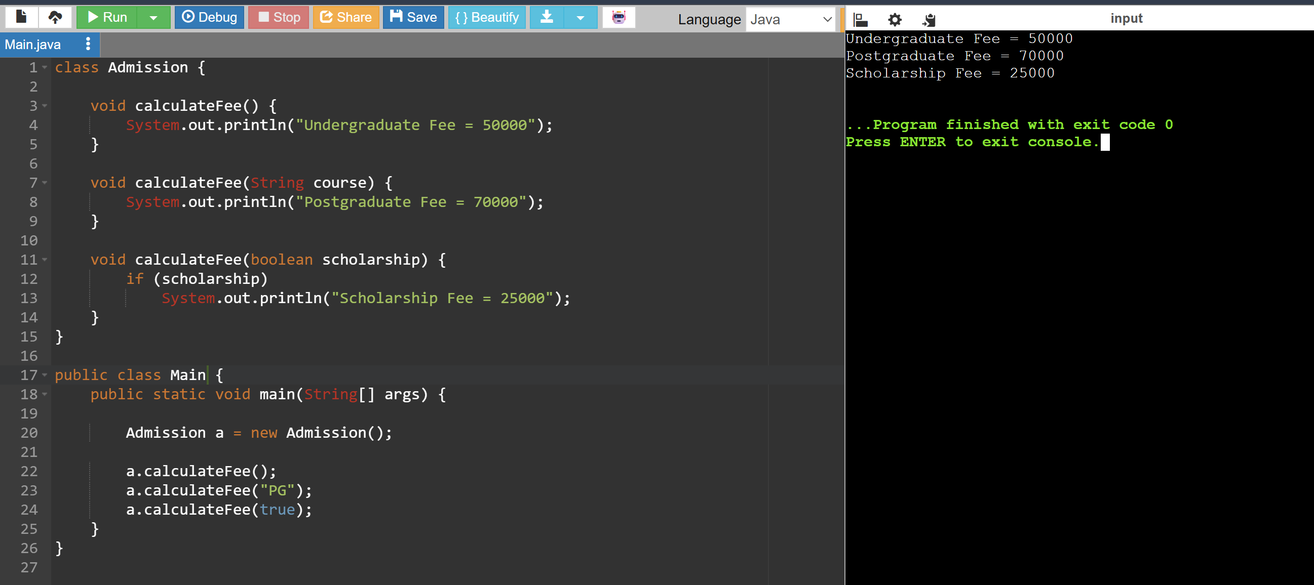

- Shape Area Calculator using Abstract Class & Polymorphism

Code:
abstract class Shape {
abstract void area();
}
class Circle extends Shape {
void area() {
double r = 5;
System.out.println("Circle Area = " + (3.14 * r * r));
}
}
class Rectangle extends Shape {
void area() {
int l = 4, b = 6;
System.out.println("Rectangle Area = " + (l * b));
}
}

class Triangle extends Shape {
void area() {
int b = 6, h = 4;
System.out.println("Triangle Area = " + (0.5 * b * h));
}
}

public class ShapeDemo {
public static void main(String[] args) {

Shape s[] = {
new Circle(),
new Rectangle(),
new Triangle()
};

for (Shape x : s)
x.area();
}
}
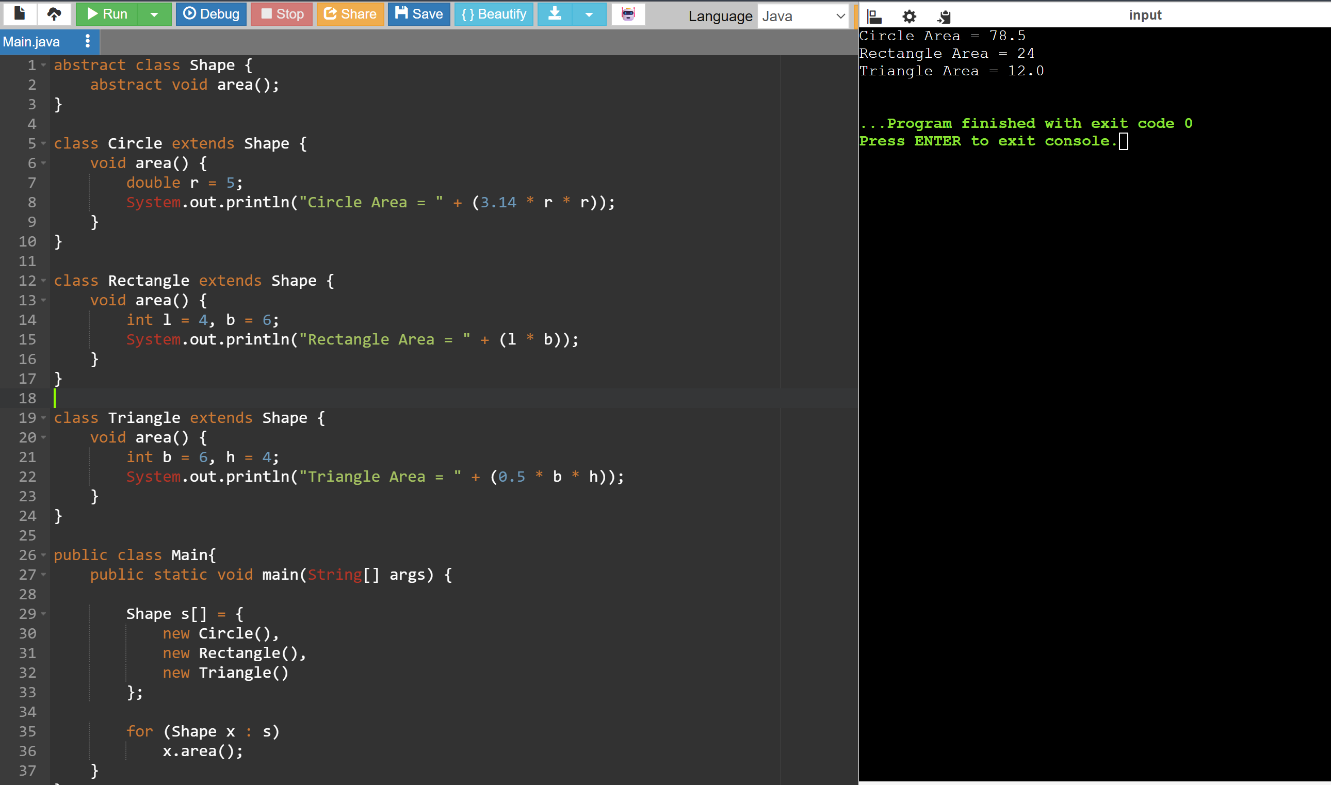

- Hospital Management System using Interfaces

Code:
interface MedicalRecord {
void addRecord();
void displayRecord();
}

class Patient implements MedicalRecord {

public void addRecord() {
System.out.println("Patient Record Added");
}

public void displayRecord() {
System.out.println("Patient Record Displayed");
}
}

class Doctor implements MedicalRecord {

public void addRecord() {
System.out.println("Doctor Record Added");
}

public void displayRecord() {
System.out.println("Doctor Record Displayed");
}
}
public class Hospital {
public static void main(String[] args) {
Patient p = new Patient();
Doctor d = new Doctor();
p.addRecord();
p.displayRecord();
d.addRecord();
d.displayRecord();
}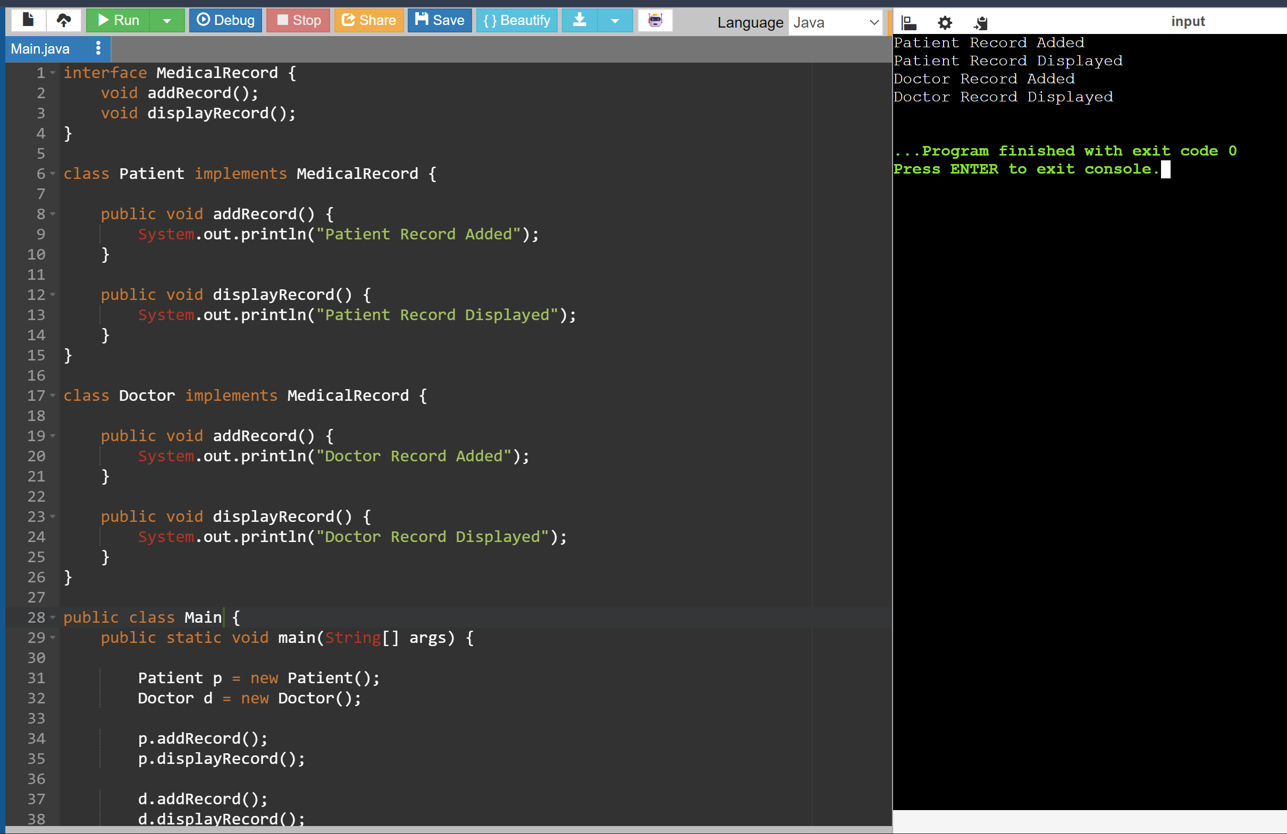
- Online Shopping Order System using Packages

Code:
class Product {
String name;
int price;
Product(String name, int price) {
this.name = name;
this.price = price;
}
}
class Order {
Product p;
Order(Product p) {
this.p = p;
}
void bill() {
System.out.println("Product : " + p.name);
System.out.println("Price : " + p.price);
}
}
public class Main {
public static void main(String[] args) {

Product p = new Product("Laptop", 50000);
Order o = new Order(p);

o.bill();
}
}
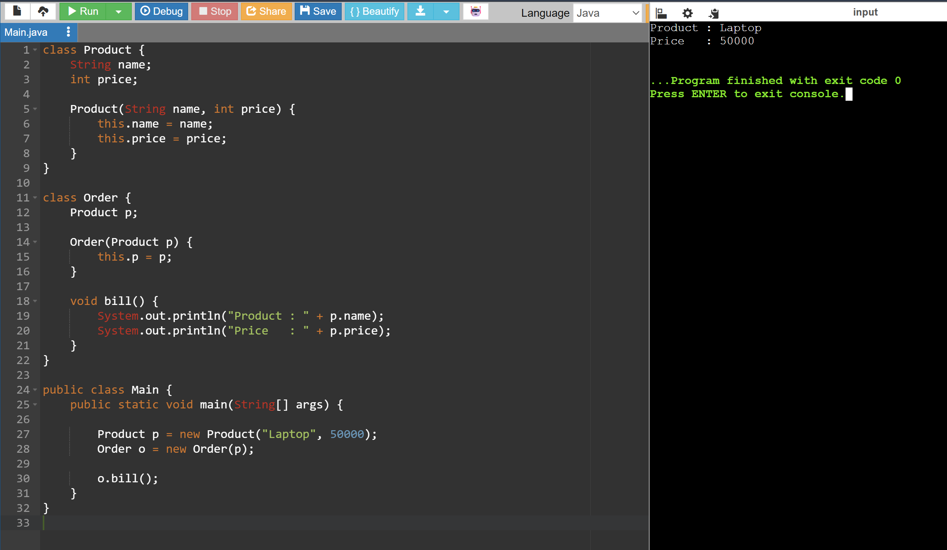

- Student Result Analyzer using Arrays of Objects

Code:
class Student {
int roll;
String name;
int m1, m2, m3;
Student(int r, String n, int a, int b, int c) {
roll = r;
name = n;
m1 = a;
m2 = b;
m3 = c;
}
void result() {
int total = m1 + m2 + m3;
double avg = total / 3.0;
System.out.println(name);
System.out.println("Total = " + total);
System.out.println("Average = " + avg);
if (avg >= 90)
System.out.println("Grade A");
else if (avg >= 75)
System.out.println("Grade B");
else
System.out.println("Grade C");
}
}
public class StudentDemo {
public static void main(String[] args) {
Student s[] = {
new Student(1, "Rahul", 90, 95, 92),
new Student(2, "Anu", 80, 75, 78)
};
int max = 0;
String topper = "";
for (Student x : s) {
x.result();
int total = x.m1 + x.m2 + x.m3;
if (total > max) {
max = total;
topper = x.name;
}
}
System.out.println("Topper = " + topper);
}
}
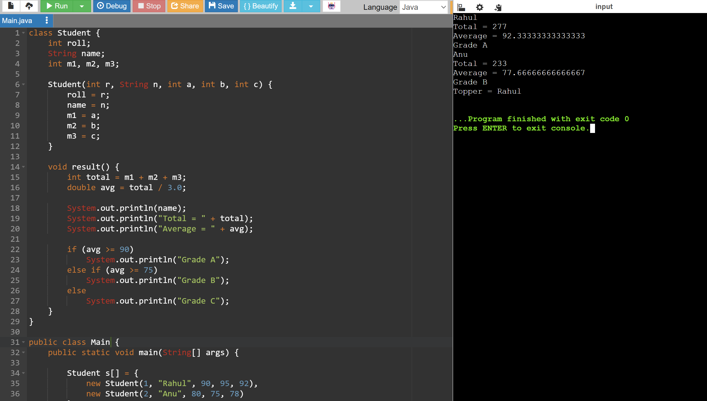

- Smart Home Device Controller using Hierarchical Inheritance

Code:
class Device {
void on() {
System.out.println("Device ON");
}

void power() {
}
}

class Light extends Device {
void power() {
System.out.println("Light Power = 20W");
}
}

class Fan extends Device {
void power() {
System.out.println("Fan Power = 75W");
}
}

class AirConditioner extends Device {
void power() {
System.out.println("AC Power = 1500W");
}
}

public class SmartHome {
public static void main(String[] args) {

Device d[] = {
new Light(),
new Fan(),
new AirConditioner()
};

for (Device x : d) {
x.on();
x.power();
}
}
}
