Name: C.C. Jyoshna
Reg.no: 192411098
Course Code: CSA0910
Course: Programming in Java
CO1-AT2
- Reverse Numbers

Pseudo code:
Start
Read number n
Set reverse = 0
While n is not equal to 0
digit = n % 10
reverse = reverse * 10 + digit
n = n / 10
End While
Print reverse
Stop
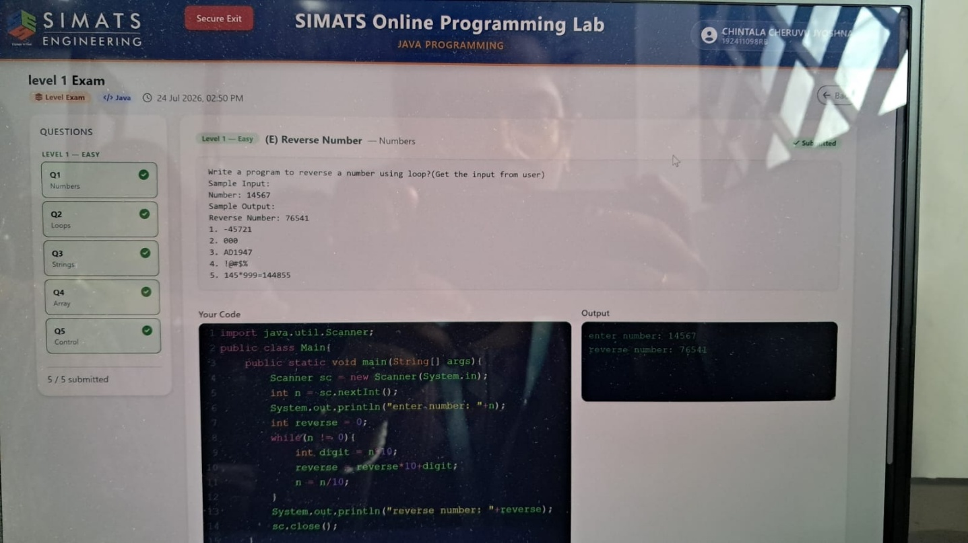

- Fibonacci Series

Pseudo code:
Start
Input n
a = 0
b = 1
sum = 0
For i = 0 to n
Print a
If i is even
sum = sum + a
End If
c = a + b
a = b
b = c
End For
Print sum
Stop
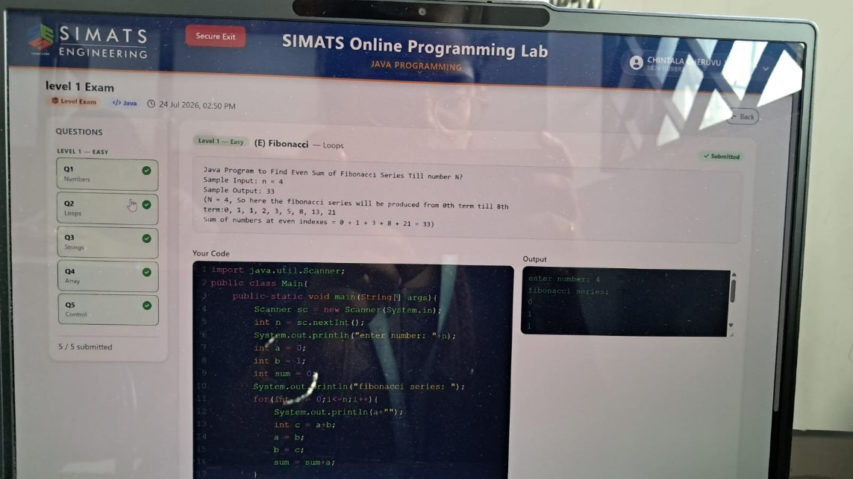

- Valid or not

Pseudo code:
Start

Input username
Input re-entered username
If username equals re-entered username
Print "User name is Valid"
Else
Print "User name is Invalid"
End If
Stop
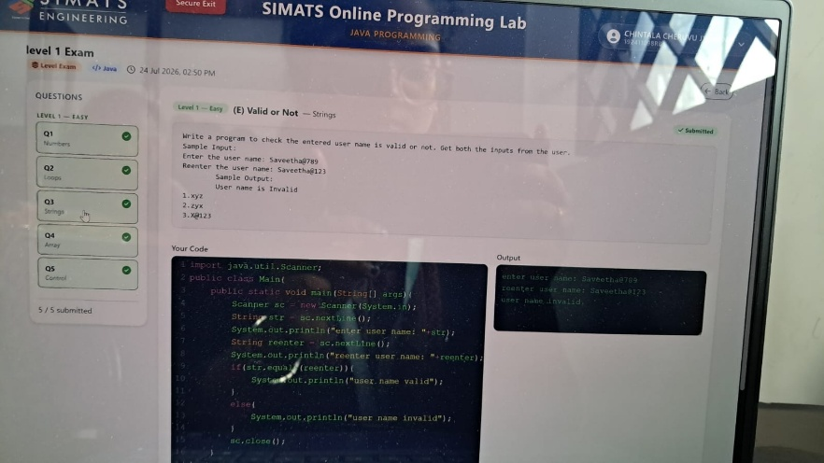

- Composite Numbers

Pseudo code:
Start
Initialize array
count = 0
For each element in array
If element is composite
count = count + 1
End If
End For

Print count
Stop
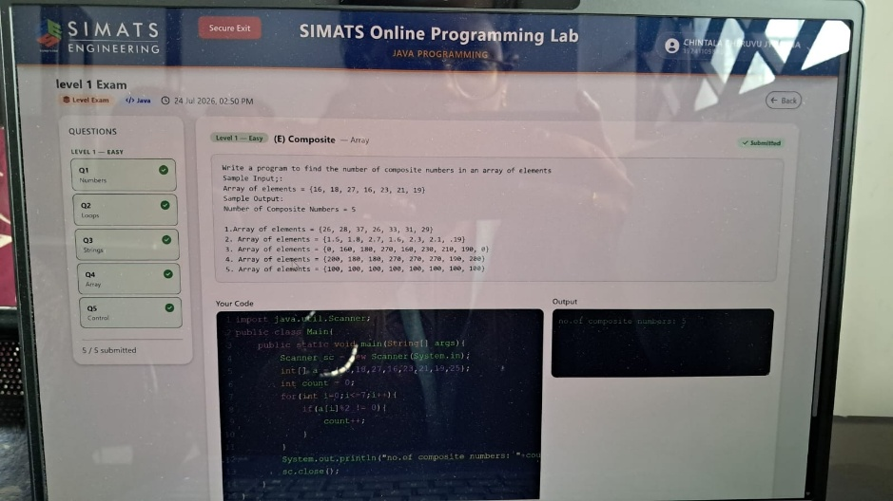

- Simple Interest

Pseudo code:
Start
Input principal amount
Input number of years
Input senior citizen (Y/N)
If senior citizen = Y
rate = 12
Else
rate = 10
End If
interest = (principal × rate × years) / 100
Print interest
Stop
