

Energy is what we do

Supplier 850 PO
X12/004010/PO 850 PO
Version: 1.1
Publication: 07/01/2025

EDI Communication with Rehlko Energy
This document outlines the specifications to exchange the EDI PO with Rehlko. The PO is used by Rehlko to procure products and services from our supplier community.
Delimiters
Values on the EDI ISA segment to identify values for EDI separators and terminators.
Type | Value
Element Separator | Asterisk (*)
Segment Terminator | Tilde (~)
Sub-element Separator | Colon (:)

Valued-Added Network (VAN)
Rehlko uses Sterling Commerce network which interconnects to network of your choice.
EDI Communication ID(s)
Rehlko uses several different ISA/GS EDI IDs depending on the specific business entity that you deal with.
USA | Canada | APAC | EMEA
Prod:  ZZ/REHLKOTRAFFIC  ZZ/REHLKOFIN  ZZ/REHLKOENGUS  ZZ/REHLKOGENUS  ZZ/REHLKOENGVND  ZZ/REHLKOCORVND  ZZ/REHLKOGENVND  Test:  ZZ/REHLKOTSTC  ZZ/REHLKOTSTF  ZZ/REHLKOTSTT  ZZ/REHLKOTSTV | Prod:  ZZ/REHLKOENGCAN  ZZ/REHLKOGENCAN | Prod:  ZZ/REHLKOENGAPAC  ZZ/REHLKOGENAPAC  ZZ/REHLKOAPACVND | Prod:  ZZ/REHLKOENGEMEA  ZZ/REHLKOGENEMEA  ZZ/REHLKOEMEAVND

EDI Contacts
Rehlko EDI Support EDI_Support@Rehlko.com or 1-248-412-0214.

Rehlko EDI PO 850 Purchase Order Notes
- There are several fields that are sent on EDI PO 850 that we expect to be included on transactions sent back to Rehlko like the Order Acknowledgement, Advanced Ship Notice, and Invoice. These are:
Description | 850 PO | 855 PR | IN 810 | SH 856
PO Number | BEG03 | BAK03 | BIG04 | PRF01
PO Date | BEG05 | BAK04 | BIG03 | PRF04
Vendor Number | N104 (N101 = II) |  | N104 (N101 = II)
Supplier Vendor Number | N104 (N101 = SU) | N104 (N101 = SU) |  | N104 (N101 = SU)
Purchasing Organization | N104 (N101 = BT) |  | N104 (N101 = BT)
PO Line Number | PO101 | PO101 | IT101 | LIN01 & SN101
Unit of Measure | PO103 | PO103, ACK03, SCH02
Buyer’s Part Number | PO109 (PO108 = BP) | PO107 (PO106 = BP) | IT107 (IT106 = BP) | LIN05 (LIN04 = BP)
Pricing Quantity | CTP10 | CTP10 | CTP10

EDI PO 850 Purchase Order Structure
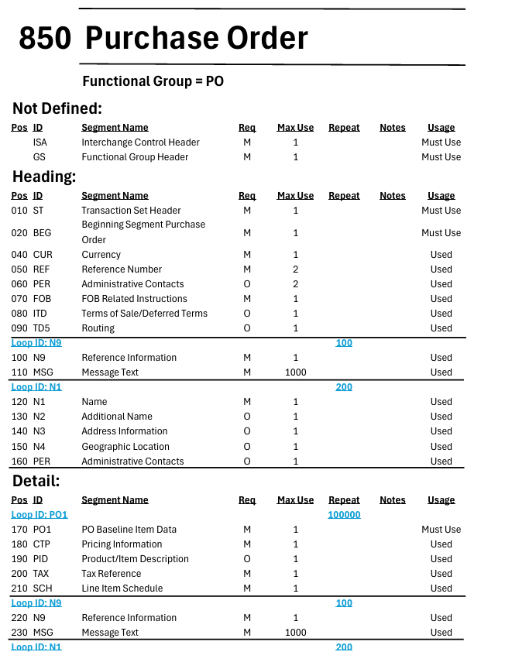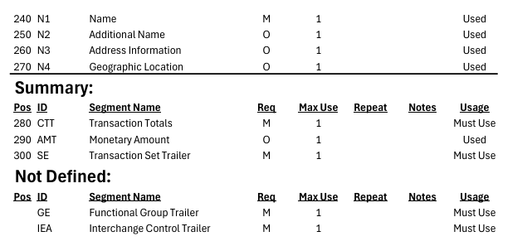

EDI PO 850 Purchase Order Segment Usage
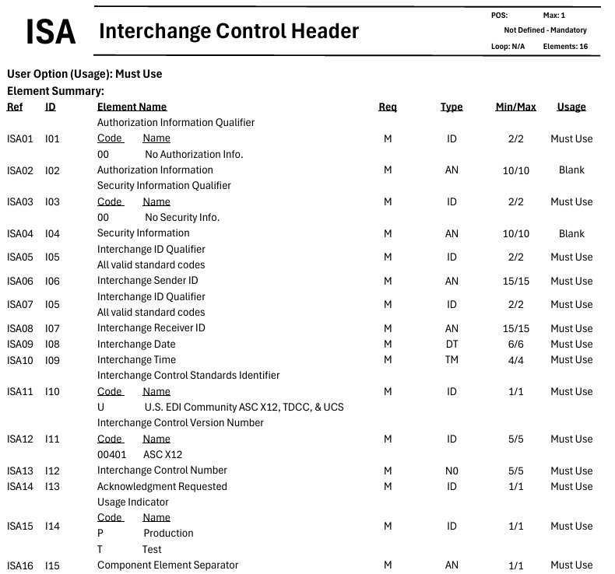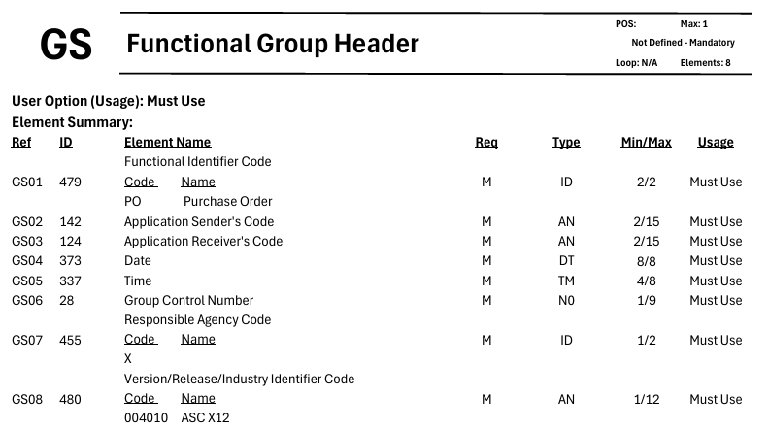
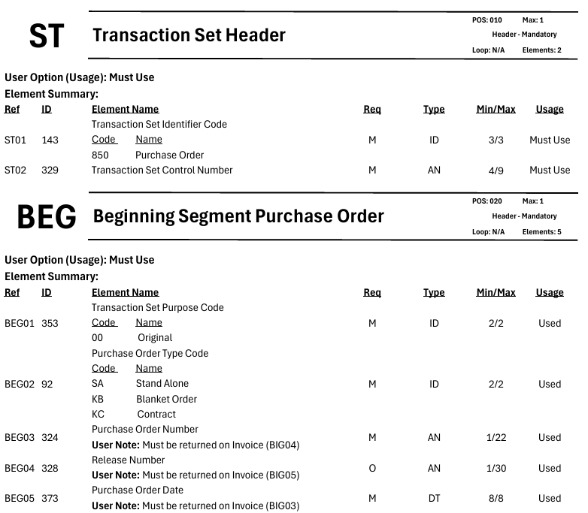
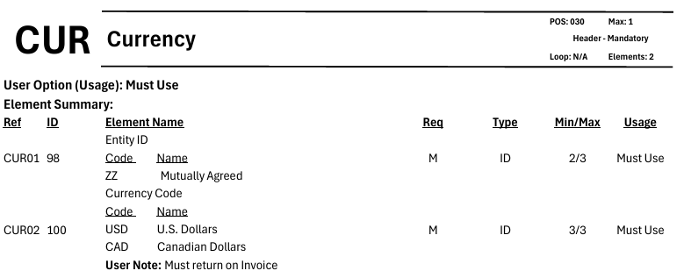

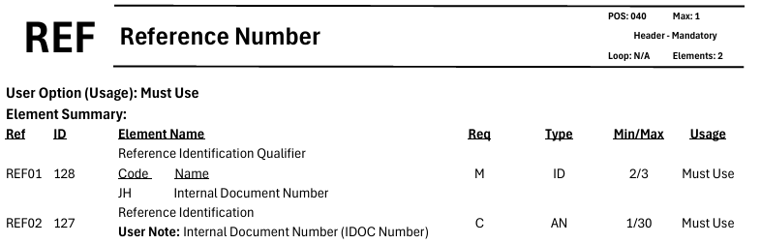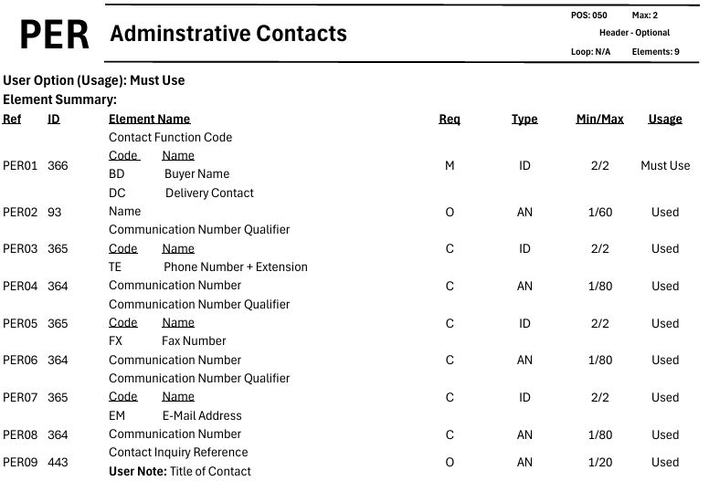
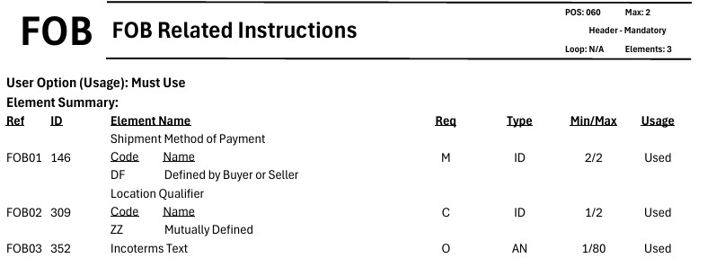
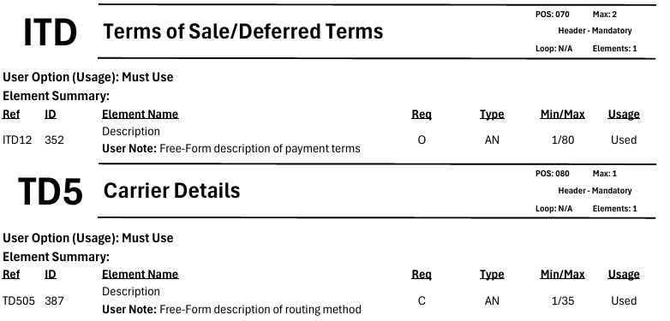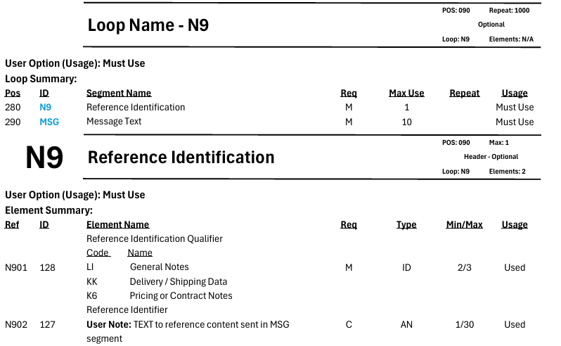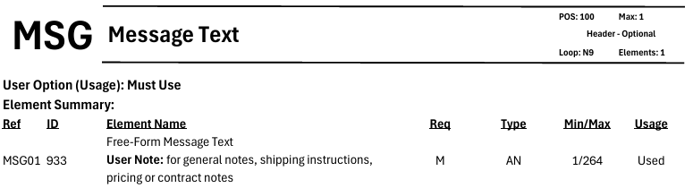

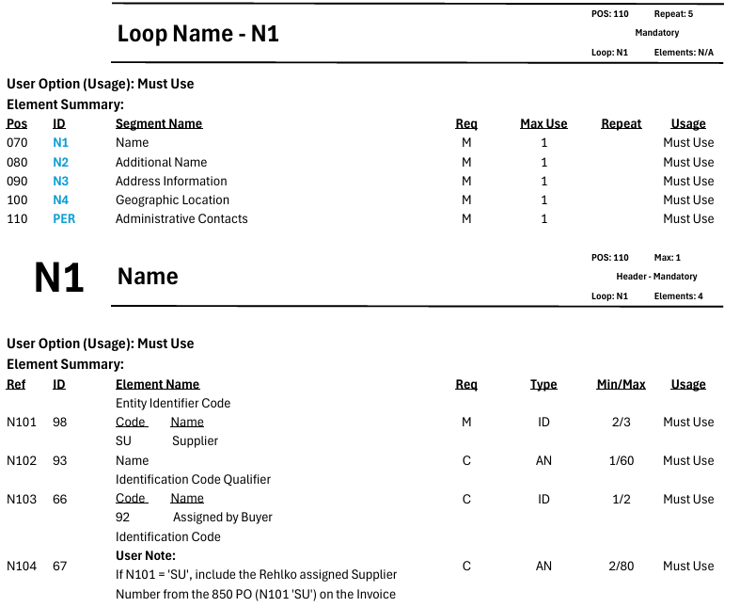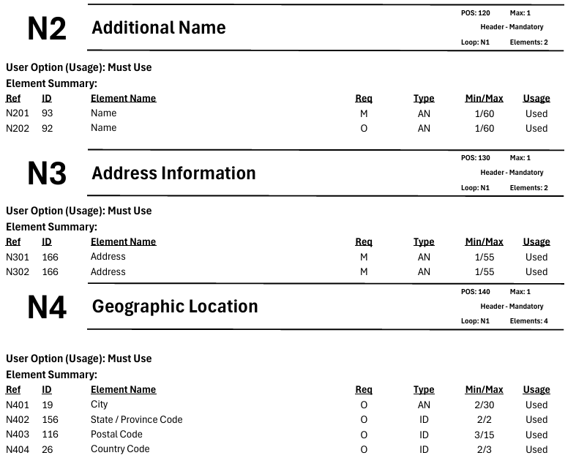
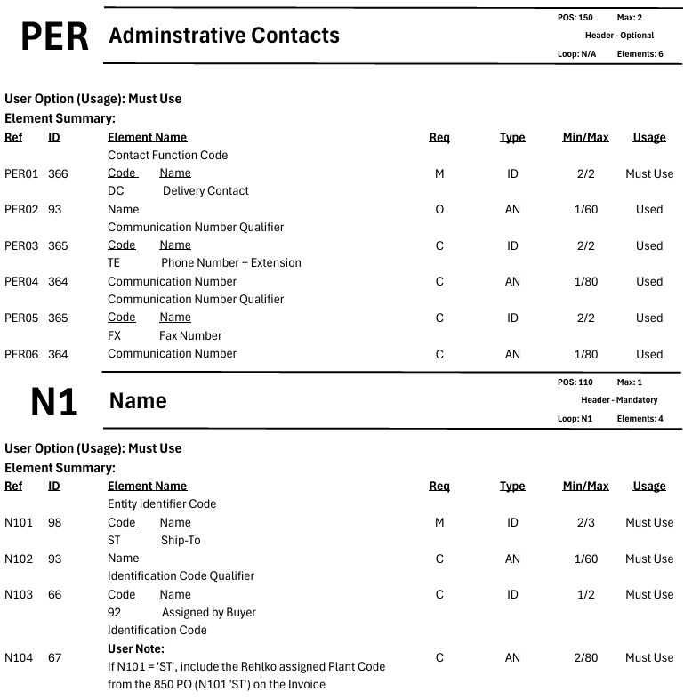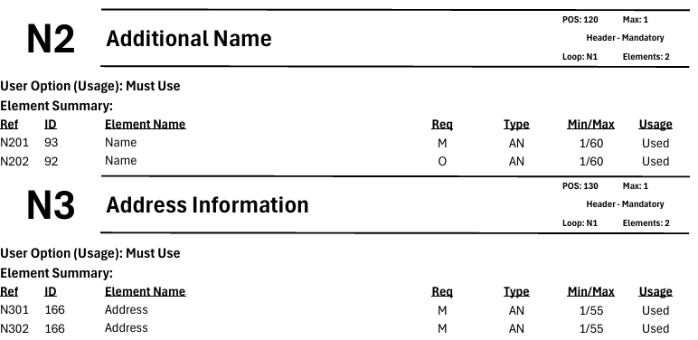
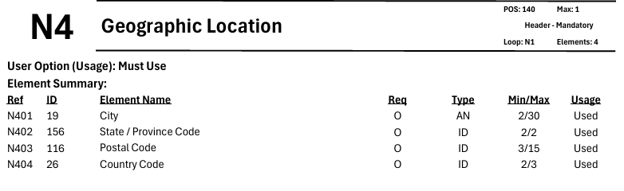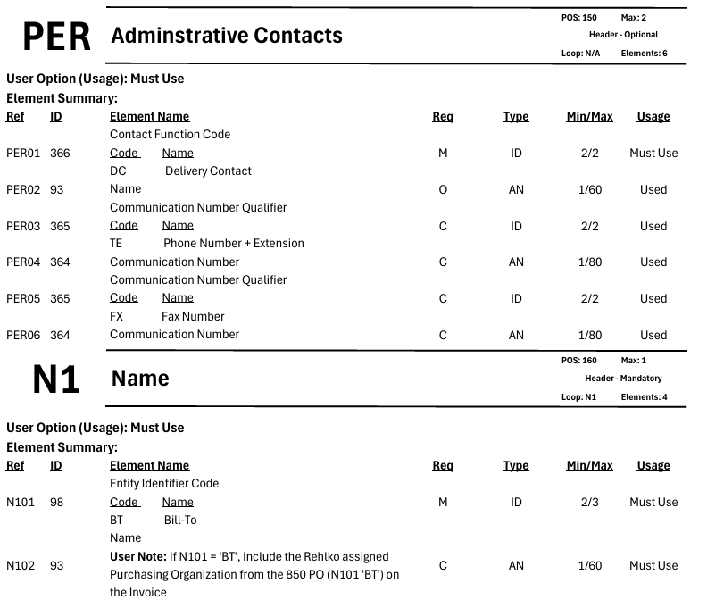
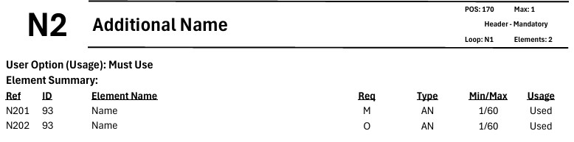
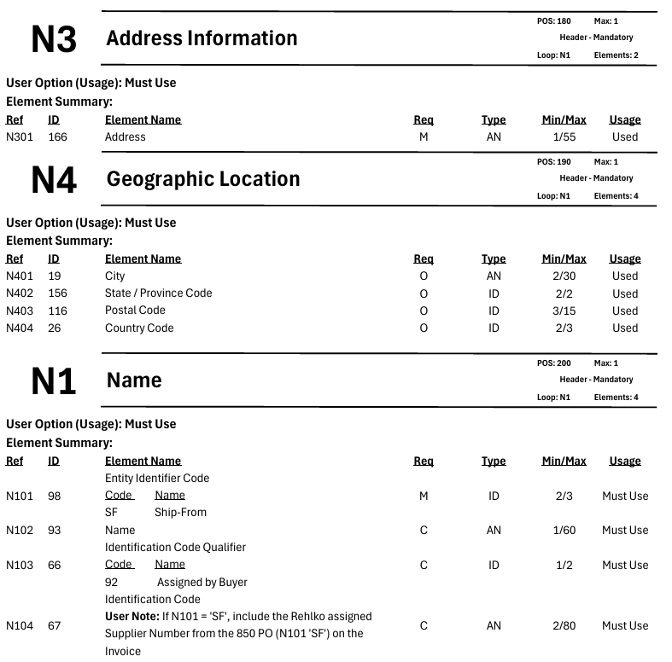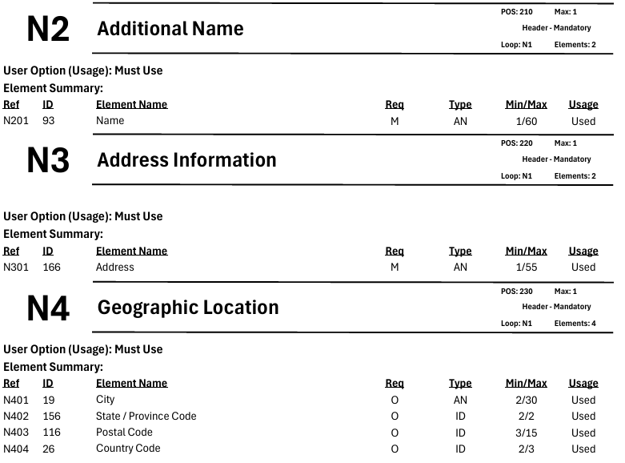
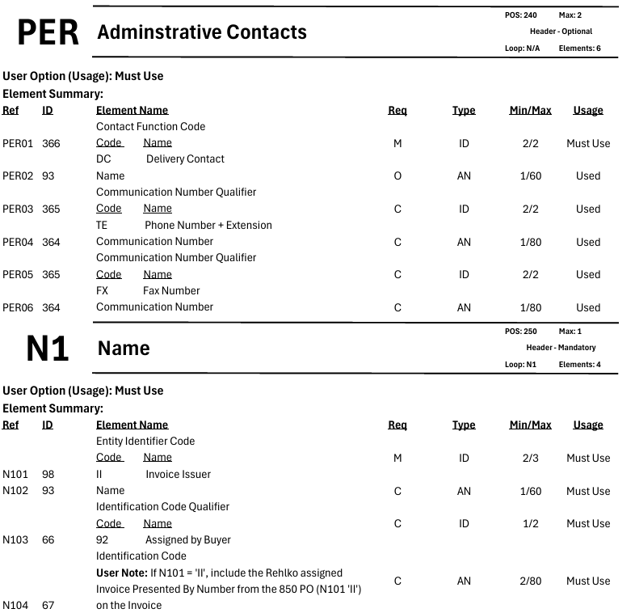
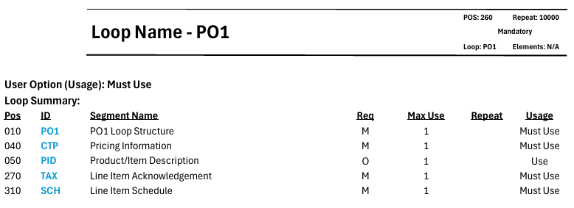

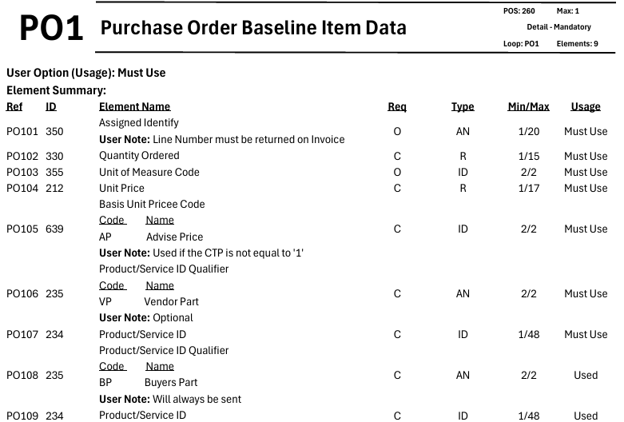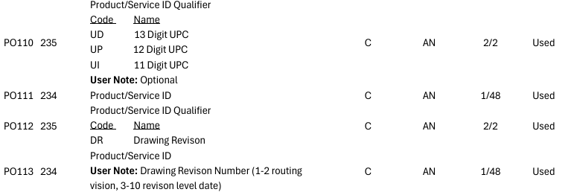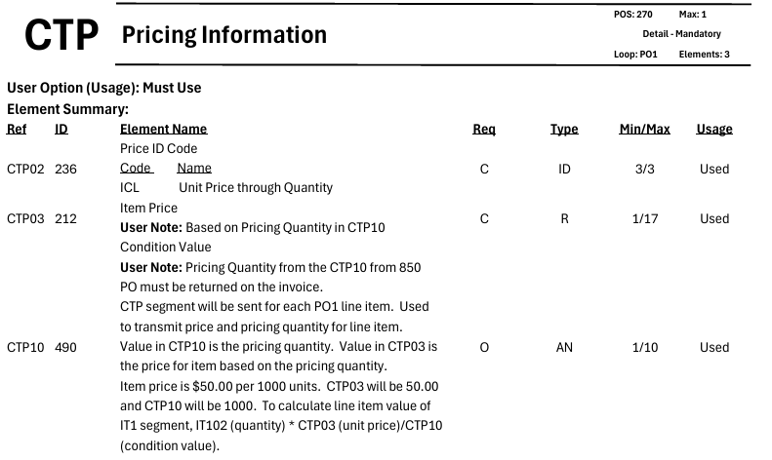
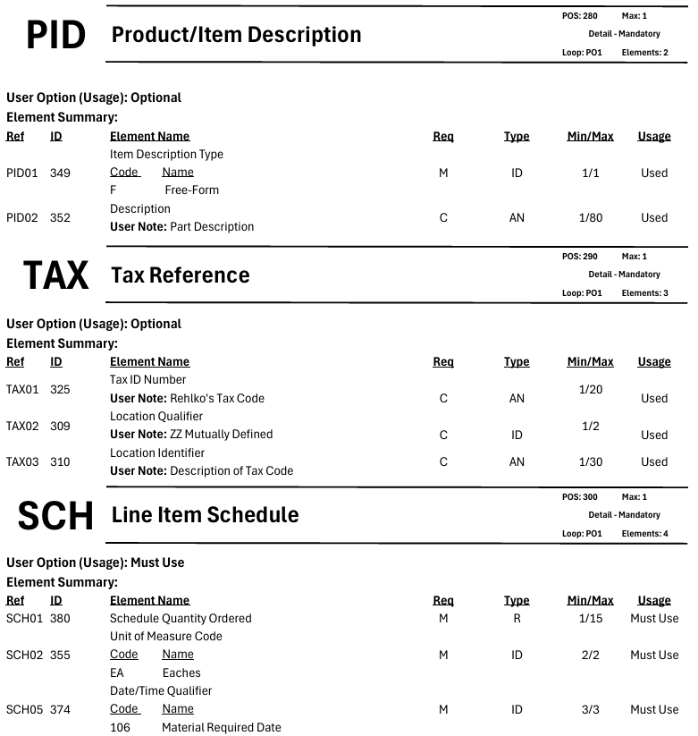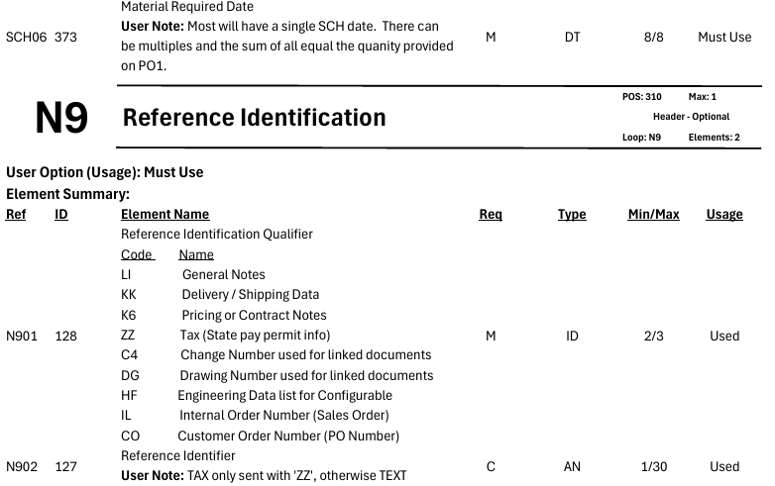
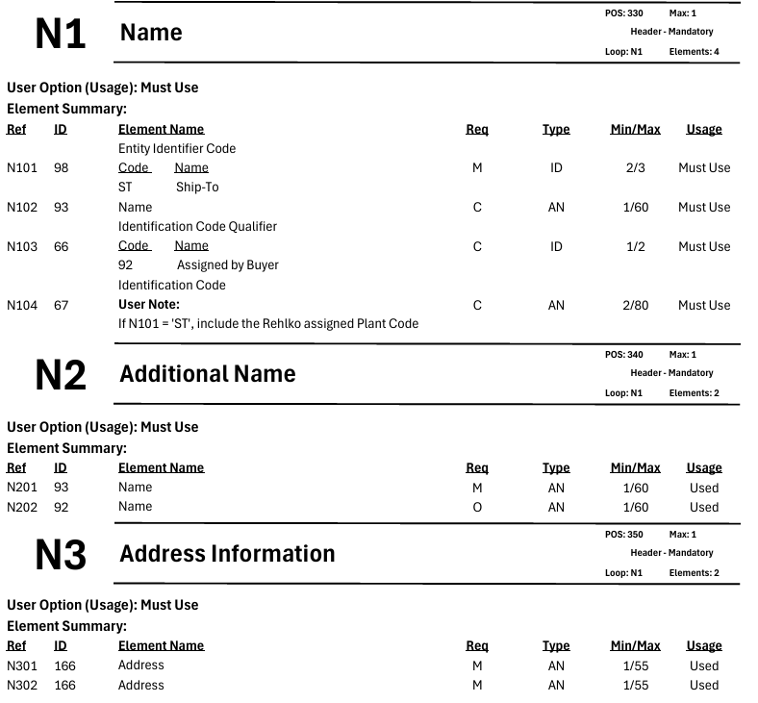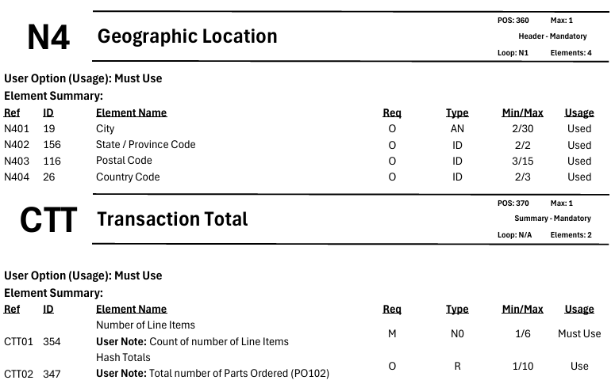
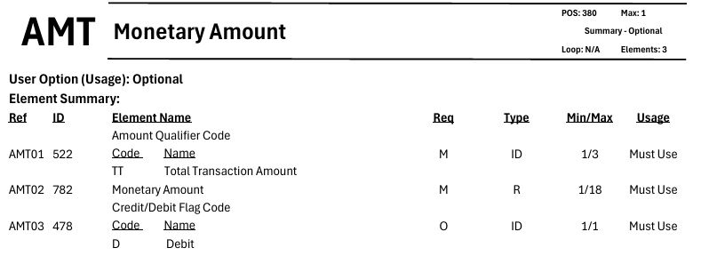
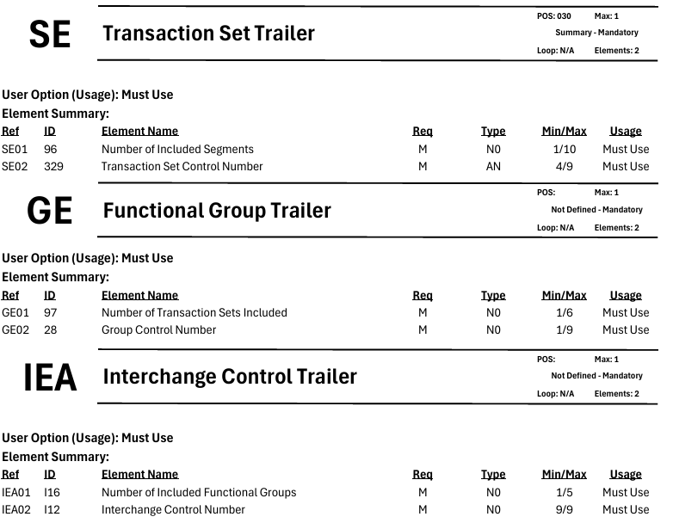

EDI PO 850 Purchase Order Sample
