AIM:

To implement the map colouring to implement csp

Program:

def is_valid_assignment(assignment, node, color):

for neighbor in graph[node]:

if neighbor in assignment and assignment[neighbor] == color:

return False

return True

def backtracking(assignment):

if len(assignment) == len(graph):

return assignment

node = select_unassigned_variable(assignment)

for color in colors:

if is_valid_assignment(assignment, node, color):

assignment[node] = color

result = backtracking(assignment)

if result:

return result

del assignment[node]

return None

for node in graph:

if node not in assignment:

return node

if __name__ == "__main__":

graph = {

'WA': ['NT', 'SA'],

'NT': ['WA', 'SA', 'Q'],

'SA': ['WA', 'NT', 'Q', 'NSW', 'V'],

'Q': ['NT', 'SA', 'NSW'],

'NSW': ['Q', 'SA', 'V'],

'V': ['SA', 'NSW']

}

colors = ['Red', 'Green', 'Blue']

assignment = backtracking({})

if assignment:

print("Valid Map Coloring:")

for node, color in assignment.items():

print(f"{node}: {color}")

else:

print("No valid coloring found.")

INPUT:

Valid map colouring

OUTPUT:

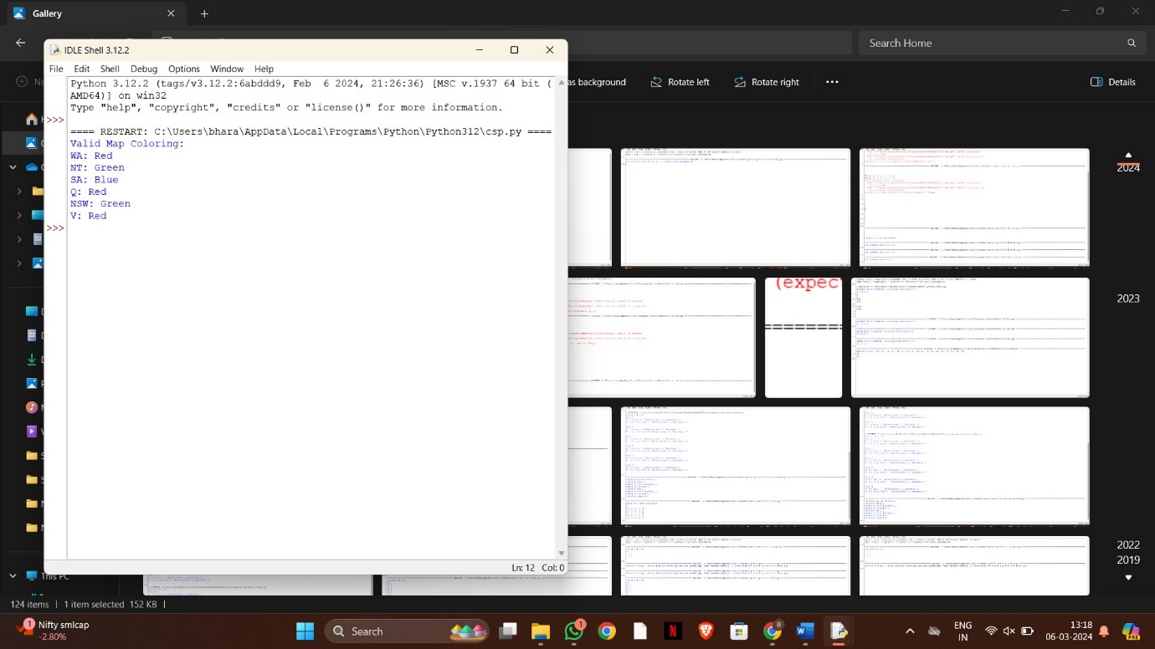

RESULT:

The implementation of map colouring of csp is successfully completed.