AIM:

To solve the minimax algorithm for gaming using python program is successfully completed

PROGRAM:

import math

def minimax (curDepth, nodeIndex,maxTurn, scores,targetDepth):

# base case : targetDepth reached

if (curDepth == targetDepth):

return scores[nodeIndex]

if (maxTurn):

return max(minimax(curDepth + 1, nodeIndex * 2,

False, scores, targetDepth),

minimax(curDepth + 1, nodeIndex * 2 + 1,

False, scores, targetDepth))

else:

return min(minimax(curDepth + 1, nodeIndex * 2,

True, scores, targetDepth),

minimax(curDepth + 1, nodeIndex * 2 + 1,

True, scores, targetDepth))

# Driver code

scores = [3, 5, 2, 9, 12, 5, 23, 23]

treeDepth = math.log(len(scores), 2)

print("The optimal value is : ", end = "")

print(minimax(0, 0, True, scores, treeDepth))

INPUT:

The optimal value is 12

OUTPUT:

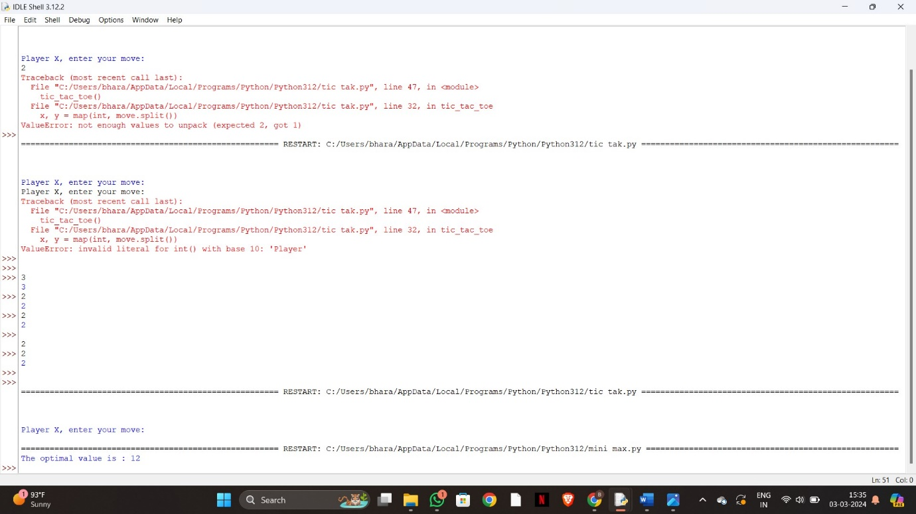

RESULT:

The solving of minimax using python programming is successfully completed .