AIM:

The aim is to solve the salesman travelling problem using python program.

PROGRAM:

from itertools import permutations

def calculate_total_distance(order, distances):

total_distance = 0

for i in range(len(order) - 1):

total_distance += distances[order[i]][order[i+1]]

total_distance += distances[order[-1]][order[0]] # Return to the starting city

return total_distance

def traveling_salesman_bruteforce(distances):

cities = len(distances)

if cities < 2:

print("Not enough cities for the problem.")

return

# Generate all possible orderings of cities

all_permutations = permutations(range(cities))

min_distance = float('inf')

optimal_order = None

for order in all_permutations:

total_distance = calculate_total_distance(order, distances)

if total_distance < min_distance:

min_distance = total_distance

optimal_order = order

return optimal_order, min_distance

if __name__ == "__main__":

# Example distances between cities (symmetric matrix)

example_distances = [

[0, 10, 15, 20],

[10, 0, 35, 25],

[15, 35, 0, 30],

[20, 25, 30, 0]

]

optimal_order, min_distance = traveling_salesman_bruteforce(example_distances)

print("Optimal order:", optimal_order)

print("Minimum distance:", min_distance)

INPUT:

Optimal order:(0,1,3,2)

OUTPUT:

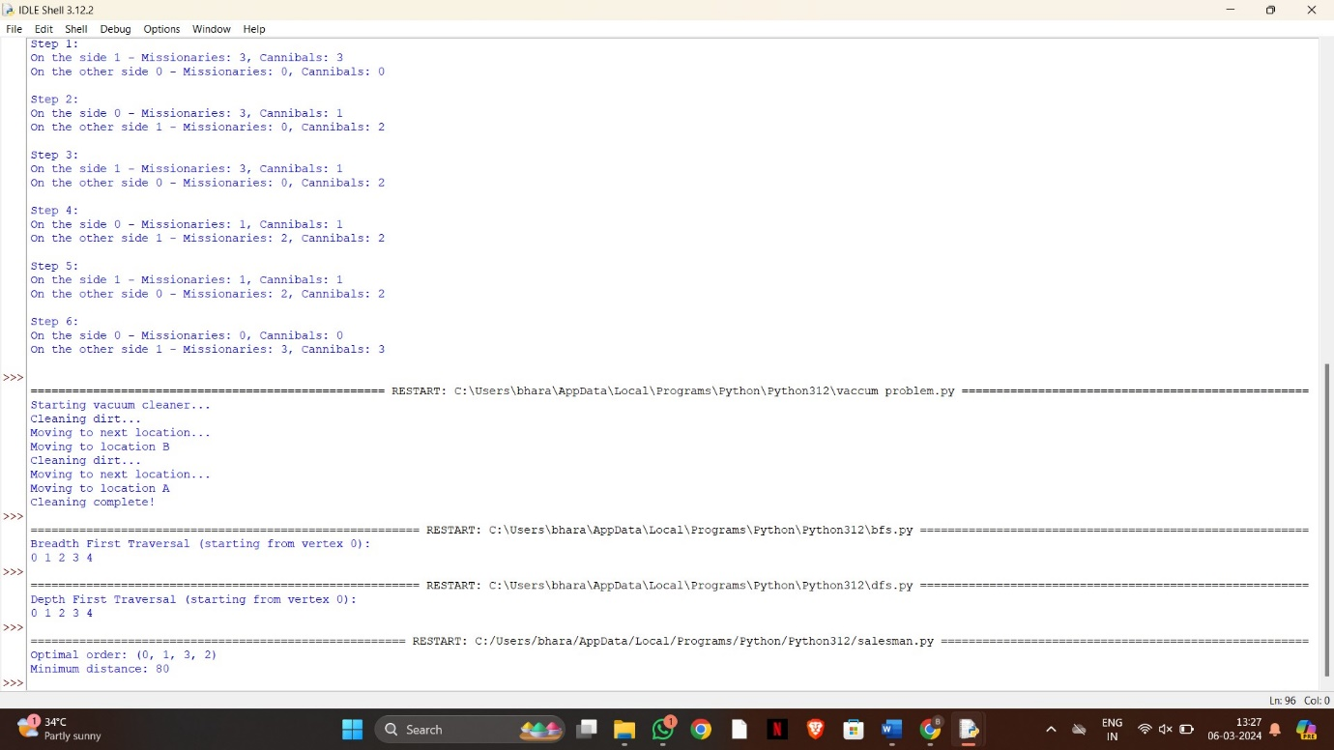

RESULT:

Thus the solving of salesman traveling using python program is successfully completed.